UL Configured Grant Type 2 in OCUDU
Implementation proposal: current state, required changes, parameters and block diagrams
Item | Value
Document | CG Type 2 implementation proposal, version 2 (supersedes "UL Configured Grant Type 2: Parameter Inventory and DCI 0_1 Integration Proposal")
Code baseline | OCUDU 6153e7bf2 (2026-08-25, "cmake: fix AOCL-FFTZ library find instructions"). All file:line references point to this commit.
Author | Surabhi P
Date | 24 September 2026
Status | Design proposal. No code has been written; every claim about the current code was checked against the source at the baseline commit.
Spec references | TS 38.321 §5.4.1, §5.8.2, §6.1.3.7 · TS 38.213 §10.2 · TS 38.212 §7.3.1.1.2 · TS 38.214 §6.1.2 · TS 38.331 ConfiguredGrantConfig

Colour code used in every table and diagram
NEW: code that does not exist and must be written. MODIFY: existing function or struct that must change.
REMOVE: an existing Type-1-only guard or assert that must be deleted or relaxed. UNCHANGED: existing code that Type 2 reuses as-is.
VERIFY: outside OCUDU (the OAI UE) or needs confirmation before relying on it. OUTPUT: result objects and hand-off points.

Contents
1. Executive summary (1.1 Corrections to the first draft)
2. Background: how CG Type 2 works (3GPP)
3. Lab setup and baseline evidence
4. What exists today (as-is): Type 1 path, the 14 places that assume Type 1, reusable parts
5. Parameters involved: ConfiguredGrantConfig, grant fields, DCI 0_1 fields, runtime state, new config
6. Proposed changes: file and function inventory (per figure, with IDs)
7. Block diagrams (Figures 1-4, landscape pages)
8. Design decisions
9. Implementation plan and test plan
10. Risks and open questions
11. Glossary

1. Executive summary
OCUDU already has a working UL Configured Grant (CG) Type 1 implementation, in which the whole grant comes from RRC. This document proposes how to add Type 2, where RRC sends only the semi-static part (periodicity, HARQ count, DMRS, MCS table) and the gNB activates or releases the grant with a DCI format 0_1 whose CRC is scrambled by the CS-RNTI. The proposal was built by reading the code at the baseline commit, not only the earlier draft.
- No new DCI bit-fields. dci_0_1_configuration and dci_0_1_pack() (dci_packing.h:780, :953) stay unchanged. Activation and release reuse the existing fields with the reserved values from TS 38.213 §10.2.
- No new RRC field. cg_configuration already treats an absent rrc_configured_ul_grant_cfg as Type 2, and the ASN.1 encoder (asn1_rrc_config_helpers.cpp:2951) already omits rrc-ConfiguredUplinkGrant when it is absent. CS-RNTI allocation (mac_controller.cpp:109) is already type-agnostic.
- The work is larger than the first draft said. It is not "one new function plus one branch". The code has 14 places that assume Type 1 (Section 4.2), including three that would crash a Type 2 UE. The full plan touches about 30 source files: 12 new symbols, 27 modified, 3 Type-1 guards removed, and 16 existing pieces reused unchanged (Section 6.5).
- Three blockers the first draft missed. (1) build_pusch_cs_rnti() asserts that the RRC grant exists (sch_pdu_builder.cpp:680). (2) Five CG-scheduler functions dereference rrc_configured_ul_grant_cfg.value(). (3) The CG scheduler has no PDCCH allocator, so it cannot send an activation DCI at all.
- Recommended approach. Keep the existing Type 1 resource planning (cg_type1_res_mng picks an offset and VRBs) and store the Type 2 grant as a DU-internal template. Send the activation DCI in a slot where (n + k2) mod P equals the planned offset. Route every grant read through one new helper, get_active_grant(), so the periodic-occasion code serves both types.
- Delivery in five phases (Section 9). Phase 0 is a behaviour-neutral refactor that can merge on its own. The main external risk is whether the OAI UE supports Type 2; check that before end-to-end testing.

1.1 Corrections to the first draft
Each point below was checked against the source at 6153e7bf2.
First draft said | What the code shows | Consequence
build_pusch_cs_rnti(): no change expected | Line 680 asserts cg_cfg.rrc_configured_ul_grant_cfg.has_value() with message "RRC-ConfiguredUplinkGrant for CG type 1 not set". | Every Type 2 occasion would hit the assert. The assert must be relaxed (I4).
The scheduler change is one added branch in add_ue_to_wheel() | rem_ue(), reserve_cg_resources(), build_cg_pusch_cfg_params(), allocate_cg_opportunity() and compute_cg_vrbs() all read the RRC grant directly. | Add get_active_grant() and route all five through it (H4, H5, I1, I2).
Add one enum entry cs_rnti_f0_1 in dci_info.h | dci_ul_info::type() returns payload.index(), so the enum must match a variant alternative. dci_0_1_configuration is already one alternative, and adding the same type twice breaks std::get<T>. | Add a distinct wrapper type (for example dci_0_1_cs_rnti_configuration) and update encode_dci(), the logger and the RNTI-type strings (F4, F5).
nof_cg_reserved gating is a bug | ue_cell::handle_reconfiguration_request() reserves CG HARQs for any CG. update_harq_reservation() then resets the count to 0 when there is no RRC grant. This is a deliberate Type-1-only guard, consistent with the header remark "Type 2 CG is not currently supported". | Not a defect in today's Type-1-only build, but it blocks Type 2. Drop the guard as part of this work (D3).
Not covered | The config validator rejects Type 2 (scheduler_ue_config_validator.cpp:29). The factory and resource manager always build or assert the RRC grant. There is no CLI option to select the type. | Configuration-path changes A1–A4, B2, B3, B5, C1 and C2.
Not covered | LCID 55 (CG Confirmation MAC CE) has no enum entry. The PDU still parses because the CE is zero-length, but handle_mac_ce() logs "Unhandled LCID" and drops it. | The gNB cannot tell whether activation or release took effect (G2–G5).
Not covered | is_cg_slot() (ue_configuration.cpp:743) says "TODO: support type 2" and only checks config. | Dynamic PUSCH would not be kept out of Type 2 occasions (J1, J2).
Not covered | alloc_ul_pdcch_ue() uses its rnti argument both as the CRC RNTI and for n_RNTI data scrambling (TS 38.211 §7.3.2.3 requires C-RNTI there). | The activation PDCCH must keep C-RNTI for scrambling and use CS-RNTI only for the CRC (F1).

2. Background: how CG Type 2 works (3GPP)

2.1 Type 1 compared with Type 2
Aspect | Dynamic grant | CG Type 1 | CG Type 2
Where the grant comes from | A DCI 0_0/0_1 (C-RNTI) for every PUSCH | RRC rrc-ConfiguredUplinkGrant | RRC semi-static part plus one activation DCI 0_1 (CS-RNTI)
Start of occasions | k2 after each DCI | timeDomainOffset relative to SFN 0 | The PUSCH slot indicated by the activation DCI (n + k2)
Stop | n/a | RRC reconfiguration | Release DCI (CS-RNTI) or RRC reconfiguration
Grant fields (TDRA, FDRA, MCS, antenna ports) | Every DCI | RRC | Activation DCI, then fixed until re-activation
HARQ process ID | Scheduler chooses one | floor(CURRENT_symbol / P) mod nrofHARQ-Processes | Same formula
UE acknowledgement | n/a | none | CG Confirmation MAC CE (LCID 55) after activation and after release
OCUDU status at baseline | Works (logs in Section 3.1) | Works | Not supported ("Type 2 CG is not currently supported", cg_configuration.h)

2.2 Activation and release validation (TS 38.213 §10.2)
The UE treats a DCI 0_1 as an activation or release only if the CRC is scrambled by CS-RNTI, NDI = 0, and the special fields below have these values. With a single CG configuration, Tables 10.2-3 and 10.2-4 apply:
DCI 0_1 field | Activation (Table 10.2-3) | Release (Table 10.2-4) | Notes
CRC scrambling | CS-RNTI | CS-RNTI | With NDI = 1 and CS-RNTI, the DCI would instead be a retransmission grant for a CG HARQ process. OCUDU does not use that (see Risk R4).
new_data_indicator | 0 | 0 | Validation field
harq_process_number | all '0' | all '0' | Validation field when only one CG configuration exists
redundancy_version | '00' | '00' | Validation field
modulation_coding_scheme | CG MCS (becomes the fixed MCS) | all '1' (31)
frequency_resource | RIV of the CG VRBs (RA type 1) | all '1' | RA type 1 is the only type OCUDU CG supports
time_resource, antenna_ports, precoding, DMRS init | Grant values, stored by the UE | Ignored | Set to template values on release for determinism

2.3 Timing, HARQ and confirmation (TS 38.321)
- Occasions (§5.8.2). The N-th occasion is at [(SFN × slotsPerFrame × symPerSlot) + (slot × symPerSlot) + symbol] = [(SFN_start × slotsPerFrame × symPerSlot + slot_start × symPerSlot + symbol_start) + N × P] mod (1024 × slotsPerFrame × symPerSlot). The _start values are those of the first PUSCH after (re)initialisation, which is the slot scheduled by the activation DCI. OCUDU's 5120-slot wheel is compatible: every allowed periodicity divides 5120, and 20480 slots per hyper-frame at 30 kHz is a multiple of 5120.
- HARQ ID (§5.4.1). HARQ Process ID = floor(CURRENT_symbol / periodicity) mod nrofHARQ-Processes, the same for both types (no Rel-16 harq-ProcID-Offset2). The existing get_harq_id() (configured_grant_scheduler_impl.cpp:19) already implements it.
- configuredGrantTimer. Applies to both types. OCUDU fixes it at 4 × P (cg_configuration::configured_grant_timer, used as cg_harq_timeout).
- CG Confirmation MAC CE (§6.1.3.7). UL-SCH LCID 55 (0b110111), zero payload. The UE triggers it on both activation and release and sends it in the next UL resource for new transmission, usually the first CG occasion.

3. Lab setup and baseline evidence
Parameter | Value
gNB | OCUDU (commit 6153e7bf2), single cell
UE | OAI nr-uesoftmodem, ZMQ device (oai_zmqdevif)
Core network | open5gs, Docker container open5gs_5gc
PCI / Band / ARFCN | 1 / n78 / dl_arfcn = 632628 (3489.42 MHz)
Bandwidth / SCS | 20 MHz, 30 kHz (51 PRB, numerology 1)
Duplexing / Transport / Mode | TDD / ZMQ RF simulation (no hardware) / Standalone, single UE
Logging | log.mac_level: debug enables both the MAC and SCHED loggers. UL grants appear as format=0_1 type=c-rnti lines.

3.1 Current dynamic-grant behaviour (SCHED debug log)
- UL PDCCH: rnti=0x4601 type=c-rnti cs_id=1 ss_id=2 format=0_1 cce=2 al=2 dci: h_id=0 ndi=0 rv=0 mcs=28 tpc=1 dai=3 mimo=0 ant=2
- UL PDCCH: rnti=0x4601 type=c-rnti cs_id=1 ss_id=2 format=0_1 cce=2 al=2 dci: h_id=0 ndi=1 rv=0 mcs=28 tpc=1 dai=3 mimo=0 ant=2
- UL PDCCH: rnti=0x4601 type=c-rnti cs_id=1 ss_id=2 format=0_1 cce=2 al=2 dci: h_id=0 ndi=0 rv=0 mcs=28 tpc=1 dai=3 mimo=0 ant=2
Observation | Meaning | Relevance to CG Type 2
h_id fixed at 0, ndi toggles | One UL HARQ process in use, with clean new-transmission toggling | CG HARQ IDs 0..N-1 are reserved for CG (first_non_reserved_harq_id), so dynamic grants move to IDs ≥ N once CG is configured
mcs = 28, constant cce/al | Stable link adaptation on the ZMQ channel | Type 2 fixes the MCS at activation, with no OLLA afterwards (handle_ul_crc_info() skips OLLA for is_cg())
dai = 3, tpc = 1 | Fields that exist only inside a DCI | Present on the activation DCI only. Periodic occasions carry no DCI.
mimo = 0, ant = 2 | 1 layer, DMRS antenna-port row 2 | Captured once in the activation DCI (antenna_ports) and reused for every occasion

3.2 Expected log after implementation (illustrative)
These lines show the target format for the Phase 5 acceptance test. They are not captured output: the CS-RNTI value and slots are placeholders.
- UL PDCCH: rnti=<cs-rnti> type=cs-rnti ss_id=2 format=0_1 ... dci: act h_id=0 ndi=0 rv=0 mcs=5 ...
- UL PUSCH: rnti=<cs-rnti> h_id=<floor(sym/P) mod N> ... cg=Yes (at n+k2, then every P slots)
- MAC: rnti=<c-rnti> CG Confirmation MAC CE received
- UL PDCCH: rnti=<cs-rnti> type=cs-rnti ... dci: rel h_id=0 ndi=0 rv=0 mcs=31 ...

4. What exists today (as-is)

4.1 Type 1 path, end to end
- Configuration. The CLI cell_cfg.cg (periodicity_slots, mcs, nof_harq_processes, max_nof_cg_rbs, grant_size/requested_bitrate) is translated into cg_builder_params. make_default_cg_config() (serving_cell_config_factory.cpp:261) always builds a cg_configuration with rrc_configured_ul_grant_cfg. make_default_cell_cg_config() (ran_cell_config_helper.cpp:444) picks the TDRA row that avoids SRS symbols.
- Per-UE resources. In the DU manager, cg_type1_res_mng::alloc_resources() (cg_res_mng.cpp:124) picks the least-loaded offset within the period and a contiguous VRB block. It stores them in the DU-internal ue_cg_config {cg_offset, vrbs} and writes them into the RRC grant.
- RRC and MAC. The ASN.1 helper encodes ConfiguredGrantConfig and rrc-ConfiguredUplinkGrant. The MAC controller allocates the CS-RNTI when cs_rnti_requested is set and maps it to the UE for PUSCH decoding.
- Scheduler set-up. ue_event_manager calls cg_sched->add_reconf_ue() (ue_event_manager.cpp:397, :912). add_ue_to_wheel() pushes the C-RNTI into periodic_pusch_slot_wheel at time_domain_offset + k × P and caches the TBS. update_harq_reservation() reserves N CG HARQs.
- Every slot. ue_scheduler_impl runs the CG scheduler before the fallback and slice schedulers. run_slot() pre-reserves CG RBs in the UL grid (reserve_*). allocate_cg_opportunity() then computes the HARQ ID with get_harq_id(), allocates the HARQ with a CG timeout, and calls build_pusch_cs_rnti() (is_cg = true, rnti = CS-RNTI, new_data = true). UCI is multiplexed onto the CG PUSCH.
- Feedback. ue_cell::handle_ul_crc_info() treats a CRC failure with SINR below cg_pusch_sinr_threshold_dB as DTX and skips OLLA for CG. CG has no retransmissions (nof_harq_retx = 0).

4.2 Places that assume Type 1
These are all the places at the baseline where a UE with cg_cfg present but rrc_configured_ul_grant_cfg absent is rejected, silently ignored or would crash.
# | Location (file:line) | What it assumes | Effect on a Type 2 UE today
1 | scheduler_ue_config_validator.cpp:29 | VERIFY(... has_value(), "Only Configured Grant type 1 supported") | UE configuration rejected
2 | serving_cell_config_factory.cpp:283-297 | make_default_cg_config() always emplaces the RRC grant | No way to express Type 2
3 | ran_cell_config_helper.cpp:455, :489 | Asserts in make_default_cell_cg_config() and compute_nof_cg_prbs_per_ue() | Abort
4 | cg_res_mng.cpp:164 | ocudu_assert(... "must be set for a Type 1 CG") | Abort
5 | configured_grant_scheduler_impl.cpp:72 | update_harq_reservation() reserves 0 HARQs without an RRC grant | No CG HARQ pool
6 | configured_grant_scheduler_impl.cpp:93 | add_ue_to_wheel() returns early | Never scheduled
7 | configured_grant_scheduler_impl.cpp:137 | rem_ue() returns early | Harmless today; must mirror the new add path
8 | configured_grant_scheduler_impl.cpp:34, :255, :284, :380 | .value() on the RRC grant in compute_cg_vrbs, reserve_cg_resources, build_cg_pusch_cfg_params, allocate_cg_opportunity | Undefined behaviour or crash once the wheel is filled
9 | sch_pdu_builder.cpp:680 | Assert in build_pusch_cs_rnti() | Crash on the first occasion
10 | ue_configuration.cpp:743 | is_cg_slot(): "TODO: support type 2" | Dynamic PUSCH not kept out of Type 2 occasions
11 | configured_grant_scheduler_impl.h:23 | Constructor takes no pdcch_resource_allocator | Cannot send an activation DCI
12 | dci_info.h:92 / mac_cell_processor.cpp:472 | No CS-RNTI UL DCI type; encode_dci() calls ocudu_terminate on unknown types | Cannot build or encode the DCI
13 | lcid_ul_sch.h / pdu_rx_handler.cpp:288 | No LCID 55 entry; default branch logs "Unhandled LCID" | Confirmation ignored
14 | cg_configuration.h:170 | Remark "Type 2 CG is not currently supported" | Documentation only

4.3 Already type-agnostic, reused as-is
- cg_configuration struct: periodicity, nof_harq_processes, DMRS, MCS table, UCI beta offsets and the CG timer are shared by both types.
- ASN.1 ConfiguredGrantConfig encoder (asn1_rrc_config_helpers.cpp:2951): encodes rrc-ConfiguredUplinkGrant only if present.
- CS-RNTI life-cycle in MAC (mac_controller::handle_ue_reconfiguration_request(), rnti_manager) and the CS-RNTI → UE mapping used to decode CG PUSCH.
- ue_cell::handle_reconfiguration_request() reserves nof_harq_processes for any CG. cell_harq_manager handles CG allocation with cg_harq_alloc_params and the timeout.
- get_harq_id(), periodic_pusch_slot_wheel, reserve_updated_ues_resources(), reserve_slot_cg_resources(), validate_cg_opportunity().
- multiplex_uci_on_pusch() (configured_grant = true), ue_cell::handle_ul_crc_info() (DTX detection, no OLLA for CG), and the PUSCH part of scheduler_result_logger (prints cg=Yes).
- dci_0_1_configuration, dci_0_1_size and dci_0_1_pack(): the wire format is the same for C-RNTI and CS-RNTI.

5. Parameters involved

5.1 ConfiguredGrantConfig (`cg_configuration`)
Field | Values / current source | Type 1 | Type 2 | Change
periodicity | sl1…sl5120; CLI periodicity_slots → cg_builder_params.periodicity (default sl40) | Used | Used identically | UNCHANGED
nof_harq_processes | 1…16; CLI (default 4) | HARQ pool size | Same | UNCHANGED
mcs_table | qam64 (fixed in factory) | Applies | Applies (TS 38.214 §6.1.4.1) | UNCHANGED
cg_dmrs_cfg / trans_precoder | Type A DMRS; transform precoding off | Applies | Applies | UNCHANGED
uci_on_pusch_cfg | Semi-static beta offsets | Applies | Applies | UNCHANGED
configured_grant_timer | static constexpr 4 | HARQ timeout 4 × P | Same | UNCHANGED
rep (repK, repK-RV) | static n1 / s1_0231 | RV 0 | RV 0 | UNCHANGED
frequency_hopping, res_alloc | static disabled / type_1 | – | Activation DCI: hopping flag 0, RA type 1 | UNCHANGED
rrc_configured_ul_grant_cfg | optional | Present | Absent | MODIFY (who fills it, B2/C1)

5.2 Grant parameters: RRC field (Type 1) mapped to DCI field (Type 2)
RRC grant field (Type 1) | DCI 0_1 field (Type 2) | Proposed OCUDU source | Kept in
time_domain_offset | (none; implied) | Activation PDCCH slot n chosen so that (n + k2) mod P = ue_cg_config.cg_offset | type2_activation_ctx.wheel_offset
time_domain_allocation | time_resource | Template TDRA index from make_default_cell_cg_config(), looked up in the list the DCI indexes | tdra_idx
freq_domain_res | frequency_resource (RIV, N_BWP) | ue_cg_config.vrbs from cg_type1_res_mng | vrbs
antenna_port | antenna_ports | get_pusch_antenna_port_mapping_row_index(1 layer, …), as the factory does today | antenna_port
dmrs_seq_initialization | dmrs_seq_initialization | 0 | –
precoding_and_nof_layers | precoding_info_nof_layers | 0 (1 layer) | –
mcs | modulation_coding_scheme | cg_builder_params.mcs (CLI mcs, default 5) | mcs (+ TBS in ue_tbs_values)
srs_resource_indicator / frequency_hopping_offset | SRI / hopping flag | Unset / 0 (static in cg_configuration too) | –

5.3 DCI 0_1 fields: dynamic grant, activation, release, periodic occasion
Field | Bits | Dynamic C-RNTI (today) | Activation (CS-RNTI) | Release (CS-RNTI) | Periodic occasion
carrier_indicator / ul_sul / bwp_indicator | 0-3 / 0-1 / 0-2 | Unset | Unset | Unset | –
frequency_resource | RA type 1 | RIV of scheduled VRBs | RIV of CG VRBs | all '1' | From cache
time_resource | 0-4 | TDRA row | CG TDRA row | Template (ignored) | From cache
frequency_hopping_flag | 0-1 | Unset | 0 | 0 | –
modulation_coding_scheme | 5 | Link adaptation | CG MCS | 11111 | Fixed (cache)
new_data_indicator | 1 | HARQ NDI | 0 (validation) | 0 (validation) | Always new tx
redundancy_version | 2 | HARQ | 00 (validation) | 00 (validation) | 0
harq_process_number | 4 | Allocator | 0000 (validation) | 0000 (validation) | floor(sym/P) mod N
first / second DAI | 1-2 / 0-2 | Per slot / unset | As for a dynamic grant (verify UE use) | 0 | –
tpc_command | 2 | Power control | Power control (applied once) | 1 (0 dB) | –
antenna_ports / precoding / dmrs_seq_init | 2-5 / var / 0-1 | DMRS / MIMO | Template values | Template (ignored) | From cache
srs_request / csi_request | 2-3 / 0-6 | Per slot / unset | 0 / 0 | 0 / 0 | –
SRI / cbg / ptrs_dmrs / beta_offset | var | Unset | Unset | Unset | –

5.4 New runtime state: `type2_activation_ctx` (one per UE)
This is the "activation cache" from the first draft, made concrete. It lives in configured_grant_scheduler_impl (for example a slotted_id_table<du_ue_index_t, type2_activation_ctx, MAX_NOF_DU_UES>, like ue_tbs_values). It is runtime state, not RRC configuration.
Field | Type | Meaning
state | enum {idle, activating, active, releasing} | Life-cycle state machine (Figure 4)
activation_slot / wheel_offset | slot_point / unsigned | PDCCH slot n, and (n + k2) mod P used by add_ue_to_wheel() and rem_ue()
tdra_idx, symbols, k2 | uint8_t / ofdm_symbol_range / unsigned | Row of the TDRA list the DCI indexed
vrbs | vrb_interval | CG frequency allocation
mcs, antenna_port | sch_mcs_index / uint8_t | Fixed after activation
nof_dci_tx, last_dci_slot | unsigned / slot_point | Retransmission of the activation or release DCI until the CG Confirmation arrives

5.5 New configuration parameters
Parameter | Where | Values / default | Purpose
cell_cfg.cg.type | CLI → du_high_configured_grants::type → cg_builder_params::cg_type | {1, 2}, default 1 | Selects Type 1 or Type 2; the default keeps current behaviour
cg_type2_activation_retx_slots (proposed) | scheduler_ue_expert_config | e.g. 2 × P (min 20 slots) | Wait before re-sending an unconfirmed activation or release DCI
cg_type2_max_dci_attempts (proposed) | scheduler_ue_expert_config | e.g. 4 | After this many attempts: give up, log a warning, fall back to dynamic grants

6. Proposed changes: file and function inventory
The IDs match the boxes in Figures 1–3, so each row can be found in the diagrams. Paths are relative to the OCUDU root; lib/scheduler/configured_grant/ is shortened to cg/.

6.1 Configuration path (Figure 1)
ID | File | Function / symbol | Action | Change and reason
A. App / CLI (apps/units/flexible_o_du/o_du_high/du_high/)
A1 | du_high_config.h:573 | du_high_configured_grants | MODIFY | Add unsigned type = 1.
A2 | du_high_config_cli11_schema.cpp:1452 | configure_cli11_cg_args() | MODIFY | Add --type with check(CLI::IsMember({1, 2})).
A3 | du_high_config_translators.cpp:1071 | CG block building du_cg_params | MODIFY | Copy type into cg_builder_params::cg_type.
A4 | du_high_config_validator.cpp | CG validation | MODIFY | Check the value; for Type 2 require a UE-specific search space that monitors DCI 0_1.
B. Cell & UE configuration builders
B1 | include/ocudu/scheduler/config/cg_builder_params.h:14 | cg_builder_params | MODIFY | Add enum class cg_type_t { type1, type2 } cg_type = type1;.
B2 | lib/scheduler/config/serving_cell_config_factory.cpp:261 | make_default_cg_config() | MODIFY | Emplace rrc_configured_ul_grant_cfg only for Type 1. For Type 2, keep the grant defaults (MCS, antenna port) in the template.
B3 | lib/scheduler/config/ran_cell_config_helper.cpp:444, :486 | make_default_cell_cg_config(), compute_nof_cg_prbs_per_ue() | MODIFY | Replace the Type-1 asserts. Compute TDRA and PRB count from the template MCS/TDRA so both types share RB planning.
B4 | include/ocudu/ran/configured_grant/cg_configuration.h | cg_configuration | UNCHANGED | Only update the remark at line 170 ("Type 2 CG is not currently supported").
B5 | lib/scheduler/config/scheduler_ue_config_validator.cpp:29 | CG UE validation | REMOVE | Delete VERIFY(... "Only Configured Grant type 1 supported") and make the TDRA check type-aware. Add a Type 2 check that a CS-RNTI and a DCI 0_1 USS exist.
C. DU manager / RRC / MAC control
C1 | lib/scheduler/rrm/cg_res_mng.cpp:124, :189 | cg_type1_res_mng::alloc_resources() / dealloc_resources() | MODIFY | Keep offset/VRB planning for both types. Write them into the RRC grant only for Type 1. Remove the assert at :164. Optionally rename the class to cg_res_mng.
C2 | include/ocudu/scheduler/config/ue_bwp_config.h:52 | ue_cg_config | MODIFY | Add mcs and tdra_idx (with operator==). This becomes the DU-internal Type 2 grant template the scheduler activates.
C3 | lib/du/du_high/du_manager/converters/asn1_rrc_config_helpers.cpp:2951 | ConfiguredGrantConfig encoder | UNCHANGED | Already omits rrc-ConfiguredUplinkGrant when absent.
C4 | lib/mac/mac_ctrl/mac_controller.cpp:109 | handle_ue_reconfiguration_request() | UNCHANGED | CS-RNTI allocation depends only on cs_rnti_requested.
C5 | OAI nr-uesoftmodem | UE MAC (CG handling) | VERIFY | Must accept a CG without rrc-ConfiguredUplinkGrant, validate the CS-RNTI DCI and send LCID 55. Unconfirmed (Risk R1).
D. Scheduler: UE add / reconfiguration
D1 | lib/scheduler/ue_scheduling/ue_event_manager.cpp:397, :912 | calls to cg_sched->add_reconf_ue() | UNCHANGED | Entry points stay the same.
D2 | cg/configured_grant_scheduler_impl.cpp:165 | add_reconf_ue() | MODIFY | For Type 2: create type2_activation_ctx{state = idle} and put the UE on the pending-activation list instead of filling the wheel. On reconfiguration of an active Type 2 UE, schedule a release first.
D3 | cg/configured_grant_scheduler_impl.cpp:59 | update_harq_reservation() | REMOVE | Drop the rrc_configured_ul_grant_cfg.has_value() term so Type 2 UEs keep their N reserved CG HARQs from configuration time (decision D6).
D4 | lib/scheduler/ue_context/ue_cell.cpp:60 | ue_cell::handle_reconfiguration_request() | UNCHANGED | Already reserves CG HARQs for any CG type.
D5 | cg/configured_grant_scheduler_impl.h | pending-activation list | OUTPUT | Hand-off to Figure 2.

6.2 Activation and release path (Figure 2)
ID | File | Function / symbol | Action | Change and reason
E. Slot entry & activation control
E1 | lib/scheduler/ue_scheduling/ue_scheduler_impl.cpp:213 | cell constructor (cg_sched) | MODIFY | Pass *params.pdcch_sched (and the expert config) to configured_grant_scheduler_impl. The CG scheduler still runs before the fallback and slice schedulers.
E2 | cg/configured_grant_scheduler_impl.cpp:188 | run_slot() | MODIFY | Call schedule_type2_activations(cell_alloc) before allocate_slot_cg_opportunities().
E3 | cg/configured_grant_scheduler_impl.cpp/.h | schedule_type2_activations() | NEW | For each UE in idle/activating/releasing: if (pdcch_slot + k2) mod P == cg_offset, UL is enabled at the PUSCH slot and the retry timer has expired, then allocate the PDCCH (F1), build the DCI (F2), set the state, and for activation call add_ue_to_wheel() so the first occasion at n + k2 is reserved and decoded.
E4 | cg/configured_grant_scheduler_impl.h | type2_activation_ctx | NEW | Runtime cache and state machine (Section 5.4).
E5 | cg/configured_grant_scheduler_impl.cpp | schedule_type2_release() | NEW | Triggered by rem_ue(), CG reconfiguration or (optionally) inactivity. Sends the release DCI and removes the UE from the wheel. On UE deletion the release is best-effort.
E6 | cg/configured_grant_scheduler_impl.cpp | get_active_grant() | NEW | Returns the resolved grant (TDRA, symbols, VRBs, MCS). Type 1 reads the RRC grant; Type 2 reads the cache, or nothing if not active. Used by H4, H5, I1 and I2.
F. DCI build / PDCCH / MAC-DL
F1 | lib/scheduler/pdcch_scheduling/pdcch_resource_allocator_impl.cpp:98-138 | alloc_ul_pdcch_ue() | MODIFY | Allocate with the C-RNTI (USS candidates and n_RNTI data scrambling, TS 38.211 §7.3.2.3), then set ctx.rnti (the CRC RNTI) to CS-RNTI. Add an optional crc_rnti parameter rather than overwriting ad hoc.
F2 | lib/scheduler/support/dci_builder.cpp/.h | build_dci_f0_1_cs_rnti() | NEW | Signature like build_dci_f0_1_c_rnti() but with no ul_harq_process_handle, plus bool release. Activation: NDI 0, HARQ 0, RV 0, grant fields from the template. Release: also MCS 31 and FDRA all ones. Payload size = format0_1_ue_size.
F3 | lib/scheduler/support/dci_builder.cpp:383 | build_dci_f0_1_c_rnti() | UNCHANGED | Reference for field sourcing (antenna ports, precoding, TPC, DAI).
F4 | include/ocudu/scheduler/result/dci_info.h:92-129 | dci_ul_rnti_config_type, dci_ul_info | MODIFY | Add cs_rnti_f0_1 to the enum and a matching variant alternative (a wrapper type). Add as_/set_cs_rnti_f0_1(), extend rnti_types to "cs-rnti", and make get_dci_format() return f0_1 for it.
F5 | lib/mac/mac_dl/mac_cell_processor.cpp:472 | encode_dci() (UL) | MODIFY | Add case cs_rnti_f0_1: return dci_0_1_pack(...). dci_0_1_pack() itself is UNCHANGED.
F6 | lib/scheduler/logging/scheduler_result_logger.cpp:173 | UL PDCCH logging switch | MODIFY | Print type=cs-rnti and act/rel so the lab test can confirm the DCI.
G. UE feedback: CG Confirmation MAC CE
G1 | OAI nr-uesoftmodem | UE | VERIFY | See C5.
G2 | lib/mac/mac_ul/lcid_ul_sch.h | lcid_ul_sch_t::options | MODIFY | Add CG_CONFIRMATION = 0b110111. sizeof_ce() returns 0 (correct). No length field.
G3 | lib/mac/mac_ul/pdu_rx_handler.cpp:216-288 | pdu_rx_handler::handle_mac_ce() | MODIFY | New case: forward {ue_index, cell, slot_rx} to the scheduler instead of "Unhandled LCID".
G4 | include/ocudu/scheduler/scheduler_feedback_handler.h:276 (+ ue_event_manager, ocudu_scheduler_adapter) | handle_cg_confirmation_indication() | NEW | New feedback API, queued and routed per cell like handle_ul_ta_report_indication().
G5 | cg/configured_grant_scheduler.h / _impl.cpp | handle_cg_confirmation() | NEW | activating → active, releasing → idle (context erased). Stops DCI retransmission.

6.3 Periodic-occasion path (Figure 3)
ID | File | Function / symbol | Action | Change and reason
H. CG scheduler: slot wheel & reservation (cg/configured_grant_scheduler_impl.cpp)
H1 | :79 | add_ue_to_wheel() | MODIFY | Replace the early return with a type branch. Type 1: offset = time_domain_offset (unchanged). Type 2: called from E3 with offset = (n + k2) mod P and the TBS from the cache.
H2 | configured_grant_scheduler_impl.h | periodic_pusch_slot_wheel | UNCHANGED | 5120-slot ring, which fits every periodicity.
H3 | :204, :228 | reserve_updated_ues_resources(), reserve_slot_cg_resources() | UNCHANGED | Only iterate the wheel.
H4 | :240 | reserve_cg_resources() | MODIFY | Read TDRA symbols and VRBs from get_active_grant().
H5 | :124, :268 | rem_ue(), stop() | MODIFY | rem_ue() uses the active offset (the Type 2 cache), skips never-activated UEs and triggers E5. stop() also clears the Type 2 contexts.
I. Per-occasion PUSCH build & HARQ
I1 | cg/…impl.cpp:365 | allocate_cg_opportunity() | MODIFY | MCS and VRBs from get_active_grant(); skip if the grant is not active. validate_cg_opportunity() (:331) is UNCHANGED.
I2 | cg/…impl.cpp:277, :31 | build_cg_pusch_cfg_params(), compute_cg_vrbs() | MODIFY | Take the resolved grant as input. Use the TDRA list the activation DCI indexed (see Risk R2).
I3 | cg/…impl.cpp:19; lib/scheduler/cell/cell_harq_manager.cpp | get_harq_id(), alloc_ul_harq() | UNCHANGED | Same HARQ formula and CG timeout for Type 2.
I4 | lib/scheduler/support/sch_pdu_builder.cpp:680 | build_pusch_cs_rnti() | REMOVE | Delete the Type-1-only assert, or change it to check that the CG configuration exists. The body only uses resolved values passed in, so it needs no other change.
I5 | include/ocudu/scheduler/result/pusch_info.h | pusch_information (is_cg = true) | OUTPUT | CS-RNTI PUSCH every P slots until release.
J. Interaction with the dynamic scheduler
J1 | lib/scheduler/config/ue_configuration.cpp:743 | ue_cell_configuration::is_cg_slot() | MODIFY | Keep it as the Type 1 (config-only) check. Add a runtime query for Type 2, for example ue_cell::is_cg_slot(slot) that uses a flag and offset set by the CG scheduler on activation or release.
J2 | grant_params_selector.cpp:419; ue_fallback_scheduler.cpp:535, 554, 1059 | is_cg_slot() call sites | MODIFY | Switch to the runtime query so dynamic PUSCH and PUCCH/UCI placement avoid active Type 2 occasions only.
J3 | lib/scheduler/uci_scheduling/uci_allocator_impl.cpp | multiplex_uci_on_pusch() | UNCHANGED | Already called with configured_grant = true.
J4 | lib/scheduler/ue_context/ue_cell.cpp:155 | ue_cell::handle_ul_crc_info() | UNCHANGED | DTX detection and fixed MCS keyed on is_cg().
J5 | lib/scheduler/logging/scheduler_result_logger.cpp:675 | PUSCH logging | UNCHANGED | Already prints cg=Yes.

6.4 Tests
ID | File | Test | Action | What it checks
T1 | tests/unittests/scheduler/cg_scheduler/configured_grant_scheduler_test.cpp | new cg_type2_* cases in the cg_duplex_test suite | MODIFY | No PUSCH before activation. Activation DCI (CS-RNTI, NDI 0, HARQ 0, RV 0) at slot n with (n + k2) mod P = offset. Periodic PUSCH from n + k2. Re-send without confirmation. Release DCI and no PUSCH afterwards. FDD and TDD.
T2 | tests/unittests/scheduler/… (dci_builder test) | build_dci_f0_1_cs_rnti activation/release | NEW | Bit patterns from TS 38.213 Tables 10.2-3/4. Packed size equals the C-RNTI DCI 0_1.
T3 | tests/unittests/mac/… (mac_ul_pdu test) | LCID 55 parsing | NEW | A PDU with CG Confirmation plus data parses, and the CE reaches the scheduler.
T4 | existing CG, validator, asn1 tests | regression | UNCHANGED | Must still pass after Phase 0 (Type 1 behaviour unchanged).

6.5 Summary counts
Action | Count | IDs
NEW | 12 | E3, E4, E5, E6, F2, G4 (API + event-manager route + adapter), G5 (interface + impl), T2, T3
MODIFY | 27 | A1–A4, B1–B3, C1, C2, D2, E1, E2, F1, F4, F5, F6, G2, G3, H1, H4, H5, I1, I2, J1, J2, T1 (+ B4 remark)
REMOVE | 3 | B5 (validator VERIFY), D3 (HARQ guard), I4 (PUSCH builder assert)
UNCHANGED (reused) | 16 | B4, C3, C4, D1, D4, F3, dci_0_1_pack/size, H2, H3, I3, J3, J4, J5, validate_cg_opportunity, CS-RNTI table, T4
VERIFY (external) | 1 | C5 / G1: OAI UE

7. Block diagrams
Figures 1–3 show every file and function the proposal touches, grouped by execution path and colour-coded (green = new, amber = modify, red = remove or relax a Type-1 guard, grey = reused unchanged, dashed purple = verify / external, blue = output or hand-off). Box IDs match the tables in Section 6. Figure 4 shows the signalling sequence and which function handles each message. The four figures follow on landscape pages.

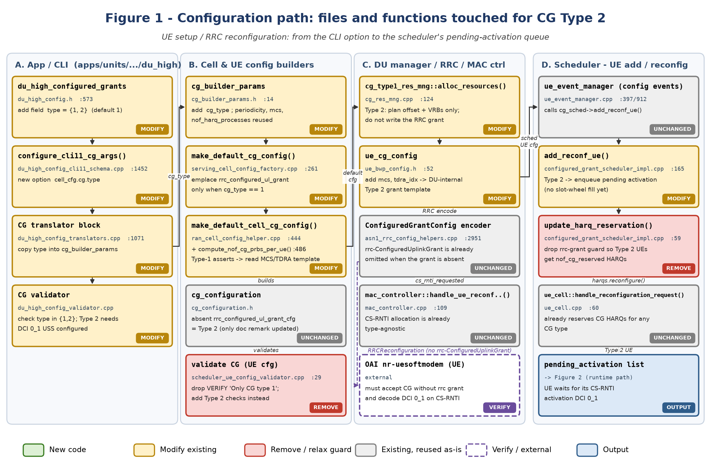
Figure 1: configuration path (IDs A1–D5 in Section 6.1).

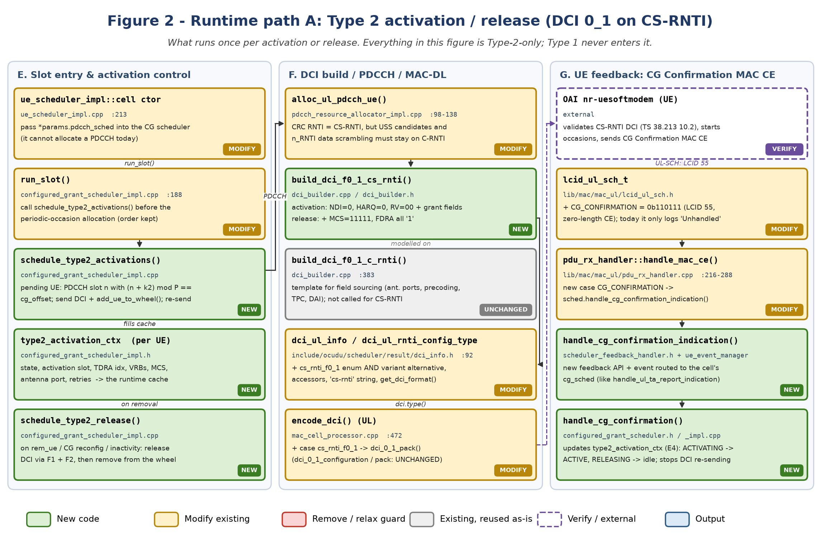
Figure 2: activation and release path (IDs E1–G5 in Section 6.2). E6 get_active_grant() is used by Figure 3.

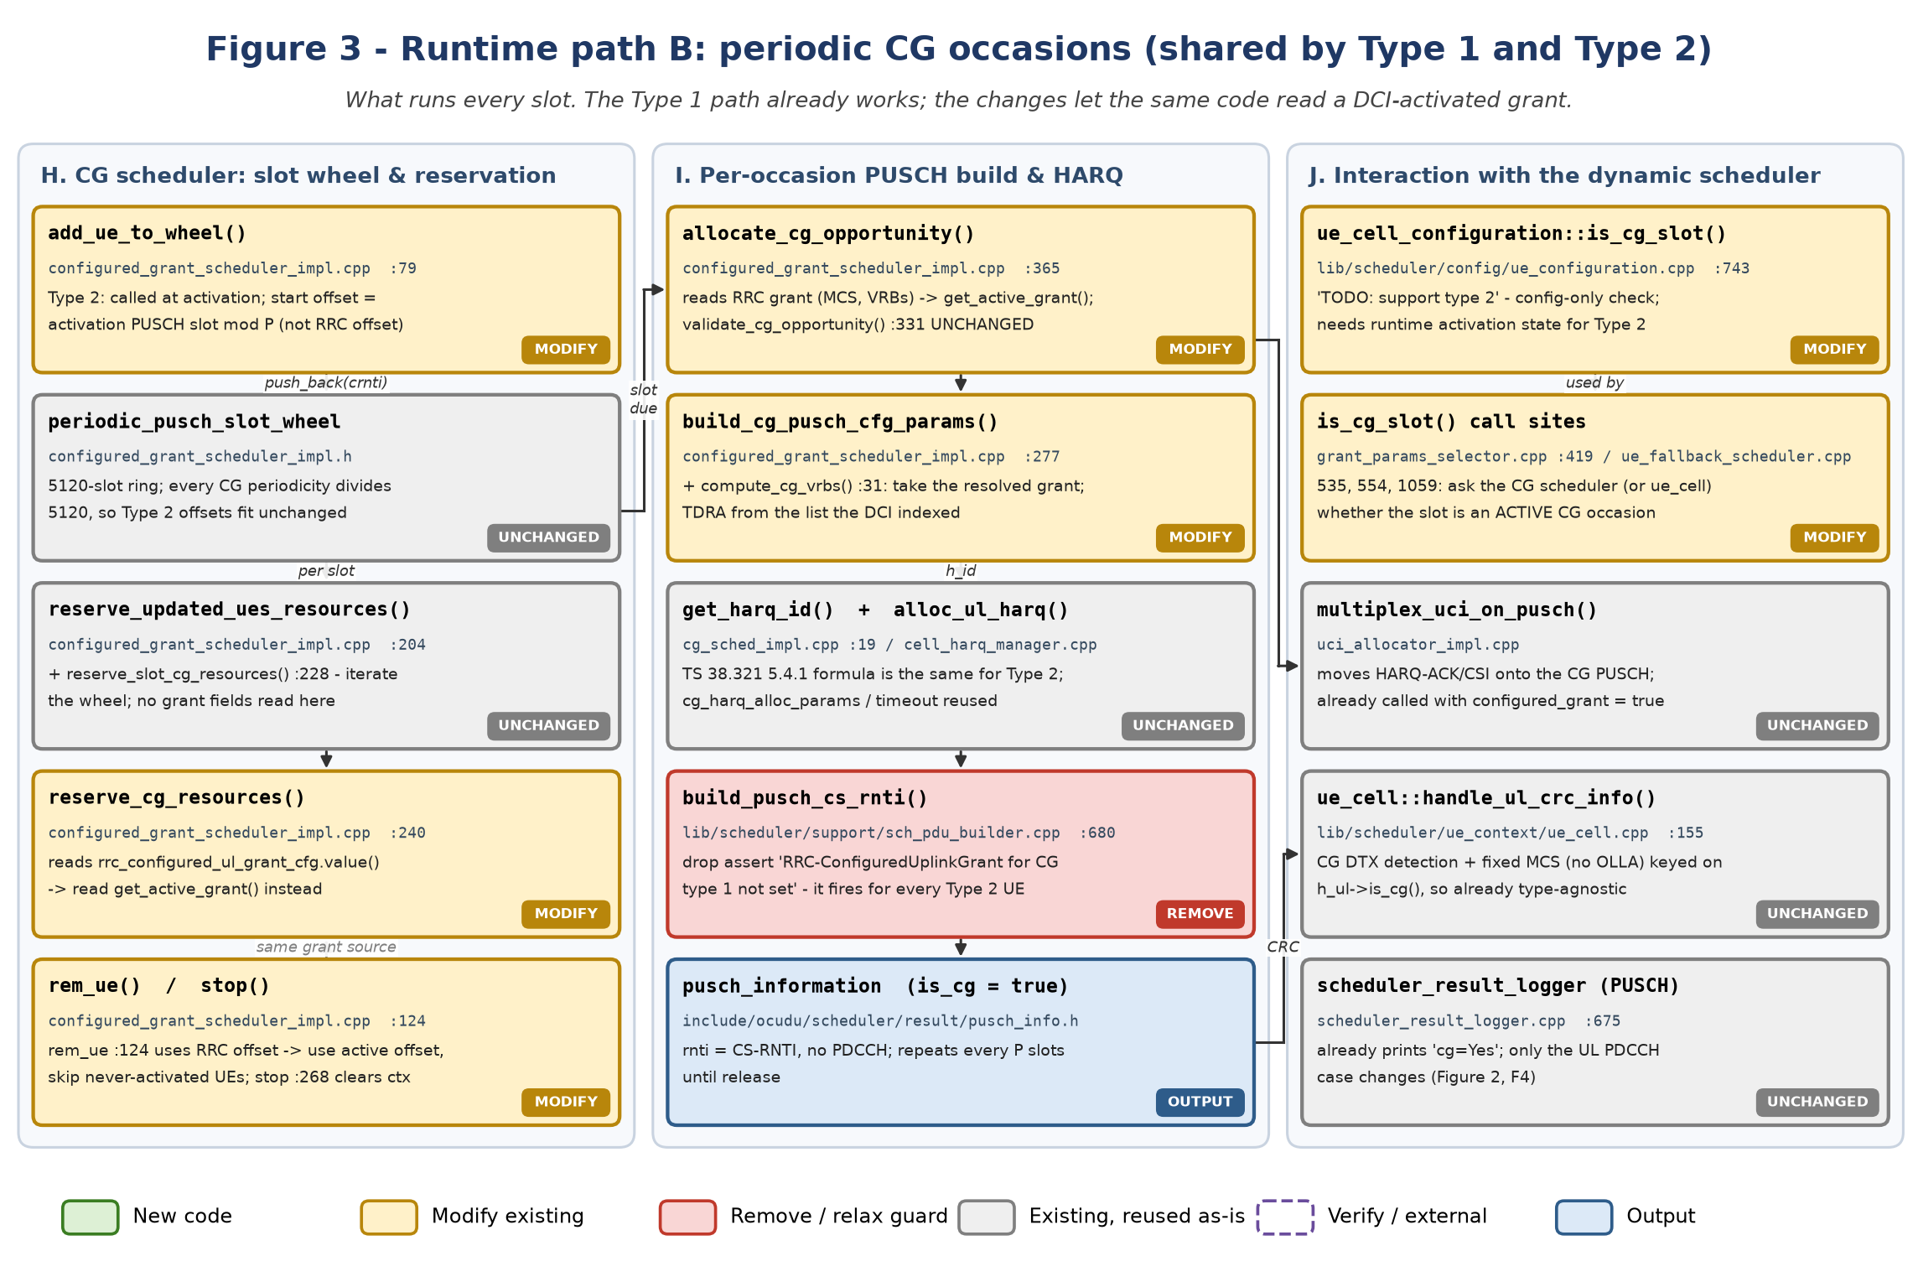
Figure 3: periodic-occasion path shared by both types (IDs H1–J5 in Section 6.3).

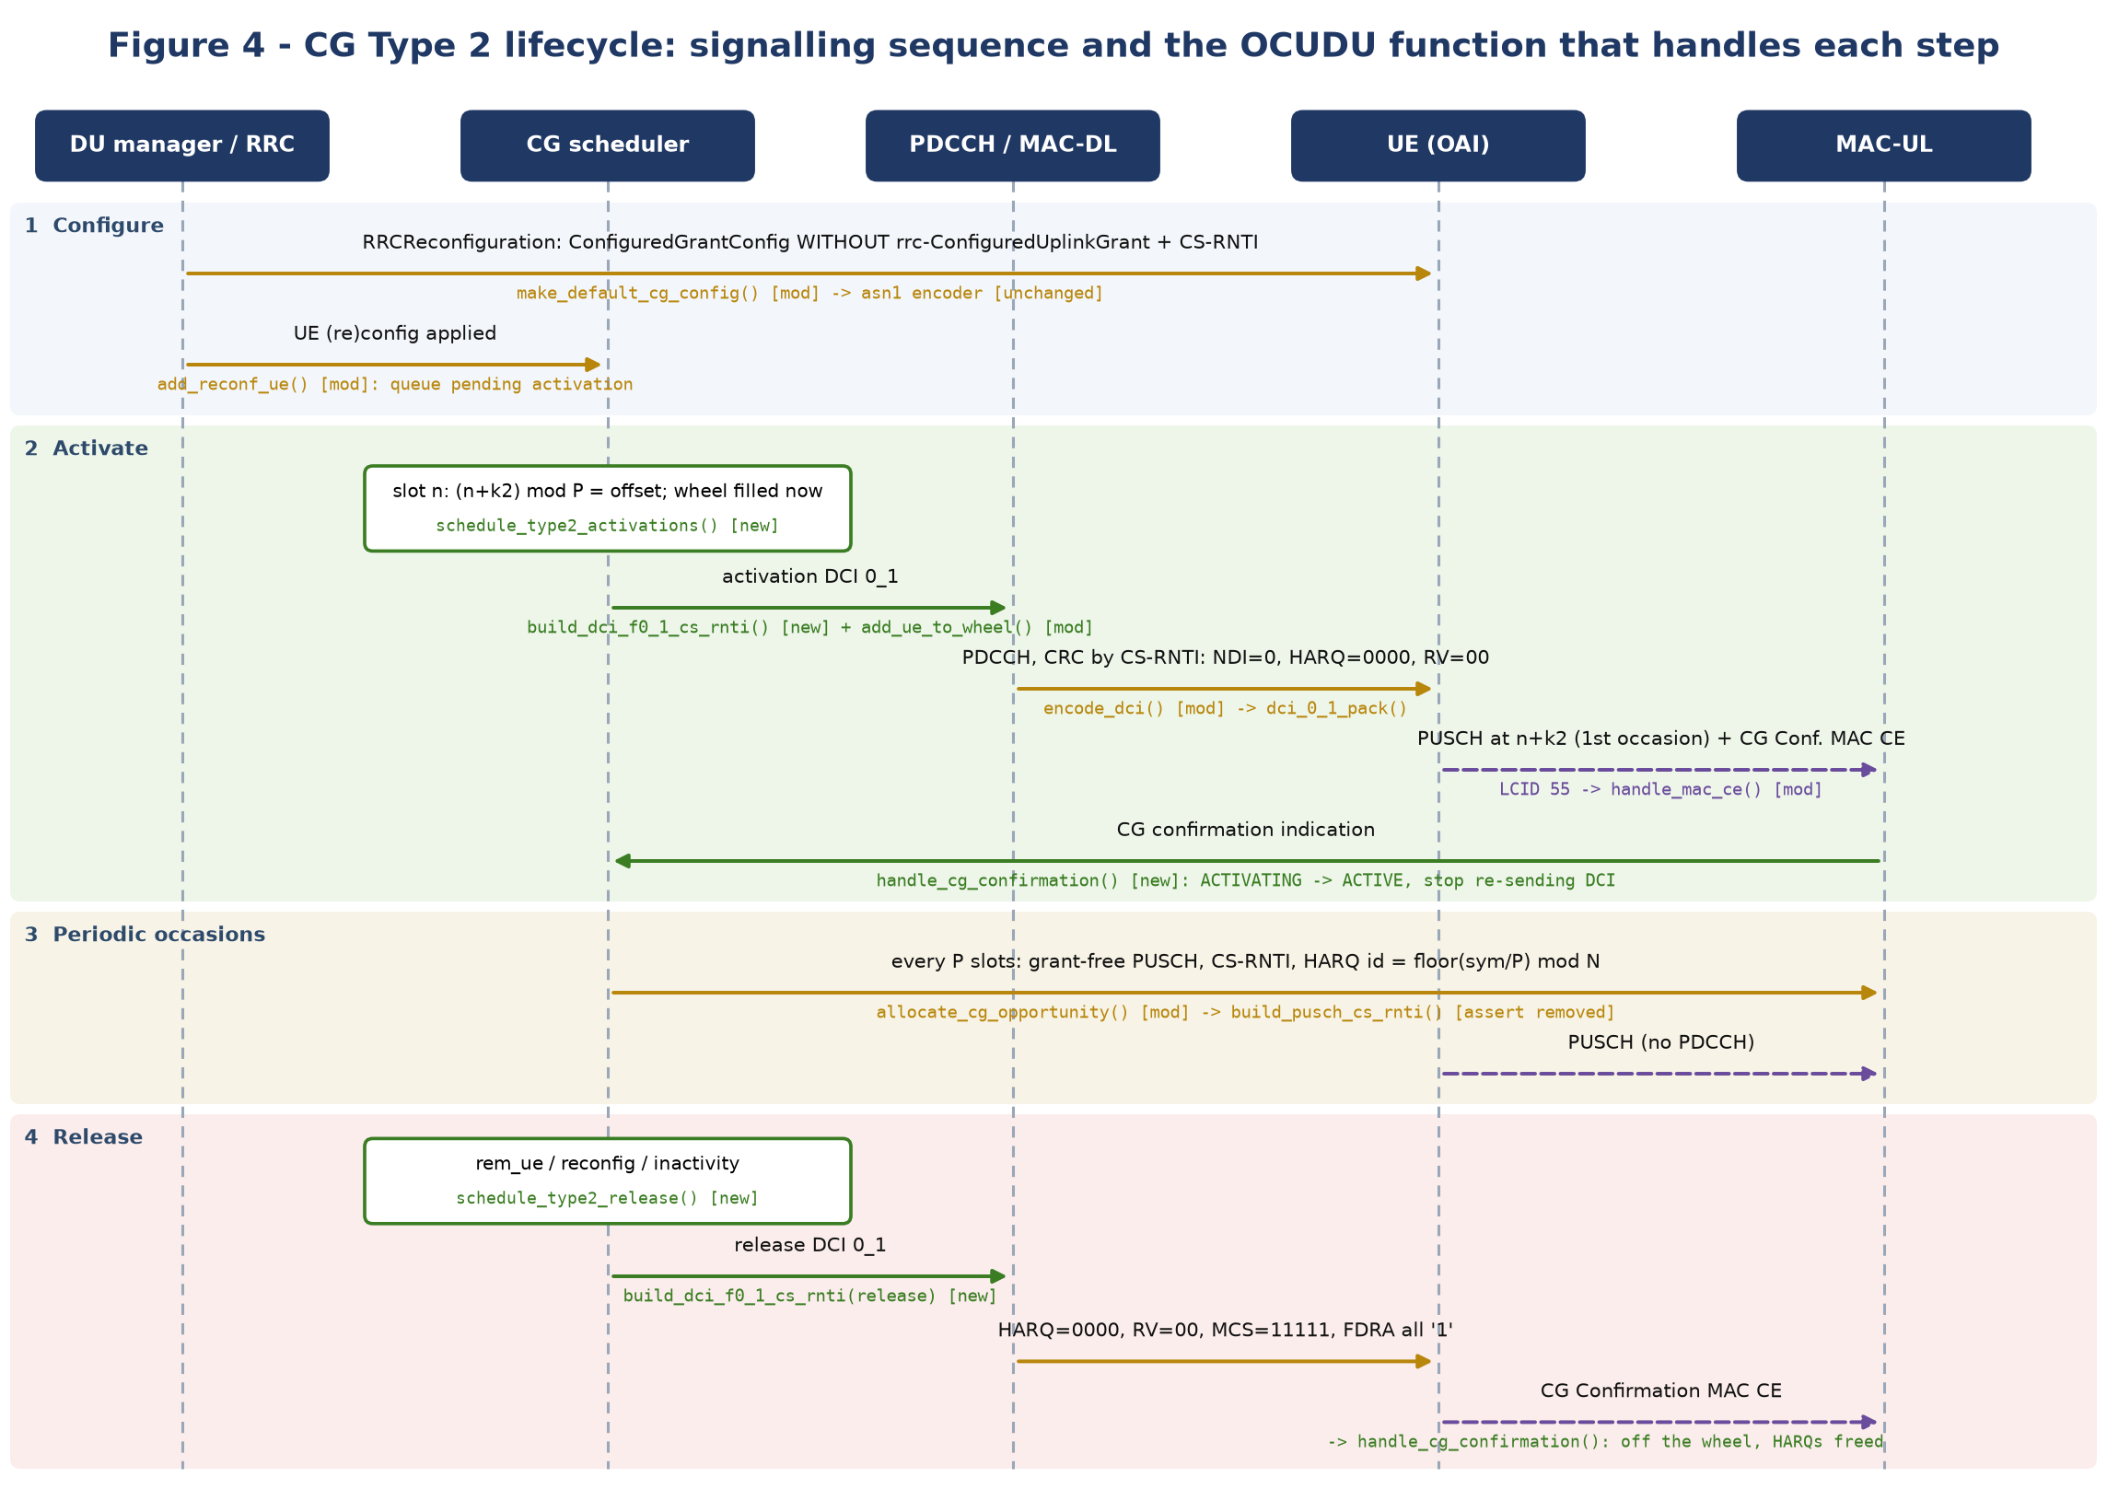
Figure 4: Type 2 lifecycle. [new] / [mod] tags match the colour code.

8. Design decisions
# | Decision | Recommendation | Why / alternative rejected
D1 | Where the Type 2 grant comes from | Reuse cg_type1_res_mng planning (offset + VRBs) and store it as a DU-internal template (ue_cg_config + MCS/TDRA). | Keeps the existing RB-collision planning with PRACH/PUCCH valid. Picking resources freshly at activation time would need a second allocator.
D2 | Which slot to send the activation DCI in | Wait until (n + k2) mod P = planned offset. | The occasions then land exactly on pre-planned, non-colliding RBs. Worst-case delay is P slots, once per activation.
D3 | Representing the CS-RNTI DCI | New variant alternative with a distinct wrapper type. | type() comes from the variant index. Reusing dci_0_1_configuration twice breaks std::get<T>. Keeping type c_rnti_f0_1 and changing only ctx.rnti would mislabel logs and hide activation DCIs from tests.
D4 | PDCCH RNTI handling | Search-space candidates and n_RNTI from C-RNTI; CRC RNTI = CS-RNTI (new optional parameter to alloc_ul_pdcch_ue()). | TS 38.211 §7.3.2.3 and TS 38.213 §10.1 tie USS hashing and scrambling to the C-RNTI.
D5 | When to fill the slot wheel | When the activation DCI is sent, not when the confirmation arrives. | The UE starts transmitting at n + k2, usually carrying the confirmation in that first PUSCH. If the confirmation doesn't arrive in time, re-send the activation.
D6 | When to reserve CG HARQs | At configuration time for both types (drop the D3 guard). | Avoids reconfiguring the HARQ entity at runtime. The cost is N idle HARQ IDs before activation.
D7 | is_cg_slot for Type 2 | Runtime flag and offset on ue_cell, set by the CG scheduler. | ue_cell_configuration is immutable config and cannot know the activation state.
D8 | Release triggers | UE removal, CG reconfiguration, and optional inactivity (no BSR for X ms). | Inactivity-based release is what makes Type 2 useful (saves resources); keep it behind a config flag.

9. Implementation plan and test plan
Phase | Scope (IDs) | Deliverable | Exit criterion
0. Refactor | E6, H4, H5, I1, I2 (Type 1 only) | get_active_grant(); no .value() on the RRC grant outside it | All existing CG tests pass; no behaviour change (can merge alone)
1. Configuration | A1–A4, B1–B5, C1, C2, D2 (queue only), D3 | Type 2 UE config accepted; RRC without rrc-ConfiguredUplinkGrant | Validator and ASN.1 unit tests; the UE attaches with Type 2 configured (no activation yet)
2. DCI | F1, F2, F4, F5, F6 | CS-RNTI DCI 0_1 can be built, encoded and logged | T2 passes; packed size equals C-RNTI DCI 0_1
3. Scheduler | E1–E5, H1, J1, J2 | Activation and release state machine; Type 2 occasions scheduled | T1 passes (FDD and TDD)
4. Confirmation | G2–G5 | LCID 55 routed to the CG scheduler | T3 passes; no "Unhandled LCID" warning
5. End-to-end | C5/G1 check, lab | ZMQ run with OAI UE | Log lines as in Section 3.2; iperf UL over CG occasions; clean release

10. Risks and open questions
# | Risk / question | Impact | Mitigation
R1 | OAI UE support for Type 2 (CS-RNTI DCI validation, LCID 55) is unverified. | High: blocks Phase 5 | Read the OAI UE MAC CG code before Phase 3. If missing, test with srsUE/COTS or patch OAI.
R2 | TDRA list mismatch: Type 1 indexes the common pusch_td_alloc_list, but DCI 0_1 in a USS indexes the dedicated list if one is configured. | Medium: wrong symbols or k2 | Resolve TDRA through ss_info.bwp->ul.td_mapper() for Type 2 and assert the template index exists there.
R3 | PDCCH blocking delays activation (the aligned slot occurs only once per P). | Low | Retry at the next aligned slot; count attempts (cg_type2_max_dci_attempts).
R4 | CG retransmission via CS-RNTI with NDI = 1 is not supported for either type (nof_harq_retx = 0). | Low (existing limitation) | Out of scope; note as follow-up.
R5 | DAI and UCI semantics on the activation DCI's first PUSCH. | Low | Compute DAI as for a dynamic grant; confirm UE behaviour in the lab.
R6 | Does pdcch_ul_information::ctx.rnti feed anything other than CRC scrambling (for example the FAPI PDU RNTI or UE lookups)? | Medium | Audit the MAC→FAPI translator in Phase 2 before changing ctx.rnti.
R7 | Multiple CG configurations (Rel-16) and harq-ProcID-Offset2 | None now | Out of scope; the HARQ field validation assumes a single configuration.
R8 | DRX or measurement gaps at the aligned activation slot | Low | is_ul_enabled() and active-time checks before sending; otherwise wait for the next aligned slot.

11. Glossary
Term | Meaning
CG Type 1 / Type 2 | Configured Grant. Type 1: the whole grant comes from RRC. Type 2: RRC gives the semi-static part, and a CS-RNTI DCI activates or releases the grant and carries its fields.
C-RNTI / CS-RNTI | Cell RNTI (dynamic scheduling) / Configured Scheduling RNTI (CG activation, release, retransmission and CG PUSCH)
Activation / release DCI | DCI 0_1 with CRC scrambled by CS-RNTI, NDI = 0, and the reserved values of TS 38.213 §10.2
CG Confirmation MAC CE | Zero-length UL MAC CE (LCID 55) that the UE sends after activation or release
NDI, RV, HARQ ID | New Data Indicator, Redundancy Version, HARQ process number. All three are validation fields in activation and release DCIs.
TDRA / RIV / VRB | Time-domain resource allocation row / Resource Indication Value (RA type 1) / Virtual Resource Block
P, N, k2 | CG periodicity in slots, nrofHARQ-Processes, PDCCH-to-PUSCH slot offset
periodic_pusch_slot_wheel | The CG scheduler's 5120-slot ring of UEs with a CG occasion in each slot
type2_activation_ctx | Proposed per-UE runtime cache and state machine for Type 2 (Section 5.4)
USS | UE-specific search space (DCI 0_1 is monitored only there)

