1. IMAGE QUANTIZATION
Part A image (generated by using Lloyd-max algorithm)
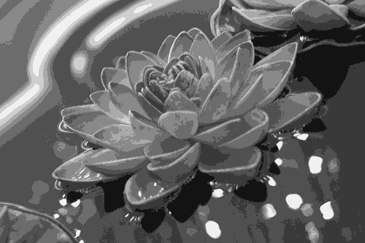

Part B image (assuming a uniform histogram for the image)
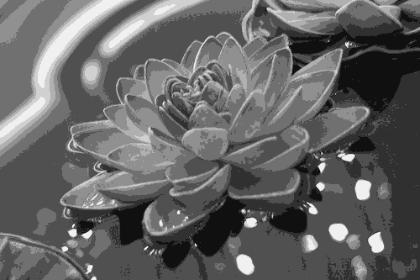

Histograms
Blue : part a histogram
Green : part b histogram
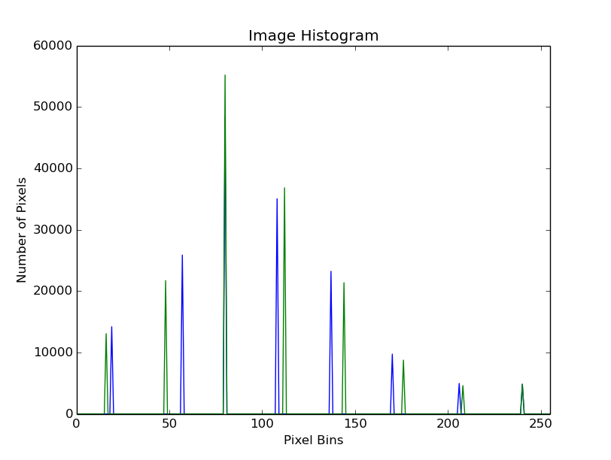
2. IMAGE ENHANCEMENT
- CONTRAST STRETCHING:
- The minimum and maximum pixel values of the image are calculated.
Minimum value = 74
Maximum value = 224
- Then the following transformation is applied to each pixel values to map the range to 0-255.

Here y is the final pixel intensity and x is the initial pixel intensity.
- The histogram is obtained by calculating the frequency of each pixel intensity and then plotting the frequencies against the pixel intensities.

- POWER LAW TRANSFORMATION:
- Since the original image appears washed out, we need to shift the histogram towards the darker values i.e. lower pixel intensities. Hence, we apply a transformation of the form where r > 1 and x and y are the initial and final pixel intensities.
- We have used the values of c = 1 and r = 2.

- HISTOGRAM EQUALIZATION:
- First, the histogram is obtained as described above.
- Then the cdf of the image is calculated using the histogram obtained in the previous step.
- Using the cdf as the transformation function, every pixel value is transformed into a new pixel value which is the corresponding pixel value of the equalized image.

Following are the images corresponding to each of the parts:
Original image:

Contrast Stretch:
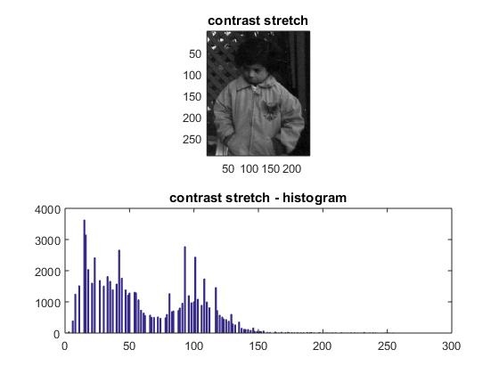
Power law:
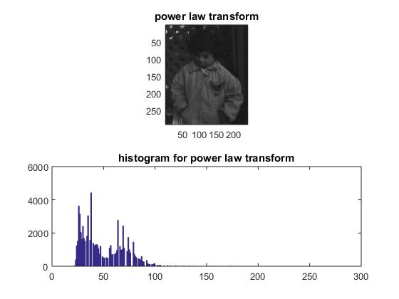

Histogram Equalization:
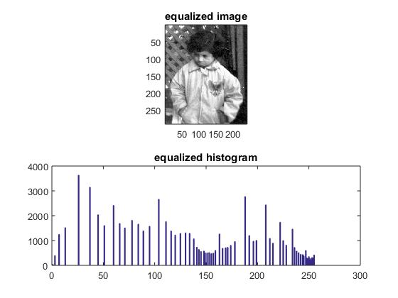

4. BILATERAL AND MEDIAN FILTERING
Bilateral Filter on Uniform Noise
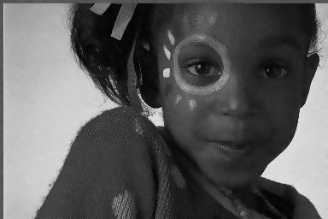

Median Filter on Uniform Noise



Bilateral Filter on Salt and Pepper Noise
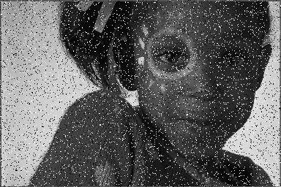

Median Filter on Salt and pepper Noise


Median then bilateral fileter on salt, pepper and uniform noise
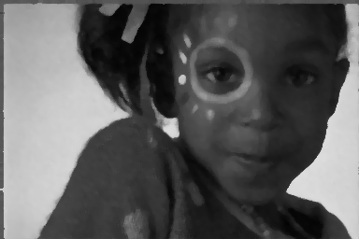

Bilateral then median filter on salt, pepper and uniform noise


Median filter:
size = 5
Bilateral filter:
domain sigma square = 64
range sigma square = 4*64
size = 5

- EDGE DETECTION
- To apply the sobel masks to the image, first the image is padded with zeroes and then the sobel filter is applied to every pixel. The results obtained are as follows:
Vertical Gradient or Horizontal edges:
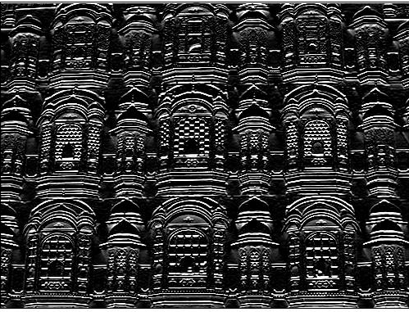

Horizontal gradient or vertical edges:
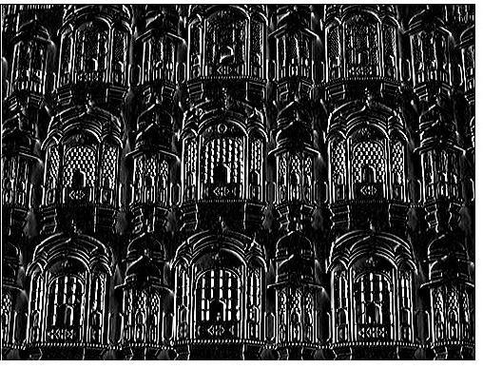

Edge map of the image:
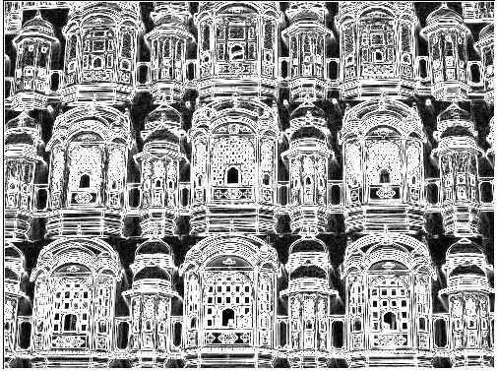

- EDGE PRESERVING SMOOTHING FILTERS
- ANISOTROPIC NON LINEAR DIFFUSION FILTER:
  - First the following four filters were applied to the image to obtain the differences in the north, south, east and west directions. (4-connectivity considered)
F_north
0 1 0
0 -1 0
0 0 0
F_south
0 0 0
0 -1 0
0 1 0
F_east
0 0 0
0 -1 1
0 0 0
F_west
0 0 0
1 -1 0
0 0 0
  - Then conduction coefficient in the four directions was calculated using the following formula:
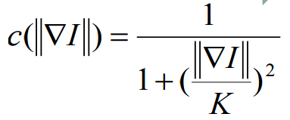
Using K=2
  - Then using the following equation with lambda = 0.05 for 20 iterations, we obtain the figures shown below.
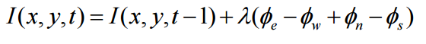

- ISOTROPIC FILTERING
  - The following filter is applied to the image to obtain the isotropic filtering of the image. We can see that after the same number of iterations used for anisotropic filter i.e. 20, the isotropic filtered image appears blurred as compared to the anisotropic filtering. The edges are not preserved in this.

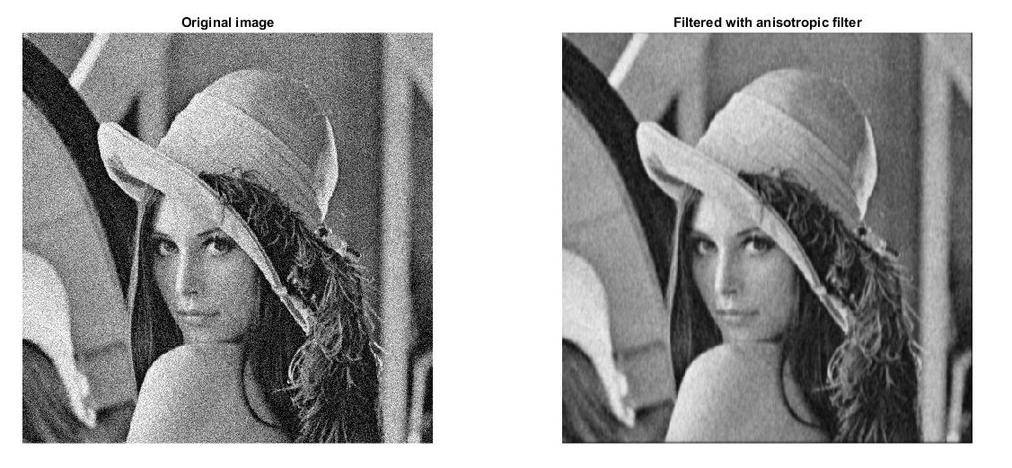
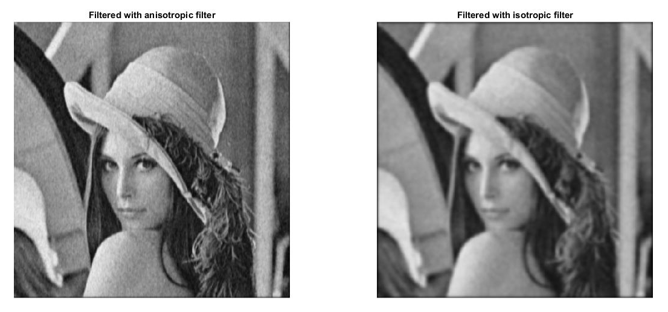

7. HARRIS CORNER DETECTION WITH NON-MAXIMAL SUPRESSION

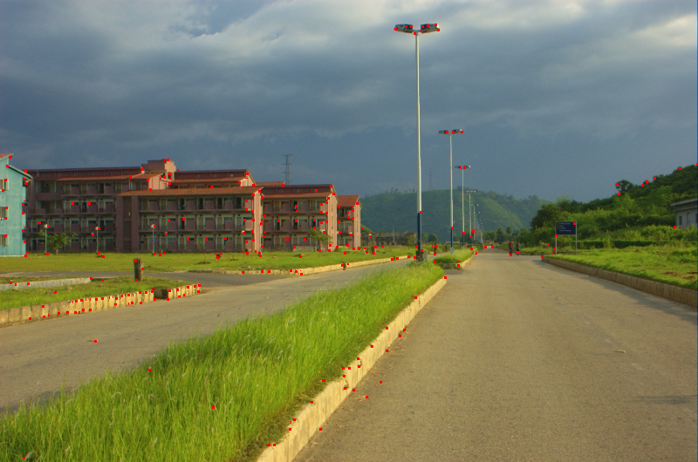
Gradients along X
Harris Corner Detecter:
window size = 2
block size = 3
Non Maximal Supression:
window length = 3

