1. Set up a new TensorFlow 2.6 Enterprise notebook without GPU from Part A for starting model training.

2. Create a managed dataset:

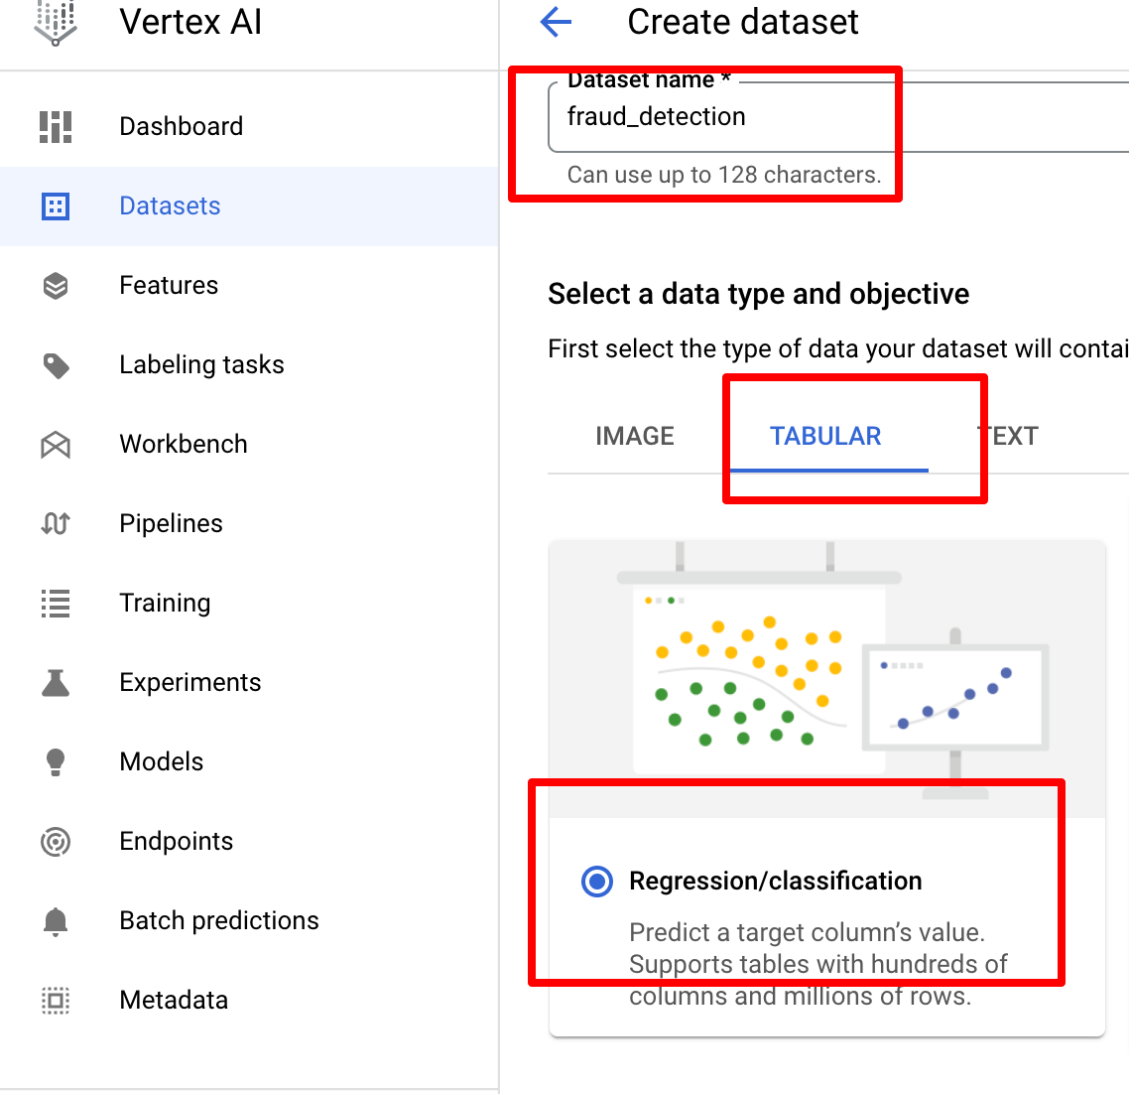

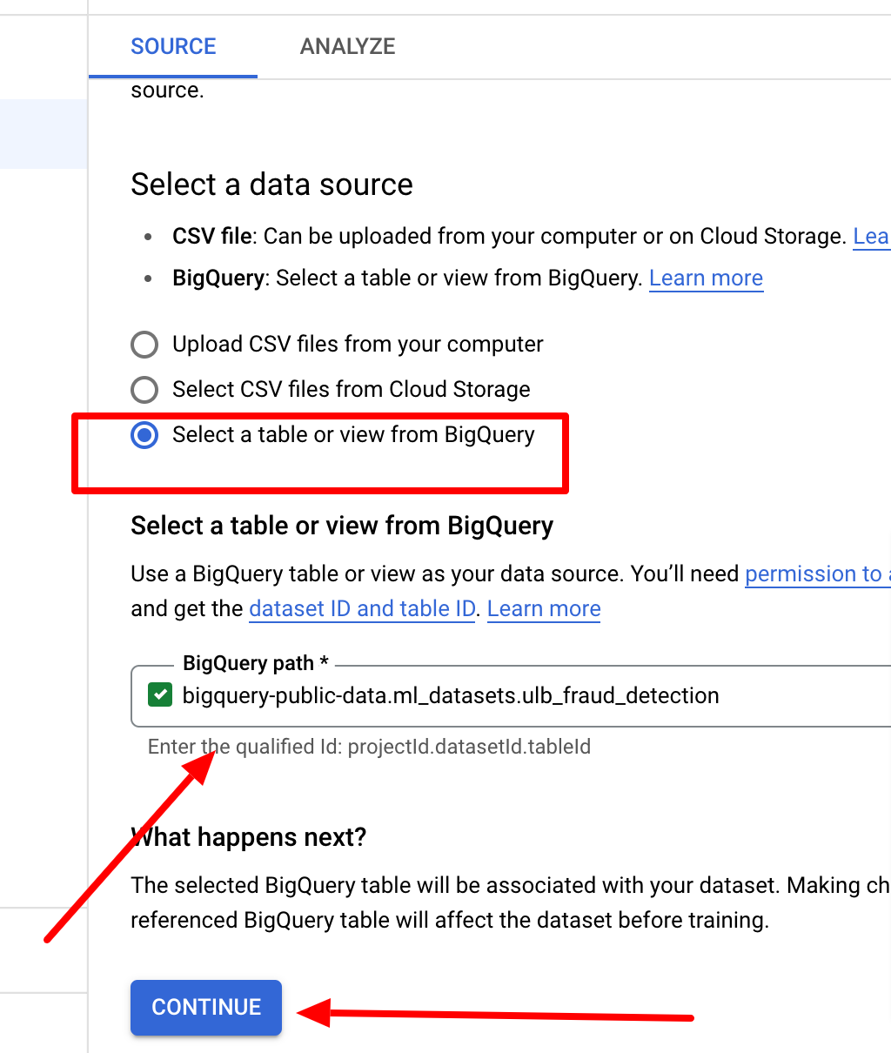

3. Analyzing dataset gives details about the variables

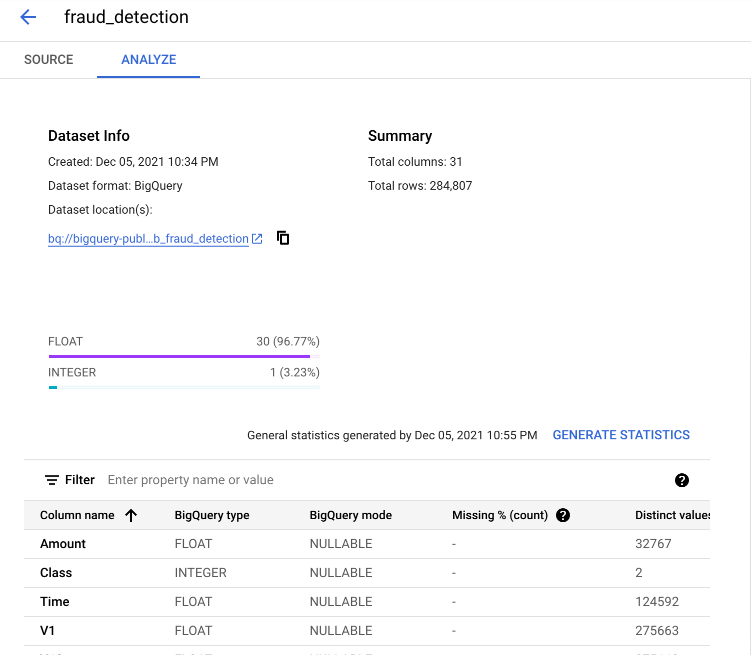

4. Train a new Model: We will use AutoML here for the same. From the above page click Train model. Select the following options and click Continue to model training.

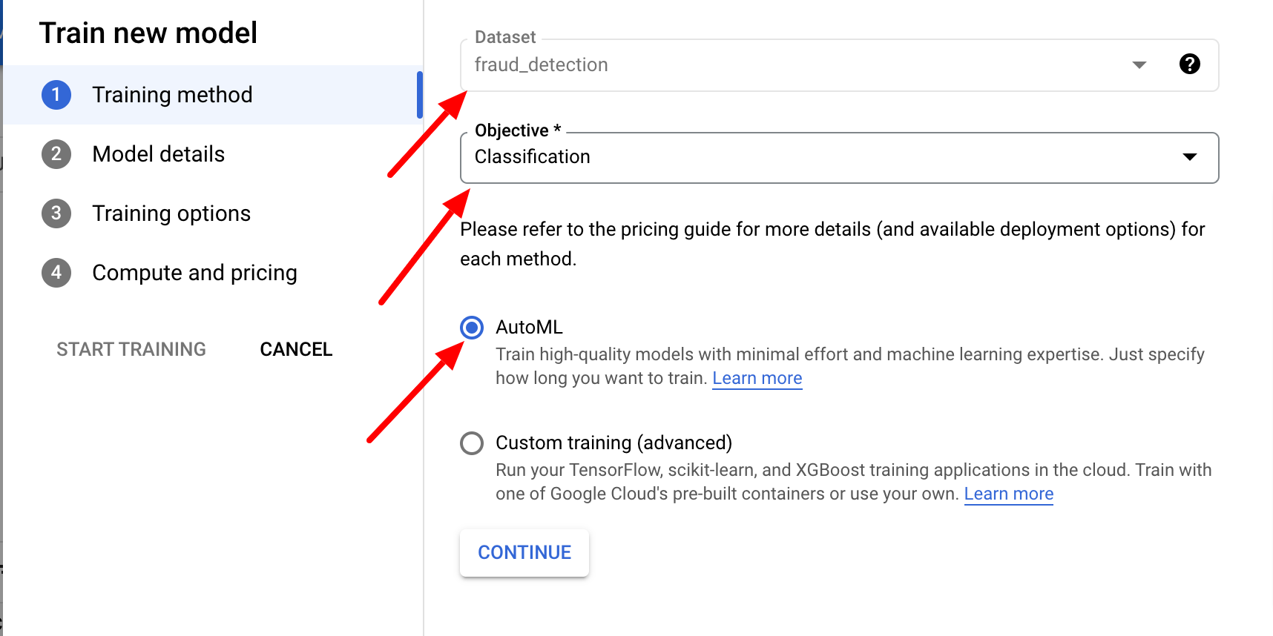

For classification modele need to select target column as below:

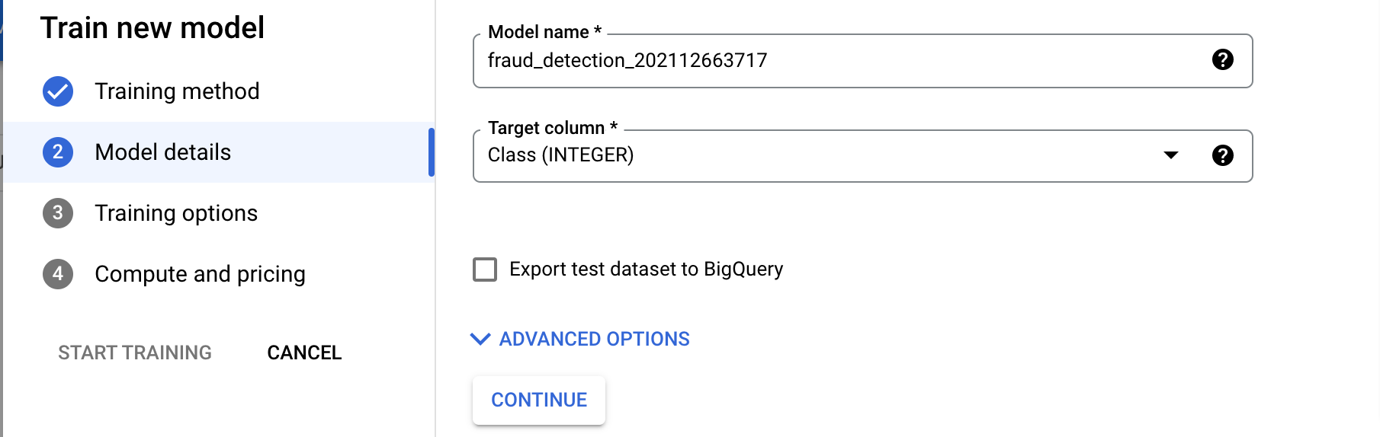

As dataset is highly imbalanced from Training options select AUC PRC option which will maximize precision-recall for the less common class:

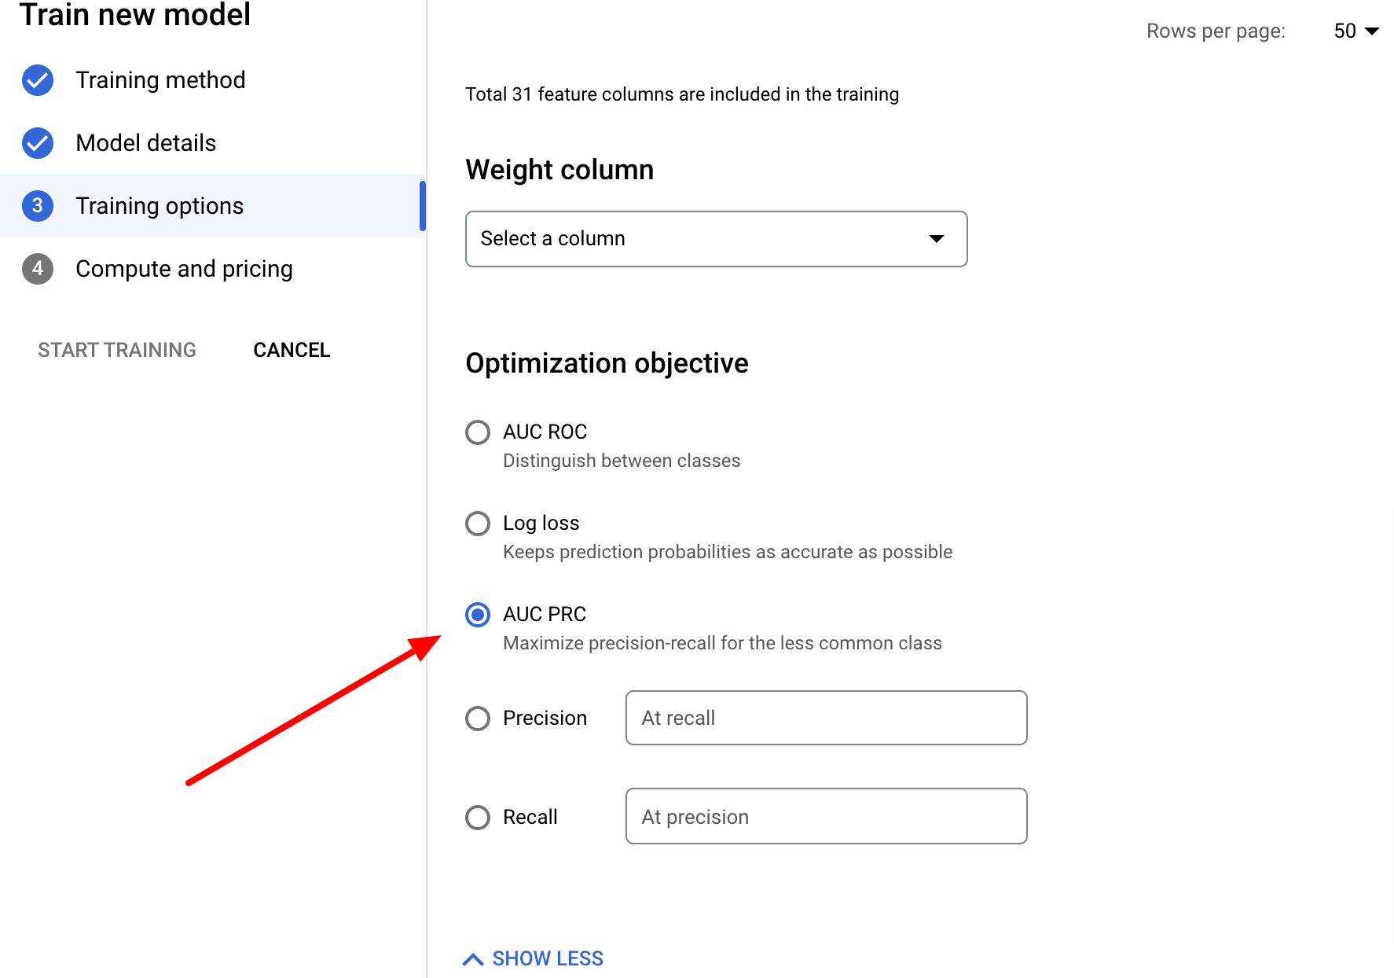

Select 1 next for budget and node hours and click start training:

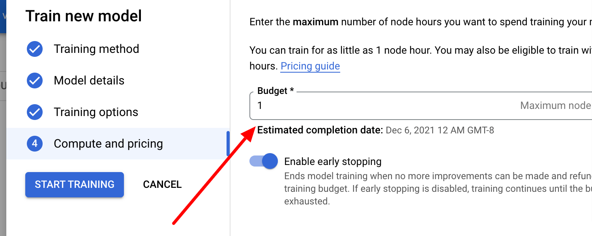

5. Model Evaluation:

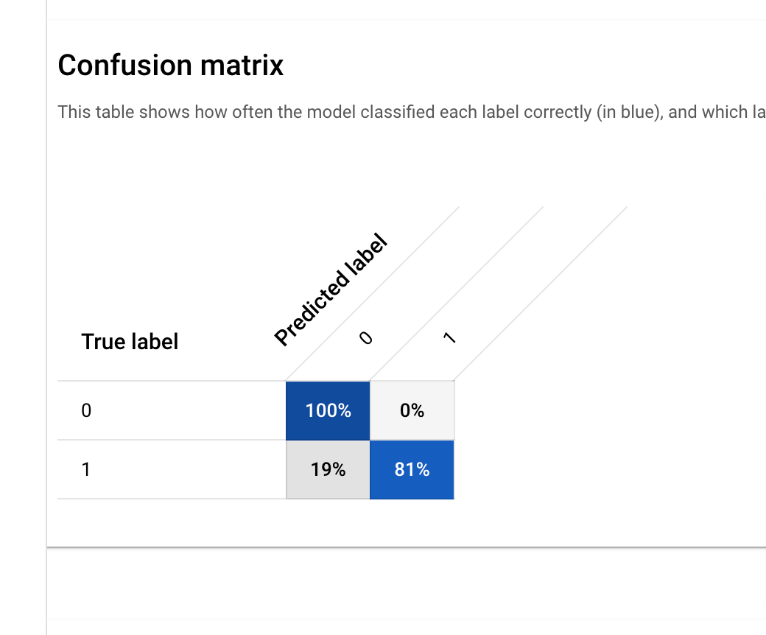

Feature Importance:

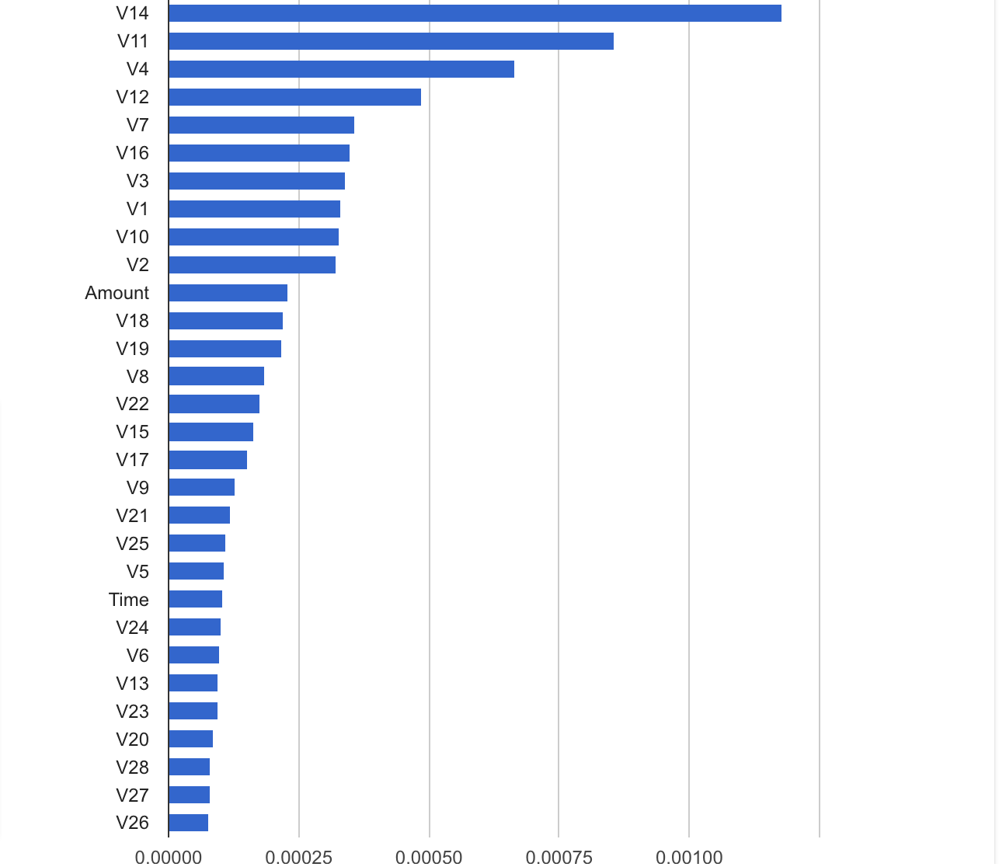

6. Deploying trained model to endpoint

Click Deploy & Test, give a name to the endpoint and click deploy.

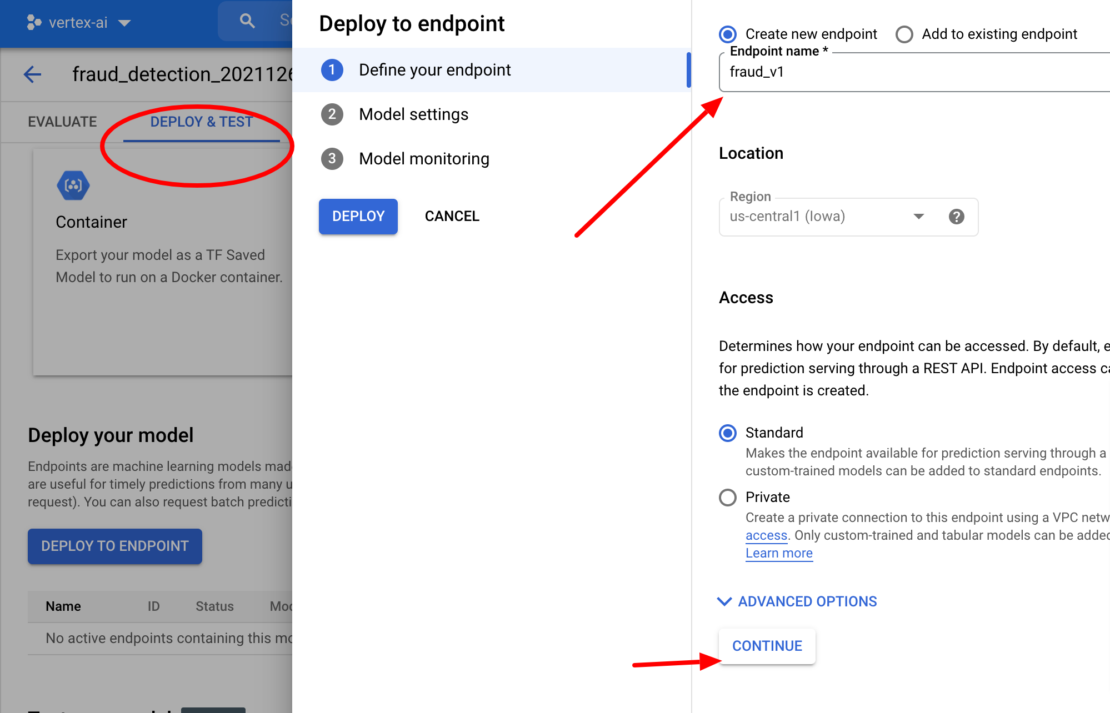

Scroll down to the page and click Predict to test the deployed endpoint:

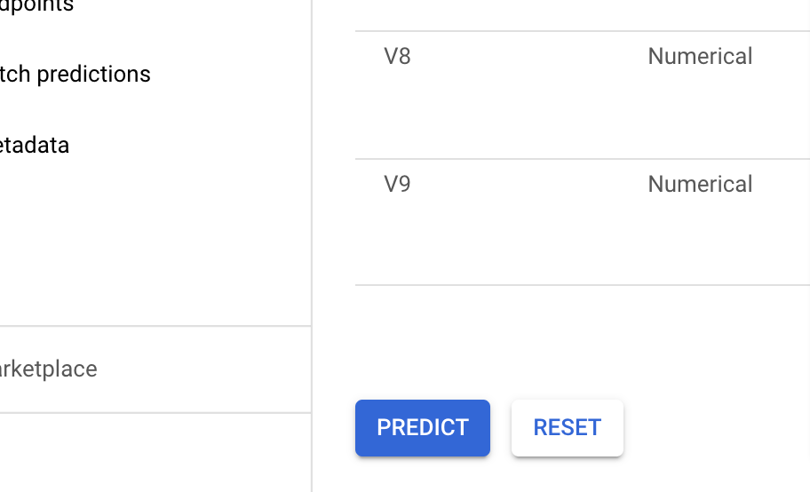

Prediction results can be viewed by scrolling up on the page:

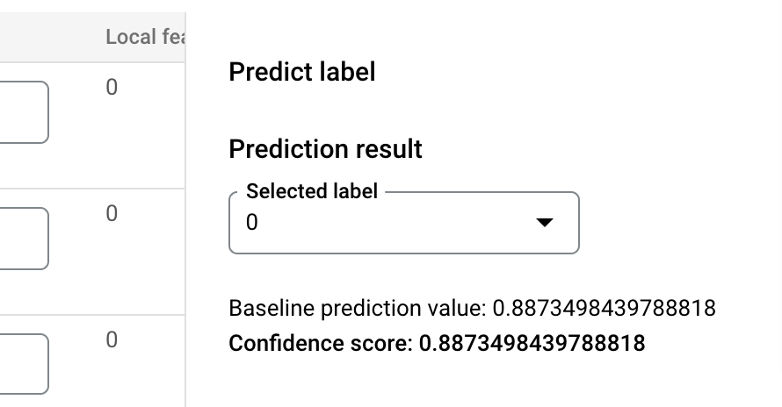

Deploying the model to a REST API:

First get Endpoint ID from here:

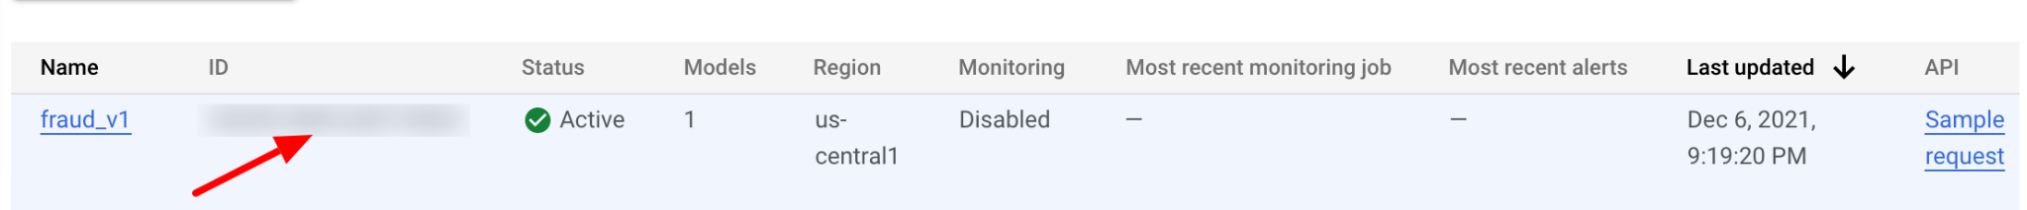

To test the model deploy endpoint:

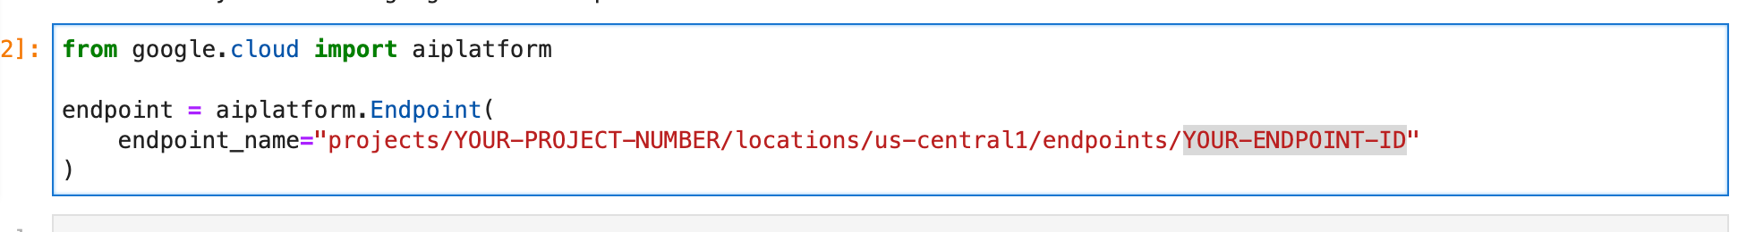

Prediction in the notebook can be obtained by:

