1. The tutorial explores the use of What-If tool to interpret and visualize a local model
2. Configure the environment and launch a new notebook:

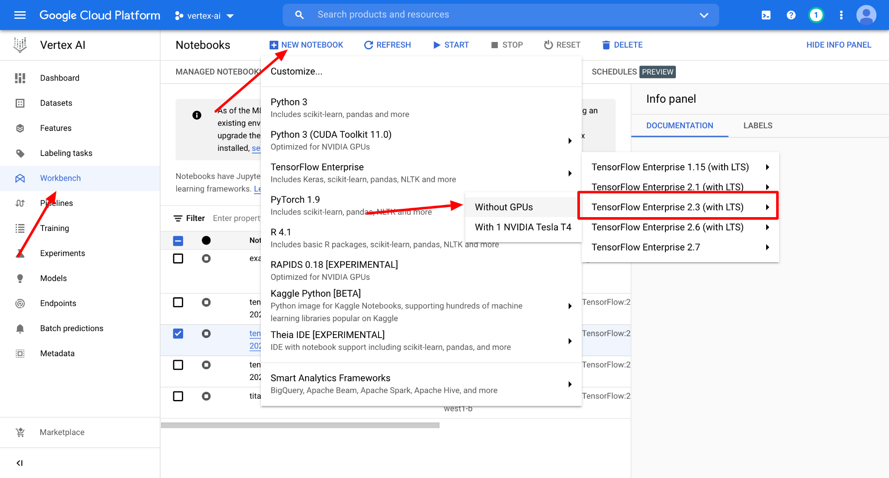

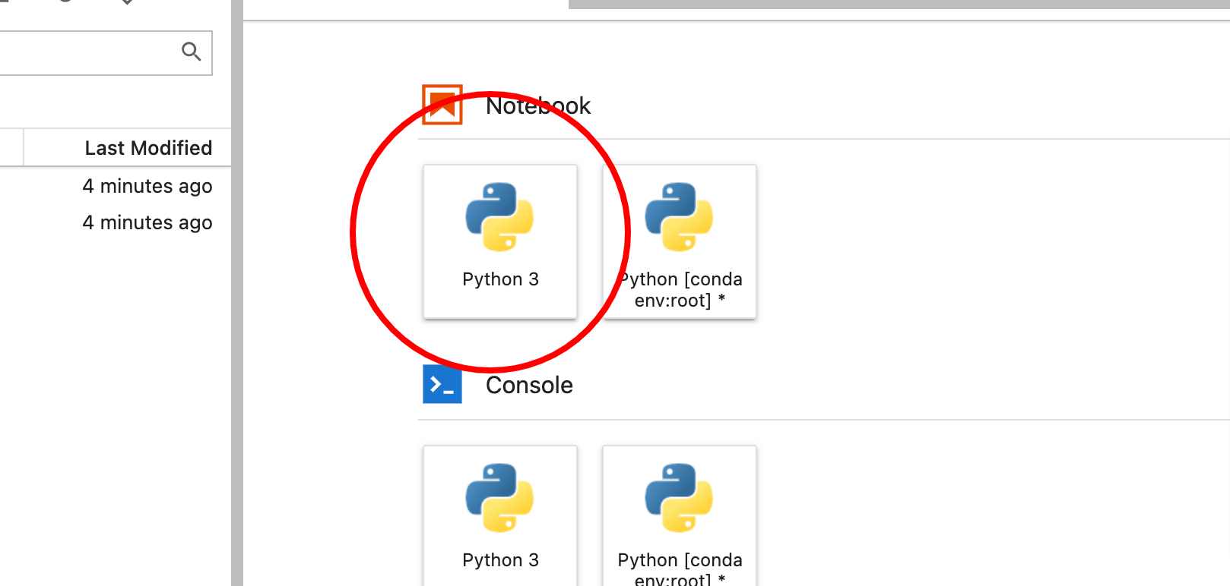

1. Confirming model stored in bucket:

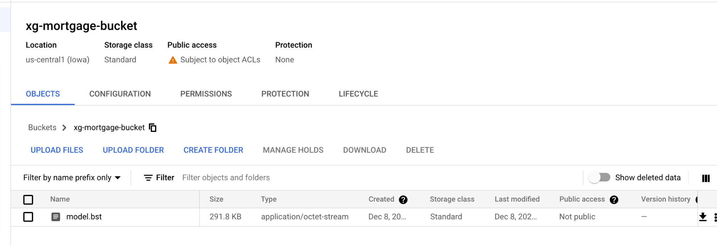

1. Get model ID from the models section after above command completes to add it to an endpoint:

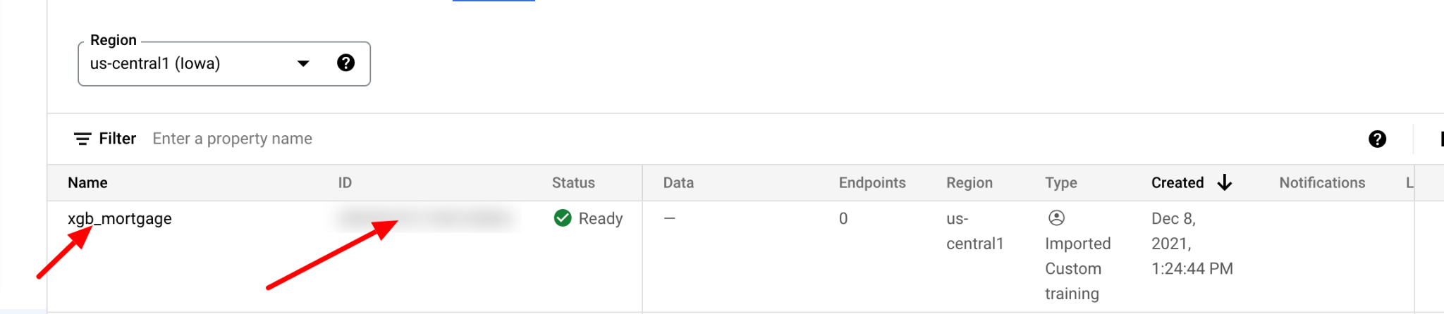

1. Copy the ID of the newly created endpoint for using it later to deploy the model:

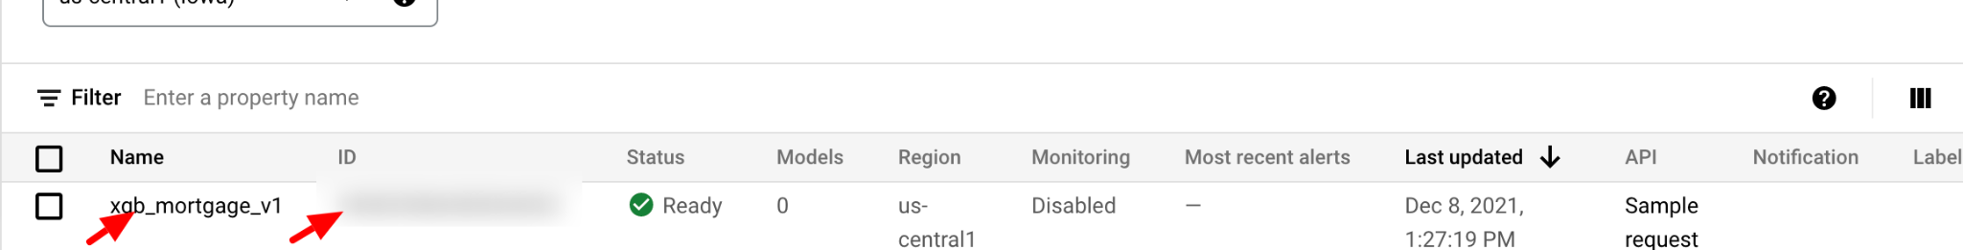

1. Endpoint Deploying:

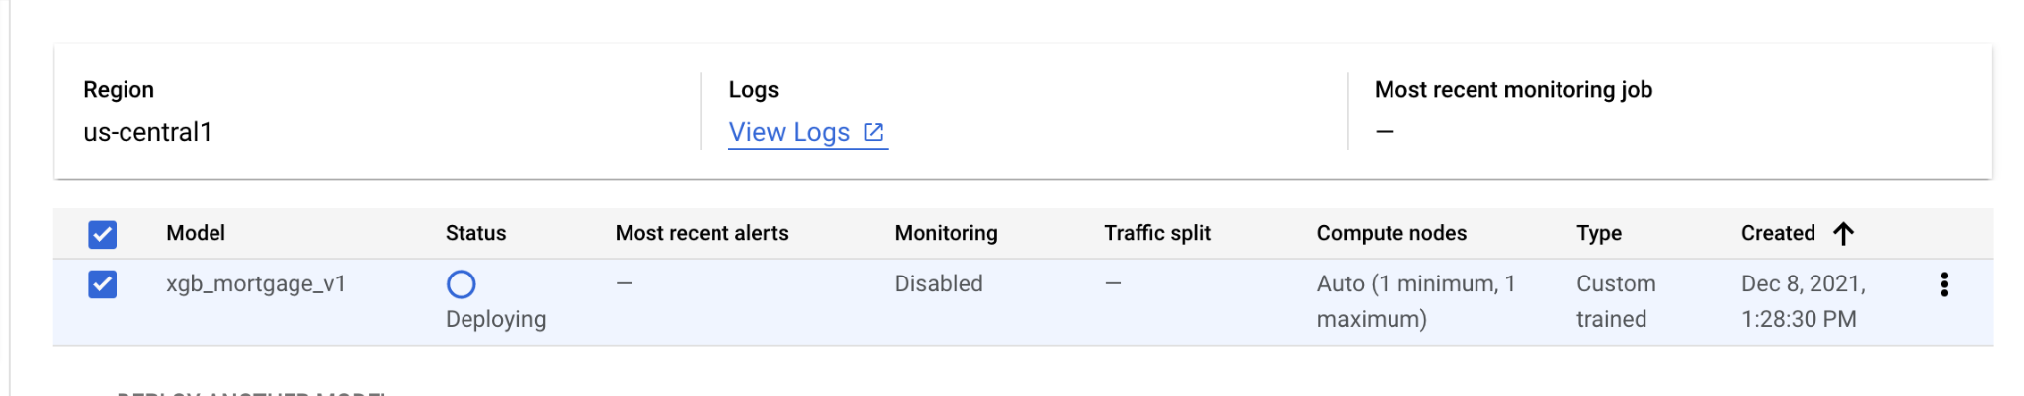

1. Predictions from model deployed:

