In this tutorial we will look at developing a time series model on the New York Taxi Data. We will look at creating a model using BigQuery ML on Google cloud Platform.

1. From Vertex AI Workbench select user-manged notebooks and create new tensorflow 2.6 without GPU notebook.

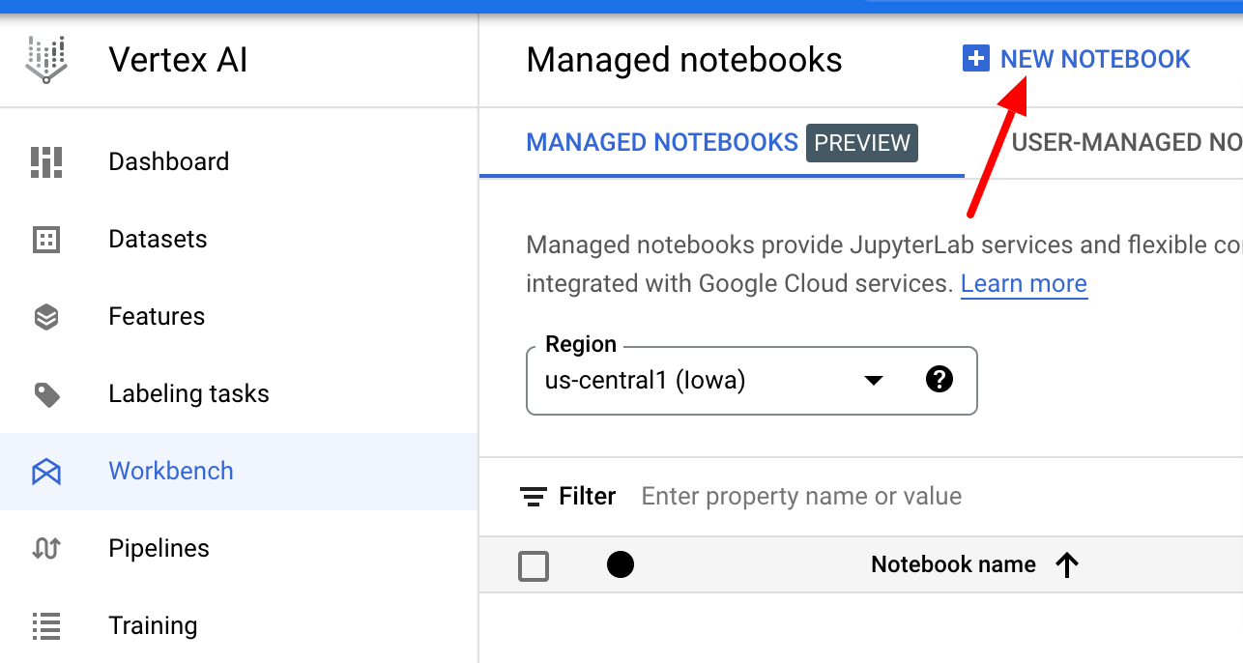

1. Navigate to bigquery and create a new dataset and then a table:

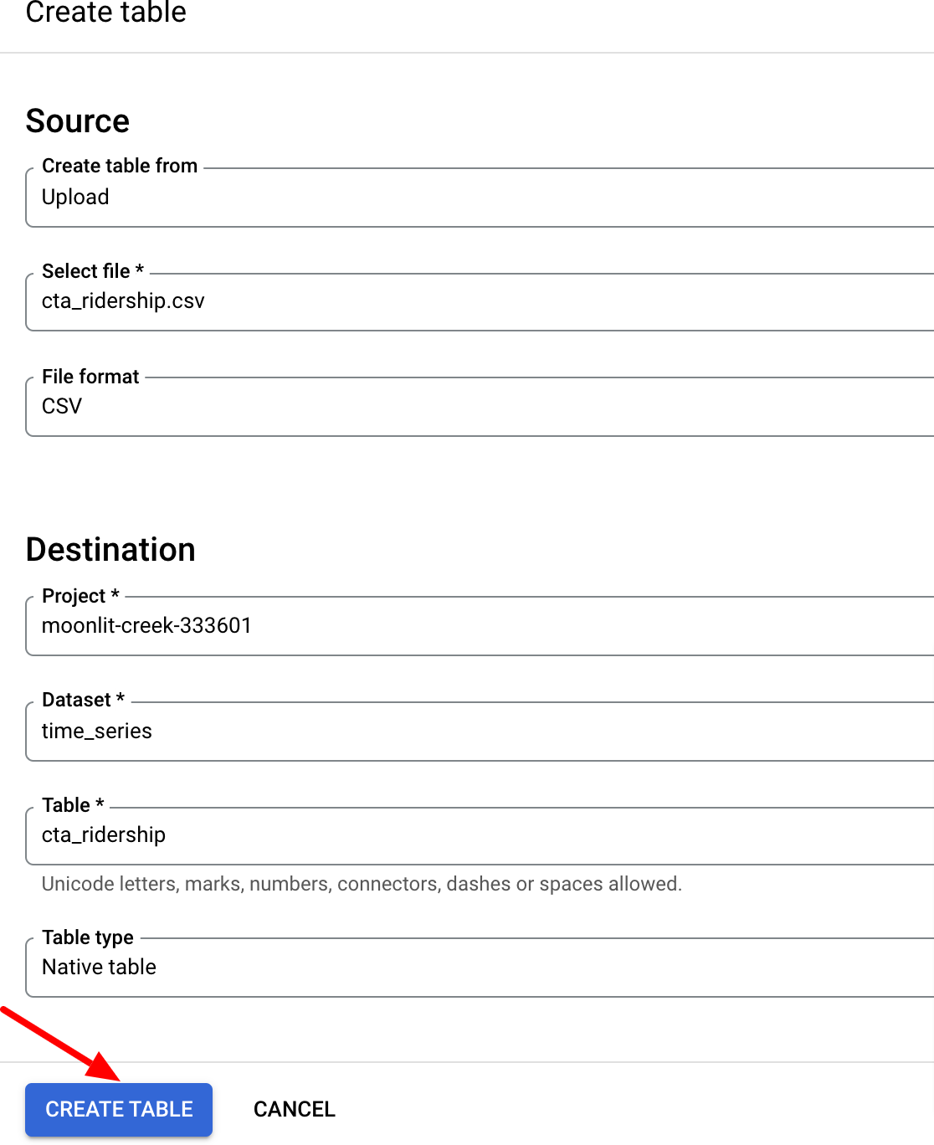

1. Create a model using Big Query ML:

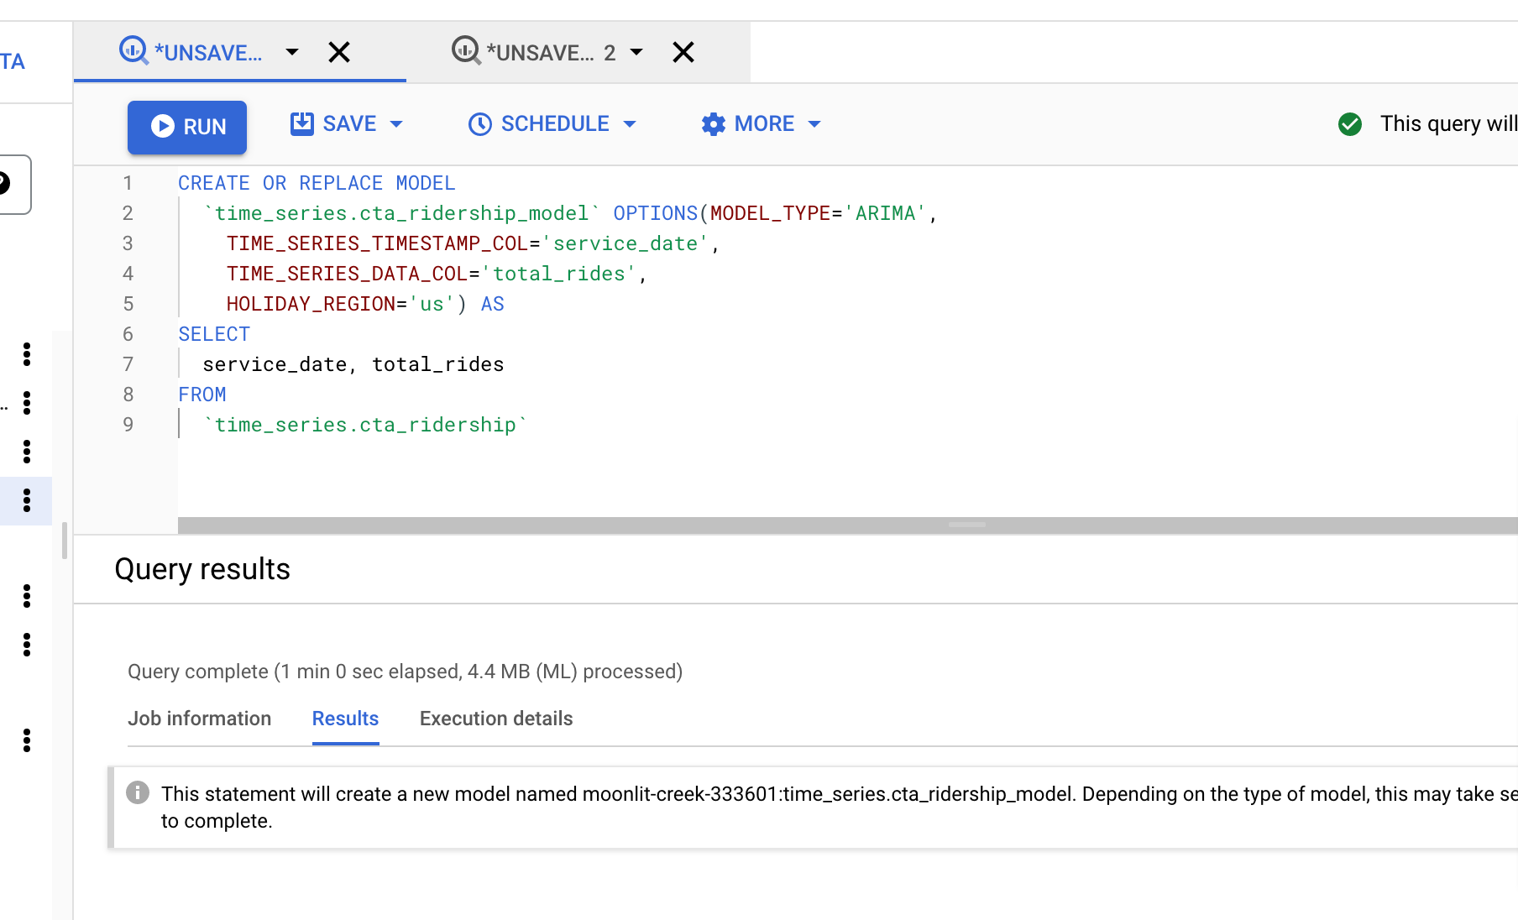

1. Evaluate the model created in step 3:

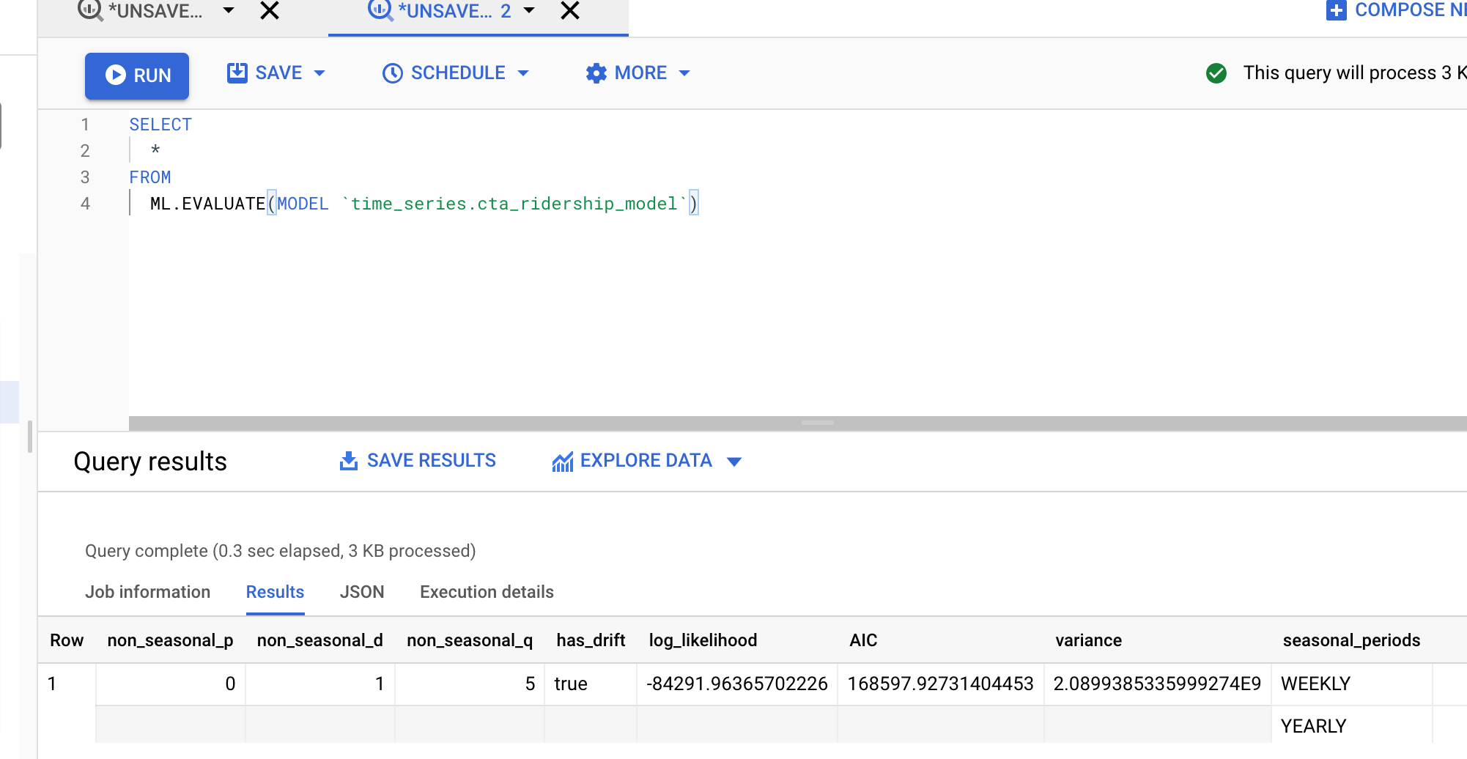

1. Running forecasts on the new model:

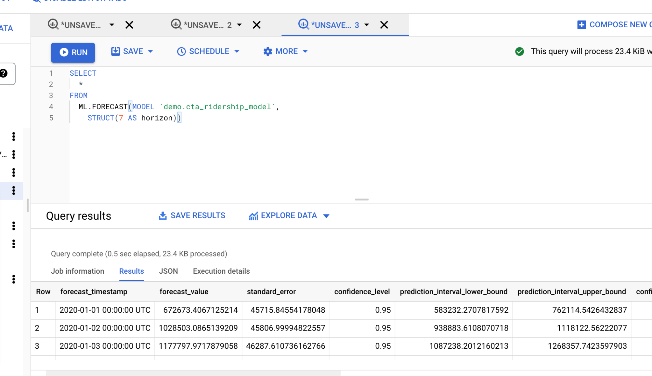

1. Cloud training using Vertex AI on BigQuery data:

First initialize a new project



Creating and running a custom job:

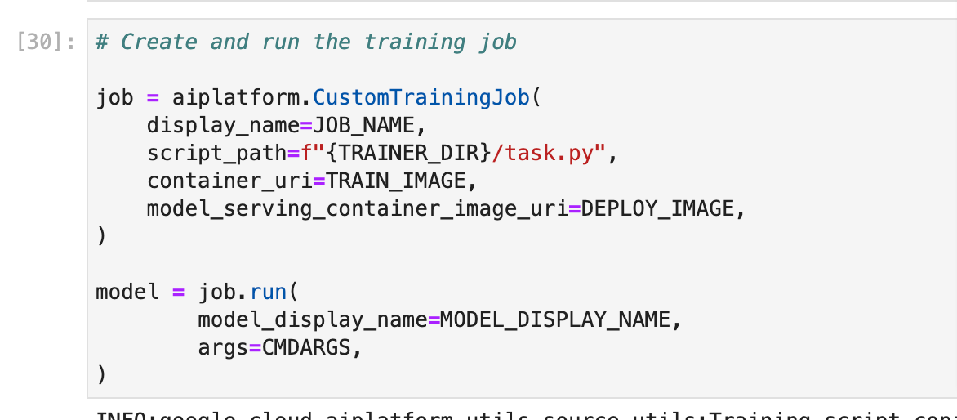

The model generated can be deployed to endpoint using to run predictions on this endpoint:

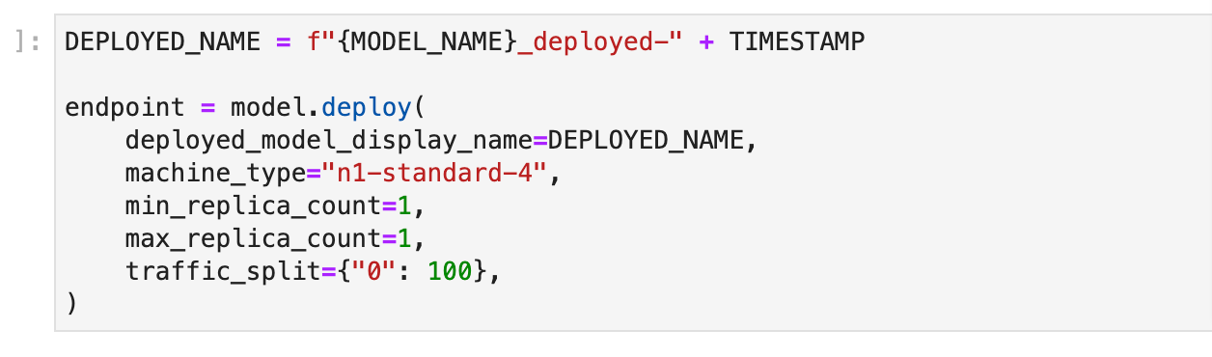

Get prediction from endpoint on the model:

