C O V E N T R Y
U N I V E R S I T Y
Faculty of Engineering, Environment and Computing
School of Computing, Electronics and Mathematics

MSc. Data Science and Computational Intelligence
7151CEM Computing Individual Research Project
Enhancing Human Pose Estimation and Scoring using Artificial Neural Network
Author: Surabhi Jarabandahalli Rammurthy
SID: 12801086
1st Supervisor: Matteo Crotti
2nd Supervisor: Dr. Alireza Daneshkhah
Submitted in partial fulfilment of the requirements for the Degree of Master of Data Science and Computational Intelligence
Academic Year: 2022/23

Declaration of Originality:
I declare that with the exception of properly cited sources, this project is completely original work of mine and is not copied from any other sources. As a result, every instance in which the previously published work from the books, journals, magazines, the internet, etc. used has been recognized by including a citation to the source in the main report's References or Bibliography lists. Furthermore, I agree to the storage and use of an electronic copy of this project for the aim of preventing and detecting plagiarism.

Statement of copyright:
I understand that Coventry University owns the copyright for this project report and for any model developed as a result of the project. Support, including the funding, is available for commercializing the products and services that are developed by staff and students. Any revenue that is generated will be slitted with the inventor/s of the product or service. For further information please see www.coventry.ac.uk/ipr or contact ipr@coventry.ac.uk

Statement of ethical engagement
I declare that a proposal for this project has been submitted to the Coventry University ethics monitoring website (https://ethics.coventry.ac.uk/) and that the application number is listed below (Note: Projects without an ethical application number will be rejected for marking).

Signed: Surabhi Jarabandahalli Rammurthy Date:14/08/2022

Please complete all fields.
First Name: | Surabhi Jarabandahalli
Last Name: | Rammurthy
Student ID number | 12801086
Ethics Application Number | P158609
1st Supervisor Name | Matteo Crotti
2nd Supervisor Name | Dr. Alireza Daneshkhah

This form must be completed, scanned and included with your project submission to Turnitin. Failure to append these declarations may result in your project being rejected for marking.
Abstract
The field of Human action/Pose estimation and scoring is a complex but extensively studied field of Human motion analysis, sports analysis and computer vision. A thorough method for jointly estimating a human's position and recognizing their actions which in turn provides the scores accordingly is presented in this research. It makes use of the potent union of Media pipe with holistic approach and Convolutional Neural Network (CNN) architectures, integrated with a Recurrent Neural Network (RNN) and time-distributed CNN. Additionally, velocity analysis to detect jump which monitors the rate of change of key points over time is incorporated. The algorithm can recognize this high-energy movement with accuracy thanks to sudden spikes in velocity in particular joint locations, which are suggestive of a jump motion. Angle analysis is also used to distinguish squat activities, which are indicated by considerable changes in joint angles, such as knee and hip flexion. Even in complex settings, the algorithm can reliably identify squat behaviors by examining the angles generated between pertinent key points.
The neural network architecture is designed to use the complex temporal dynamics present in human actions. The holistic analysis of sequential input frames to capture dependencies and apparently learning long-term dependencies enhances the neural network to leverage the overall performance and scoring process. We used Regression and classification problems are on the neural networks to compare the effectiveness of each of these methods for the Video Dataset. Regression is employed for the purpose of forecasting the continuous numerical values corresponding to the joint key points of human subjects whereas classification is based on their distinctive temporal patterns and spatial arrangements, the network is set up to classify human behaviors into different categories in the classification model.
The method's advantage in terms of precise pose estimation, leap and squat detection, and action recognition is shown by experimental findings on benchmark datasets. The study advances human-centered computer vision applications by providing a flexible framework that can manage joint posture estimation and action identification and scoring thanks to the adaptability of ANNs. The results show the promise of ANN-based solutions in the field of human motion analysis, opening up new possibilities for interactive systems, surveillance, sports analysis, and beyond.

Acknowledgements
My deepest gratitude goes out to my supervisor Matteo Crotti for his continuous support and continual direction throughout this project. He had been so gracious as to offer comments at each stage of the project and quickly review my progress. I was able to further improve my work thanks to his feedback. I would also Like to thanks Dr. Alireza Daneshkhah and Sara Sardari for all the guidance and contribution in sharing the insights about the requirements.
Every faculty member who has instructed me in this course and shared their invaluable knowledge with me is also appreciated and thanked for helping me finish my project.

Table of Contents
Abstract 1
Table of Contents 2
Acknowledgements 2
1 Introduction………………………………………………………………………………………8
1.1 Problem Statement 9
1.2 Project Aims and Objectives 9
2.Literature Review 11
3. Methodology 17
4. Requirements 18
4.1 Data requirements 18
4.2 System Requirements 18
4.3 Functional Requirements 19
4.4 Non – Functional Requirements 19
4.5 Technical Requirements 19
5. Dataset 19
6. Design 21
7. Techniques 22
7.1 Data Pre-processing 22
7.2 Pose Estimation 23
7.3 Velocity Analysis 24
7.4 Angle Analysis 25
7.5 CNN+RNN Neural Network 26
7.5 Time Distributed Neural Network 27
8. Implementation 27
8.1 Data splitting and balancing 27
8.2 CNN+RNN Architecture 27
8.3 Time Distributed Architecture 29
8.4 Training and Testing 29
9. Results 30
10 Project Management 34
10.1 Project Schedule 34
10.2 Risk Management 34
10.3 Quality Management 34
10.4 Social, Legal, Ethical and Professional Considerations 35
11 Conclusions 36
12 Achievements 36
11 Future Work 37
11 Student reflections 37
Bibliography and References
Appendix A – Project plan
Appendix B – Meeting records
Appendix C- Project Presentation
Appendix D- Certificate of Ethics Approval

Table of Figures
FIGURE 1 - Pose estimation in sports analysis
FIGURE 2 - Stacked hourglass network
FIGURE 3 - Architecture of measurement system
FIGURE 4 - Schematic View of DNN based pose Regression
FIGURE 5 - Kinematic representation of Human body pose
FIGURE 6 - Dynamic flow of the methodology
FIGURE 7 - Waterfall model for the project
FIGURE 8 - Representation of Squat Video data
FIGURE 9 - Overview of Design flow
FIGURE 10 - Key Point representation by Media Pipe
FIGURE 11 - Jump velocity representation
FIGURE 12 - Squat Angle representation
FIGURE 13 - Combined CNN and RNN network
FIGURE 14 - Time Distributed Network
FIGURE 15 - CNN Architecture
FIGURE 16 - Time Distributed Architecture

- Introduction
The advancement of technology has provided a significant way to discover the fields of sports analysis, health care surveillance to human-computer interaction powered by machine learning, Deep learning and artificial Intelligence. Because of improved optimization and feature engineering techniques, computer vision has made considerable strides in posture estimation and Scoring during the past two decades. In addition to many other benefits, the use of Artificial Intelligence in sports is growing quickly and attracting greater attention from both the academic community and business community. Increasing sporting performance, tracking recovery progress, and creating natural and intuitive human-computer interactions are just a few of the many applications that could be made possible by the capacity to precisely sense and quantify human movements. An ideal posture estimate and scoring system should resist to distortion and obstruction, accurate in estimating novel postures and insensitive to the changes in the background caused by objects such as clothes and lighting. Initial research uses complex structured prediction and reliable image attributes to overcome these challenges. Foregoing produces local interpretation. Whereas the latter infers globally reliable position and scoring system.
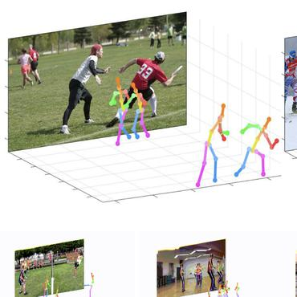
Fig 1. Pose estimation in sports analysis
Furthermore, depending on how colors are represented, whether they are dynamic or static, and how many coordinates are taken into account, the input to the posture estimate and scoring model can take many various forms. Because the information derived from each type of input varies, each type is processed differently. In this research a video input is considered where the Frames are recolored for processing as per the requirements. This research mainly focuses on action detection and scoring of Jump and Squat exercises providing a thorough and complex comprehension of these movements involving deep learning techniques. Understanding athletic prowess, evaluating physical capacities, and delivering individualized feedback for performance improvement depend on the precise detection and assessment of these actions.
ConvNets are now widely accepted as the basic structural need for action detection, substantially substituting graphical models which established significant improvements hence serving as basics to this research paper. We continue on this path and provide a novel architecture of Convolutional Neural network for the Frames of video and Recurrent neural networks for the obtained features and in order to preserve the temporal structure of the sequence and enable a more precise scoring method, time-distributed layers allow us to apply the same change to every temporal slice of the input. We reduce spatial dimensions of the frames and apply the LSTM along with the dense layers for a sophisticated approach not only to enhance the precision but also to provide robust scoring system. The key points obtained from the human body acts as a basics for the whole idea proposed above. The change in the key points over time determines the posture of the human. In this paper we apply the Classification and Regression problems for the network’s best precision and performance. After the application of various methods and algorithms we explore the most promising results. This work is helpful in analyzing the dynamics and insights of interactive motion-based technologies. This combination of computer vision, deep learning, and biomechanical understanding promises a future in which human movement is decoded with unheard-of precision as we set out on this innovative voyage. The effects of this research go well beyond the confines of academic, extending to practical solutions that improve human potential and wellbeing.
  - Problem Statement
The current scoring procedures be in need of objectivity and accuracy, which leads to subjective evaluations and inconsistent results. By employing position estimation and deep learning to build an automated grading system, this research seeks to get beyond these limitations. Accurate assessment of physical activity is made possible by obtaining the values from the video data for velocity, angles and body postures. However, there are still issues with controlling execution variations, preserving pose estimation precision, and developing interpretable deep learning models. A reliable system is essential, one that can skillfully describe temporal connections and successfully handle high-dimensional data. By utilizing cutting-edge machine learning techniques like CNNs, RNNs, and time-distributed neural networks, complicated motions like jumps and squats may be estimated accurately, improving scoring accuracy and dependability.
  - Project Aim and Objectives
The primary aim of this research project is to engineer a deep learning model for the estimation and scoring/ranking of human actions. This will involve the utilization of a comprehensive video dataset for both training and testing phases. The ultimate goal is to augment the capabilities of human action recognition systems.
The objectives include:
- The objective is to utilize advance algorithms for the meticulous analysis of human action estimation in the video input. Analyzing the body key points to estimate the action performed.
- To use insights from trained deep learning models to improve the scoring system for physical activities, enhancing accuracy and reducing bias.
- Combine video data with extracted features to form a dataset, which will be used to train a neural network for accurate analysis and scoring of human actions.
- Acquiring dataset and Installation of all the necessary libraries and packages for the development of Neural networks.
- Model development to analyze/Score jump and squat.
- Evaluating the results obtained from regression and classification problems applied and comparing the accuracy for the best model.

  - Report Structure
The structure of the report defines each and every section that has been defined in the report. It focuses on flow of the project where it provides information about the activities performed at the specific section of the report. Below mentioned is the flow provided.
Section 1: This section provides information about the Introduction, Problem Statement and aims and objectives of the research.
Section 2: The section provides the information on literature review and research analysis done for the current work
Section 3: This section reviews the approach and the justification for its selection for this project activity are covered in this part.
Section 4: This section discusses requirement collecting and various approaches used to finalise requirements and datasets.
Section 5: The general structure of the input dataset is given in this section, along with a brief description of each attribute.
Section 6: This section describes the project design and the flow of the project.
Section 7: This section describes the various methods applied in the research analysis.
Section 8: This section covers the specifics of how each of the methods used in section 7 was implemented.
Section 9: This section covers the implementation of the project with testing and validation of regression and classification.
Section 10: The project management parts of this research are included in this section, along with a brief explanation of the main procedures.
Section 11: This section provides the critical evaluation of the project.
Section 12: This section describes the conclusions and future works that can be done on the research

- Literature Survey

  - Stacked Hourglass networks for Human Pose Estimation
The paper by Alejandro Newell, Kaiyu Yang, and Jia Deng emphasizes the importance of estimating human poses as a crucial step in comprehending individuals in pictures and videos. The author analyses the development of pose estimation research, stressing the "DeepPose" term developed by Toshev et al. as a transitional step from traditional methods to deep networks. This change is notable because it heralds the incorporation of Convolutional Neural Networks (ConvNets) in pose estimation systems, which have significantly improved on industry benchmarks by taking the place of manually created features and graphical models. The sophistication of the models and the calibre of the features, however, placed constraints on these strategies. With the development of deep learning, convolutional neural networks (ConvNets) have become an effective method for learning high-level features and end-to-end mappings from images to poses. The author has depicted the use of cascade to improve the predictions where the human body were completely segmented using the convolutional neural networks. The authors are quite explicit that their study is solely focused on the task of keypoint localisation of a single person's instance from an RGB photograph.
In order to anticipate human position, the author has presented their cutting-edge “stacked hourglass” network design, which collects and combines the available data from all the scales of image. The main aim behind the architecture of hourglass is to gather typical information at every scale. It has been depicted that in this network while recognizing the characteristics like face, Hand, Limbs there is a need of local evidence, a final pose estimation needs a coherent understanding of the entire body. A straightforward, minimalist structure called the hourglass has the ability to take all of these characteristics and combine them to produce predictions at the pixel level.
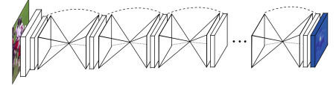
Fig 2. Stacked hourglass network
Along with analyzing many choices for layer design in their network, the authors also examine how layers are specifically implemented inside the hourglass design. They put their entire network design to the test by switching out layer modules in accordance with new information. They noticed an improvement in network efficiency when they switched from traditional convolutional layers with big filters and no fewer steps to more recent techniques like the residual learning modules. Finally, according to results depicted the model has achieved an accuracy of 91.2% and delivered ground breaking outcomes. For the current research we employ the feature sampling and the intermediate supervision of the CNN which improves the overall performance of the current work.

  - An approach to sport activities recognition based on an inertial sensor and deep learning
In the work by Grzegorz Pajak, Pascal Krutz, Justyna Patalas-Maliszewska, Matthias Rehm, Iwona Pajak, and Martin Dix the authors explore the field of Human activity recognition(HAR) with the main focus on sports analystics. The authors emphasise how modern developments in the human lifestyle are driving the increasing importance of sensor technologies, IoT, and cloud computing in sports analytics and personal fitness monitors. This study uses a dataset from three UWB sensors with additional inertial data, which contains a reduced data set consisting of 17 training sets, followed by 1444 samples describing exercises and 2024 samples with breaks, which were grouped in the ratio 70:15:15, for CNN training. The dataset is based on literature studies and selected sports activities, including squats, pull-ups, and dips. The paper dives into the supervised learning for data catergorization of human movement and the unsupervised learning for the purpose of Data augmentation and extracting the features. This method has played a crucial role in recognizing the human activity. The author has reviewed numerous deep learning techniques such as CNN and RNN and layer wise training CNN’s. This work used the CNNs which is combined with use of pooling, soft-max classifier, rectified linear unit activation function, and CNNs in combination. SVM and 1D-CNN are examples of binary classifiers that are used for static and moving images, respectively. It has been depicted that various works produced earlier has many application in the field of HAR of sports and the models where the CNN is combined with classifiers, But none of those were insightfully designed for the purpose of sport’s training. The Model uses the decision tree and naïve bayes as classifiers in this work. The neural network has the sliding window technique which obtains the raw data from all the sensors in order to feed into the network. This model has depicted the performance of depends on the fact of choosing the initial weights.
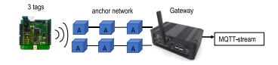
Fig 3. Architecture of measurement system
Once the CNN has been applied an architecture of ENN (Ensemble Neural network) is depicted. The architecture is based on the idea of aggregating many CNNs and training is done by splitting the data arbitrarily. The probabilities aggregated from every single network in order to perform the classification. It has been described that the newly introduced network has performed better than the methods produced earlier. The measure of performance is described where the algorithms has given the accuracy and performance up to 97 percent. The paper has concluded the combination of CNN and ENN has provided great results and performance and computational efficiency is drastically reduced by this architecture. The current work extracts the use of CNN for classification and feature extraction from this work. The performance modelling and design of network is referred to include in the current work. This paper has provided a great deal of information to which is utilized in the current work.

  - DeepPose: Human Pose Estimation via Deep Neural Networks
In the work published by Alexander Toshev and Christian Szegedy depicts the method for pose estimation using the DNNs. The author aims to obtain maximum precision by building a frame as DNN-based Regression issue for body joints and incorporate a DNN regressor cascade fro the input image. This research highlights the difficulties in estimating the human poses, including occlusions, indistinct joints and powerful articulations which proves the necessity of holistic reasoning. The DNNs can naturally provide the comprehensive reasoning for the mentioned complications. The author emphasizes the attempts to capture more complex spatial linkages and interactions between body components have been made in more modern methodologies, although they have had mixed results in practical issues. In order to offer their innovative approach, the authors make the case for a comprehensive understanding of human pose estimation. The network architecture is designed to utilize the generic convolutional DNN architecture which has up to seven layers such as pooling, convolutional and connected layers. This network uses 200*200 picture for input and produces a 2k coordinate vector. The K in here represents the count of joints. The network has used the back propagation with L2 deprivation and adaptive gradient updating. The proposed network increases the resolution of the sub-images surrounding each joint to improve the prediction from the last one. By learning features at finer scales and utilising more context data, this process enhances the quality of joint localisation. By learning features at finer scales and utilising more context data, this process enhances the quality of joint localisation. Then, for each joint, a sub-image is cropped around the estimated joint location from the earlier process and input to a DNN that forecasts a change in vector to further improve the joint location.
The performance evaluation is carried out using 2 metrics percent of proper parts (PCP), which counts a limb as detected if its endpoints are within half of the limb length from the ground truth, and percent of detected joints (PDJ), which considers a joint as detected if its distance from the ground truth is within a fraction of the torso diameter. The authors demonstrate that their approach, when applied to the two datasets and the two metrics, yields result that are state-of-the-art or better. By analysing it on two comparable datasets, they also demonstrate that their strategy generalises effectively to different domains. In the current work we use regression as well as the problem along with classification hence this work provides the ground for the regression problem. We extract the application of DNN for regression from this work. The holistic approach will also be applied in the current work which improves precision of joint localization.
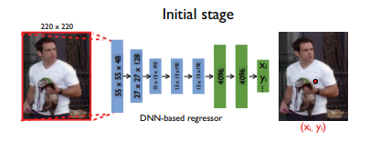
Fig 4. Schematic View of DNN based pose Regression

  - Research and Analysis of Video-Based Human Pose Estimation
In the work published by Zheng Wang, Jing Sun, Qingxiao Xu, and Kun Liu the authors have presented the user-defined rules and pattern matching are the foundation of a unique framework for human posture estimate and recognition. The video dataset is given as input for this model. In order to describe pose information, the authors suggest using OpenPose to extract skeleton coordinates from video frames and then calculating various angles as well as distances. The author has applied this framework in various applications and compare the results of this work with CNN oriented methodologies which subsequently proves their work is more precise and faster. An algorithm has been implemented which aggregates the how often same action is performed in the video. This work focuses its application majorly on the fields of table tennis training, boot camp scenes and pilot driving. The main aspect of action recognition is to capture the temporal dynamics and semantics of human motion.
To extract skeleton coordinates from pictures and videos, it first applies OpenPose, a cutting-edge method for estimating 2D human poses. The foundation of OpenPose is part affinity fields (PAFs), vector fields that store the position and orientation of body parts. From the input image or video, OpenPose utilises a CNN to predict PAFs and joint heatmaps, and then uses a greedy method to put them together into body poses. The pose feature are represented by calculating various angles and distance between the joints. Author depicts that These characteristics do not necessitate any further modelling or learning because they are based on the data's initial geometric relationship. Further pattern matching is used in order to classify poses into various categories and The constraints or requirements for each pose type are stated in user-defined rules, which are logical expressions. These approaches are fast, novel and effective as described. The framework presented in this paper, which relies on the original geometric relationship of the data rather than sophisticated models, is a novel approach to human pose estimate research, according to the publication's conclusion. This approach limits on capturing the depth information when there is change in motion. This work has provided a great insight which could be referred to the current work as this uses video as input. The current work adopts the angle calculation and use of pre trained models to estimate the pose and determine the scoring accordingly. This work is could be extended to involve 3D estimation as mentioned by the author and more realistic applications could be designed.

  - Human Body Pose Estimation and Applications
In the paper published by Amrutha K, Prabu P and Joy Paulose depicts the sign language recognition using the mediapipe framework a system that can recognise and follow in real-time body position, hand motions, and facial landmarks. The presented article explores the various architectures for current pose estimation and Body models which also includes skeleton-based, contour-based, and volume-based models, as well as OpenPose, HRNet, DeepCut, and AlphaPose. These architectures produce part affinity fields or heatmaps to identify the important points of body parts and employ deep neural networks to learn characteristics from photos. The authors then suggest a MediaPipe-based 3D posture estimation-based sign language recognition system and it is a a comprehensive strategy that combines data from the face, hands, and body to produce reliable pose estimation in a variety of situations. In order to extract features from the input video of signers doing various signs against various backgrounds, the authors employ MediaPipe. As soon as the characteristics have been normalised, a Random Forest classifier is used to recognise the signs and calculate their probabilities. The authors provide the findings of their study based on a real-time dataset that included 10 distinct signs made by five different signers. The authors demonstrate that their method can produce excellent accuracy and probability values for the majority of the signals, particularly "sad" and "blank". The authors also go over the system's drawbacks and difficulties, including head angle variability, camera distance, elbow visibility, and sign ambiguity.
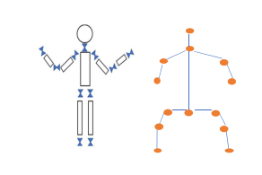
Fig 5 Kinematic representation of Human body pose
The study makes contributions to the fields of human posture estimate and sign language recognition by offering a thorough analysis of current approaches and difficulties as well as by putting forth a novel method that makes use of MediaPipe to carry out multi-modal pose estimation in real-time. This work has used mediapipe which is implemented in the current work. The pose estimation and keypoint extraction features are extracted from this work to our research. The holistic presentation also serves as base of the current work which is implemented above.
  - Efficient Multi-Person Hierarchical 3D Pose Estimation for Autonomous Driving
The article proposed by Renshu Gu, Gaoang Wang, Jenq-Neng Hwang focuses on Identifying a human's appearance in an image by identifying key spots on various body components is called "3D human pose estimation." This work uses input from moving cameras in natural settings which are monocular photos or videos. The author has demonstrated that this model makes use of a hierarchical 3D human body model and temporal data from ocular odometry and tracking. The approach is capable of handling numerous users, occlusion, and bad weather and does not require pose bases or 3D training data.
The architecture flows as initially the author estimates the 2D pose and track using OpenPose which is a CNN and TrackletNet. Then a Visual odometry and ground plane estimate for 3D human localisation using SVO and RANSAC is done. Then by utilising a variable human body model with bone length and joint angle limitations, hierarchical 3D human pose estimation will be captured using weak-perspective projection and joint optimisation, camera coordinate transformation. The mathematical formulations of the projection, localization, and estimate problems are provided, along with an explanation of each step's specifics by the authors. The authors also provide examples of the benefits of their hierarchical approach, including how it can make estimation simpler, make it less complex, and make it more robust. The research tests the effectiveness of the suggested strategy using a number of benchmark moving-camera footage, including the Kitti dataset 5, the ETH dataset 6, and user-generated data. The efficient solution is provided by this model by torso estimation as a PNP problem. Then analyse each limb's position estimation, define and resolve an optimisation issue, and finally each limb rests in a low-dimensional pose space without interfering with the other limbs. The paper is compared with many other previous works and it shows that this work can achieve better results and also suitable for real time processing. The current work focuses on multi person and object identification which could be included in the current work which could make it more precise and increase the performance.

  - Video Annotation Tool using Human Pose Estimation for Sports Training
In this paper by João Diogo, Rui Rodrigues, Rui Neves Madeira, Nuno Correia introduces the integration of Human pose estimation technique into an existing web-based multimodal video annotation tool, applying it to the sports context, where basketball is the first case study. The author proposes the motion notes annotation tool which can combine the motion information and human pose. In order to upbring the motion notes annotation tool the architecture is designed which follows as mentioned.
Initially the author will process the videos with OpenPose algorithm in order to make the 2D estimation of co ordinates of 18 joints of the human body. Then the model uses proximity and depth techniques which will ensure the stability over numerous frames. While creating various forms of annotations for a body component while video playback, dynamic annotations can use 2D coordinates as an input. To analyse the movement of each and every person insightfully a selective pose analysis on a blank background is performed. To dynamically emphasise various video timestamps when the corresponding images feature a certain mobility or gesture, movement detection utilising a rules-based system is used. The outcomes are compared both qualitatively as well as numerically with a number of cutting-edge techniques in the publication. In practical basketball footage with many players and dynamic motions, the research demonstrates how the suggested method may produce precise and organic outcomes. The study also demonstrates which, for the majority of behaviours in the Human3.6M dataset, the suggested strategy may exceed the ones currently in use. According to the report, their approach is suited for processing in real time because it can run at 30 frames per second on an i5 laptop. In conclusion, the research proposes an innovative and effective technique for incorporating human posture estimation features into a web-based multimodal video annotation tool for sports training. This method has provided the insights into the Motion Notes annotation tool and individual pose analysis which provides a base structure for the current work. The 2D estimation of joint coordinates will be implemented in to the current work along with the Depth techniques.
  - Dynamic Gesture Recognition with Pose-based CNN Features derived from videos using LSTM
The author Kankana Roy and Rajiv R. Sahay employs a pose-based video descriptor and a long short-term memory (LSTM) network to suggest a unique technique for recognising dynamic movements from monocular video sequences. Author demonstrates that many previous methods have been produced which fail to clearly differentiate the similar gestures hence In this paper, a unique method for extracting pose-based CNN features from video frames is presented. It makes use of a dynamic human body model with limitations on bone length and joint angle, together with a pre-trained convolutional neural network (CNN). A 2D pose estimation is done using OpenPose to estimate the body keypoints. The 3D Human localization is carried out by ground plane estimation and Viual odometry with the help of SVO and RANSAC algorithms. The model performs Pose-based feature extraction creates a 1024-dimensional feature vector for each frame using a GoogLeNet 5 CNN that has already been trained. The concatenation and feature normalization is carried out by L2 normalization. Localization and feature extraction is performed by reducing complexity and enhancing the robustness.
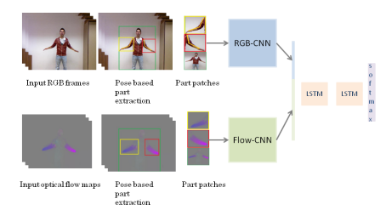
Fig.6 Dynamic flow of the methodology
The author presents a LSTM network for pose based video description and classification and the pre trained CNN for the purpose of feature extraction. This model achieves an accuracy of 95% and outperformed many traditional methods by using the deep learning techniques. The LSTM and CNN structure will be considered for the current structure to implement the scoring system based on classification and regression.
- Methodology
The process of Software development life cycle which is an organized procedure for the purpose of designing, Building and testing the software that has been developed. The objective of the SDLC is to create product that fulfils or exceeds client demands and is provided on schedule and on budgets. The stages of the cycle are mentioned in the below figure. We have considered the waterfall model for our project as this provides clear structure of the entire process. Below are reasons to consider this model.
- Clear and Fixed Requirements
The requirements for human pose estimation and scoring, such as specific poses, velocity measurements, and angles to be analyzed, are clearly defined from the beginning and are not expected to change, the Waterfall model offers a structured and straightforward approach.
- Mature Technology and Methods
the deep learning techniques and algorithms for human pose estimation are mature and well-understood, there might be less need for iterative experimentation, making a linear approach like Waterfall more suitable.
- Integration Complexity
Integrating velocity and angle analysis with deep learning involve complex data pipelines. The Waterfall model provides a systematic approach, ensuring that once the system design phase is completed, the integration will work seamlessly during the implementation phase.
- Research and Development Separation
The deep learning models for human pose estimation are developed separately and the project is more about deployment and integration, the Waterfall model can be a fit since it provides a clear separation between development and implementation.
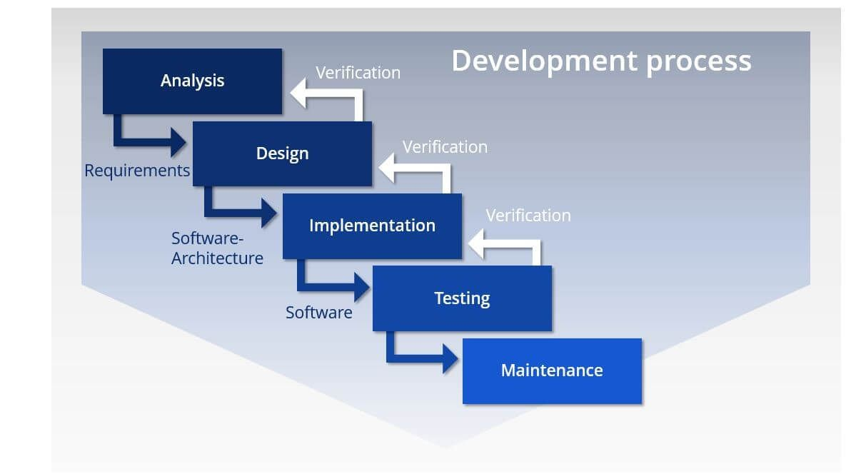
Fig 7. Waterfall model for the project
- Requirements
The requirements section provides the brief about deep comprehension of the project's requirements and established a clear course for its advancement. It defines the Proper gathering and documenting of this research. Below mentioned are the brief necessities for the current project.
  - Data Requirements:
The Deep Learning or machine learning model needs the training data to enhance the learning models. A high amount of data is collected as per the network needs. A through research is necessary for acquiring the correct set of data in the appropriate formats which are fed to the neural network. For this research an experiment is conducted where the data is collected from records of actions performed.
  - System Requirements
This step is very crucial as the need for the machine with capable hardware is necessary while designing, developing and implementing the models as working with Artificial neural network and Deep learning architectures might be computationally demanding. The need for right amount of memory and processors speeds should be satisfied. The mentioned system is used for this project.

- Type of system: x64-based PC
- Operating system: Microsoft windows 10
- Random access memory: 8GB
- Processor: AMD A4-9125 RADEON R3, 4 COMPUTE CORES 2C+2G

  - Functional Requirements

- Detecting and removing objects in the video other than the action performing subject.
- Labelling the key indices/points to determine angle.
- Removing the corrupted video.
- Detecting the Front view of the body.
- Represent the Pose estimation.
- For each identified joint between successive frames, the system must calculate the speed or rate of movement.
- The system should automatically assess the pose based on pre-defined standards, taking velocity and angle readings into consideration.
- Feature scaling and localization.
- Split the action of Jump and Squat into different files.
- Splitting the dataset into train and test.
- Building the CNN+RNN and Time Distributed Neural Networks for Classification and Regression problems.
- Visualization tools to understand the outcomes.

  - Non – Functional requirements

- Google Collaboratory is utilized for coding.
- System with minimal latency to process videos.
- User data, especially recorded videos should be securely stored and protected against unauthorized access.
- Varying conditions should not affect the system

  - Technical requirements

- A high-definition camera may be necessary for a camera-based system. Definitions should be made for parameters such frame rate, resolution, and field of view.
- Deep learning libraries and frameworks like Tensorflow and MediaPipe for poses estimation.
- Information about the management of data backups and steps for data recovery in the event of errors.

- Dataset
The dataset is intended to facilitate the creation of Deep learning models that carry out human posture estimation, velocity analysis, angle analysis, and subsequent scoring. These models support the comprehension and quantification of human movement patterns for a range of applications, including sports analysis, physical rehabilitation, and others. The dataset contains a selection of videos documenting various human movements and activities. In order to maintain the resilience of the models, these videos use a variety of lighting, camera angles, backgrounds, and apparel.
For this Research an experiment is conducted for the purpose of data collection. We have approximately 12 children performing the action of Jump and Squat with various speeds and angles from one person to another. This will be recorded using a High-resolution camera from the front angle. We have almost 12 folders containing approximately 10-12 recorded videos per folder of both Jump and Squat activities in a mkv format which will be converted into .mp4 format for the purpose of processing. After obtaining the activity parameters by applying different methods and functions an excel file of dataset is created which has 210 rows after removing corrupted and unformatted videos.
The Poses within the videos are manually scored reflecting the quality of correctness of the pose. This dataset is divided into Training, Testing and validation to feed into the neural networks. The videos containing sensitive information are removed or anonymized. Standard annotations should be maintained in this dataset. Below attached is the pictorial representation of Squat and Jump Dataset from the folders.

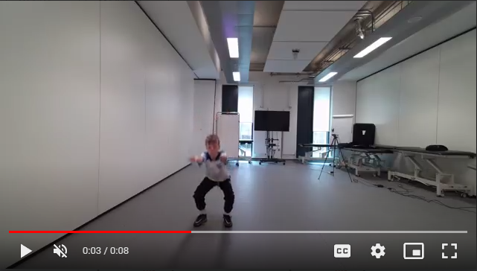
Fig.8 Representation of Squat Video data

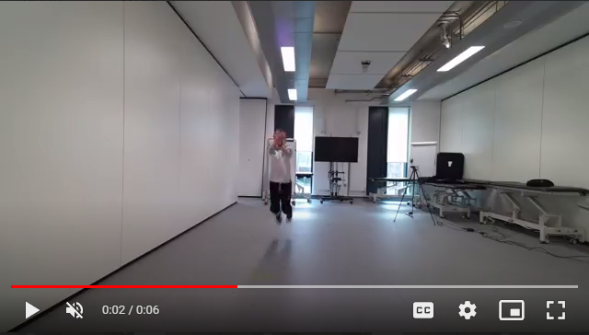
Fig.8 Representation of Jump Video data
- Design
The Designing process of this research has been broken down into a number of distinct structural blocks of information, each of which carries out a certain set of pre-determined tasks. The below figure represents the flow of the research where each stage represents the interconnection between the current and upcoming process. The task is carried out in an order for the accurate results and performance.
Step 1: Data Loading and Pre-Processing: The initial process in the research is to load the data to the cloud as we are Google Collaboratory for the code execution. Hence the entire data needs to be uploaded. This is followed by Data pre-processing which is one of the main steps of any research. The model requires the compatible data which is free from all the corrupted and non-compatible videos which might be present. Once after this we will be able to perform activities such as Feature selection and Localization for further process of training and testing of the model. These steps help in increasing the performance of the model by training and validating from which estimates can be obtained.
Step 2: Pose estimation: The next step is to perform the pose estimation where the key indices are defined for the human body and drawing the skeleton structure of the pose. This step provides the location of joints, shoulders etc. Scaling is also performed. This step forms the base structure for the further process where we need to determine the actions.
Step 3: Velocity and Angle analysis: Third step is determining whether the person is performing Jump or Squat. The below section provides brief about Velocity and angle analysis where different features are selected and localization is applied for accurate predictions. The parameters obtained from this step will be stored into an excel sheet which will be used for the further steps.
Step 4: Model Formation: This step will focus on creating the CNN+RNN and Time Distributed CNN for the problem of Classification and Regression. The Models will be trained and tested for the Jump and Squat Dataset. The result will be compared to check for the best method to solve the research problem. The steps are monitored for the Hyperparameter during the execution of this step.
Step 5: Training the Model: This is the step where the neural network will be fed with the data set which was split into training and testing for the video dataset. We will observe the loss and accuracy of classification and regression models as we feed and train the network. As we do not have the large dataset we need to train with the limited dataset. In future model could be trained with huge data for accuracy and performance.
Step 6: Model Evaluation and Results: This the step where the obtained results will be evaluated and compared for the best models out of the applied neural network. We will observe a number of Hyperparameters at this stage and fine tune at this point. Parameters such as activation layer, max pooling, Hidden layers, Kernal size etc. will be monitored. This step is responsible to provide and keep the whole model outcome which will be very necessary for the future references.
Below mentioned is the figure which represents the flow of the research conducted step by of the entire process.
network train, test
Jump

Input Videos
Data Pre-Processing
Pose Estimation
Velocity Analysis

Angle Analysis
Squat

Conclusions of results
Neural Network creation
Network Training
Result Comparison and Evaluation

Hyperparamet-er Tuning
Saving Results

Fig 9. Overview of Design flow

- Techniques

  - Data Pre-Processing
The Data -Pre processing is a very important part of the project development. This step makes the data to be more accurate and better without any kind of Unwanted noise or objects in the background before feeding it into the Neural networks. Below mentioned are few steps performed to make sure the data is Video data is in the standard format.
Video Frame Extraction:
The videos will be converted into individual frames to process each image separately. We maintain the consistent frame rate for extraction to maintain uniformity across the dataset.
Feature Scaling:
Feature Scaling can accelerate the convergence of gradient descent during training as the optimization landscape will be uniformly scaled. While combining the video data from multiple cameras with different color calibrations feature scaling provides consistency. We apply rescaling for functions in neural networks after Min-Max scaling to [0,1], data is transformed to [-1,1] by application of the formula
X rescaled =2∗X norm−1
Reliability between frames must be ensured while scaling video data characteristics. The mean and standard deviation, for example, should normally be calculated throughout the entire dataset then uniformly applied to each frame if you're standardising pixel values.
Frame normalization
The complex challenge of achieving homogeneity across various video sources is encapsulated in frame normalisation in video datasets, ensuring the best interoperability with cutting-edge machine learning systems. This involves scaling values typically between 0 and 1 to harmonise pixel intensity distributions, standardising frame resolutions while keeping intrinsic aspect ratios to avoid distortions, and guaranteeing temporal uniformity by lining up different frame rates. Conversion to a canonical color space, the use of sophisticated methods to modify brightness, contrast, and background variance, as well as the implementation of noise-reduction techniques, may all be required concurrently with the process. In order to strengthen the integrity and consistency of video data and open the door for more precise and effective computer analysis, this careful normalisation procedure is crucial.

  - Pose Estimation
Identifying the location and orientation of body parts in pictures or videos of people is called "human pose estimation," and it frequently entails using skeletal joint coordinates. It provides complex insights into movement dynamics when paired with velocity and angle analysis, which is essential in fields like sports statistics, physical treatment, and dance choreography.
In this research we have used MediaPipe for estimating the pose as this is one of the most sophisticated open-source framework designed by google to address various cross-platform perceptual computing tasks. The Pose model from MediaPipe is skilled in locating 33 different body markers in 2D space. These landmarks provide a thorough skeleton representation of the human figure, spanning the upper chest, lower body, and facial region as in the below figure. utilises machine learning in a multi-stage process. To begin with, a BlazePose model is used to foretell where important body landmarks will be. The landmark coordinates' accuracy is increased post-detection, and various calculations and improvements are made to guarantee their consistency across frames in video applications. We define the key points which will serve as base in determining the pose estimation. The below mentioned is the code used to implement the mediapipe into the research where each function performs various actions to determine the pose of the human body.
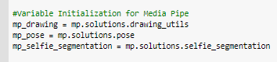
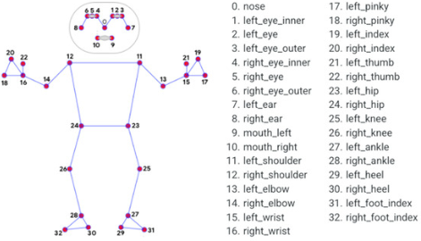
Fig 10. Key Point representation by Media Pipe

  - Velocity Analysis
A process of Velocity analysis is defined in order to detect the action of jump. This involves measuring and interpreting the speed and direction of motion which is predominantly vertical axis. It is a vector Quantity implying both Direction and Magnitude. Below mentioned is the kinematic equation to determine the velocity.
𝑣 = 𝑢 + 𝑎 𝑡
Understanding the jumper's power is possible by analysing the velocity just before takeoff. A higher jump often results from a higher take-off velocity. This in turn will be used to rate the action performed. In our research we consider the difference in speeds between two consecutive frames of the video to determine the velocity. The mid 30 frames will be considered to find the difference in speeds. The variables considered are nose_velocity, Left_hio_velocity, right_hip_velocity, left_shoulder_velocity and right_shoulder_velocity. If the total number of frames in the video are less than 2 then the function is defined return the value as false else the value returned will be true. A threshold value is defined on the basis of few previous research which is the key criteria to detect Jump action. If the action performed does not exceed the threshold value it will not be labelled as Jump. The change in velocity will be captured by a get_velocity function which will append the values and store in an array of values. Below mentioned figure depicts the typical velocity analysis.
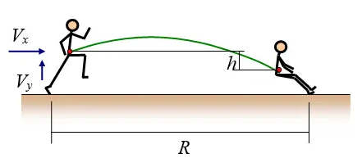
Fig 11. Jump velocity representation
  - Angle Analysis
Many sports movements and workouts are built on the squat, a basic movement pattern. When joint angles are measured and analysed during a squat, biomechanical effectiveness, injury risk, and technique effectiveness may all be learned. In this research we try to determine the angle of the squat by defining a vector between three points which is in turn used to determine the angles. The angles will be calculated in radians and will be later converted into angle. A arctan2 function is used to find the angle between the joints. The variables considered are left_hip, right_hip. Left_knee, right_knee, left_ankle and right_ankle. The squat scoring is determined by defining the threshold values for left_angle and right_angle. If the squat is flexed above the mentioned threshold values it will not be recognized as squat. The criteria’s are based on previous research and review on the literature. Below mentioned is the pictorial representation of angle analysis in which squat action is performed.

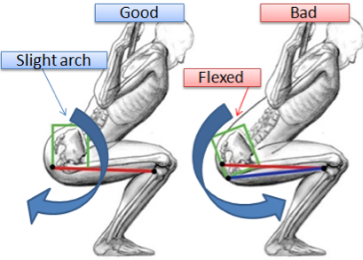
Fig 11. Squat Angle representation

  - CNN+RNN Neural Network
One of the most important architectures in deep learning is the combination of recurrent neural networks with convolutional neural networks, or CNNs. The hybrid is especially useful for applications that need sequences of pictures or videos, such as video categorization, action identification, and gesture detection since it can use both spatial and temporal processing skills. The CNN component is particularly used for the video processing. They are able to identify regional trends, such as edges and textures, through convolutional layers. Spatial hierarchies are created by downsampling these patterns using pooling layers. In order to process sequential data, RNNs keep a memory that stores details about earlier steps in the series. Their suitability for tasks like time series prediction or natural language processing, which need for a comprehension of the temporal dynamics of data, results from this. In this Research we will apply the CNN+RNN structure as it is the most robust and precise. This will be applied for the problems of classification as well as regression. This combination will enable simultaneous spatial and temporal processing, capturing relationship between individual frames. Below mentioned is the typical pictorial view of the network.
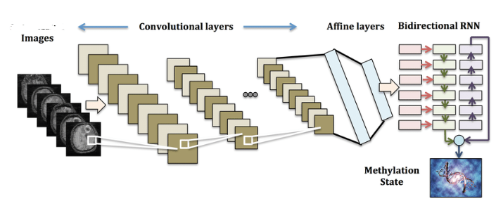
Fig 12. Combined CNN and RNN network

  - Time Distributed Neural Network
When working with sequences and wanting to apply a layer to each temporal slice of an input, a time-distributed neural network is a term most often used in relation to recurrent neural networks (RNNs). Every input in a neural network series generally consists of a number of timesteps. According to traditional RNN designs, the input sequence is processed one timestep at a time, with a hidden state being maintained to transmit knowledge from one timestep to the next. The outcome will keep the temporal dimension if the time distributed layer is utilized. For instance, the output will still retain the shape (timesteps, output_features) if a time-distributed dense layer is applied to a set of shape (timesteps, features). TimeDistributed wrapper is a tool that may be used with libraries like TensorFlow/Keras to accomplish this goal. The layer's operations are applied to each timestep by enclosing ordinary layers in TimeDistributed. In this Research this model has given great results in both regression and classification problems. Consider spreading a dense layer over the timesteps. Mathematically, a dense layer can be described as:
y=Wx+b

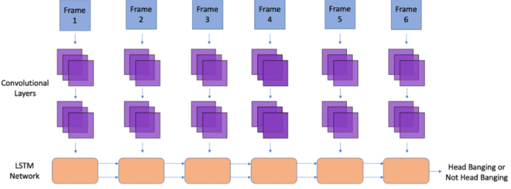
Fig 13. Time Distributed Network

- Implementation
The section of implementation is where the research and project deployment are discussed. The Code for this research is written in python language and was executed on the google Collaboratory platform. We have saved all the videos on the Google drive and processed within the code. The data visualization is done using the matplot libraries. We have imported all the required packages and libraries necessary for the neural network. The implementation focuses on applying the above mentioned two neural networks on the classification and the regression problems. The Below explained are followed for the neural network architectures.
  - Data splitting and Balancing
Data balancing is a crucial preprocessing step, particularly in supervised learning, where the performance of the model can be considerably impacted by the distribution of classes. When the majority of the classes in a dataset are underrepresented, the model is more likely to forecast that group, which could result in biassed or subpar performance. We have applied the splitting of the CSV file which includes the data of Squat and Jump into two different files which will be fed into the neural network. The squat and jump data will be balanced as there is less dataset to tarin the neural network. This process will consistently help in increasing the accuracy of the model.
  - CNN+RNN Architecture
The below mentioned figure represents the CNN+RNN architecture for the classification and regression problem. The below attached figure shows the formation of the neural network. The CNN architecture has been built using the MobileNet which is lightweight and efficient model.
We wrap the CNN base model with timedistributed layer in order to process each frame independently. This will help in extracting the features from it. We try to flatten the video input when it is given as output. For the RNN model An LSTM layer of units 128 is applied and ‘relu ’activation function is used to build the model. We concatenate the results and apply compile the model. This model uses ‘adam’ as optimizer function. The mean squared error and absolute mean error will be calculated to evaluate the overall performance and accuracy of the model. The model has been run for almost 40- 50 epochs for each activity of jump and squat.
The Squat and Jump activities are scored with the great accuracy. But there is bit loss in applying this model to the jump activity hence accuracy should be improved by applying more dense layers and larger set of data. The below architecture depicts the flow of model where many convolutional layers are applied. The function Maxpool is also applied multiple times in order to perform the downsampling after applying the convolutional layer. The losses of the model will be depicted in the following result section.

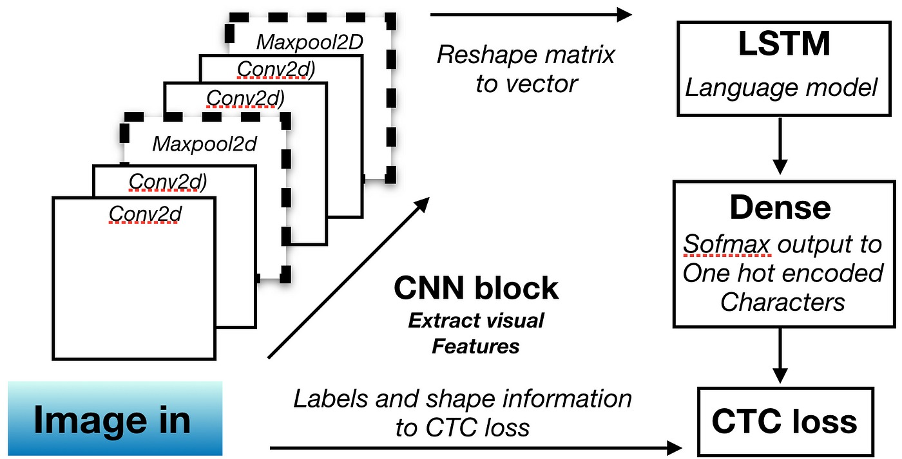
Fig 14 CNN Architecture
Regression Problem
The combination of CNN and RNN as a regression problem deals with the sequential video data where temporal patterns and spatial features are detected. The objective of a regression setup may be to predict certain continuous variables, such as the height of the leap or the angle of the squat, in the context of identifying movements like jumping and squatting from video data. Regression output from the RNN's last layer can be connected to a dense layer with a single neuron. When striving for exact regression results, deep architectures like CNN+RNN need a lot of labelled training data.
Classification Problem
For video-based activity recognition, Convolutional Neural Networks (CNN) and Recurrent Neural Networks (RNN) function well together. The objective of leaping and squatting detection within a classification framework is to classify every sequence (or a portion of it) into specified classes, such as "jumping", "squatting", or "other activity". There are frequently asymmetries in video datasets, with some actions (such "other") being more common than "jump" or "squat." To solve this, techniques like oversampling, undersampling, or employing class weights might be used.

  - Time Distributed Architecture
The time distributed architecture used in this project has many layers of LSTM applied to it around 256. This will be passed on to the time distributed network as in the below architecture. Many Conv2D layers are applied along with Maxpooling. The ‘relu’ activation function is used as well in order to predict the scoring of Jump and Squat. The final 64 dense layers have been added and fed into the neural network. The optimizer used here is ‘Adam’. The loss is shown as R2 squared and accuracy of classification is shown as well. This Architecture has many hidden layers which will contribute on feature scaling. For a 2D layer like a CNN, TimeDistributed effectively changes the input shape from (batch_size, time_steps, ...) to (batch_size * time_steps, ...) before passing it through the wrapped layer. After processing, it then reshapes the output back to (batch_size, time_steps, ...)

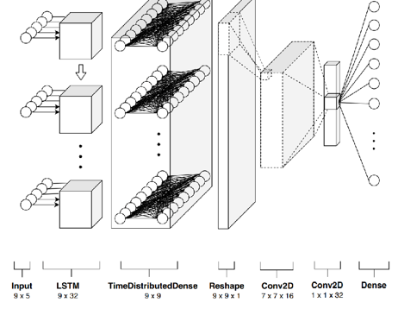
Fig 15 Time Distributed Architecture
Regression Problem
In Regresssion, a CNN is applied to each frame of the video sequence individually using the TimeDistributed wrapper to extract important spatial information from each frame. The input video sequence, which has the following dimensions: number of frames, frame height, frame width, and channels, is transformed into a feature sequence, which has the following dimensions: number of frames, feature height, feature width, and feature channels.
Classification Problem
The classification problem is applied on Time distributed network In order to extract spatial information for each frame in the video sequence, a CNN is used. The information concerning the postures, orientations, and relative placements of the human body in various frames is contained in these spatial properties. The TimeDistributed wrapper makes sure that the CNN analyses every frame separately, extracting spatial information with shared weights for each frame. As a result, an input video sequence of shape (number_of_frames, frame_height, frame_width, channels) gets transformed into a feature sequence of shape (number_of_frames, features_height, features_width, feature_channels).
- Results
This section describes the results obtained in the corresponding neural network models. Below mentioned figures shows the following for each of the model.
Regression Models
CNN+RNN for Squat: The result shows good accuracy in predicting the squat for CNN and RNN combined network. R2 squared value is close to 1 which shows model is fitting well. The trend represents the good accuracy.
Test RMSE: 0.32903166899715613
R2: 0.7088812738503241
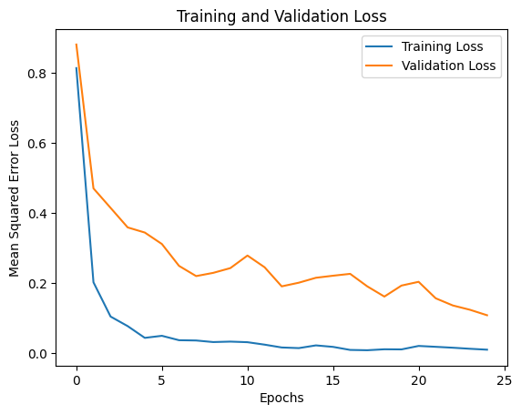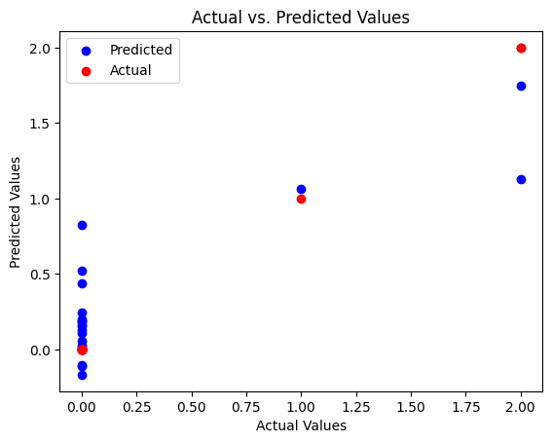
Time Distributed CNN for Squat: The model is perfectly fitting here as the accuracy of the model is good R2 square is 0.93 which is close to one hence this fits better than the previous one.
Test RMSE: 0.15225773123165084
R2: 0.9376619160156339
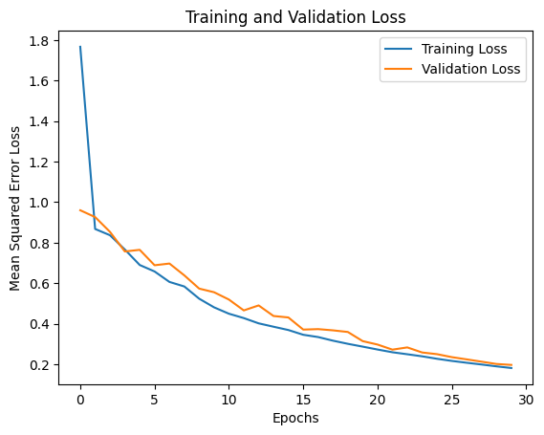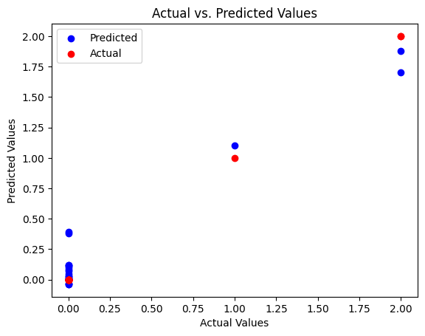
CNN+RNN for Jump: This model is for jump has not giving great accuracy but it is giving positive results which is a good sign of the model the residual map of actual vs predicted values is also represented.
Test RMSE: 0.5345561629719917
R2: 0.3315782657980384
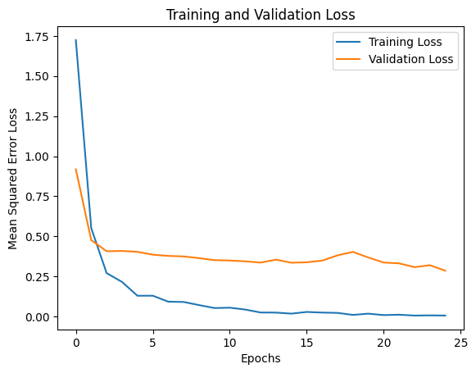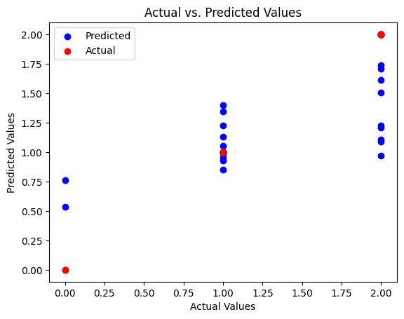
Time Distributed CNN for Jump: This model fits better for the squat data as the R2 value is 96 and close to one which shows the data is fitting very well. Below represented graphs shows the tends.
Test RMSE: 0.1301322522813026
R2: 0.9603873612074747
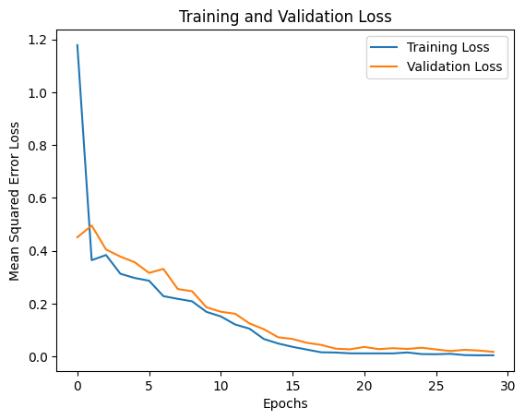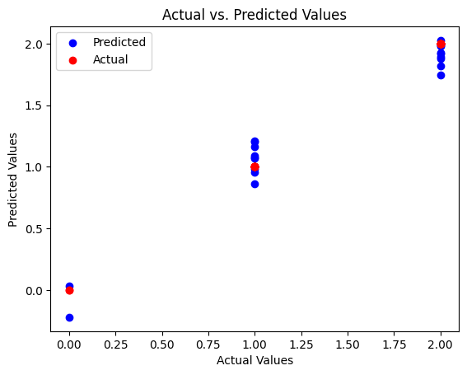
Overall, the time distributed model is predicting the scoring of squat and jump accurately than the CNN + RNN model.
Classification Models
Time Distributed CNN for Squat: This model for classification has given the accuracy of 90% which shows the trend is constant but it is classifying the scores accurately as mentioned in the below graphs.
1/1 [==============================] - 1s 1s/step - loss: 0.2250 - accuracy: 0.9048
Accuracy {:.4f} 0.9047619104385376
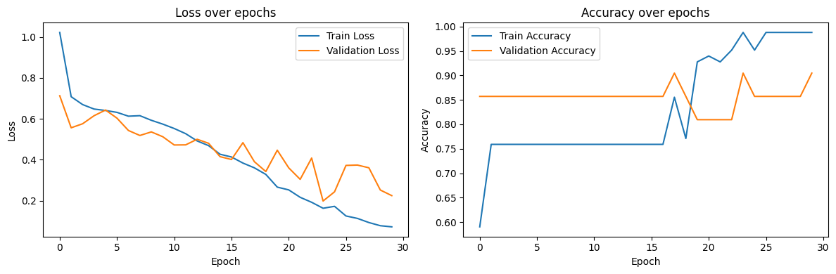
Time Distributed CNN for Jump – The time distributed has performed very well for squat but for Jump it gives 55% where the graphs shows a bit of curves for predicted and actual values.
accuracy:{:.4f} 0.550000011920929
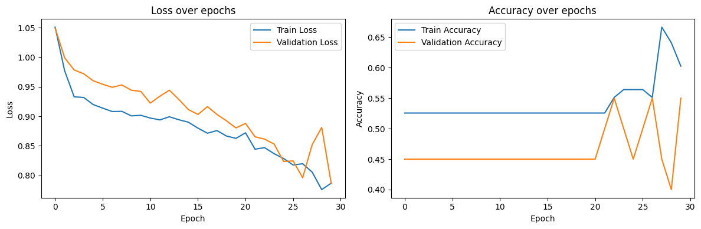
The CNN+RNN model for squat and Jump in the classification problem is overfitting which is represented in the code.
EDA:
- Distribution of scores.
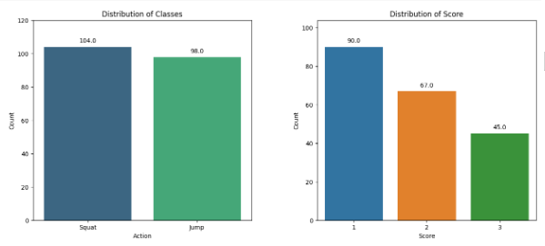
- Histogram of the parameters.

- 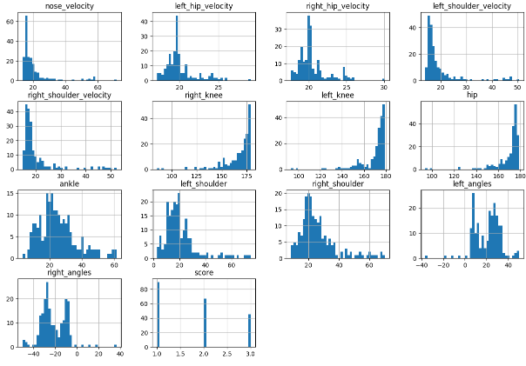

10.Project Management
The practise of guiding individuals to reach a specific goal within a predetermined window time frame is referred to as project management. This process is used to track the progress of the course. This has various number of aspects such as Project initiation, Planning process, scheduling, Budgeting, Monitoring, communicating the delivering the developed product which could be useful in the real-world sense. This practice will bring out the more precise and accurate models as the progress will be kept on monitoring from time to time. The Project management institute defines the project as a unique product designed and developed to meet the unique goals and objectives.
Below is an explanation of the three key areas of project management: project scheduling, risk analysis, and quality management.
10.1 Project Scheduling
There is a set deadline for each endeavour that must be met. Every project begins with the definition of the responsibilities that must be accomplished in order to finish it, and each job is given an anticipated time frame. The scheduling of this project is done thoroughly and according to that the task were completed with the proper feedback provided time to time. This is shown graphically in a Gantt chart with swim-line view. This Gantt chart is used to monitor the status of projects and their backlog in relation to deadlines. (Harned). There is a Gann Chart in the appendix.
10.2 Risk Management
One of the most important aspects of project management is risk management. The definition of a risk is an unanticipated incident that could happen while a project is being carried out. The risks have been gradually reduced to make sure the project is running smoothly without any kind of problems. The risks that were caused in between could have a great negative impact on the overall development of the project. Hence it should be understood and taken care. Additionally, this risk reduction aids in avoiding project roadblocks that might negatively impact the project schedule.

No | Risk | Impact | Risk | Mitigation Plan
1 | Loss of Video Data | There is a slight loss of data as videos were corrupted | Medium | Data access is denied for unauthorized userd
2 | Risk of health | The delay might happen in the schedule | Medium | In order to keep on track with schedule extra time should be given.
3 | System crash | Loss of code and data. | Medium | A backup or recovery plan has to be made to prevent it.
4 | Loss of equipment | Loosing the model and paths might delay the schedule. | Medium | Having uploaded the data university drive.

10.3 Quality Management
Organisations use a systematic strategy called quality management to make sure that their goods, services, and operations meet or exceed consumer expectations and adhere to relevant regulations. It places a strong emphasis on client-centeredness, ongoing development, and employee involvement at all levels. Quality management aims to increase customer satisfaction, operational efficiency, and competitive advantage by including ideas like leadership, process optimisation, evidence-based decision-making, and relationship management. Organisations strive to decrease faults, boost efficiency, and continuously improve their offerings through the use of tools and processes like Six Sigma, ISO 9001, and Total Quality Management, assuring long-term success and client loyalty. I have been contacting my supervisor during the course of the entire project. The improvements were applied after every meeting to meet the expected results and quality All the meeting details are provided in the below appendix.
10.4 Social, Legal, Ethical and Professional Considerations
There are always some things we should be aware of when it comes to data because it is the most important component of any Machine Learning or Deep Learning study. However, the data utilised in this project was obtained from the exercise conducted by my supervisor with 10 children that is recorded and stored. The data has been stored in the Coventry University password protected file which could be accessed by particular members involved in the project development. My supervisor has provided the access to me to use the data for the research purpose only. The HPC platform, which also has a password protection system, was utilised to generate the virtual machines using university-provided login information. Protection of data is followed without any room for mistakes. The consent of the people is taken before recording the video and subsequently the faces are hidden for identity protection. There are ethical implications for this research as the project has been approved from ethics group and the certificate has been attached in the Appendix below.
11. Critical Evaluation
We shall outline the project's main advantages and drawbacks in this part. The main boost to this work has been the generation of an important quantity of data utilising various methods. In order to develop the Deep Learning model, it requires a lot of data, hence the balancing of the data has been done in order to gain the accuracy with the data that is available. The less data to train the neural network has impacted on the accuracy and performance hence more data should be collected in the future to train and test. Based on my research, I've discovered that the majority of bounding box detection techniques depend on labelling the photos, hence labelling is crucial for obtaining accurate findings. In this project we will label the actions by processing the videos and no manual annotations are done. The model has been trained and tested with different methods and approaches to compare which is the best suitable method, this may help in improving the scoring system.
12.Conclusion
The summary of the conclusions of the projects are as mentioned below.
- From the above results it can be seen that the Time distributed model has outperformed and CNN+RNN model in scoring the squat and Jump of Regression Problem.
- For this dataset the regression models are performing better than the classification models due to the nature of data and parameters.
- The models have given wide range results in terms of scoring. Over all we could say the regression model are performing more accurately with both the applied models but classification models are fairly low compared to regression.
13. Achievements
The section describes the goals that are met in the research. The main question was Can artificial neural networks enhance human pose estimation using video input by creating a reliable pose scoring system for accurate assessment and scoring of human poses? I believe from the research conducted we are able to accurately classify and predict the action performed and scoring is done whether the performed action is good, bad or average. Different neural networks have been applied and trained which are now capable of predicting the scores of the Squat and Jump.
The second Research question was how does this approach compare to conventional methods in terms of accuracy, efficiency, and applicability in various practical settings and the previous works? I have done the literature review which gave me different view to solve the problem. The traditional methods were using only single model which reduced the scope of the project. In this research we have worked on multiple methods and there has been loss of accuracy at some points in Jump detection. A future work can be done to score the jump action more accurately.
14. Future Work
The research project can always be improvised and its efficiency could always be increased. I have observed that this research could be improvised in terms of accuracy and precision. As we have less amount of data there is a problem of unbalanced data. The future work can be done on implementing the Gann on this data in order to computationally increase the efficiency of the whole algorithm. Different networks could be applied to predict the scoring of the action other than the one that are applied above. I recommend to study the relationship between different body parameters which could be implemented in the learning algorithms to predict scoring. This might be applied in the real-world scenarios as well.
The Dynamic Time Wrapping is another improvement that could be applied to the project where the algorithm can be implemented to measure the similarity between two temporal sequences, which may vary in speed. In this case I would suggest to apply dynamic time wrapping to the video data in order to analyse the jump and Squat with the precise time frame. The computational complexity can be high for very long sequences, though various optimizations and approximations exist to address this. But DTW is highly flexible, able to align sequences of different lengths effectively. It is robust against certain types of time-based distortions, like stretching or compression.
15. Student Reflections
The project has been very exiting and challenging at the same time. This research topic is new and provided a great way learning the application of Deep leaning in sports analytics. Understanding the requirements and having consistent feedback from my supervisor has helped me to gain a great knowledge in the area. To create the Deep learning model a constant understanding of jump and squat mechanism was required which was a great deal of knowledge.
Managing the time and progress of the project was critical. The changes implemented were taking time for the system to run hence computationally it was challenging. The insights obtained from dataset has helped more in understanding the model structure. The meeting that was help every week were helpful to consistently improve the accuracy of the overall model. The conducted literature review has made me go through variety of models and techniques that could possibly be applied to Artificial neural networks.
Finally, I believe this research gave me a great opportunity to work in terms of real-world scenario and made me understand the application of Deep learning in various fields. The data analysis and algorithms applied were satisfactory. I am satisfied with the way the research was conducted and the results as well. I was able to find the solutions to the mentioned research question with all the research and process we have gone through. Working in a team has bought the best of me as a team player. We have worked and helped each other to understand the whole mechanism of the project.

Bibliography and References
Newell, A., Yang, K., & Deng, J. (2016). Stacked hourglass networks for human pose estimation. In Computer Vision–ECCV 2016: 14th European Conference, Amsterdam, The Netherlands, October 11-14, 2016, Proceedings, Part VIII 14 (pp. 483-499). Springer International Publishing.
Pajak, G., Krutz, P., Patalas-Maliszewska, J., Rehm, M., Pajak, I., & Dix, M. (2022). An approach to sport activities recognition based on an inertial sensor and deep learning. Sensors and Actuators A: Physical, 345, 113773.
Toshev, A., & Szegedy, C. (2014). Deeppose: Human pose estimation via deep neural networks. In Proceedings of the IEEE conference on computer vision and pattern recognition (pp. 1653-1660).
Wang, Z., Sun, J., Xu, Q., & Liu, K. (2022, November). Research and Analysis of Video-Based Human Pose Estimation. In International Conference on Data Mining and Big Data (pp. 178-191). Singapore: Springer Nature Singapore.
Amrutha, K., Prabu, P., & Paulose, J. (2021, November). Human Body Pose Estimation and Applications. In 2021 Innovations in Power and Advanced Computing Technologies (i-PACT) (pp. 1-6). IEEE.
Gu, R., Wang, G., & Hwang, J. N. (2019, March). Efficient multi-person hierarchical 3d pose estimation for autonomous driving. In 2019 IEEE Conference on Multimedia Information Processing and Retrieval (MIPR) (pp. 163-168). IEEE.
Diogo, J., Rodrigues, R., Madeira, R., & Correia, N. (2022, November). Video Annotation Tool using Human Pose Estimation for Sports Training. In Proceedings of the 21st International Conference on Mobile and Ubiquitous Multimedia (pp. 262-265).
Roy, K., & Sahay, R. R. (2018, December). Dynamic Gesture Recognition with Pose-based CNN Features derived from videos using LSTM. In Proceedings of the 11th Indian Conference on Computer Vision, Graphics and Image Processing (pp. 1-9).
https://production-media.paperswithcode.com/tasks/Screenshot_2019-11-27_at_18.07.04_kj5hNGA.png ( fig 1)
https://www.ionos.co.uk/digitalguide/websites/web-development/waterfall-methodology/
- https://www.google.com/search?sxsrf=AB5stBipXvy7nkWE9EXtukNbOvkO8hWwBw:1691565525125&q=images+of+pose+estimation+using+mediapipe&tbm=isch&source=lnms&sa=X&ved=2ahUKEwjD2fTRhM-AAxXlVUEAHdyGCLwQ0pQJegQIDRAB&biw=681&bih=647&dpr=1#imgrc=Y8bWAh_QPF6XSM
https://www.real-world-physics-problems.com/physics-of-jumping.html
https://injuryactive.com/the-importance-of-correct-squat-mechanics/
https://www.researchgate.net/figure/CRNN-Architecture-Overview-Combining-CNN-and-RNN-to-predict-the-methylation-state-from_fig5_322167103
https://campus.datacamp.com/courses/machine-translation-in-python/implementing-an-encoder-decoder-model-with-keras?ex=10

Appendix A – Project Plan
Code link- https://github.com/surabhijr/Human-pose-estimation
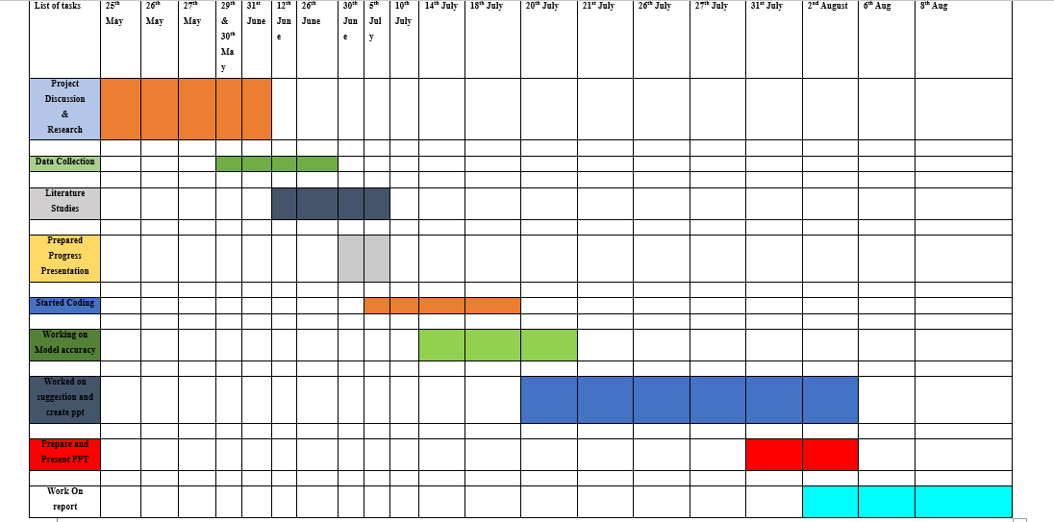

Appendix B – Interim Progress Report and Meeting Records

Discussed Topics | Date
- An introduction session was held for the Project and the team  - Initial review of the project | 25 / 05 / 2023
- Data collection was done.  - A deep literature review was performed. | 31 / 05 / 2023
- A presentation of Research outcomes was done  - Previous reports and works were shared. | 26 / 06 / 2023
- Code should be modified.  - Suggestions were provided to include new parameters. | 05 / 07 / 2023
- Criteria to detect jump and squat were provided.  - Discussed about analysis | 14 / 07 / 2023
- Accuracy of the Ann was discussed  - Suggested to apply regression model. | 20 / 07 / 2023
- A regression and classification models were presented.  - Improvements are suggested | 26 / 07 / 2023
- Meeting with support supervisor Sara  - Suggested to add another process of DWT | 27 / 07 / 2023
- Presentation of PPT | 2 / 08 / 2023
- Meeting with Sara  - We told DWT not possible due to lack of time | 01 / 08 / 2023

Appendix D – Project Presentation
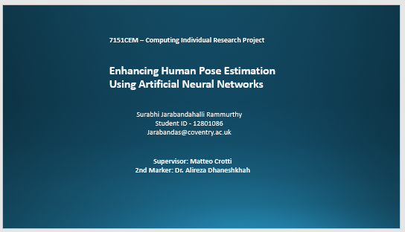
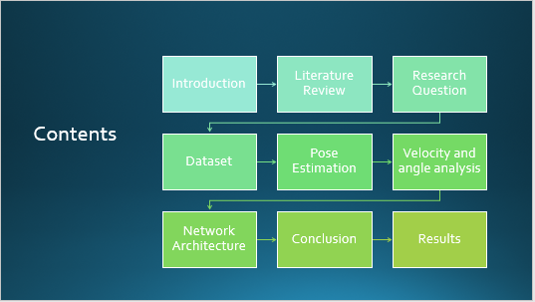

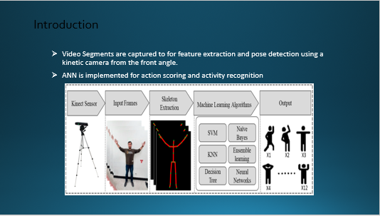

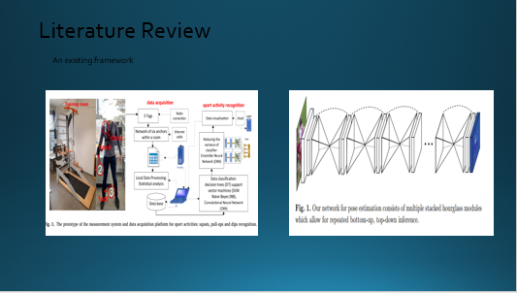

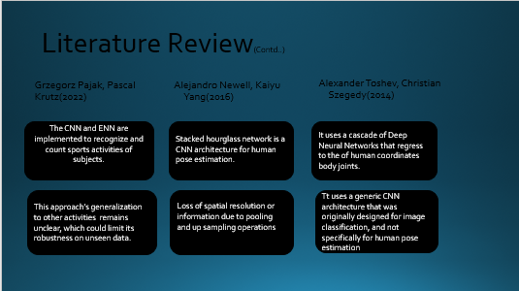

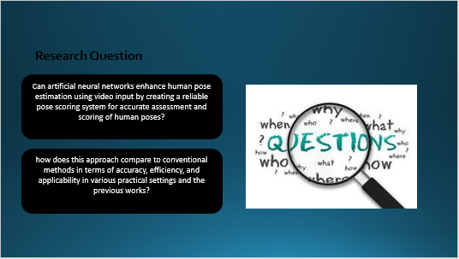

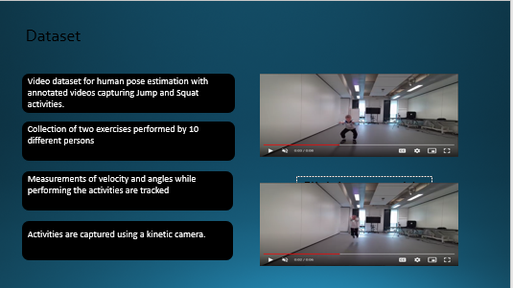

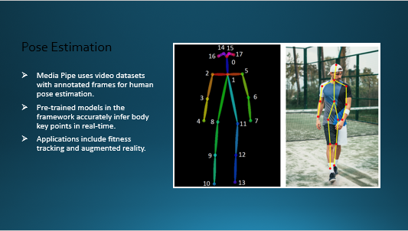

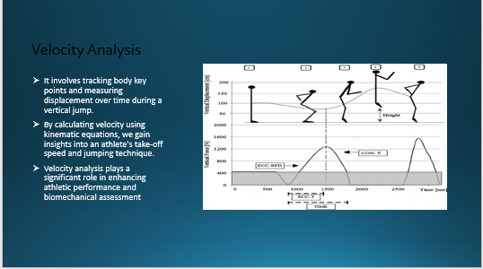

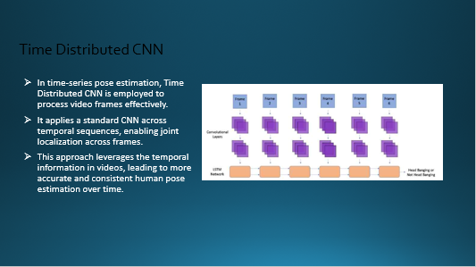

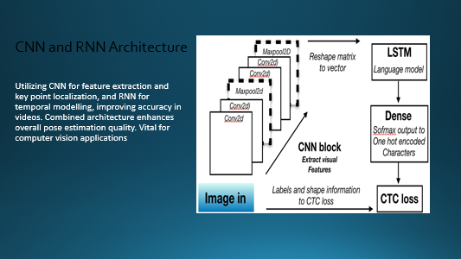

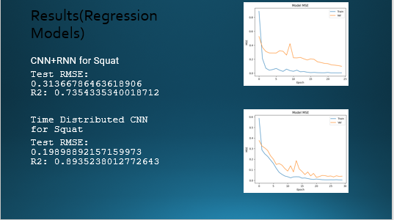

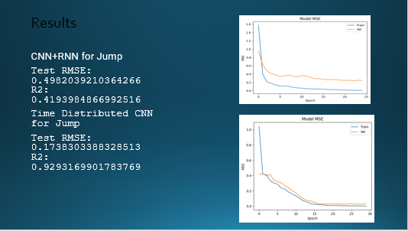

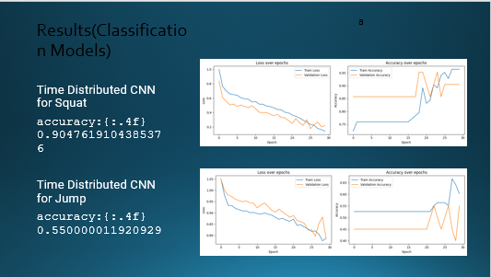

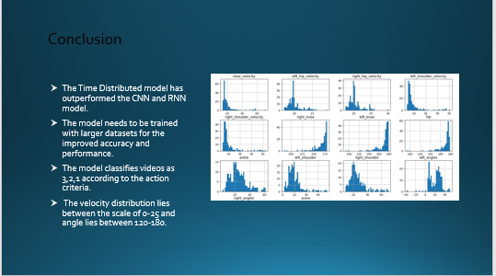



Certificate Of Ethics Approval



