Evaluation tool for weather sensor data

Process to be followed:

1. Take data to be acted upon from mongoDb into json file
2. Pipe the json file to any of the following scripts available for manipulating data

.

1. Input stream( Input_file.sh)

It is responsible for fetching the stored data from any of the 3 sources(NOAA data, Weather underground, Open Weather Map) and then inserting into a json file which act as an input for other scripts.

a) In the script enter the following:

The source - NOAA for NOAA data, OW for Open Weather Map and WU for weather underground

First row id(row_idf) and Last row id(row_idl) - Range of records you want to provide as input

b) Run the script (./input_file.sh)

Input stream of data

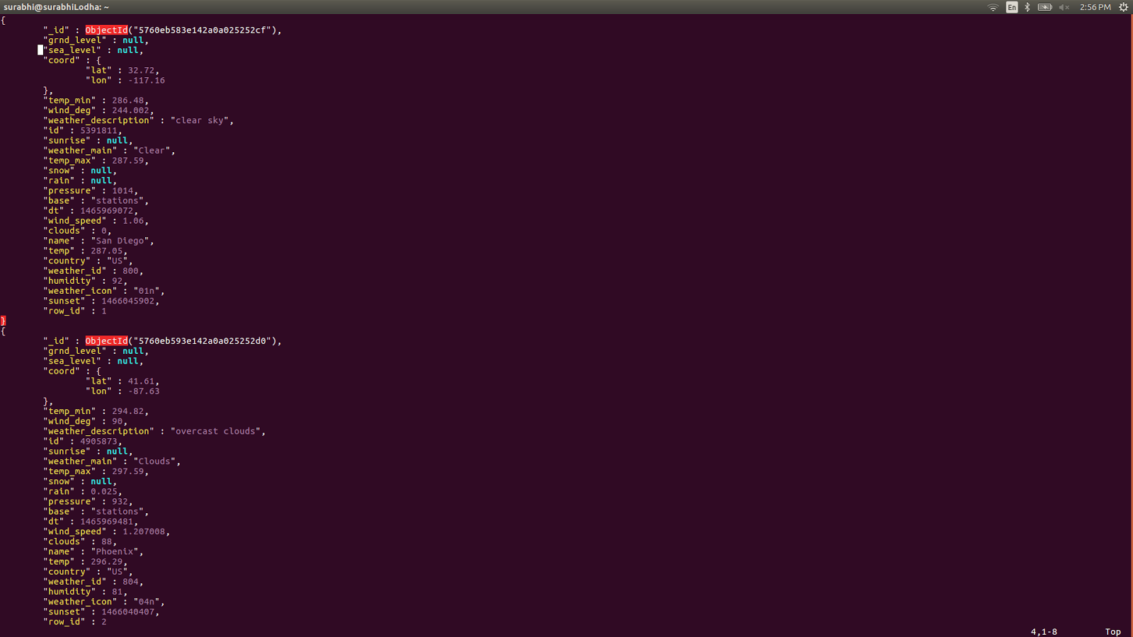

2. Change column names (change_column_name.sh)

Enter the field names whose label you want to swap as input to the script change_column_name.sh. For ex- we need to swap temperature and pressure labels for our Open Weather Map data.

1. We enter the two column names temp(colf) and pressure(coll) in the script
2. Run change_column_names.sh

Input:

|  |
| --- |
| {  "_id" : ObjectId("5760eb663e142a0a025252f6"),  "grnd_level" : null,  "sea_level" : null,  "coord" : {  "lat" : 45.64,  "lon" : -122.66  },  "temp_min" : 279.26,  "wind_deg" : 183.002,  "weather_description" : "light rain",  "id" : 5814616,  "sunrise" : null,  "weather_main" : "Rain",  "temp_max" : 283.15,  "snow" : null,  "rain" : null,  **"pressure" : 1016,**  "base" : "cmc stations",  "dt" : 1465968950,  "wind_speed" : 1.06,  "clouds" : 92,  "name" : "Vancouver",  **"temp" : 281.36,**  "country" : "US",  "weather_id" : 500,  "humidity" : 100,  "weather_icon" : "10n",  "sunset" : 1466049726,  "row_id" : 40  } |

Result:

|  |
| --- |
| {  "_id" : ObjectId("5760eb663e142a0a025252f6"),  "grnd_level" : null,  "sea_level" : null,  "coord" : {  "lat" : 45.64,  "lon" : -122.66  },  "pressure_min" : 279.26,  "wind_deg" : 183.002,  "weather_description" : "light rain",  "id" : 5814616,  "sunrise" : null,  "weather_main" : "Rain",  "pressure_max" : 283.15,  "snow" : null,  "rain" : null,  "temp" : 1016,  "base" : "cmc stations",  "dt" : 1465968950,  "wind_speed" : 1.06,  "clouds" : 92,  "name" : "Vancouver",  "pressure" : 281.36,  "country" : "US",  "weather_id" : 500,  "humidity" : 100,  "weather_icon" : "10n",  "sunset" : 1466049726,  "row_id" : 40  }  ] |

3. Drop column (Drop_column.sh)

Run the script with parameter as the field name you want to delete.

For ex- ./input_file.sh | ./drop_column.sh temp

|  |
| --- |
| [  {  "grnd_level" : null,  "sea_level" : null,  "coord" : {  "lat" : 32.72,  "lon" : -117.16  },  "temp_min" : 286.48,  "wind_deg" : 244.002,  "weather_description" : "clear sky",  "id" : 5391811,  "sunrise" : null,  "weather_main" : "Clear",  "temp_max" : 287.59,  "snow" : null,  "rain" : null,  "pressure" : 1014,  "base" : "stations",  "dt" : 1465969072,  "wind_speed" : 1.06,  "clouds" : 0,  "name" : "San Diego",  "temp" : 287.05,  "country" : "US",  "weather_id" : 800,  "humidity" : 92,  "weather_icon" : "01n",  "sunset" : 1466045902,  "row_id" : 1  }  ] |

Result:

|  |
| --- |
| [  {  "grnd_level": null,  "sea_level": null,  "coord": {  "lat": 32.72,  "lon": -117.16  },  "temp_min": 286.48,  "wind_deg": 244.002,  "weather_description": "clear sky",  "id": 5391811,  "sunrise": null,  "weather_main": "Clear",  "temp_max": 287.59,  "snow": null,  "rain": null,  "pressure": 1014,  "base": "stations",  "dt": 1465969072,  "wind_speed": 1.06,  "clouds": 0,  "name": "San Diego",  "country": "US",  "weather_id": 800,  "humidity": 92,  "weather_icon": "01n",  "sunset": 1466045902,  "row_id": 1  }  ] |

4. Insert null (insert_null.sh)

To insert null value as a value for a particular field, run insert_null.sh with the field name as the parameter.

For ex - ./input_file.sh 1 4 | ./insert_null.sh temp

|  |
| --- |
| [  {  "grnd_level" : null,  "sea_level" : null,  "coord" : {  "lat" : 32.72,  "lon" : -117.16  },  "temp_min" : 286.48,  "wind_deg" : 244.002,  "weather_description" : "clear sky",  "id" : 5391811,  "sunrise" : null,  "weather_main" : "Clear",  "temp_max" : 287.59,  "snow" : null,  "rain" : null,  "pressure" : 1014,  "base" : "stations",  "dt" : 1465969072,  "wind_speed" : 1.06,  "clouds" : 0,  "name" : "San Diego",  "temp" : 287.05,  "country" : "US",  "weather_id" : 800,  "humidity" : 92,  "weather_icon" : "01n",  "sunset" : 1466045902,  "row_id" : 1  }  ] |

Result:

|  |
| --- |
| [  {  "grnd_level": null,  "sea_level": null,  "coord": {  "lat": 32.72,  "lon": -117.16  },  "temp_min": 286.48,  "wind_deg": 244.002,  "weather_description": "clear sky",  "id": 5391811,  "sunrise": null,  "weather_main": "Clear",  "temp_max": 287.59,  "snow": null,  "rain": null,  "pressure": 1014,  "base": "stations",  "dt": 1465969072,  "wind_speed": 1.06,  "clouds": 0,  "name": "San Diego",  "temp": null,  "country": "US",  "weather_id": 800,  "humidity": 92,  "weather_icon": "01n",  "sunset": 1466045902,  "row_id": 1  }  ] |

5. Change unit (./change_unit.sh)

In order to change unit of a particular field run .change_unit.sh with parameters as following:

1. Column name whose unit needs to be changed
2. Conversion function for converting the unit which is defined in conversion_function.sh

Users can define their own conversion function too in the conversion_function library

For ex- we want to convert temperature from Fahrenheit to Celsius. In order to achieve this we will can do ./input_file.sh 1 4 | ./change_units.sh temp temp_Fahrenheit_to_Celsius

Input:

|  |
| --- |
| [  {  "grnd_level" : null,  "sea_level" : null,  "coord" : {  "lat" : 32.72,  "lon" : -117.16  },  "temp_min" : 286.48,  "wind_deg" : 244.002,  "weather_description" : "clear sky",  "id" : 5391811,  "sunrise" : null,  "weather_main" : "Clear",  "temp_max" : 287.59,  "snow" : null,  "rain" : null,  "pressure" : 1014,  "base" : "stations",  "dt" : 1465969072,  "wind_speed" : 1.06,  "clouds" : 0,  "name" : "San Diego",  "temp" : 287.05,  "country" : "US",  "weather_id" : 800,  "humidity" : 92,  "weather_icon" : "01n",  "sunset" : 1466045902,  "row_id" : 1  }  ] |

Result:

|  |
| --- |
| [  {  "grnd_level": null,  "sea_level": null,  "coord": {  "lat": 32.72,  "lon": -117.16  },  "temp_min": 286.48,  "wind_deg": 244.002,  "weather_description": "clear sky",  "id": 5391811,  "sunrise": null,  "weather_main": "Clear",  "temp_max": 287.59,  "snow": null,  "rain": null,  "pressure": 1014,  "base": "stations",  "dt": 1465969072,  "wind_speed": 1.06,  "clouds": 0,  "name": "San Diego",  "temp": 140.27,  "country": "US",  "weather_id": 800,  "humidity": 92,  "weather_icon": "01n",  "sunset": 1466045902,  "row_id": 1  }  ] |

6. Change encoding (change_encoding.sh)

In order to change the encoding of the value of the fields, we can use this function.

It has following parameters.

1. The field name whose encoding needs to be changed
2. The function name used to change the encoding

All the functions are available in encoding_function.sh library. Users can define their own encoding functions too in the library.

For ex - we need to change the date encoding from EPOC to Datetime.

We can do so by running the following command.

../input_file.sh 1 2 | ./change_encoding.sh dt change_epoch_to_date

Input:

|  |
| --- |
| [  {  "grnd_level" : null,  "sea_level" : null,  "coord" : {  "lat" : 32.72,  "lon" : -117.16  },  "temp_min" : 286.48,  "wind_deg" : 244.002,  "weather_description" : "clear sky",  "id" : 5391811,  "sunrise" : null,  "weather_main" : "Clear",  "temp_max" : 287.59,  "snow" : null,  "rain" : null,  "pressure" : 1014,  "base" : "stations",  "dt" : 1465969072,  "wind_speed" : 1.06,  "clouds" : 0,  "name" : "San Diego",  "temp" : 287.05,  "country" : "US",  "weather_id" : 800,  "humidity" : 92,  "weather_icon" : "01n",  "sunset" : 1466045902,  "row_id" : 1  } |

Result:

|  |
| --- |
| [  {  "grnd_level": null,  "sea_level": null,  "coord": {  "lat": 32.72,  "lon": -117.16  },  "temp_min": 286.48,  "wind_deg": 244.002,  "weather_description": "clear sky",  "id": 5391811,  "sunrise": null,  "weather_main": "Clear",  "temp_max": 287.59,  "snow": null,  "rain": null,  "pressure": 1014,  "base": "stations",  "dt": "Wed Jun 15 06:37:52 PDT 2016",  "wind_speed": 1.06,  "clouds": 0,  "name": "San Diego",  "temp": 287.05,  "country": "US",  "weather_id": 800,  "humidity": 92,  "weather_icon": "01n",  "sunset": 1466045902,  "row_id": 1  }  ] |