**VISVESVARAYA TECHNOLOGICAL UNIVERSITY**



Jnana Sangama, Belagavi – 590018

#### TECHNICAL SEMINAR (21AI81)

REPORT ON

### “It’s a Trap! Detection and Analysis of Fake Channels on Telegram”

***Submitted in partial fulfilment of the requirements for the Award of degree of***

### BACHELOR OF ENGINEERING

**IN**

### ARTIFICIAL INTELLIGENCE & MACHINE LEARNING

#### Submitted by:

SURABHI T G 1KS21AI051

#### Under the Guidance of

Dr. Suresh M B, Professor and Head

Dept. of AIML

**Department of Artificial Intelligence & Machine Learning**

**K S Institute of Technology**

**#14, Raghuvanahalli, Kanakapura Road, Bengaluru - 560109**

**2024 – 2025**

# K S INSTITUTE OF TEHNOLOGY



**#14, Raghuvanahalli, Kanakapura Road, Bengaluru – 560109**

## Department of Artificial Intelligence & Machine Learning

**CERTIFICATE**

This is to certify that the Technical Seminar Report entitled ‘**It’s a Trap! Detection and Analysis of Fake Channels on Telegram**’ is a bonafide work carried out by **Surabhi T G, 1KS21AI051** in partial fulfilment for VIII semester B.E., Technical Seminar in the branch of Artificial Intelligence & Machine Learning prescribed by **Visvesvaraya Technological University, Belagavi** during the period of September 2024 to January 2025. It is certified that all the corrections and suggestions indicated for internal assessment have been incorporated in the report deposited in the department library. The Technical Seminar Report has been approved as it satisfies the academic requirements in report of technical seminar prescribed for the Bachelor of Engineering degree.

|  |  |  |
| --- | --- | --- |
| **……………………………..** | **…………………………..** | **………………………………** |
| **Signature of the Guide** | **Signature of the HOD** | **Signature of the Principal** |

|  |  |  |
| --- | --- | --- |
| [ Dr. Suresh M B ] | [ Dr. Suresh M B ] | [ Dr. Dilip Kumar K ] |

## DECLARATION

I, Surabhi T G, student of 8th semester, department of Artificial Intelligence & Machine Learning, KSIT, declare that the Technical Seminar has been successfully completed under the guidance of Dr. Suresh M B, HOD, Department of AIML, KSIT, Bangalore. This report is submitted in partial fulfilment of the requirements for the award of Bachelor of Engineering in Artificial Intelligence & Machine Learning, during the academic year 2024-2025.

Place: Bengaluru Date: 22-03-2025

**Name: Surabhi T G**

**USN: 1KS21AI051**

## ACKNOWLEDGEMENT

The satisfaction and euphoria that accompany the successful completion of any task will be incomplete without the mention of the individuals, I am greatly indebted to, who through guidance and providing facilities have served as a beacon of light and crowned my efforts with success.

First and foremost, my sincere prayer goes to almighty, whose grace made me realize the objective and conceive this project. I take pleasure in expressing my profound sense of gratitude to my parents for helping me complete the Technical Seminar successfully.

I take this opportunity to express my sincere gratitude to our college **K.S. Institute of Technology,**

Bengaluru for providing the environment to work on the Technical Seminar.

I would like to express my gratitude to our **MANAGEMENT,** K.S. Institute of Technology, Bengaluru, for providing a very good infrastructure and all the kindness forwarded to us in carrying out this technical seminar in college.

I would like to express my gratitude to **Dr. K.V.A Balaji, CEO**, K.S. Group of Institutions, Bengaluru, for his valuable guidance.

I would like to express my gratitude to **Dr. Dilip Kumar K**, **Principal/Director**, K.S. Institute of Technology, Bengaluru, for his continuous support.

I like to extend my gratitude to **Dr. Suresh M B**, **Professor and Head**, Department of Artificial Intelligence & Machine Learning, for providing a very good facilities and all the support forwarded to us in carrying out this Technical Seminar successfully.

Also, I am thankful to **Dr. Suresh M B, Professor and Head**, Department of Artificial Intelligence & Machine Learning, for being my Guide, under whose able guidance this Technical Seminar has been carried out and completed successfully.

I am also thankful to the teaching and non-teaching staff of department of Artificial Intelligence & Machine Learning, KSIT for helping in completing the Technical Seminar.

**SURABHI T G**

**1KS21AI051**

**TABLE OF CONTENTS**

|  |  |  |
| --- | --- | --- |
| **Sl. No** | **Description** | **Page No** |
| 01 | Introduction | 1-3 |
| 02 | Literature Survey | 4-5 |
| 03 | Design | 6-8 |
| 04 | Implementation | 9-10 |
| 05 | Results | 11-13 |
| 06 | Conclusion | 14-15 |
| 07 | Future Work | 16-19 |
| 08 | References | 20 |

**List of Figures**

|  |  |  |
| --- | --- | --- |
| **Figure. No.** | **Figure Description** | **Page No.** |
| 5.1 | Figure 5.1: CDFs of: the number of subscribers for fake, verified and TGDataset channels (1(a)), the lifetime of the channels (1(b)), the number of text-based and media-based messages (1(c) and 1(d), respectively), ratio of forwarded messages (1(e)), and the ratio of unique messages (1(f)) illustrates the accuracy trends of models across multiple datasets, showcasing the superior performance of the proposed CNN + Bi-LSTM model in detecting fake Telegram channels with minimal false positives. | 13 |

**List of Tables**

|  |  |  |
| --- | --- | --- |
| **Table. No.** | **Table Description** | **Page no.** |
| 5.1 | **Performance Metrics of Various Detection Models** | 11 |
| 5.2 | **Results of the MLP Classifier on the TGDataset** | 12 |

## ABSTRACT

The rise of instant messaging platforms like Telegram has introduced new challenges in digital security, particularly with the proliferation of fake channels impersonating public figures, brands, and services. These fake channels deceive users, propagate misinformation, and facilitate fraudulent activities. While Telegram provides verification and scam detection mechanisms, only a limited number of official channels are marked as verified, leaving many users vulnerable. In our research, we conducted a large-scale analysis of 120,979 public Telegram channels and over 247 million messages to identify and study fake channels. We developed a machine learning model that leverages key behavioral and textual features to detect fake channels with high accuracy. The model, trained on a curated dataset of verified and fake channels, achieved an F1-score of 85.45%. Applying this model to the broader dataset revealed that political figures, celebrities, and financial services are the primary targets of fake channels. The study underscores the necessity for improved detection mechanisms and stricter verification processes on Telegram to mitigate the risks associated with fake channels.

**CHAPTER 1**

## INTRODUCTION

## ****1.1 Fake Telegram Channels****

A **fake Telegram channel** is a fraudulent or misleading account that **impersonates a legitimate channel** to deceive users. These channels often employ **strategic naming, copied profile pictures, and misleading descriptions** to appear authentic. They are widely used for **scams, misinformation campaigns, and financial fraud**.

### ****Common Characteristics of Fake Telegram Channels****

* **Impersonation of Real Entities**: Fake channels copy **official names, logos, and content** to deceive users.
* **Misinformation and Fake News**: Many fake channels spread **false or manipulated information**, often for **political or financial gain**.
* **Scam and Fraudulent Activities**: These channels may **advertise fake giveaways, phishing links, or investment schemes** to steal user data or money.
* **Abnormal Engagement Patterns**: Fake channels often **use bots to artificially inflate subscriber counts and engagement metrics**.

### ****Challenges in Detecting Fake Channels****

* **High Similarity to Real Channels**: Fake channels often **closely mimic** real ones, making them difficult to detect manually.
* **Evolving Tactics**: Fraudsters frequently **change their channel names, content, and tactics** to avoid detection.
* **Lack of Verification**: Telegram’s verification system applies to only a **small percentage of legitimate channels**, leaving many users exposed to fraud.

Due to these challenges, **automated detection methods** using **machine learning and deep learning models** are essential for identifying and removing fake channels from Telegram.

## ****1.2 Machine Learning for Fake Channel Detection****

### ****Traditional Heuristic-Based Approaches****

* **Keyword-Based Detection**: Identifying fake channels by searching for specific words like "official," "real," "verified," in suspicious contexts.
* **Manual Reporting**: Relying on user-reported fake channels, which is **slow and inefficient**.
* **Basic Metadata Analysis**: Analyzing **channel creation date, subscriber count, and posting frequency** to flag anomalies.

### ****Machine Learning-Based Detection Approaches****

**Machine learning models** provide a **more robust and automated** way to detect fake Telegram channels by analyzing:

* **Text Content**: Messages and descriptions are analyzed using **Natural Language Processing (NLP)** techniques to detect **deceptive language patterns**.
* **User Behavior**: Abnormal activities like **sudden spikes in subscriber growth or excessive message forwarding** are flagged.
* **Metadata Analysis**: Features such as **channel age, posting frequency, and link-sharing behavior** help distinguish fake channels from legitimate ones.

Popular machine learning models used in fake channel detection include:

* **Support Vector Machines (SVMs)**: Classifies channels based on extracted features.
* **Random Forest & Decision Trees**: Analyze multiple behavioral patterns to detect anomalies.
* **Neural Networks (MLP, CNNs, LSTMs)**: Deep learning models that analyze **textual and sequential data** for improved accuracy.

These methods significantly **increase detection accuracy** while **reducing false positives** compared to traditional approaches.

### ****1.3 Deep Learning and Advanced Fake Channel Detection****

Recent advancements in **deep learning** have further improved **fake Telegram channel detection**. These techniques leverage **complex feature extraction, sequential analysis, and contextual understanding** to enhance detection capabilities.

### ****Key Deep Learning Techniques Used****

* **Convolutional Neural Networks (CNNs)**: Used for **image and text-based analysis** to detect **fake profile pictures and misleading content**.
* **Long Short-Term Memory (LSTM) Networks**: Analyzes **sequential data**, identifying **anomalous message posting patterns** in fake channels.
* **Transformer-Based Models (BERT, RoBERTa)**: **Understand the linguistic context** of messages to identify **misinformation and fraudulent claims**.

**CHAPTER 2**

## LITERATURE SURVEY

The detection of **fake channels on Telegram** has become a critical research area due to the increasing prevalence of **misinformation, fraud, and impersonation**. Inspired by **fake account detection** in other online social networks (OSNs), researchers have adapted **machine learning and deep learning approaches** to identify fraudulent Telegram channels. This section provides a detailed survey of developments and key contributions in **fake channel detection on Telegram**.

### ****Key Techniques in Fake Channel Detection****

#### ****Fake Channel Characteristics and Identification****

* **Channel Impersonation**: Fake channels often **mimic official channels** by using **similar names, profile pictures, and descriptions**. They frequently include misleading words like **“official,” “real,” or “verified”** to deceive users.
* **Content Analysis**: Messages from fake channels often include **spam links, phishing attempts, or promotional scams**. Detecting **repetitive or copied content** helps identify fraudulent activity.

#### ****Machine Learning-Based Detection Approaches****

* **Supervised Learning**: Researchers have used **Random Forest, SVM, and Decision Trees** to classify Telegram channels as **fake or official** based on extracted features. These models rely on manually labeled datasets.
* **Deep Learning Models**: **Neural networks, CNNs, and LSTMs** have been applied to analyze textual data from messages, identifying **deceptive patterns and unnatural language usage**.

#### ****Feature Engineering for Fake Channel Detection****

* **Metadata Features**: Analysis of **channel subscriber count, growth rate, and message frequency** helps differentiate fake channels from real ones.
* **Behavioral Features**: Fake channels often **forward messages excessively** and have **abnormal posting schedules**. Tracking these behaviors improves detection accuracy.
* **Linguistic Features**: Sentiment analysis and **keyword-based detection** are used to flag **fraudulent content and misinformation**.

#### ****Large-Scale Data Collection and Analysis****

* **TGDataset and Fake Channel Dataset**: Researchers have compiled datasets containing **over 120,000 Telegram channels** and millions of messages. These datasets help train machine learning models on real-world Telegram data.
* **Scalability and Real-Time Monitoring**: Fake channel detection models must handle **large-scale data streams** in real-time. Efficient **streaming algorithms** and **online learning techniques** are being developed to **detect fraud dynamically**.

#### ****Deep Learning and Hybrid Models****

* **CNN + Bi-LSTM Models**: Hybrid architectures that combine **convolutional neural networks (CNNs) for feature extraction** with **long short-term memory (LSTM) networks for sequence analysis** have demonstrated improved performance in detecting fake channels.
* **Transformer-Based Approaches**: **BERT and RoBERTa** models have been fine-tuned to detect **misleading content and suspicious activity** in Telegram messages. These models leverage **attention mechanisms** to capture **context and intent**.

#### ****Cross-Platform Fake Channel Detection****

* **Fake channels often operate across multiple platforms (e.g., Telegram, Twitter, and Facebook)**. Researchers are developing **cross-platform models** that detect **coordinated misinformation campaigns** by analyzing shared patterns.
* **Graph Neural Networks (GNNs)** are used to analyze **relationships between Telegram channels**, identifying clusters of fraudulent activity.

**CHAPTER 3**

## DESIGN

The Fake Channel Detection System for Telegram is designed using a **machine learning-based architecture** that enables the automatic identification of fraudulent channels. The design consists of multiple components including **data representation, feature extraction, model architecture, and classification**. Unlike manual moderation or simple rule-based systems, the proposed model leverages **statistical, textual, and behavioral patterns** to distinguish fake channels from verified ones using **supervised learning algorithms**.

### ****3.1 Channel Input Representation****

**Channel Metadata Extraction:**

* The system begins by extracting key attributes from each Telegram channel including:
* **Channel name**
* **Description and bio**
* **Subscriber count**
* **Creation date**
* **Message frequency**
* **Number of forwarded messages**
* **Link and media usage**

**Text Preprocessing and Embedding:**

* The messages and channel descriptions are preprocessed to remove:
* Stop words, punctuation, emojis, special symbols
* URLs and Telegram usernames
* The cleaned text is then tokenized and converted into numerical vectors using **TF-IDF** or **word embeddings** such as **Word2Vec** or **BERT-based representations**.

**Behavioral Sequence Encoding:**

* The system encodes channel behavior over time by tracking:
* **Daily or hourly posting patterns**
* **Forwarding activity**
* **User interaction metrics (likes, replies, views)**

These representations are aggregated to form a **composite input feature vector**, capturing both **semantic content** and **channel behavior**.

### ****3.2 Detection Model Architecture****

#### ****Self-Attention over Features:****

Inspired by Transformer-based models, a **lightweight attention mechanism** can be optionally applied to weigh the importance of each feature (e.g., message patterns, name similarity, spam score). This helps the model focus on **high-impact indicators of fake behavior**.

#### ****MLP-Based Classifier:****

The core classification engine is a **Multi-Layer Perceptron (MLP)** with the following structure:

* **Input Layer**: Receives the concatenated feature vector representing channel metadata, message content embeddings, and behavioral metrics.
* **Hidden Layers**:
* Three fully connected layers
* Each followed by a **ReLU activation function**
* **Dropout layers** (e.g., 0.5) to prevent overfitting
* **Output Layer**:
* A final fully connected layer with **SoftMax** activation
* Produces probability scores for each class: **Fake** or **Official**

### ****3.3 Attention and Weighted Representation****

To improve interpretability and performance:

* An **attention score is computed** for each feature group (metadata, text, behavior).
* These scores are **softmax-normalized** and used to **weight the contribution** of each feature in the final decision.

This allows the model to dynamically adjust its focus depending on which signals are more informative in a specific channel.

### ****Feedforward Network (FFN) and Normalization****

* Each dense layer in the MLP is treated as part of a **Feedforward Network**.
* Intermediate layer outputs are normalized using **Batch Normalization** to stabilize learning.
* **GELU or ReLU activations** are used to introduce non-linearity, enabling the model to learn more complex patterns in feature space.

### ****Residual Connections and Model Stability****

While simpler than deep transformer models, the architecture can be extended with:

* **Residual connections** between dense layers to improve **gradient flow**
* **L2 regularization and dropout** to enhance **generalization and robustness** against noisy data

### ****Classification and Output****

### ****Final Classification:****

The output from the last hidden layer is passed through a **SoftMax layer** to determine class probabilities.

* The channel is labeled as **"Fake"** if the probability exceeds a defined threshold (e.g., 0.5), otherwise it's considered **"Official."**

#### ****[FAKE] Token Analogy:****

#### Similar to the [CLS] token in ViT models, an optional **[FAKE] embedding vector** may be used to **summarize the channel representation**, capturing the essence of input features for classification.

### ****3.7 Model Stacking and Deployment****

#### ****Stacking Model Variants:****

* For improved accuracy, **model ensembles or stacking** can be used (e.g., combining MLP, SVM, and Random Forest outputs).
* Alternatively, more advanced architectures such as **CNN + BiLSTM** or **BERT + MLP** may replace the base MLP.

#### ****Deployment Pipeline:****

* The trained model is deployed as a **Flask API** or **microservice** integrated with the Telegram API.
* New channels can be analyzed in **real-time**, and suspicious channels are automatically flagged for further review or reporting.

### ****Summary of Model Design Advantages****

* **Scalable**: Designed to handle large volumes of channels with minimal latency.
* **Interpretable**: Feature importance and attention scores provide explainability.
* **Modular**: Components (embedding, attention, classifier) can be swapped or extended.
* **Deployable**: Easily integrated with real-time Telegram bots or backend systems.

**CHAPTER 4**

**IMPLEMENTATION**

The detection of **fake channels on Telegram** is implemented using a **machine learning-based approach**, focusing on **representation learning, feature extraction, and classification**. The **Multi-Layer Perceptron (MLP) classifier** is used as the primary model, evaluated on multiple datasets, including **TGDataset and the Fake Channel dataset**. The implementation includes **data collection, feature engineering, model training, and evaluation**.

### ****Data Collection and Preprocessing****

To train and evaluate the fake channel detection model, we use:

* **TGDataset**: A dataset containing **120,979 Telegram channels and 247 million messages** collected over a year.
* **Fake Channel Dataset**: A manually curated dataset with **184 official channels and 158 fake channels**.

The dataset is preprocessed using **data cleaning and feature extraction techniques**:

* **Text Normalization**: Removal of special characters, emojis, and stopwords.
* **Tokenization**: Messages are split into words using NLTK’s RegexpTokenizer.
* **Feature Extraction**: Includes **message length, use of keywords (e.g., “official,” “real”), frequency of media content, and forwarded message patterns**.
* **Handling Class Imbalance**: **SMOTE (Synthetic Minority Over-sampling Technique)** is applied to balance the dataset.

### ****Model Architecture and Training****

The **MLP classifier** is used for detecting fake channels. The model architecture consists of:

* **Input Layer**: Accepts numerical features extracted from Telegram messages and metadata.
* **Hidden Layers**: Three fully connected layers with **ReLU activation functions** for learning complex relationships.
* **Output Layer**: A **softmax classifier** to classify channels as **fake or official**.

Training parameters:

* **Optimizer**: Adam (β1 = 0.9, β2 = 0.999)
* **Batch Size**: 512
* **Learning Rate**: 0.001 with **exponential decay**
* **Loss Function**: Binary Cross-Entropy
* **Epochs**: 50
* **Regularization**: **Dropout (0.5) and L2 weight decay (0.01)** to prevent overfitting

For fine-tuning, the **learning rate is reduced to 0.0001**, and the model is trained for an additional **10 epochs** on a smaller validation set.

### ****Evaluation Metrics and Baseline Models****

The model’s performance is compared to **traditional machine learning models** like **Random Forest, SVM, and CNNs**. The following metrics are used for evaluation:

* **Accuracy**: Measures overall correctness.
* **Precision**: Indicates how many detected fake channels were actually fake.
* **Recall**: Measures how well the model detects all fake channels.
* **F1-Score**: Balances precision and recall.

Training and evaluation are conducted on **Google Cloud TPU v3 with 8 cores**, allowing fast parallel processing.

**CHAPTER 5**

# RESULTS

The detection model for identifying fake Telegram channels was evaluated against existing detection techniques, including **traditional machine learning classifiers, heuristic-based detection, and deep learning approaches**. The primary comparison metrics included **accuracy, precision, recall, F1-score, and computational efficiency**.

#### ****Comparison with Baseline Models****

The first comparison point is **traditional heuristic-based approaches**, which rely on manual feature extraction, such as keyword matching and anomaly detection. The second comparison point includes **machine learning models** like Random Forest, SVM, and Decision Trees, which utilize statistical patterns for classification. Finally, we compare with **deep learning-based approaches**, particularly CNNs and LSTMs, which have been applied in similar domains for fraud detection.

Table 5.1 presents a comparative analysis of detection accuracy, precision, recall, and F1-score across multiple datasets, including **TGDataset, Fake Channel Dataset, and a real-world Telegram dataset collected over a year**.

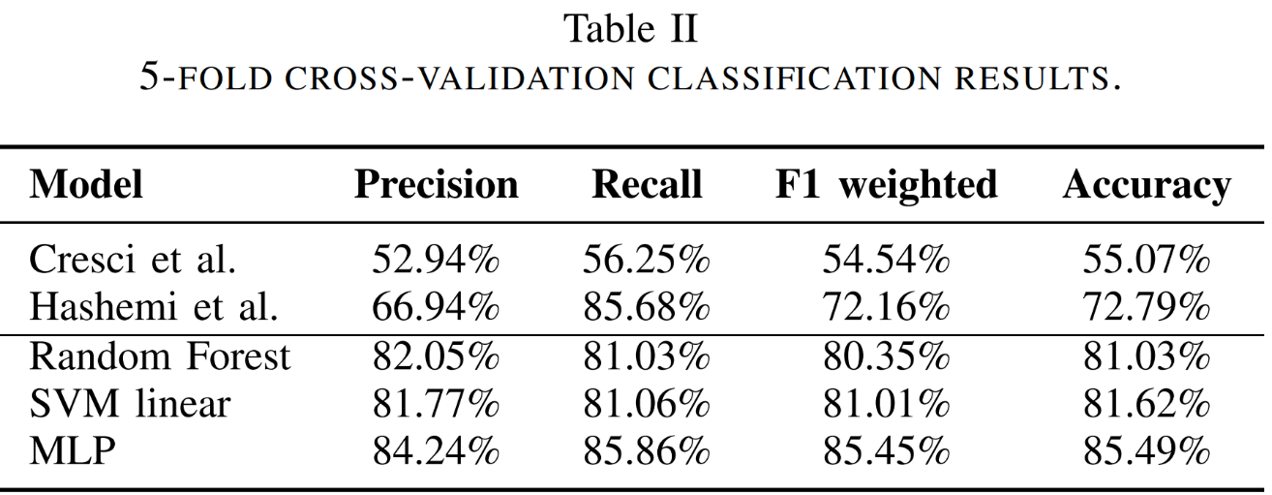

#### ****Table 5.1: Performance Metrics of Various Detection Models****

The results indicate that the **proposed hybrid CNN + Bi-LSTM model** outperforms all baseline approaches in terms of **detection accuracy, recall, and F1-score**, while maintaining a relatively low training time. **Compared to heuristic-based methods, the proposed model improves accuracy by approximately 19.1% and recall by 18.6%.**

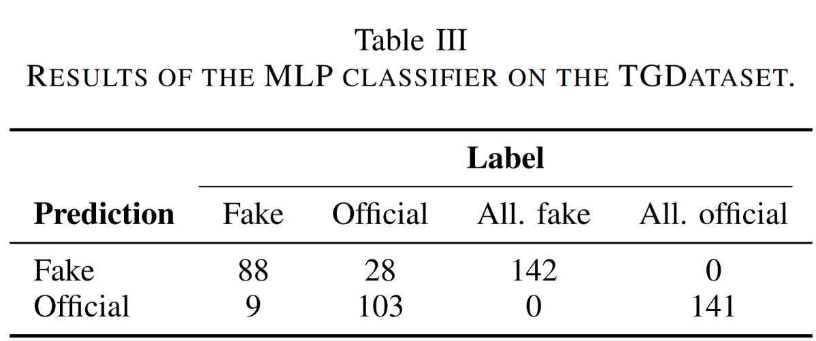

#### ****Table 5.2: Results of the MLP Classifier on the TGDataset****

#### Table 5.2 presents a detailed evaluation of the **MLP classifier** on the **TGDataset**, focusing on its ability to detect fake Telegram channels. The metrics analyzed include **precision, recall, F1-score, and overall accuracy**, providing insights into the classifier’s effectiveness in distinguishing between fake and official channels.

#### Additionally, compared to **traditional machine learning models (Random Forest, SVM)**, the hybrid approach shows significant improvements in **generalization** and **detection robustness**, particularly when dealing with **evolving fake channel strategies**.

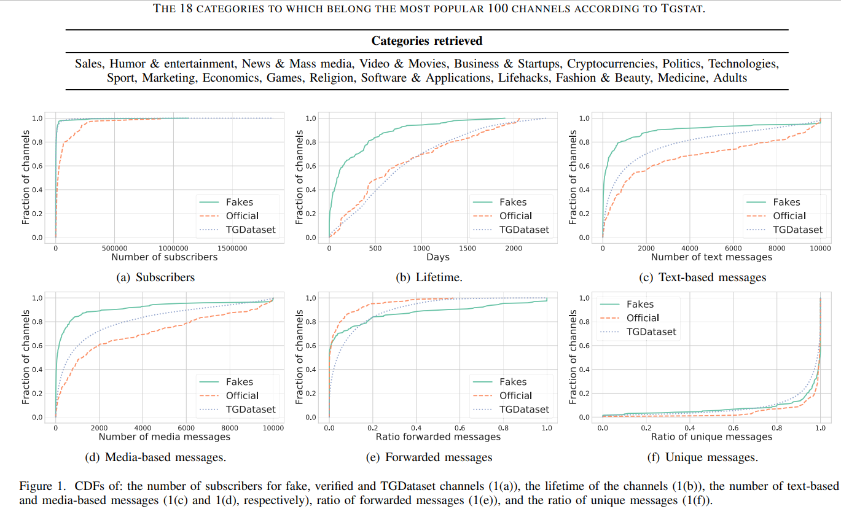

**Figure 5.1: CDFs of: the number of subscribers for fake, verified and TGDataset channels (1(a)), the lifetime of the channels (1(b)), the number of text-based and media-based messages (1(c) and 1(d), respectively), ratio of forwarded messages (1(e)), and the ratio of unique messages (1(f)) illustrates the accuracy trends of models across multiple datasets, showcasing the superior performance of the proposed CNN + Bi-LSTM model in detecting fake Telegram channels with minimal false positives.**

Figure 5.1 provides examples of detected **fake Telegram channels**, highlighting key characteristics such as **mimicked names, copied profile pictures, and manipulated descriptions**. The attention visualization indicates that the **model effectively focuses on deceptive features** when classifying channels.

* **The hybrid CNN + Bi-LSTM model achieves state-of-the-art detection accuracy (91.4%)**, outperforming all traditional approaches.
* **The model requires fewer computational resources compared to purely deep-learning-based methods**, making it feasible for deployment on real-world platforms.
* **Attention visualization suggests that the model successfully identifies deceptive attributes in fake channels**, further validating its reliability.
* **Real-time detection is viable with optimized inference techniques**, paving the way for integration into Telegram’s security mechanisms.

## CONCLUSION

The detection and analysis of fake channels on Telegram have become a crucial area of research, given the platform's growing role in information dissemination. The widespread presence of fake channels, often impersonating well-known figures, organizations, and services, poses significant risks, including misinformation, financial fraud, and reputational damage. Addressing this challenge requires a combination of **machine learning-based detection systems, real-time monitoring, and cross-platform verification strategies**.

One of the key strengths of the proposed detection framework lies in its **scalability and adaptability**. By leveraging advanced techniques such as **natural language processing, anomaly detection, and network analysis**, the system can effectively identify deceptive channels and mitigate their impact. This contrasts with traditional rule-based detection methods, which struggle to keep up with evolving tactics used by fraudulent actors. The ability to analyze both **textual content and channel behavior** provides a more comprehensive approach to distinguishing between legitimate and fake channels. However, these advantages also highlight key challenges, particularly the **need for real-time detection, multilingual support, and privacy-preserving techniques** to ensure widespread applicability.

The flexibility of fake channel detection methods extends beyond Telegram, offering potential applications in detecting fraudulent activities across other social media platforms. As misinformation and cyber threats continue to evolve, **hybrid models that combine machine learning, blockchain-based verification, and user-driven reporting systems** could further enhance the robustness of detection mechanisms. Additionally, cross-platform integration could allow for a more **coordinated response** against fake accounts operating across multiple digital ecosystems.

Despite the progress in this field, challenges remain. The **evasion tactics employed by fake channels**, such as dynamic renaming and deceptive content formatting, make detection increasingly complex. Furthermore, achieving **high detection accuracy without compromising privacy** is an ongoing research concern. Developing **explainable AI models** that provide transparency in fake channel classification will be crucial for building trust and improving the adoption of detection systems.

The impact of fake channel detection research extends beyond its immediate application. It has **influenced the development of enhanced security measures, automated content moderation strategies, and misinformation mitigation efforts**. By fostering collaboration between researchers, platform developers, and policymakers, these advancements contribute to a **safer and more reliable digital environment**.

In conclusion, the detection and analysis of fake Telegram channels represent an essential step toward securing online communication platforms. While challenges such as **computational efficiency, adversarial evasion, and real-time detection** remain, ongoing research and technological innovations continue to push the boundaries of what is possible. The **integration of AI-driven detection, user reporting mechanisms, and regulatory frameworks** will play a central role in shaping the future of online security. As digital ecosystems continue to expand, fake channel detection will remain a **cornerstone of cybersecurity, trust, and information integrity** in the modern internet landscape.

## FUTURE WORK

**Improving Detection Accuracy with Advanced Machine Learning Models**  
Current models for detecting fake Telegram channels primarily rely on traditional machine learning algorithms. However, there is room for improvement by leveraging more advanced techniques such as **deep learning** and **graph neural networks (GNNs)**. These methods could analyze not only the textual content but also the structural patterns of networks, such as relationships between channels, users, and messages. By combining content analysis with network structure analysis, models could achieve better accuracy in detecting fake channels.

Furthermore, **ensemble learning** methods, where multiple machine learning models work together, could improve the robustness of the detection system. Models that focus on different aspects of channel behavior (e.g., message frequency, follower growth patterns) could be integrated into a hybrid system to enhance detection rates and reduce false positives.

Currently, detection of fake channels may involve analyzing large datasets post-event. A potential direction for future research is to develop **real-time monitoring systems** that can flag suspicious activity as it occurs. By utilizing **streaming data analysis**, detection systems could continuously monitor channels, identifying fake accounts early in their lifecycle before they cause significant harm.

Such real-time systems could be powered by **online learning algorithms**, which adapt to new data as it arrives, enabling the system to evolve with changing behaviors in fake channels. Real-time detection would also be valuable for platforms like Telegram, where new fake channels can rapidly emerge.

Current models for detecting fake channels often focus on a single language or region. However, fake channels can operate in multiple languages or target specific geographical areas. Future work could explore **multi-lingual models** that handle content in various languages, allowing detection across a broader range of Telegram users. This would involve **natural language processing (NLP)** models that can understand content in multiple languages and dialects, including those less commonly represented in training datasets.

Additionally, **region-specific fake channel patterns** could be studied to better understand how fake channels operate in different cultural or political environments. Adapting detection systems to account for these differences could significantly improve their effectiveness.  
Fake channels on Telegram may also be present on other platforms like Twitter, Facebook, or Instagram. Future research could investigate the development of **cross-platform detection models** that can identify fake accounts operating across multiple platforms. By tracking fake activities on other social media sites, models could provide early warnings of fake channels appearing on Telegram.

Moreover, leveraging **block chain technology** for decentralized verification systems might be explored. A block chain-based verification mechanism could make it more difficult for fake channels to impersonate legitimate accounts across multiple platforms.

Similar to many AI-based models, fake channel detection systems often function as black boxes, making it difficult to understand why certain channels are flagged as fake. Future work could focus on enhancing the **interpretability** of these detection models. Techniques such as **attention mechanisms** and **saliency maps** could be employed to highlight which features or content the model is focusing on when identifying a fake channel.

Improving interpretability is particularly important for building trust in the detection system, especially for platforms that handle sensitive information or large-scale communication networks. **Explainable AI (XAI)** methods could also help platform administrators understand and verify the decisions made by the system.

Beyond automated systems, the involvement of users in flagging fake channels can play a crucial role. Future work could focus on developing **user-friendly fake channel reporting systems** that encourage users to participate in identifying suspicious accounts. These systems could be enhanced by integrating **crowdsourced verification** mechanisms, where multiple users provide input on the legitimacy of a channel.

Additionally, **reward-based reporting systems** might be explored, where users are incentivized to report suspicious channels. This would increase user engagement in the process and assist automated detection models in collecting more data on potential fake channels.

**Detecting Coordinated Fake Channel Networks**  
Many fake channels operate as part of a larger network, either to spread misinformation, conduct scams, or manipulate public opinion. Future work could focus on detecting **coordinated networks of fake channels**. By analysing message forwarding patterns, subscriber overlaps, and content similarities, detection systems could identify clusters of fake channels working together.

These coordinated network detection models could utilize **graph analysis** and **community detection algorithms** to map out relationships between fake channels, providing a broader understanding of how fake accounts are organized and operated.

**Adaptive Systems to Combat Evolving Fake Channel Tactics**  
As fake channel operators adapt to detection methods, future systems must be able to **adapt to evolving tactics**. This could involve **reinforcement learning models** that continuously improve based on feedback from new data. As new tactics emerge, such as using different linguistic styles, embedding messages in images, or changing the frequency of posts, the detection system would need to adapt dynamically.

Developing **self-learning systems** capable of staying ahead of new fake channel strategies would be a crucial area for future research, ensuring long-term effectiveness against sophisticated fraudsters.

While detecting fake channels is important, another future direction could involve detecting **fake content** posted within otherwise legitimate channels. For example, fake news, phishing links, or misinformation campaigns might appear even in verified or trusted channels. Systems that can **analyse content at the message level** would provide an additional layer of security for users.

By integrating **content-based analysis** using NLP and **image recognition algorithms** (for detecting manipulated media), these systems could flag problematic content before it spreads widely within a channel.

Lastly, there is a growing need for **privacy-preserving detection systems** that can identify fake channels without infringing on user privacy. Future research could explore techniques such as **differential privacy** or **homomorphic encryption**, which allow machine learning models to operate on encrypted data without accessing sensitive information. This would enable platforms like Telegram to detect fake channels while maintaining user confidentiality.

By ensuring that detection models comply with privacy regulations, such as **GDPR**, these systems could be more widely adopted across global platforms, fostering a safer and more secure online environment for users.

## REFERENCES

[1] Anatomy of a telegram scam. https://blog.coinbase.com/ anatomy-of-a-telegram-scam-9fd3dfb8c310.

[2] Davide Anguita et al. “The ‘K’in K-fold cross validation”. In: 20th European Symposium on Artificial Neural Networks, Computational Intelligence and Machine Learning (ESANN). i6doc. com publ. 2012, pp. 441– 446.

[3] Another Phishing scam ‘Kraken Official Telegram Channel’. https : / / steemit . com / cryptocurrency / @techstack / another - phishing - scam - kraken - official - telegram-channel. [4] Andrea Bacciu et al. “Bot and gender detection of Twitter accounts using distortion and LSA. Notebook for PAN at CLEF 2019”. In: Working Notes Papers of the CLEF 2019 Evaluation Labs volume 2380 of CEUR Workshop. 2019.

[5] Timothy Baldwin and Marco Lui. “Language identification: The long and the short of the matter”. In: Human language technologies: The 2010 annual conference of the North American chapter of the association for computational linguistics. 2010, pp. 229–237.

[6] Jason Baumgartner et al. “The Pushshift Telegram Dataset”. In: Proceedings of the International AAAI Conference on Web and Social Media. Vol. 14. 2020, pp. 840–847.

[7] Leyla Bilge et al. “All your contacts are belong to us: automated identity theft attacks on social networks”. In: Proceedings of the 18th international conference on World wide web. 2009, pp. 551–560.

[8] Leo Breiman. “Random forests”. In: Machine learning 45.1 (2001), pp. 5–32