**MODERN AGRICULTURE ASSISTANCE SYSTEM FOR FARMERS: WEB APPLICATION**

**Abstract**

Modern agriculture system requires modern way to get assistance. The use of internet has increased, and farmers are also looking for solution to their problems online. Also, for good farming assistance, farmers need weather forecast as well. Web Application based on PHP and MySQL. Farmers can now check daily Mandi rates to sell the products. Farmers can ask for help if needed. With advancement in technology, use of information technology in the field of agriculture has become mandatory different reasons.

Agriculture is a top priority in India but today people engaged in agriculture are from lower class and face many problems in their daily life due to extreme poverty. In India, about 15% of GDP (good domestic product) comes from agriculture, but these jobs employ 50% of our working population. Income generation is one of the biggest causes of farmer suicides in India. Lack of awareness of modern technology or advanced techniques leads to farm poverty, although farmers work hard and produce by farmers, in today's market, farmers are forced by agents, which leads to poverty. The role of the middleman in marketing the agricultural product must be removed to ensure direct sales between farmers and customers. The study shows changes in consumer preferences in India when it comes to food choices. Currently several organizations are selling fresh fruits and vegetables and people in India prefer to buy them through online websites, Farmeeco plays a significant role in predicting the outcome of these digital fruit and vegetable markets. This will talk about information regarding Farmeeco, their previous works, software and tools adopted by the company to manage their online applications, as well as their marketing strategies. Keywords: Farmeeco, Fruit And Vegetable, Marketing, Smart Farm, Website.

INTRODUCTION

Modern life is necessary at this point. In our nation, farmers often harvest using the weather and meteorological information. Crops and plants. But today, everyone may access all agricultural information thanks to technology. In Bangladesh today, smart systems and innovative technologies are widely used. Large and small farmers are receiving newer, more precise equipment for less and more productivity as a result of recent technology advancements and its marketing. Fortunately, technological breakthroughs are helping farmers all across the world produce more food and sell it for much less money. Opportunities for more accurate farming can boost output and revenue while using less expensive water and fertilizers. Therefore, we think that "Smart Farming System" will help contemporary, scientific farming develop. In conclusion, this system will support farmers by providing a single platform for all smart ways to integrate farming.

It requires talent to cultivate. A farmer has to be aware of the best times to sow, irrigate, fertilize, and harvest. Additionally, they must understand how to safeguard us against pesticides and post-harvest harvesting. In the past, when there were a variety of pathogens in the crops that were grown on land during the farming season but there was no effective way to protect the crops from those diseases, farmers would go to the pesticides merchants in the market, and they would always recommend starting with primary medication and most of them. As a result, crop loss occurs most frequently as a result of improper treatment that is delayed. After examining these concerns, we began working on the "Smart Farming System" online web application, which was mostly developed from all those

Fortunately, modern technology is helping farmers all across the world produce more food and work together to sell it for a far more affordable price.

Through the smart farming system, we can quickly resolve many of these issues. The Smart Farming System initiative is crucial in helping farmers diagnose their crops early.

* The Doctor's Directory system makes it simple for farmers to get in touch with agricultural specialists.
* By creating an account on our smart farming system website, anyone may ask any question they have about agriculture at any time.
* If farmers register on the "Smart Farming System" website, the Agriculture Consultant or any other registered member will be able to help them with their issues.
* Blogs on a range of agricultural topics are available to everyone for the benefit of farmers. Farmers will have access to the Disease Prediction Blog's information to identify various

The Disease Prediction Blog will enable farmers to recognize various diseases on their own crops. Farmers who want guidance on their farming practices can simply get in touch with agricultural advisors. Additionally, Bangladeshi agricultural students can sign up on our platform to work as freelancers. This will provide a solution to their unemployment issues.

**Motivation**

Seeing the ongoing condition of farmers, it was found out that; problems need modern way of solving. Advancing in information technology has changed the way of doing business, way of communication. So why not to use the modern way to solve the problem which has been existing since really long in Agriculture Sector. Farmer should be able to contact the expert & get the suggestions from them on specific topic. Farmers should also be able to see weather forecast which would help farmers to make better decisions to get maximum yield from their field. Because, Farmers are the feeder, so they deserve something better.

**Problem Statement**

For farmers getting to know the real time rate of Mandi daily is difficult. It is very difficult for farmers to communicate with experts because there would be no expert available in remote areas. Also, farmers always suffer due to unwanted rain, or dryness. They won’t have access to weather forecast. Due to this every year, there’s increase in price due to which common citizen suffer. Also, thousands of farmers do suicide, because they can’t pay their loans, which they are supposed to pay after selling their crops. But, lack of proper idea on farming and other things, and unaware of weather and other circumstances farmers aren’t able to grow crops as expected. Selling and buying of agriculture related products is one of the challenge for farmers.

**Objective & Scope**

Primary objective of the system is to help farmers to communicate with experts whenever they have any issues, also farmers should be able to enter the result of the soil test in system and get the meaning behind it with suggested crops.

The objective of the designed system aims the following five points:

• Affordable: The systems must be affordable as the price is one of the main factors that kept on mind during design phase.

• Portable: The systems to be portable and easy use, this web app can be accessed through Phone as well.

• Safe: The safety of the system is achieved by making the system live on AWS.

• Fast: The response time of the server should be quick; farmers would be in remote location where internet speed would be very less.

• Accurate: The system must be accurate; therefore, the most accurate algorithms have been chosen.

**Scope**

The system can be used in any remote location and could be applicable at any location. Mostly implementing the system in district wise level would help. Most of the district have agriculture department, so this could be implemented in that level to help farmers.

**Methodology**

The Proposed System differs from existing technology where the area of specialization is taken into consideration to overcome drawback of existing system. With the proposed system, Farming Assistance with a web application and upload that record on web server. Farmers to post the queries they have, and experts to respond them. Farmers can also see the weather forecast, and other aspects of it.

Farmers would be able to sell or buy products required. Communication with expert is now easier moreover making it as a web application has increased the efficiency.

Use of HTML, CSS and JavaScript with php and MySQL has increased the feasibility.

**SYSTEM DESIGN**

Process in which device is implemented using different methodologies and design principles is referred as system design.

**Definitions, Acronyms and Abbreviations**

CFD - Context Flow Diagram

ER - Entity Relationship Diagram

UI - User Interface

DFD- Data Flow Diagram

**Design considerations**

**Assumptions and dependencies**

* All the fields must be entered in the prescribed format.
* All the mandatory field’s needs to be filled.
* Proper internet connection is required.
* GUI designed is very easy for the end users to understand and use.
* In case of any error the application should display proper error messages

**Development methods**

* MYSQL serve is used as back end.
* HTML, MySQL, CSS, Bootstrap, JavaScript are used to develop this application

**System perspective**

The entire system is divided in to small parts known as Architecture design. These subsystems provide particular services. The architectural design is basically a framework of the system that control and communicate. 3-tier architecture is also called as n-tier architecture.

The Three Tier architecture is given below:

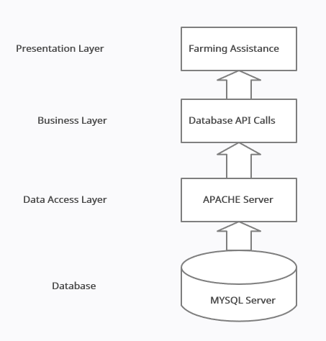

**Fig-Architectural Design for farming assistance**

**Context flow diagram**

A context flow diagram defines the high-level process of application along with various system boundaries, sub parts and environments. It comprises the function of the whole system in association with external entities. The external entities are data stores, system, organizational groups etc.

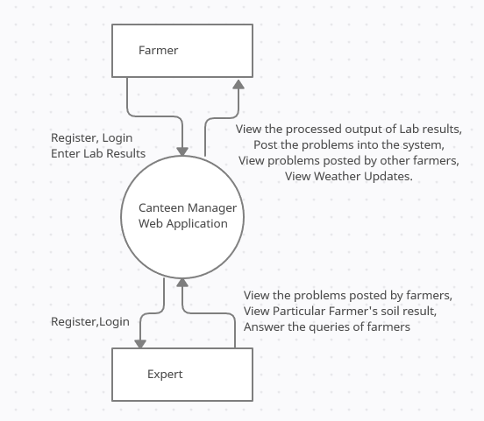

**Fig: CFD for Farming Assistance**

**Data flow diagram**

DFD shows flow of data in entire system. It is a graphical representation of the system. Represents the multiple levels that are crystal clear. I t shows what data flows in and out of the system. And where exactly the data is stored.

**Level 1.1: Farmer**

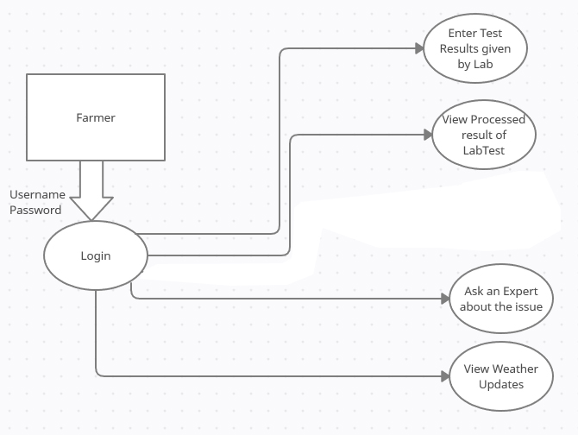

**Fig: DFD for Farming Assistance**

**Level 1.2: Expert**

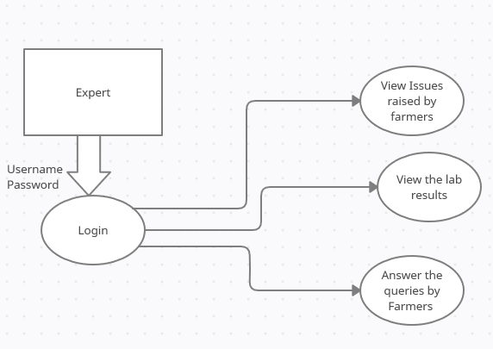

**Fig: DFD for Expert**

**DETAILED DESIGN**

Detail design is the final phase of design where the plans are refined and the execution cost is estimated before the actual software is developed or implemented.

**Use case diagram**

Use case diagram depict how different users interact or communicate with the system.

**Symbols and notations used:**

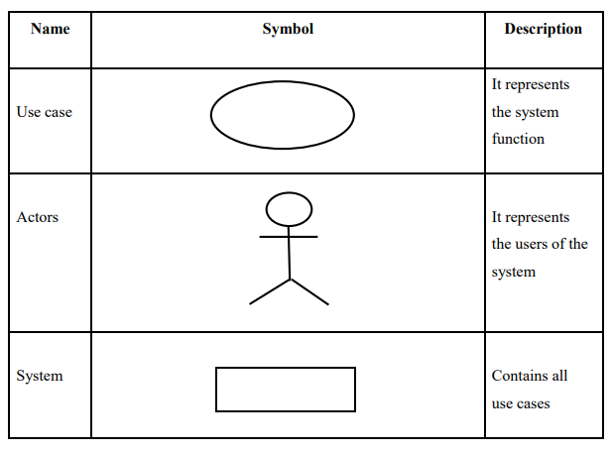

**Use Case Diagram**

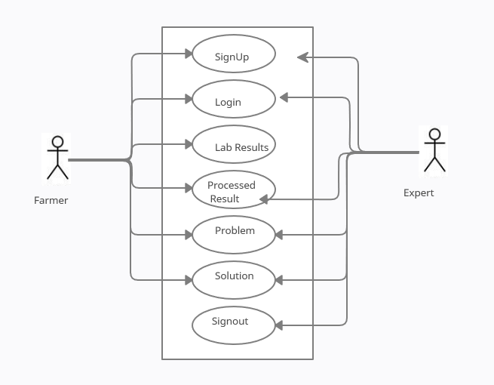

**Fig: Use Case Diagram**

**USE CASES**

**● Signup**

Customer needs to sign up by providing details.

**● Login**

All the users need to authenticate themselves by giving username and password.

**● Lab results**

After login Farmer has to enter Lab results.

**● Processed Results**

The data submitted by farmer will be processed and shown in tabular format as processed results with suggestions.

**● Problems or Queries**

Farmers post the queries and problems they have and get answered by experts.

**● Solutions**

Farmers get to the see the solutions provided for other problems posted by other farmers and solution posted by Expert as well.

**● Sign-out**

Once done with the use of system, logout.

**Sequence diagram**

Display the series of communication that takes place between the different parts of a system in a use case against a timeline success. These diagrams are helpful where the timing relationships between interactions are important.

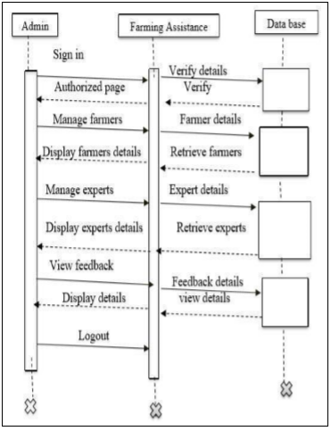

Fig: Sequence Diagram for admin

Fig-Shows the tasks performed by the Admin. At first Admin login to the application and then he can add, edit expert’s details. Admin can also view feedback submitted by farmers and farmer details.

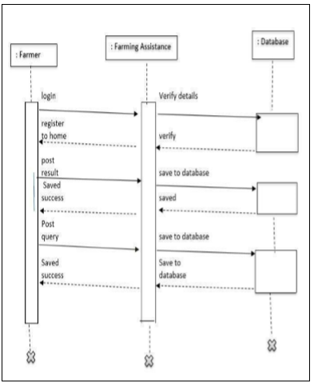

Fig: Sequence Diagram for farmer

Fig-shows the tasks performed by the Farmer. At first farmer needs to sign up by providing details. Later he/she can login to the application and then he can enter the lab result and can post queries about crops. Farmer can also chat with experts

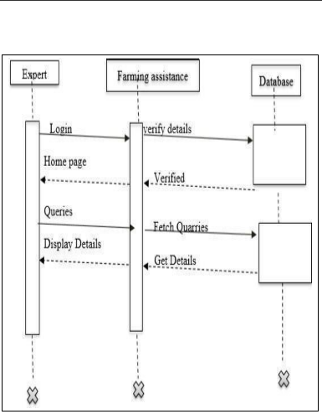

Fig: Sequence Diagram for expert

Fig-shows the tasks performed by the Experts. At first experts needs to sign up by providing details. Later he/she can login to the application. Expert can view the lab report posted by farmers. Expert can give suggestions to the farmer**.**

**Activity diagrams**

Similar to flowchart that depict flow of control from operations to operation and is represented from a particular start point to end point

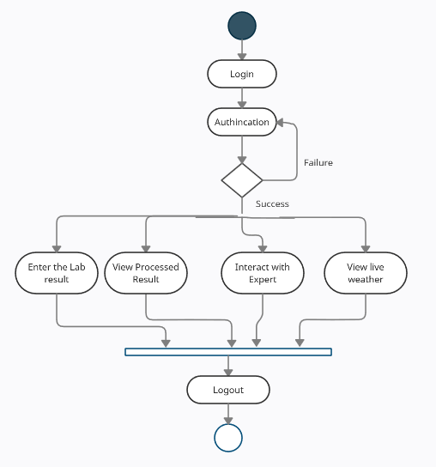

**Fig-Farmer activity**

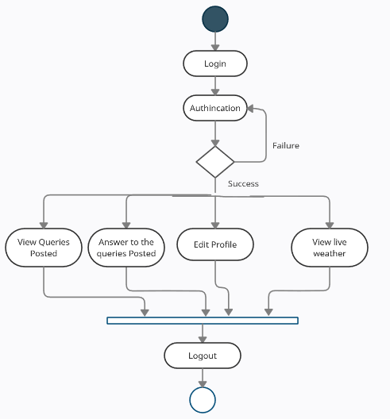

**Fig-Expert Activity**

**Database Design**

**ER Diagram**

It depicts the relationship between various entities of a data model.it is nothing but a high-level structure of a database with relationships. Various notations are used to denote the different types of information in entity-relationship diagram.

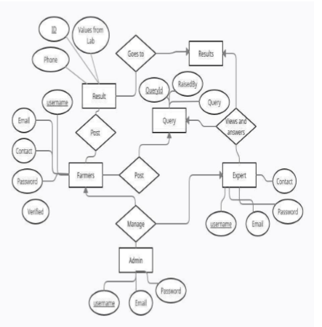

**Data Dictionary**

Data base is a container that holds the data for the application. Database is made up tables. Eleven tables present in the system are as follows

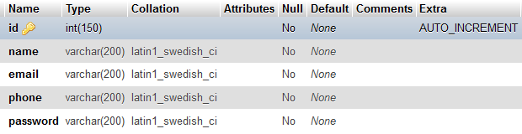

Fig-User/ farmer Table

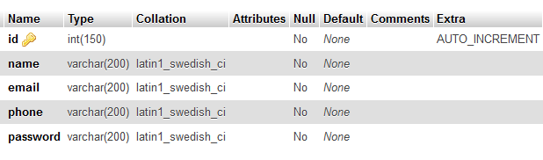

Fig-Expert Table

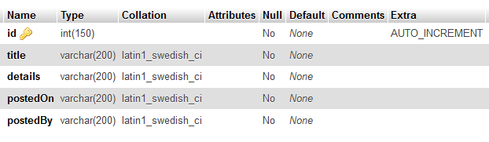Fig- Problem Posted Table

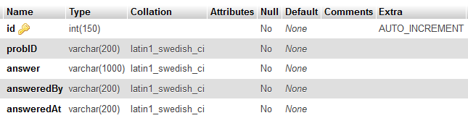

Solutions

**IMPLEMENTATION**

**Modules Description**

The proposed project has following 7 modules.

They are:

• Login module

• Sign up module

• Post Lab result

• Processed Result

• Interaction

• Weather Update

**Login module:**

User needs to login through the credentials, for opening the application.

On Successful login he/she will be redirected to the respective home pages based on the user role.

User can select different options and traverse through the app.

Pseudo code:

Enter login credentials

If Correct

Redirect to home page

Else

Display Error Message

**Sign up module:**

User/ Farmers and Experts registers on site.

If the details entered are valid then a unique customer identification number will be generated and assigned to the customer.

If any entered data is wrong then a warning message will be shown.

Pseudo code:

Enter details required

If Email or Phone Exist

Display Duplicate data Message

Else

Save data to database

If saved

Display Success Message

Else

Display Error Message

**Post Lab Results:**

Farmer once logged in can enter Lab results, they receive from lab.

Pseudo code:

Enter Lab results

Save

If Saved

Display Success Message

Else

Display Error Message

**Processed Results:**

Once the Lab results are entered into the database. System has to process it and give final result based on Lab inputs/

Pseudo code:

Enter Phone number of Farmer

Show the Processed result along with solutions

**Weather update:**

Farmer can see Live Weather update.

Pseudo code:

Get Weather update from live data online

**SOFTWARE TESTING**

**Testing Objectives**

● Checking the app to see if it meets the requirement specified.

● Create a test case, which find the possible errors and undiscovered bugs.

**Login Page**

|  |  |  |  |  |
| --- | --- | --- | --- | --- |
| **Test case** | **Input Test case** | **Test description** | **Output** | **Result** |
| 1 | Invalid Email ID or Password | User is not a registered or invalid credentials | Invalid User | Pass |
| 2 | Email ID or Password is left empty | Email ID or Password cannot be empty | Enter data | Pass |

**Signup form**

|  |  |  |  |  |
| --- | --- | --- | --- | --- |
| **Test case** | **Input Test case** | **Test description** | **Output** | **Result** |
| 1 | Entered Details asked in form | User is added successfully | Saved Successfully | Pass |
| 2 | Enter invalid email | Email is not correct | Enter valid data | Pass |

**Add Lab results**

|  |  |  |  |  |
| --- | --- | --- | --- | --- |
| **Test case** | **Input Test case** | **Test description** | **Output** | **Result** |
| 1 | Entered Details asked in form | Data is added successfully | Saved Successfully | Pass |
| 2 | Details left empty | Details required not entered successfully | These fields are required | Pass |

**Posting Queries**

|  |  |  |  |  |
| --- | --- | --- | --- | --- |
| **Test case** | **Input Test case** | **Test description** | **Output** | **Result** |
| 1 | Entered Details asked in form | Data is added successfully | Saved Successfully | Pass |
| 2 | Details left empty | Details required not entered successfully | These fields are required | Pass |

**Interacting with farmers**

|  |  |  |  |  |
| --- | --- | --- | --- | --- |
| **Test case** | **Input Test case** | **Test description** | **Output** | **Result** |
| 1 | Fill the details required | Details saved | Details saved successfully | Pass |
| 2 | Details left empty | Details required not entered successfully | These fields are required | Pass |

**Test Cases**

**BUSINESS PROCESS MODELING**

The number of web users in India is growing quickly these days, and a huge number of them are happily sitting and relaxing while receiving aid with shipping goods from the global market. Finding a business opportunity and turning a respectable profit are both extremely doable. People are content to pay a premium price for a business opportunity that can be obtained for little money. The farmer will be advantageous to the administrator (admin), and another upgrade to this user task would be quite significant. It will create new business opportunities. Nowadays, everyone has a smartphone, therefore it will be simple to offer services to Android users as well. It will also be simpler to promote this business because everyone has a smartphone.

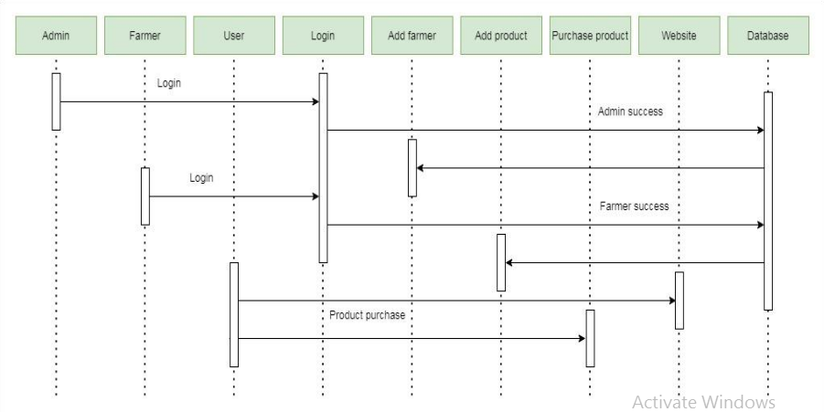

Figure: Business Process Model

Figure displays. The farmer's information can only be added, deleted, or updated by the administrator. By inputting the appropriate email address and password, the administrator has complete control over updating the page at any moment. Each module maintains its own email address and password for security reasons. The only person who may add, remove, and update the information about the fruits and vegetables that are available on his or her farm is the farmer; website visitors will not see this page. Order details are only visible to farmers. The person who accesses the website to make an online or offline purchase of any fruits and vegetables is known as a user.

**PROPOSED**

The Proposed System differs from existing technology where the area of specialization is taken into consideration to overcome drawback of existing system. With the proposed system, Farming Assistance with a web application and upload that record on web server.

**HARDWARE AND SOFTWARE SPECIFICATIONS**

* **Hardware Requirements**
  + Processor - Intel Pentium 4( 1.50 GHZ) or above
  + RAM - Minimum 1GB
  + Hard Disk - 128 GB
* **Software Configuration:**

**Web based application**

* + Operating system : Windows XP/7/10
  + IDE : Sublime text
  + Front-end : Html, CSS, Bootstrap framework
  + Server side programming : PHP
  + Client side scripting : Ajax, JavaScript
  + Database : MySQL
  + Server : Apache server
  + Tool Kit : Google Chrome developer tools
  + Other libraries : JQuery

**Expected Results**

In Farming Assistance, we use PHP and MySQL Database. Simple UI and easy to find navigation items are the key points. Farmer should be able to register, login. After logging into dashboard, display weather forecast by calling google weather API which will give you real time data. User should be able to enter the soil test results and get result based in this soil test data. Farmer should be able to download the processed info into a pdf file. Also, the system should show how the soil test result data will affect particular crop, ex take Tomato, Grapes and Pomegranate. Farmer should also be able to post their queries which should be answered by Experts.

**This project has three modules**

i.e., user, canteen,

* User / farmer
* Admin
* Experts

**User Module**

1. Register as farmer

2. Enter Soil results provided by lab

3. View the processed output of result based in input entered by farmer

4. Suggestions for farming for crops based in result

5. Based in result show how the soil is for certain crops, for now take reference of 2-3 crops, Tomato, Grapes and Pomegranate

6. Download the result in PDF file

7. Post Queries they have

8. View Queries Posted by other farmers with Expert Response (if available)

**Expert**

1. Register as Expert
2. View Problems of Farmers
3. Write the response in simple language which farmer understand

**Admin**

1. Manage Farmers
2. Manage Experts

**CONCLUSION**

The web application Named Farming Assistance is able to solve modern day problem which farmers are farmers. Now remote farmers have the one touch solution, they can post the queries they have, and interact with the experts which are located all over nation. Farmers were getting difficulty in understanding what does the lab result mean which they give for soil testing. Now they can post the lab result and get processed and easily understandable solution.

Farmers also will get suggestions like how the soil is for certain crops what kind of things to be added into the soil such that they get optimum benefit out of it.

For farmers weather update plays and crucial role. So in this web app they will receive live update of weather as well.

Thus the system is able to solve modern day problems which farmers were facing.

Websites:

1. <https://springframework.guru/spring-jdbctemplate-crud-operations>
2. <https://www.w3schools.com/>
3. <https://www.javatpoint.com/spring-boot-tutorial>
4. <https://spring.io/guides/gs/scheduling-tasks/>
5. <https://www.javatpoint.com/example-of-sending-email-using-java-mail-api>
6. <https://howtodoinjava.com/spring-boot2/crud-application-thymeleaf>