SIMATS ENGINEERING
ASSESSMENT TOOL 2

COURSE NAME: Cryptography and Network Security COURSE CODE: CSA51

COURSE OUTCOME COVERED

CO1: Apply classical encryption techniques using symmetric and asymmetric ciphers to encrypt and decrypt data for the ensuring data security. (BL3, BL4)

Assessment Tool Weightage: 40%

QUESTIONS: 5 Total Marks:50

Annexure A

CONCEPT MAPPING

Code of Conduct:

I Surabhi Surya(192421267) (Name / Reg No) certify that this submission is my original work and that I have adhered to the guidelines specified for this assessment.
I understand that any violation of academic integrity rules will result in disciplinary action.


Signature of the student:

CSA5116-Cryptography And Network Security

Name:P.S.Surabhi Surya
Reg No:192421267
Faculty:Anbalagan E

Concept Maps in Cryptography and Network Security
Security Attacks & Goals, Classical Ciphers, Steganography, and Number Theory

1. Security Attacks, Threats, Risks and Security Goals
The concept map below traces four canonical attack types through the threat they realize, the concrete risk an organization faces, and the CIA security goal that mitigates that risk.
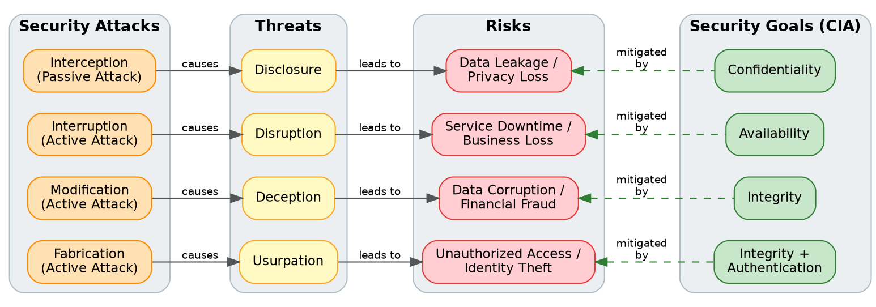
Figure 1: Attacks -> Threats -> Risks -> Security Goals

a. How each attack leads to specific threats and risks
Attack | Threat it Realizes | Resulting Risk | Mitigating Goal | Real-world Example
Interception (passive) | Disclosure - an unauthorized party gains access to data or a system | Data leakage / loss of privacy or trade secrets | Confidentiality | A hacker sniffs unencrypted Wi-Fi traffic at a cafe and captures a user's login credentials.
Interruption (active) | Disruption - a service or resource is made unavailable or unusable | Downtime, lost revenue, denied access for legitimate users | Availability | A DDoS attack floods an e-commerce server with traffic, taking the checkout page offline during a sale.
Modification (active) | Deception - false data is accepted as genuine | Corrupted records, fraudulent transactions | Integrity | An attacker intercepts a bank transfer request and changes the destination account number.
Fabrication (active) | Usurpation - unauthorized control of a system function | Identity theft, rogue accounts, unauthorized system control | Integrity + Authentication | A phishing site fabricates a fake login page to harvest and reuse a victim's credentials.

b. How security goals mitigate each attack chain
- Confidentiality restricts information access to authorized parties, directly countering interception-based disclosure (e.g., TLS encryption prevents Wi-Fi sniffing from exposing login data).
- Integrity ensures data is not altered in transit or storage, countering both modification (deception) and fabrication (usurpation); digital signatures and checksums let a bank detect a tampered transfer instruction.
- Availability guarantees authorized users can access resources when needed, countering interruption; techniques like rate-limiting, redundancy, and CDNs keep a service reachable during a DDoS attack.

2. Comparing Substitution Techniques
The map compares four classical substitution ciphers along three dimensions: key usage, complexity, and security strength.
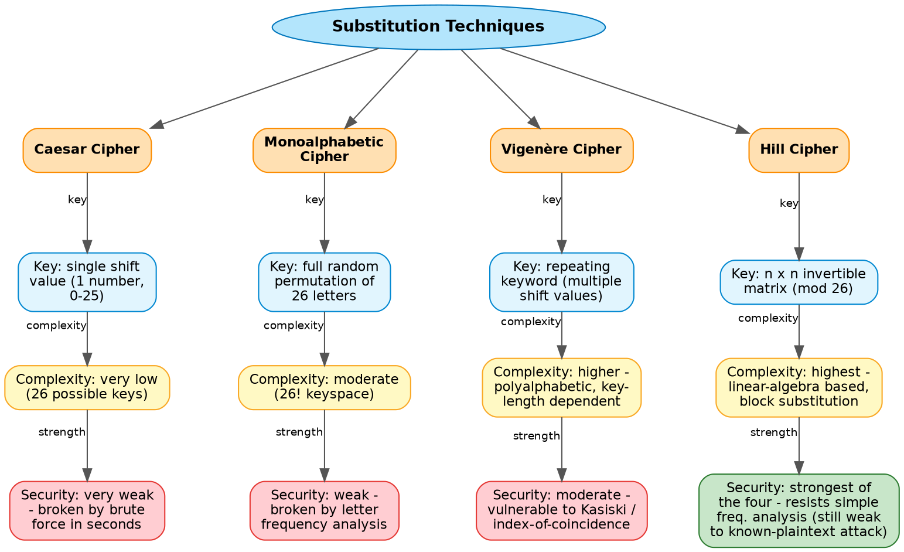
Figure 2: Caesar vs Monoalphabetic vs Vigenere vs Hill Cipher
Cipher | Key Usage | Complexity | Security Strength
Caesar Cipher | Single numeric shift (0-25) | Very low - 26 possible keys | Very weak - broken instantly by brute force
Monoalphabetic Cipher | Full random permutation of the 26-letter alphabet | Moderate - 26! possible keys, but structure is simple | Weak - broken quickly by letter-frequency analysis
Vigenere Cipher | Repeating keyword producing multiple shift values | Higher - polyalphabetic, strength scales with key length | Moderate - vulnerable to Kasiski examination and index-of-coincidence attacks once key length is found
Hill Cipher | An n x n invertible matrix over mod 26 | Highest - linear-algebra based block substitution | Strongest of the four against frequency analysis, but linear (fully breakable with a known-plaintext attack)

Which technique is most secure, and why
Among these four, the Hill Cipher offers the strongest resistance to classical cryptanalysis. Because it enciphers blocks of letters simultaneously through matrix multiplication rather than one letter at a time, it destroys the single-letter frequency distribution that defeats the Caesar and Monoalphabetic ciphers, and it is not limited by a short repeating key the way the Vigenere cipher is (which keeps it safe from Kasiski-style attacks). However, "most secure" is relative only within this classical group: because Hill encryption is a linear transformation, it is completely broken by a known-plaintext attack - an attacker who obtains as few as n matching plaintext/ciphertext block pairs can solve for the key matrix using linear algebra. All four remain far below the security bar required for real systems; they matter today mainly as pedagogical stepping stones toward polyalphabetic and, eventually, computational (DES/AES, RSA) cryptography.

3. Classical Encryption Schemes: Substitution vs Transposition
This map contrasts the two families of classical ciphers by method, effect on data structure, and resulting security level.
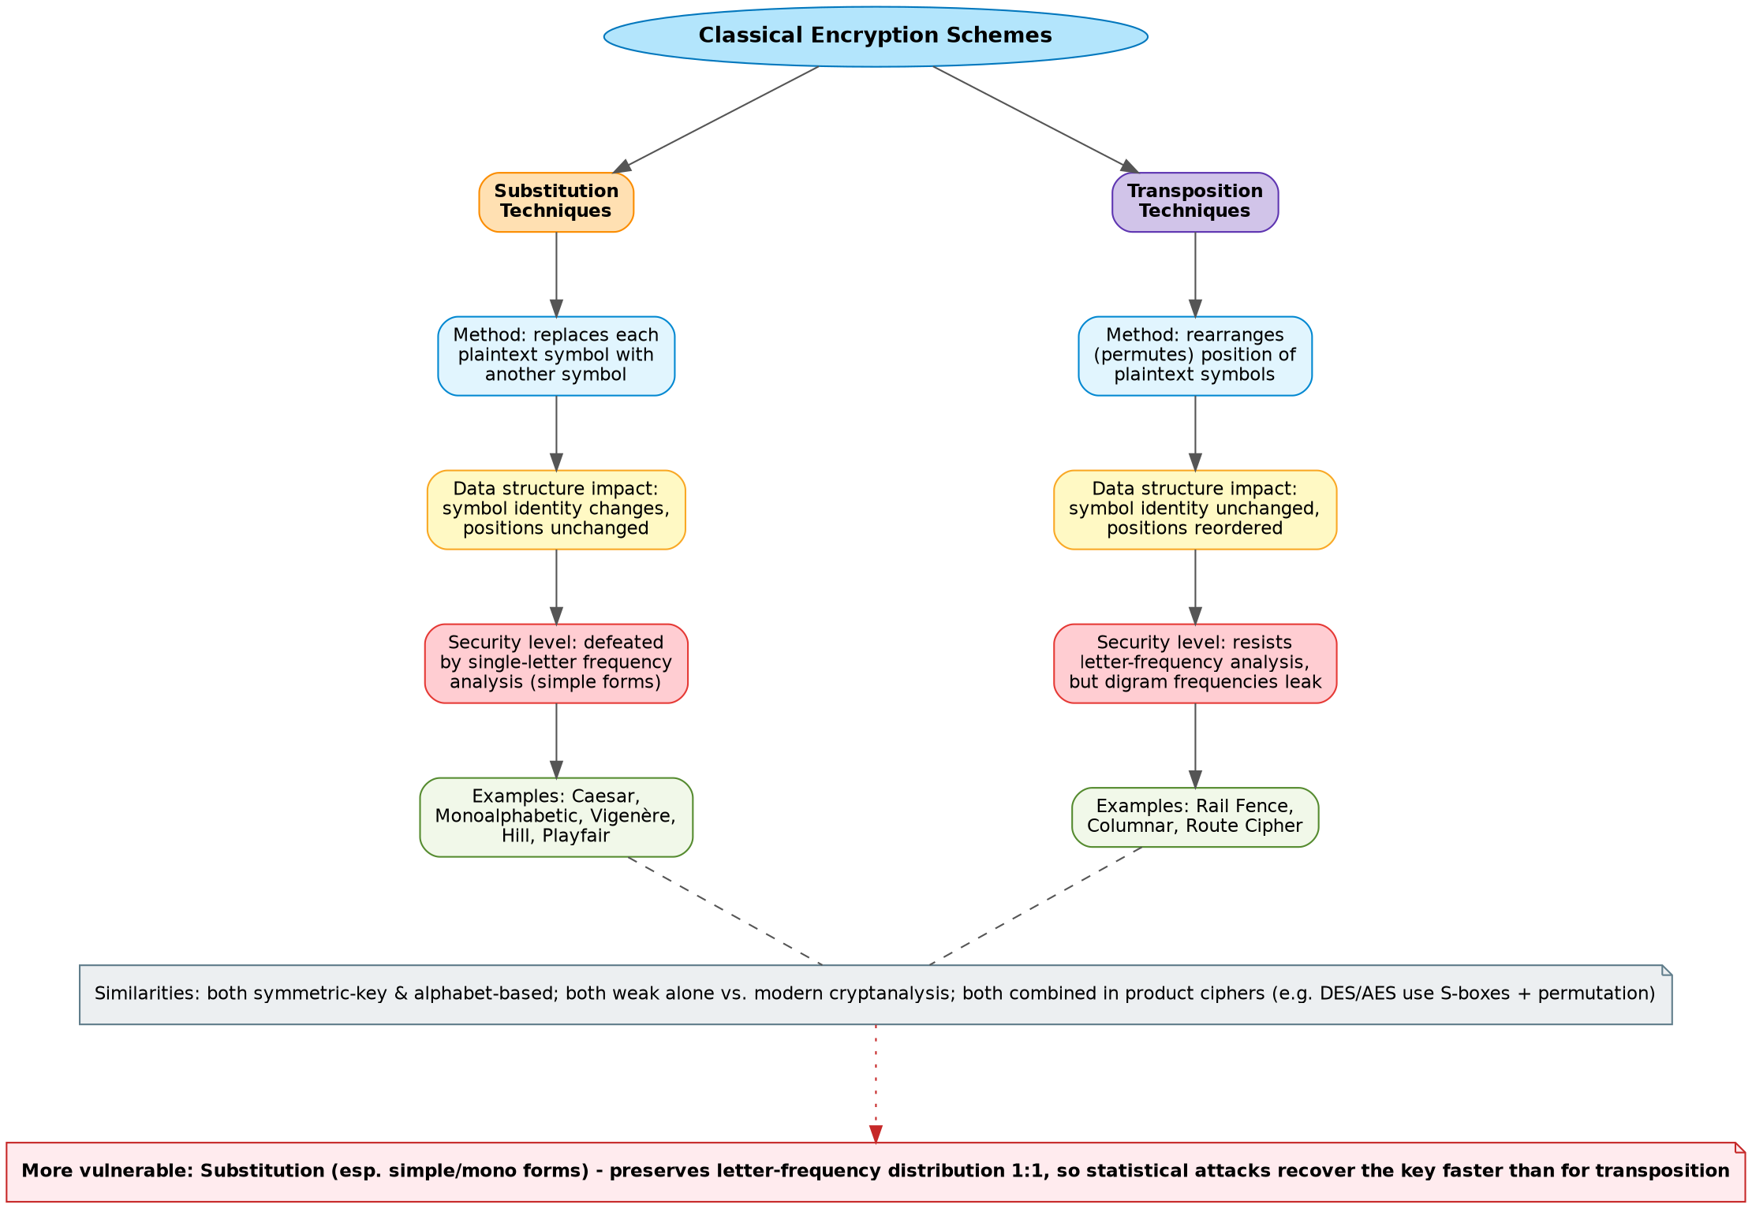
Figure 3: Substitution vs Transposition Techniques

a. Differences and similarities
Aspect | Substitution | Transposition
Basic operation | Replaces each symbol with a different symbol | Reorders the position of symbols; symbol identity is unchanged
i. Effect on data structure | Changes symbol identity while keeping position fixed - letter-frequency statistics of the alphabet are preserved | Changes symbol position while keeping identity fixed - letter frequencies are preserved, but digram/positional patterns are shuffled
i. Security level | Simple forms (Caesar, Monoalphabetic) fall quickly to single-letter frequency analysis; polyalphabetic/block forms (Vigenere, Hill) raise the bar | Resists single-letter frequency analysis by design, but is still vulnerable once digram frequencies or column patterns are examined
Similarities | Both are symmetric-key, alphabet-based classical techniques; both are insecure by modern standards used alone; both are combined as building blocks in modern product ciphers (e.g., AES layers substitution S-boxes with permutation/diffusion steps)

ii. Which is more vulnerable to attack, and why
Substitution techniques - especially the simple Caesar and Monoalphabetic forms - are generally more vulnerable. Because each plaintext symbol always maps to the same ciphertext symbol, the ciphertext inherits the exact letter-frequency distribution of the underlying language (e.g., 'E' remains the most frequent letter, just relabeled). A cryptanalyst can align observed ciphertext frequencies against known language statistics and recover the substitution mapping with very little ciphertext. Transposition ciphers do not have this weakness, since the letters themselves are untouched, only reordered; their frequency distribution matches the plaintext exactly, but that alone does not reveal the key. Instead, transposition is broken by analyzing digram/trigram patterns or by guessing column widths, which generally requires more effort and more ciphertext than simple frequency analysis. In short, simple substitution leaks the most information the fastest, making it the weaker of the two classical families.

4. Steganography: Data Hiding, Watermarking, Survivability
This map shows how the three steganography concepts relate to one another and to secure communication.
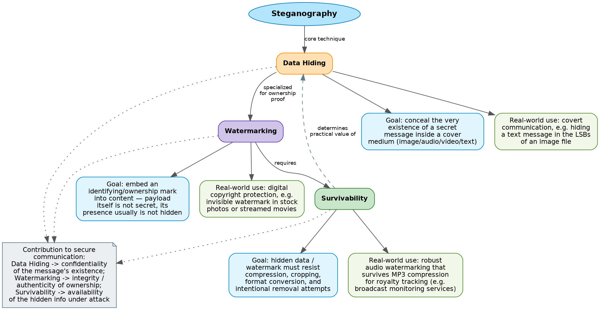
Figure 4: Data Hiding, Watermarking and Survivability

a. Relationships between the concepts
- Data Hiding is the core technique underlying all steganography: it conceals the very existence of a message inside an innocuous cover medium (image, audio, video, or text).
- Watermarking is a specialized application of data hiding aimed at embedding an identifying or ownership mark into content, where the presence of the mark is often not itself secret - only its removal is meant to be difficult.
- Survivability is a requirement that watermarking (and to a lesser extent, general data hiding) must satisfy in practice: the embedded information must remain recoverable after the cover medium is compressed, cropped, re-encoded, or otherwise processed - and, for watermarks, it must resist deliberate removal attempts.

b. Contribution to secure communication
Concept | Contribution to Secure Communication | Real-world Application
Data Hiding | Confidentiality of the message's existence - an observer cannot even tell a secret is being transmitted, defeating traffic analysis | Hiding a covert text message in the least-significant bits (LSBs) of a photograph shared over a public channel
Watermarking | Integrity and authenticity of ownership - proves who created or holds rights to content, deterring tampering and unauthorized redistribution | Invisible digital watermarks embedded in stock photography or streamed films to trace leaks and prove copyright
Survivability | Availability of the hidden information under real-world processing or attack - the payload keeps working even after the medium is altered | Robust audio watermarking that survives MP3 compression, used by broadcast-monitoring services to track royalty payments

5. Number Theory Concepts Used in Cryptography
This map connects five foundational number-theory concepts and shows how they support public-key encryption and decryption, primarily in RSA.
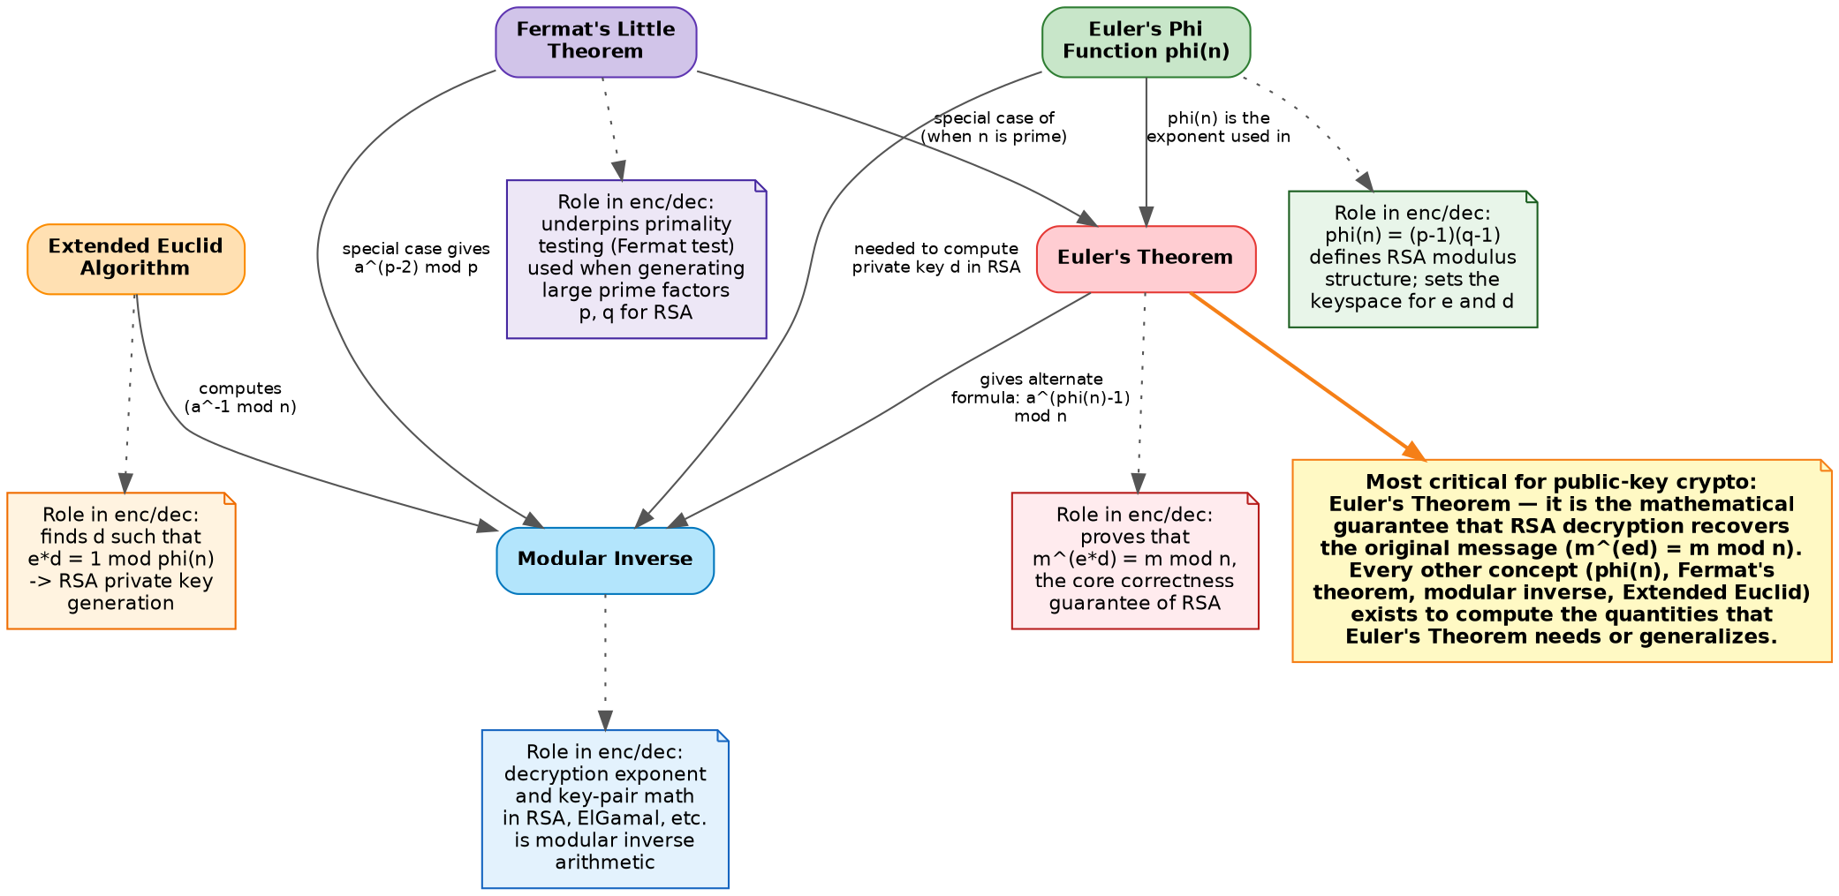
Figure 5: Modular Inverse, Extended Euclid, Fermat's Little Theorem, Euler's Phi Function, Euler's Theorem

a. Mathematical connections
- The Extended Euclidean Algorithm computes integers x and y such that ax + ny = gcd(a, n); when gcd(a, n) = 1, x mod n is the Modular Inverse of a mod n.
- Euler's Phi Function, phi(n), counts the integers less than n that are coprime to n; for n = p*q with p, q prime, phi(n) = (p-1)(q-1).
- Euler's Theorem states that if gcd(a, n) = 1, then a^phi(n) = 1 (mod n) - it generalizes modular exponentiation for any modulus n.
- Fermat's Little Theorem is the special case of Euler's Theorem when n = p is prime: a^(p-1) = 1 (mod p), so phi(p) simplifies to p-1.
- Modular Inverse can therefore be computed two ways: via the Extended Euclidean Algorithm directly, or - when the modulus is prime - via Fermat's Little Theorem as a^(p-2) mod p, or more generally via Euler's Theorem as a^(phi(n)-1) mod n.

b. Role in encryption/decryption
Concept | Role in Encryption/Decryption
Extended Euclid Algorithm | Computes the RSA private exponent d, the modular inverse of the public exponent e modulo phi(n)
Modular Inverse | Is exactly the decryption exponent/key-pair relationship exploited in RSA and similar public-key schemes
Fermat's Little Theorem | Underpins probabilistic primality testing used to find the large primes p and q needed to build an RSA modulus, and offers a fast inverse formula for prime moduli
Euler's Phi Function | Defines phi(n) = (p-1)(q-1), which sets the keyspace and the exact relationship e*d = 1 (mod phi(n)) that key generation must satisfy
Euler's Theorem | Provides the correctness proof that decryption recovers the original message: m^(ed) = m (mod n)

c. Most critical concept for public-key cryptography
Euler's Theorem is the most critical of the five for public-key cryptography. It is the mathematical guarantee that RSA actually works: it proves that raising a ciphertext to the private exponent d returns the original plaintext, m^(ed) = m (mod n), whenever e and d are chosen as multiplicative inverses modulo phi(n). Every other concept in the map exists in service of that guarantee - Euler's Phi Function supplies the modulus phi(n) that the theorem operates on, the Extended Euclidean Algorithm is the computational tool used to find the inverse pair (e, d) the theorem requires, Fermat's Little Theorem is simply the prime-modulus special case that also supports primality testing during key generation, and Modular Inverse is the specific quantity the theorem's proof revolves around. Without Euler's Theorem, none of the other tools would combine into a working, provably-correct encryption/decryption scheme - it is the capstone result that turns the surrounding number theory into RSA.

