CSA5116 Cryotography and network security
Name:P.S.Surabhi Surya
Reg No:192421267
Lab Programs - Cycle 3
EX. NO: 18 IMPLEMENTATION OF HASH FUNCTION - MD5
AIM:
To write a Python program to implement the MD5 hash function.
DESCRIPTION:
MD5 (Message Digest Algorithm 5) is a widely used cryptographic hash function that takes an input message of any length and produces a fixed-size 128-bit (32 hexadecimal character) digest. It processes the message in 512-bit blocks through four rounds of bitwise operations, modular additions and non-linear functions, so that even a tiny change in the input produces a completely different digest. MD5 is no longer considered secure against deliberate collision attacks, but it is still used for basic integrity checks such as verifying file downloads.
ALGORITHM:
STEP-1: Read the input message from the user.
STEP-2: Encode the message into bytes so it can be processed by the hash function.
STEP-3: Create an MD5 hash object using the hashlib library and feed the encoded message into it.
STEP-4: Compute the digest of the message and convert it into its hexadecimal representation.
STEP-5: Display the message, its 128-bit MD5 digest and the digest length in bits.
PROGRAM: (Implementation of HASH FUNCTION - MD5 - Python)
# Experiment No: 18
# Implementation of Hash Function - MD5

import hashlib

message = input("Enter the message to be hashed: ")

hash_object = hashlib.md5(message.encode())
digest_hex = hash_object.hexdigest()

print("\nMessage :", message)
print("MD5 Hash (hex) :", digest_hex)
print("Hash length :", len(digest_hex) * 4, "bits")

OUTPUT:
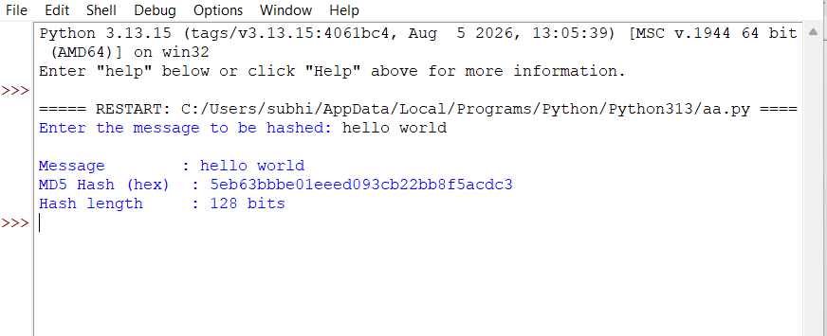
RESULT:
Thus the MD5 hash function was implemented successfully using Python.

EX. NO: 19 IMPLEMENTATION OF HASH FUNCTION - SHA-512
AIM:
To write a Python program to implement the SHA-512 hash function.
DESCRIPTION:
SHA-512 is a member of the SHA-2 family of cryptographic hash functions published by NIST. It processes the input message in 1024-bit blocks using 64-bit words and 80 rounds of bitwise logical operations and modular additions to produce a fixed-size 512-bit (64-byte) digest. Its much larger digest and stronger internal design make SHA-512 far more resistant to collision and pre-image attacks than MD5 or SHA-1, and it is widely used in digital certificates, blockchain systems and secure password storage.
ALGORITHM:
STEP-1: Read the input message from the user.
STEP-2: Encode the message into bytes so it can be processed by the hash function.
STEP-3: Create a SHA-512 hash object using the hashlib library and feed the encoded message into it.
STEP-4: Compute the digest of the message and convert it into its hexadecimal representation.
STEP-5: Display the message, its 512-bit SHA-512 digest and the digest length in bits.
PROGRAM: (Implementation of HASH FUNCTION - SHA-512 - Python)
# Experiment No: 19
# Implementation of Hash Function - SHA-512

import hashlib

message = input("Enter the message to be hashed: ")

hash_object = hashlib.sha512(message.encode())
digest_hex = hash_object.hexdigest()

print("\nMessage :", message)
print("SHA-512 Hash (hex) :", digest_hex)
print("Hash length :", len(digest_hex) * 4, "bits")
OUTPUT:
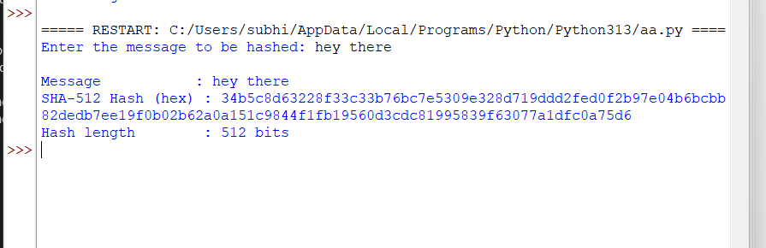
RESULT:
Thus the SHA-512 hash function was implemented successfully using Python.

EX. NO: 20 IMPLEMENTATION OF HASH FUNCTION - SHA-1
AIM:
To write a Python program to implement the SHA-1 hash function.
DESCRIPTION:
SHA-1 (Secure Hash Algorithm 1) is a cryptographic hash function that takes an input message of any length and produces a fixed-size 160-bit (40 hexadecimal character) digest. Like MD5, it processes the message in fixed-size blocks through multiple rounds of bitwise operations and modular additions using an internal chaining state. Practical collision attacks have since been demonstrated against SHA-1, so it is no longer recommended for security-critical applications such as digital certificates, but it remains useful for learning the structure of iterative hash functions.
ALGORITHM:
STEP-1: Read the input message from the user.
STEP-2: Encode the message into bytes so it can be processed by the hash function.
STEP-3: Create a SHA-1 hash object using the hashlib library and feed the encoded message into it.
STEP-4: Compute the digest of the message and convert it into its hexadecimal representation.
STEP-5: Display the message, its 160-bit SHA-1 digest and the digest length in bits.
PROGRAM: (Implementation of HASH FUNCTION - SHA-1 - Python)
# Experiment No: 20
# Implementation of Hash Function - SHA-1

import hashlib

message = input("Enter the message to be hashed: ")

hash_object = hashlib.sha1(message.encode())
digest_hex = hash_object.hexdigest()

print("\nMessage :", message)
print("SHA-1 Hash (hex) :", digest_hex)
print("Hash length :", len(digest_hex) * 4, "bits")
OUTPUT:
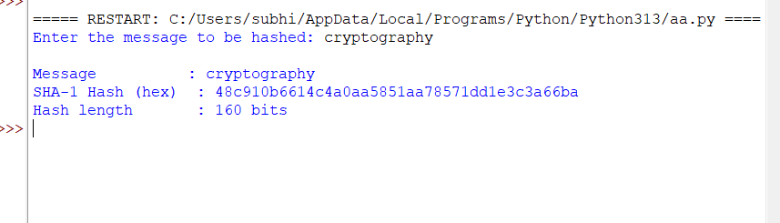
RESULT:
Thus the SHA-1 hash function was implemented successfully using Python.

EX. NO: 21 IMPLEMENTATION OF DIGITAL SIGNATURE
AIM:
To write a Python program to implement the Digital Signature algorithm using RSA.
DESCRIPTION:
A digital signature lets a sender prove the authenticity and integrity of a message using their private key, and lets any receiver verify it using the sender's public key. The sender first computes a hash (message digest) of the message and then encrypts that digest with their RSA private key to form the signature. The receiver independently hashes the received message, decrypts the signature using the sender's public key, and checks that the two digests match; a match proves the message came from the claimed sender and was not altered in transit.
ALGORITHM:
STEP-1: Read two prime numbers, p and q, from the user, verify they are prime and distinct, and generate the RSA public key (e, n) and private key (d, n).
STEP-2: Read the message from the user and compute its hash (message digest) using the SHA-256 algorithm.
STEP-3: At the sender's side, sign the digest by encrypting it with the private key: signature = digest^d mod n.
STEP-4: At the receiver's side, recover the digest from the signature using the sender's public key: recovered = signature^e mod n.
STEP-5: Independently recompute the digest of the received message and compare it with the recovered digest; if they match, the signature is verified.
PROGRAM: (Implementation of DIGITAL SIGNATURE - Python)
# Experiment No: 21
# Implementation of Digital Signature (RSA based)

import hashlib
import math

def is_prime(n):
if n < 2:
return False
for i in range(2, int(math.isqrt(n)) + 1):
if n % i == 0:
return False
return True

p = int(input("ENTER FIRST PRIME NUMBER\n"))
q = int(input("ENTER ANOTHER PRIME NUMBER\n"))
if not (is_prime(p) and is_prime(q)) or p == q:
print("WRONG INPUT")
exit()

message = input("ENTER MESSAGE\n")

n = p * q
phi = (p - 1) * (q - 1)

e = 2
while e < phi:
if math.gcd(e, phi) == 1:
break
e += 1
d = pow(e, -1, phi) # modular inverse

print("\nPUBLIC KEY (e, n):", (e, n))
print("PRIVATE KEY (d, n):", (d, n))

# Sender side: hash the message and sign the hash with the private key
digest = int(hashlib.sha256(message.encode()).hexdigest(), 16) % n
signature = pow(digest, d, n)
print("\nMESSAGE DIGEST (mod n):", digest)
print("DIGITAL SIGNATURE :", signature)

# Receiver side: verify by recovering the digest with the public key
recovered_digest = pow(signature, e, n)
received_digest = int(hashlib.sha256(message.encode()).hexdigest(), 16) % n

print("\nRECOVERED DIGEST (from signature) :", recovered_digest)
print("COMPUTED DIGEST (from message) :", received_digest)

if recovered_digest == received_digest:
print("\nSIGNATURE VERIFIED: The message is authentic and unaltered.")
else:
print("\nSIGNATURE NOT VERIFIED: The message may have been tampered with.")
OUTPUT:
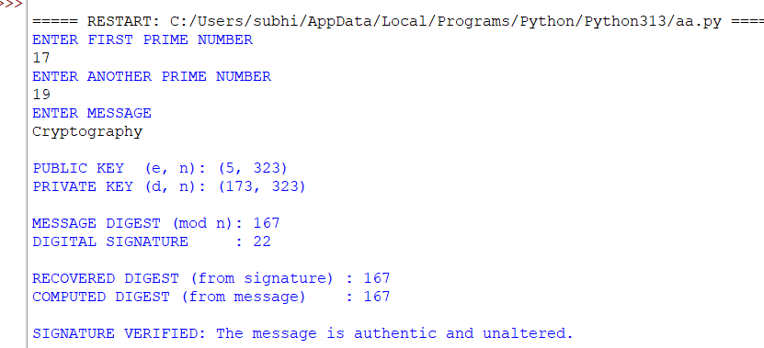
RESULT:
Thus the Digital Signature algorithm was implemented successfully using Python.

