CSA5116 Cryotography and network security

Name:P.S.Surabhi Surya
Reg No:192421267
Lab Programs

EX. NO: 1 IMPLEMENTATION OF CAESAR CIPHER
AIM:
To implement the simple substitution technique named Caesar Cipher using Python language.
DESCRIPTION:
In a Caesar cipher, each letter in the plain text is replaced by a letter found by shifting a fixed number of positions (the key) down the alphabet. For example, with a key of 3, A becomes D, B becomes E, and so on. When the shift goes past Z, it wraps around to the beginning of the alphabet (X becomes A, Y becomes B, Z becomes C). To decrypt, the same shift is applied in the reverse direction.
ALGORITHM:
STEP-1: Read the plain text from the user.
STEP-2: Read the key value from the user.
STEP-3: For every character in the plain text, shift it forward by the key value, wrapping around the alphabet using the modulo operator.
STEP-4: Display the resulting cipher text.
STEP-5: To decrypt, shift every character of the cipher text backward by the same key value and display the recovered plain text.
PROGRAM: (Implementation of Caesar Cipher - Python)
# Experiment No: 1
# Implementation of Caesar Cipher

def encrypt(text, key):
result = ""
for ch in text:
if ch.isupper():
result += chr((ord(ch) + key - 65) % 26 + 65)
elif ch.islower():
result += chr((ord(ch) + key - 97) % 26 + 97)
else:
result += ch
return result

def decrypt(text, key):
return encrypt(text, -key)

plain = input("Enter the plain text: ")
key = int(input("Enter the key value: "))

cipher = encrypt(plain, key)
back = decrypt(cipher, key)

print("\nPLAIN TEXT:", plain)
print("ENCRYPTED TEXT:", cipher)
print("AFTER DECRYPTION:", back)
OUTPUT:
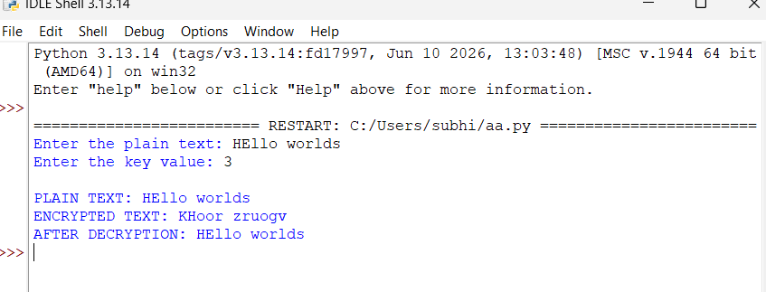RESULT:
Thus the implementation of Caesar cipher was executed successfully using Python.

EX. NO: 2 IMPLEMENTATION OF PLAYFAIR CIPHER
AIM:
To write a Python program to implement the Playfair substitution technique.
DESCRIPTION:
The Playfair cipher begins by constructing a 5x5 key table using a keyword, in which 'I' and 'J' share the same cell so that all 25 remaining letters of the alphabet fit into the grid. The plain text is then split into digraphs (pairs of letters). Depending on whether the two letters of a pair lie in the same row, the same column, or form a rectangle in the table, a set of substitution rules is applied to produce the cipher text pair.
ALGORITHM:
STEP-1: Read the keyword and the plain text from the user.
STEP-2: Build a 5x5 key matrix from the keyword (removing duplicate letters and merging I/J), filling remaining cells with the unused letters of the alphabet in order.
STEP-3: Split the plain text into digraphs, inserting an 'X' when both letters of a pair are the same or when a single letter is left over.
STEP-4: For each pair, apply the row rule, column rule, or rectangle rule to obtain the cipher letters.
STEP-5: Combine the resulting pairs to display the complete cipher text, and reverse the same rules to decrypt.
PROGRAM: (Implementation of Playfair Cipher - Python)
# Experiment No: 2
# Implementation of Playfair Cipher

def generate_key_table(key):
key = key.upper().replace("J", "I")
seen = set()
table = []
for ch in key:
if ch not in seen and ch.isalpha():
seen.add(ch)
table.append(ch)
for ch in "ABCDEFGHIKLMNOPQRSTUVWXYZ": # no J
if ch not in seen:
seen.add(ch)
table.append(ch)
matrix = [table[i*5:(i+1)*5] for i in range(5)]
return matrix

def find_position(matrix, ch):
for r in range(5):
for c in range(5):
if matrix[r][c] == ch:
return r, c

def prepare_text(text):
text = text.upper().replace("J", "I")
text = "".join(ch for ch in text if ch.isalpha())
pairs = []
i = 0
while i < len(text):
a = text[i]
b = text[i+1] if i+1 < len(text) else 'X'
if a == b:
pairs.append((a, 'X'))
i += 1
else:
pairs.append((a, b))
i += 2
return pairs

def encrypt_pair(matrix, a, b):
r1, c1 = find_position(matrix, a)
r2, c2 = find_position(matrix, b)
if r1 == r2:
return matrix[r1][(c1+1) % 5] + matrix[r2][(c2+1) % 5]
elif c1 == c2:
return matrix[(r1+1) % 5][c1] + matrix[(r2+1) % 5][c2]
else:
return matrix[r1][c2] + matrix[r2][c1]

def decrypt_pair(matrix, a, b):
r1, c1 = find_position(matrix, a)
r2, c2 = find_position(matrix, b)
if r1 == r2:
return matrix[r1][(c1-1) % 5] + matrix[r2][(c2-1) % 5]
elif c1 == c2:
return matrix[(r1-1) % 5][c1] + matrix[(r2-1) % 5][c2]
else:
return matrix[r1][c2] + matrix[r2][c1]

key = input("Enter key: ")
plain = input("Enter the plain text: ")

matrix = generate_key_table(key)
print("\nKey Matrix:")
for row in matrix:
print(" ".join(row))

pairs = prepare_text(plain)
cipher = "".join(encrypt_pair(matrix, a, b) for a, b in pairs)
decrypted = "".join(decrypt_pair(matrix, a, b) for a, b in [(cipher[i], cipher[i+1]) for i in range(0, len(cipher), 2)])

print("\nEntered text :", plain)
print("Cipher Text :", cipher)
print("Decrypted Text :", decrypted)

OUTPUT:
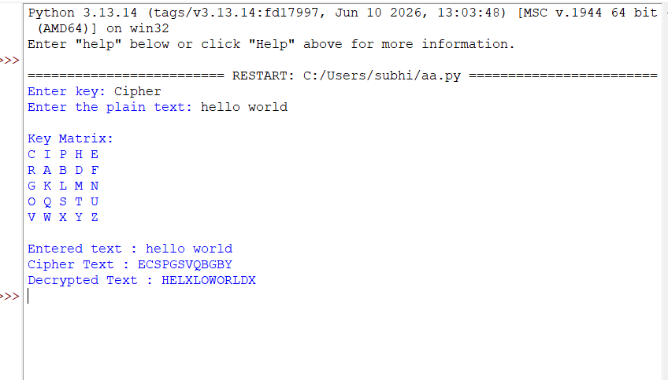RESULT:
Thus the Playfair cipher substitution technique was implemented successfully using Python.
EX. NO: 3 IMPLEMENTATION OF HILL CIPHER
AIM:
To write a Python program to implement the Hill cipher substitution technique.
DESCRIPTION:
In the Hill cipher, each letter is represented by a number modulo 26 (A=0, B=1, ... Z=25). The plain text is split into blocks of n letters, and each block is treated as a vector that is multiplied by an invertible n x n key matrix under modulo 26 arithmetic to produce the cipher text block. Decryption is performed by multiplying the cipher block with the modular inverse of the key matrix.
ALGORITHM:
STEP-1: Read the plain text from the user and convert every letter to its numeric equivalent (A=0 ... Z=25).
STEP-2: Split the numeric plain text into blocks of length three.
STEP-3: Multiply each block (as a column vector) with the 3x3 key matrix, then reduce the result modulo 26 to obtain the cipher block.
STEP-4: Convert the resulting numbers back to letters to form the cipher text.
STEP-5: To decrypt, compute the modular inverse of the key matrix and multiply it with the cipher blocks, reducing modulo 26 to recover the original plain text.
PROGRAM: (Implementation of Hill Cipher - Python)
# Experiment No: 3
# Implementation of Hill Cipher

import numpy as np

def mod_inverse_matrix(matrix, modulus):
det = int(round(np.linalg.det(matrix)))
det_inv = pow(det % modulus, -1, modulus)
adj = np.round(det * np.linalg.inv(matrix)).astype(int) % modulus
inv = (det_inv * adj) % modulus
return inv.astype(int)

key_matrix = np.array([[6, 24, 1],
[13, 16, 10],
[20, 17, 15]])

plain = input("Enter plain text (multiple of 3 letters): ").upper()
nums = [ord(ch) - 65 for ch in plain]

cipher_nums = []
for i in range(0, len(nums), 3):
block = np.array(nums[i:i+3])
result = key_matrix.dot(block) % 26
cipher_nums.extend(result)

cipher_text = "".join(chr(n + 65) for n in cipher_nums)
print("Encrypted Cipher Text :", cipher_text)

inv_key = mod_inverse_matrix(key_matrix, 26)
decrypt_nums = []
for i in range(0, len(cipher_nums), 3):
block = np.array(cipher_nums[i:i+3])
result = inv_key.dot(block) % 26
decrypt_nums.extend(result)

decrypted_text = "".join(chr(int(n) + 65) for n in decrypt_nums)
print("Decrypted Cipher Text :", decrypted_text)
OUTPUT:
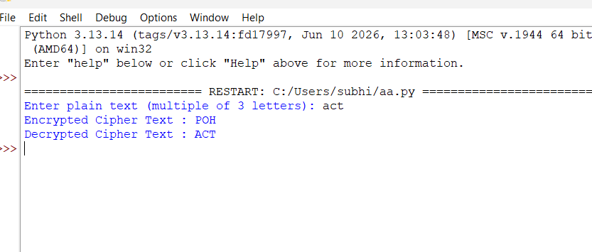
RESULT:
Thus the Hill cipher substitution technique was implemented successfully using Python.

EX. NO: 4 IMPLEMENTATION OF VIGENERE CIPHER
AIM:
To implement the Vigenere cipher substitution technique using a Python program.
DESCRIPTION:
The Vigenere cipher encrypts a message using a repeating keyword. Each letter of the plain text is shifted by an amount determined by the corresponding letter of the keyword (A=0, B=1, and so on), with the keyword repeated as many times as needed to match the length of the plain text. Because the shift changes from letter to letter, the Vigenere cipher is a polyalphabetic substitution cipher, unlike the single-shift Caesar cipher.
ALGORITHM:
STEP-1: Read the plain text (or cipher text) and the keyword from the user.
STEP-2: Repeat the characters of the keyword so that its length matches that of the message.
STEP-3: For encryption, add the numeric value of each message character to the numeric value of the corresponding key character, modulo 26, to obtain the cipher character.
STEP-4: For decryption, subtract the numeric value of the key character from the cipher character, modulo 26, to recover the plain character.
STEP-5: Display the resulting text and repeat for further encrypt/decrypt operations until the user exits.
PROGRAM: (Implementation of Vigenere Cipher - Python)
# Experiment No: 4
# Implementation of Vigenere Cipher

def encrypt(plain, key):
result = ""
for i, ch in enumerate(plain):
k = key[i % len(key)]
result += chr(65 + ((ord(ch.upper()) - 65) + (ord(k.upper()) - 65)) % 26)
return result

def decrypt(cipher, key):
result = ""
for i, ch in enumerate(cipher):
k = key[i % len(key)]
value = (ord(ch.upper()) - 65) - (ord(k.upper()) - 65)
result += chr(65 + (value % 26))
return result

while True:
print("\n1. Encrypt Text\t2. Decrypt Text\t3. Exit")
choice = int(input("Enter Your Choice : "))
if choice == 3:
break
elif choice == 1:
plain = input("Enter Plain Text: ")
key = input("Enter Key Value: ")
print("Resultant Cipher Text:", encrypt(plain, key))
elif choice == 2:
cipher = input("Enter Cipher Text: ")
key = input("Enter the key value: ")
print("Resultant Plain Text:", decrypt(cipher, key))
else:
print("Please Enter Valid Option.")

OUTPUT:
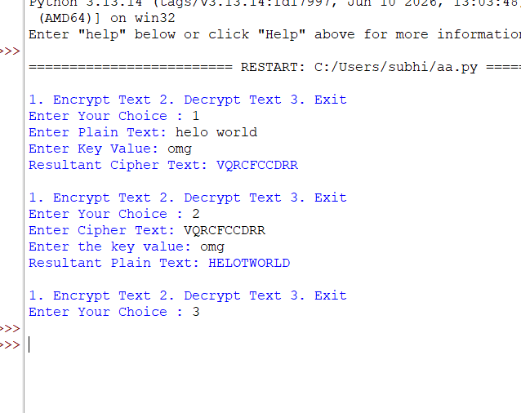
RESULT:
Thus the Vigenere cipher substitution technique was implemented successfully using Python.

EX. NO: 5 IMPLEMENTATION OF RAIL FENCE - ROW & COLUMN TRANSFORMATION TECHNIQUE
AIM:
To write a Python program to implement the rail fence transposition technique.
DESCRIPTION:
In the simple two-rail version of the rail fence cipher, the plain text characters are written alternately onto two imaginary rails: characters at even index positions go onto the first rail and characters at odd index positions go onto the second rail. The cipher text is then formed by reading the first rail followed by the second rail. Decryption reverses this process by splitting the cipher text back into the two rails and interleaving them.
ALGORITHM:
STEP-1: Read the plain text from the user.
STEP-2: Collect all characters at even index positions into one group and characters at odd index positions into another group.
STEP-3: Concatenate the even-position group followed by the odd-position group to form the cipher text.
STEP-4: To decrypt, split the cipher text back into the two groups of the appropriate sizes.
STEP-5: Interleave the two groups back into their original even and odd positions to recover the plain text.
PROGRAM: (Implementation of Rail Fence - Row & Column Transformation Technique - Python)
# Experiment No: 5
# Implementation of Rail Fence - Row & Column Transformation Technique

def encrypt(text):
even = text[0::2]
odd = text[1::2]
return even + odd

def decrypt(cipher):
n = len(cipher)
half = (n + 1) // 2
even_part = cipher[:half]
odd_part = cipher[half:]
result = [''] * n
result[0::2] = even_part
result[1::2] = odd_part
return "".join(result)

print("\t\tRAIL FENCE TECHNIQUE")
text = input("\nEnter the input string : ")

cipher = encrypt(text)
print("\nCipher text after applying rail fence :")
print(cipher)

decrypted = decrypt(cipher)
print("\nText after decryption :", decrypted)

OUTPUT:
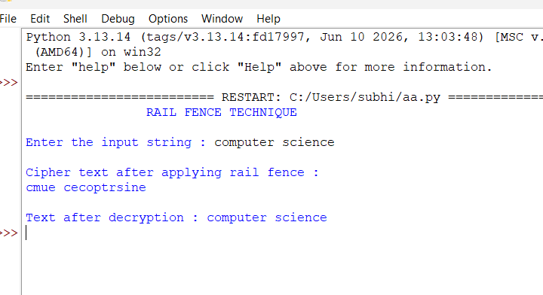
RESULT:
Thus the rail fence algorithm was executed successfully using Python.

EX. NO: 6 IMPLEMENTATION OF DES
AIM:
To write a Python program to implement the Data Encryption Standard (DES) algorithm.
DESCRIPTION:
DES is a symmetric-key block cipher that operates on 64-bit blocks of data using a 64-bit key, of which 56 bits are actually used for the encryption/decryption operations (the remaining 8 bits are parity bits). The algorithm applies 16 rounds of permutation and substitution operations (via S-boxes) to the plain text, combined with sub-keys derived from the main key, to produce the cipher text. The same key is used, in reverse round order, to decrypt the cipher text.
ALGORITHM:
STEP-1: Read the plain text message and the 64-bit (8 character) secret key from the user.
STEP-2: Use the DES algorithm, in Electronic Code Book (ECB) mode with PKCS5 padding, to encrypt the message using the secret key.
STEP-3: Encode the resulting encrypted bytes in Base64 so that they can be displayed as printable text.
STEP-4: Use the same secret key to decrypt the cipher bytes back to the original message.
STEP-5: Display the key, the encrypted (Base64) message, and the decrypted message.
PROGRAM: (Implementation of DES - Python)
# Experiment No: 6
# Implementation of DES (Data Encryption Standard)
# Uses the pyDes pure-python implementation of DES

import base64
try:
import pyDes
except ImportError:
import subprocess
subprocess.run(["pip", "install", "pyDes", "--break-system-packages", "-q"])
import pyDes

key = "DESCRYPT" # 8-byte (64-bit) symmetric key
message = input("Enter message to encrypt: ")

des_obj = pyDes.des(key, pyDes.ECB, padmode=pyDes.PAD_PKCS5)

encrypted = des_obj.encrypt(message.encode())
encoded = base64.b64encode(encrypted).decode()
print("\nDES Symmetric key :", key)
print("Encrypted message :", encoded)

decrypted = des_obj.decrypt(encrypted).decode()
print("Decrypted message :", decrypted)

OUTPUT:
Enter message to encrypt: computer

DES Symmetric key : DESCRYPT
Encrypted message : HCe1DWJ63fkAscTskOqj3g==
Decrypted message : computer
RESULT:
Thus the Data Encryption Standard algorithm was implemented successfully using Python.

EX. NO: 7 IMPLEMENTATION OF RSA
AIM:
To write a Python program to implement the RSA encryption algorithm.
DESCRIPTION:
RSA is an asymmetric cryptographic algorithm that uses a pair of keys: a public key for encryption and a private key for decryption. Two large prime numbers p and q are chosen and multiplied to obtain the modulus n. Euler's totient, phi(n) = (p-1)(q-1), is then computed, and a public exponent e that is co-prime to phi(n) is selected. The private exponent d is computed as the modular multiplicative inverse of e modulo phi(n), satisfying (m^e)^d = m (mod n) for every message m.
ALGORITHM:
STEP-1: Read two prime numbers, p and q, from the user and verify that both are prime and distinct.
STEP-2: Compute the modulus n = p * q and Euler's totient phi(n) = (p-1) * (q-1).
STEP-3: Select a public exponent e that is co-prime to phi(n), and compute the private exponent d as the modular inverse of e modulo phi(n).
STEP-4: Encrypt each character of the message as (character value)^e mod n to obtain the cipher text.
STEP-5: Decrypt each cipher value as (cipher value)^d mod n to recover the original message.
PROGRAM: (Implementation of RSA - Python)
# Experiment No: 7
# Implementation of RSA

import math

def is_prime(n):
if n < 2:
return False
for i in range(2, int(math.isqrt(n)) + 1):
if n % i == 0:
return False
return True

p = int(input("ENTER FIRST PRIME NUMBER\n"))
q = int(input("ENTER ANOTHER PRIME NUMBER\n"))

if not (is_prime(p) and is_prime(q)) or p == q:
print("WRONG INPUT")
exit()

msg = input("ENTER MESSAGE\n")

n = p * q
phi = (p - 1) * (q - 1)

# choose e coprime to phi
e = 2
while e < phi:
if math.gcd(e, phi) == 1:
break
e += 1

d = pow(e, -1, phi) # modular inverse

print("\nPUBLIC KEY (e, n):", (e, n))
print("PRIVATE KEY (d, n):", (d, n))

# map each lowercase letter a-z to 1-26 so values stay within range of n
encrypted = [pow(ord(ch) - 96, e, n) for ch in msg]
print("\nTHE ENCRYPTED MESSAGE IS (numeric form)")
print(encrypted)

decrypted = "".join(chr(pow(c, d, n) + 96) for c in encrypted)
print("\nTHE DECRYPTED MESSAGE IS")
print(decrypted)
OUTPUT:
ENTER FIRST PRIME NUMBER
7
ENTER ANOTHER PRIME NUMBER
13
ENTER MESSAGE
hello

PUBLIC KEY (e, n): (5, 91)
PRIVATE KEY (d, n): (29, 91)

THE ENCRYPTED MESSAGE IS (numeric form)
[8, 31, 38, 38, 71]

THE DECRYPTED MESSAGE IS
hello
RESULT:
Thus the RSA encryption technique was implemented successfully using Python.

EX. NO: 8 IMPLEMENTATION OF DIFFIE-HELLMAN KEY EXCHANGE ALGORITHM
AIM:
To implement the Diffie-Hellman Key Exchange algorithm using a Python program.
DESCRIPTION:
The Diffie-Hellman algorithm allows two parties to establish a shared secret key over an insecure channel without ever transmitting the key itself. Both parties agree on a public prime n and a public base g. Each party then chooses a private random number, computes a public value using modular exponentiation, and exchanges these public values. Both parties can then independently compute the same shared secret key using their own private value and the public value received from the other party.
ALGORITHM:
STEP-1: Both parties agree on and share the public values n (a prime) and g (a base).
STEP-2: The first party selects a private value x and computes the public value A = g^x mod n, which is sent to the second party.
STEP-3: The second party selects a private value y and computes the public value B = g^y mod n, which is sent to the first party.
STEP-4: The first party computes the shared secret key as B^x mod n.
STEP-5: The second party computes the shared secret key as A^y mod n; both results are equal, giving the shared secret key.
PROGRAM: (Implementation of Diffie-Hellman Key Exchange Algorithm - Python)
# Experiment No: 8
# Implementation of Diffie-Hellman Key Exchange Algorithm

n = int(input("Enter the value of n : "))
g = int(input("Enter the value of g : "))

x = int(input("Enter the value of x for the first person : "))
a = pow(g, x, n)

y = int(input("Enter the value of y for the second person : "))
b = pow(g, y, n)

key_first = pow(b, x, n)
key_second = pow(a, y, n)

print("\nA (public value sent by first person) :", a)
print("B (public value sent by second person) :", b)
print("\nKey for the first person is :", key_first)
print("Key for the second person is :", key_second)

OUTPUT:
Enter the value of n : 23
Enter the value of g : 5
Enter the value of x for the first person : 6
Enter the value of y for the second person : 15

A (public value sent by first person) : 8
B (public value sent by second person) : 19

Key for the first person is : 2
Key for the second person is : 2
RESULT:
Thus the Diffie-Hellman key exchange algorithm was successfully implemented using Python.

EX. NO: 9 IMPLEMENTATION OF MD5
AIM:
To write a Python program to implement the MD5 hashing technique.
DESCRIPTION:
MD5 (Message Digest Algorithm 5) processes an input message of any length and produces a fixed-length 128-bit hash value known as a message digest. The message is padded and processed in 512-bit blocks, which are used to update a 128-bit internal state through a series of bitwise operations, modular additions, and left rotations. The resulting 128-bit digest is typically expressed as a 32-character hexadecimal number and is often used to verify data integrity.
ALGORITHM:
STEP-1: Read the input string from the user.
STEP-2: Pass the input string, encoded as bytes, to Python's hashlib MD5 hash function.
STEP-3: Compute the 128-bit digest of the input string.
STEP-4: Convert the digest to its hexadecimal string representation.
STEP-5: Display the original string along with its computed MD5 hash value.
PROGRAM: (Implementation of MD5 - Python)
# Experiment No: 9
# Implementation of MD5

import hashlib

print("\tMD5 ENCRYPTION ALGORITHM IN PYTHON\n")

msg = input("Input String to be Encrypted using MD5 : \n")

digest = hashlib.md5(msg.encode()).hexdigest()

print("\nInput String to be Encrypted using MD5 :")
print("\t", msg)
print("\nThe MD5 code for input string is:")
print("\t= 0x" + digest)
print("\n\tMD5 Encryption Successfully Completed!!!")
OUTPUT:
MD5 ENCRYPTION ALGORITHM IN PYTHON

Input String to be Encrypted using MD5 :
The quick brown fox jumps over the lazy dog

Input String to be Encrypted using MD5 :
The quick brown fox jumps over the lazy dog

The MD5 code for input string is:
= 0x9e107d9d372bb6826bd81d3542a419d6

MD5 Encryption Successfully Completed!!!
RESULT:
Thus the implementation of the MD5 hashing algorithm was completed successfully using Python.
EX. NO: 10 IMPLEMENTATION OF SHA-1
AIM:
To implement the SHA-1 hashing technique using a Python program.
DESCRIPTION:
SHA-1 (Secure Hash Algorithm 1) is a cryptographic hash function that takes an input message of any length (up to 2^64 bits) and produces a 160-bit hash value known as a message digest. SHA-1 processes the padded message in 512-bit blocks, updating a 160-bit internal state made up of five 32-bit words through 80 rounds of bitwise operations. It is designed so that it is computationally infeasible to find two different messages that produce the same digest, allowing the digest to serve as a compact digital fingerprint of the original data.
ALGORITHM:
STEP-1: Create a message digest object configured to use the SHA-1 algorithm.
STEP-2: Display the algorithm name and provider information for the message digest object.
STEP-3: For each sample input string, encode it as bytes and update the digest object with it.
STEP-4: Compute the resulting 160-bit digest and convert it to its hexadecimal string representation.
STEP-5: Display the SHA-1 digest corresponding to each sample input string.
PROGRAM: (Implementation of SHA-1 - Python)
# Experiment No: 10
# Implementation of SHA-1

import hashlib

def sha1_of(text):
return hashlib.sha1(text.encode()).hexdigest().upper()

print("Message digest object info:")
print(" Algorithm =", "SHA1")
print(" Provider =", "hashlib (Python Standard Library)")

for input_str in ["", "abc", "abcdefghijklmnopqrstuvwxyz"]:
print(f'\nSHA1("{input_str}") = {sha1_of(input_str)}')
OUTPUT:
Message digest object info:
Algorithm = SHA1
Provider = hashlib (Python Standard Library)

SHA1("") = DA39A3EE5E6B4B0D3255BFEF95601890AFD80709

SHA1("abc") = A9993E364706816ABA3E25717850C26C9CD0D89D

SHA1("abcdefghijklmnopqrstuvwxyz") = 32D10C7B8CF96570CA04CE37F2A19D84240D3A89
RESULT:
Thus the SHA-1 hashing technique was implemented successfully using Python.

