AND Perceptron

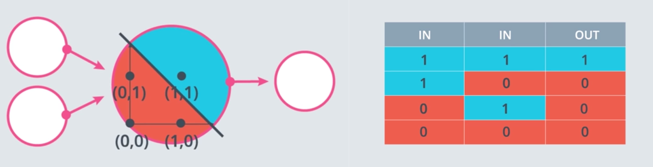

AND to OR

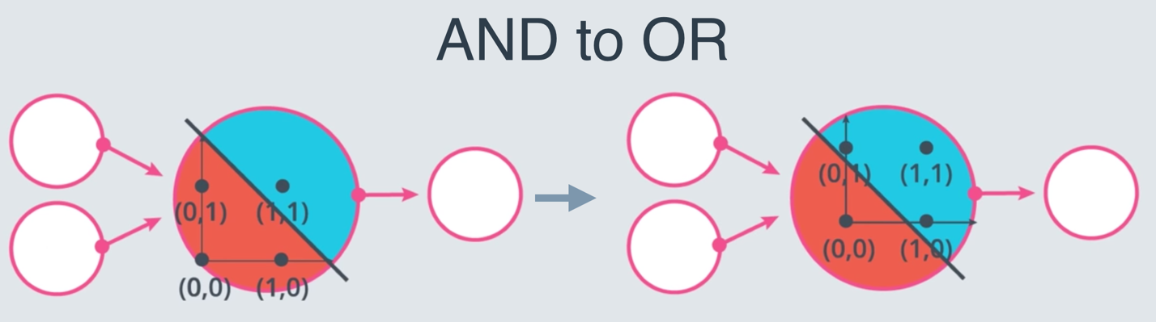

OR Perceptron

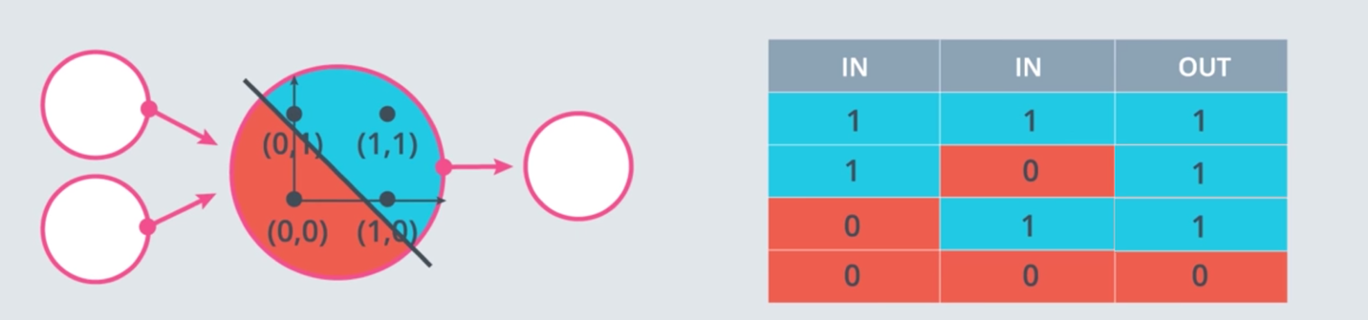

XOR

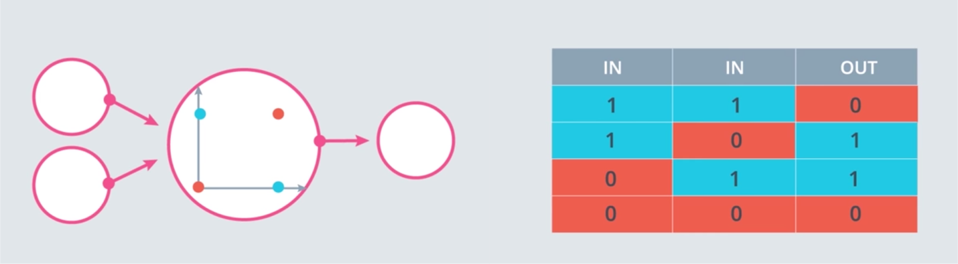

**Quiz: Build an XOR Multi-Layer Perceptron**

Now, let's build a multi-layer perceptron from the AND, NOT, and OR perceptrons to create XOR logic!

The neural network below contains 3 perceptrons, A, B, and C. The last one (AND) has been given for you. The input to the neural network is from the first node. The output comes out of the last node.

The multi-layer perceptron below calculates XOR. Each perceptron is a logic operation of AND, OR, and NOT. However, the perceptrons A, B, and C don't indicate their operation. In the following quiz, set the correct operations for the perceptrons to calculate XOR.

[[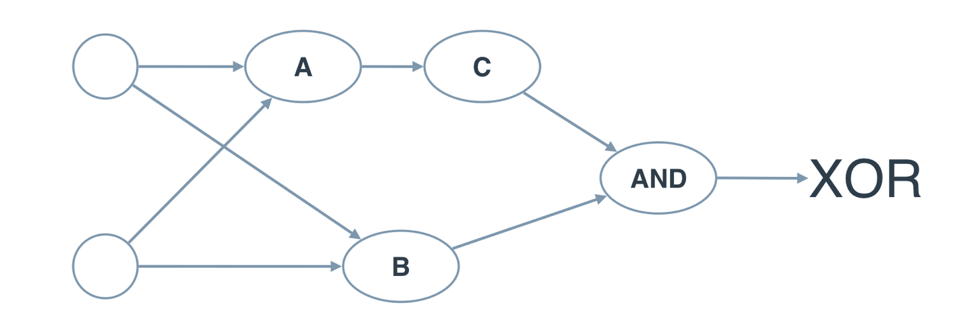](https://classroom.udacity.com/me)](https://classroom.udacity.com/me)

And if we introduce the **NAND** operator as the combination of **AND** and **NOT**, then we get the following two-layer perceptron that will model **XOR**. That's our first neural network!

