**2.Class Diagram and Solution**

**2.1.Solution**

**2.1.1. Beginning**

**2.1.1.1.** Create classes for people and its subclasses, films and its subclasses, class Methods and class Main.

**2.1.1.2.** Take the people.txt ,films.txt and commands.txt as a command-line argument and assign them to arrays.

**2.1.2. People class creation process**

**2.1.2.1.** I have defined these attributes as private because they are special attributes belonging to this class

**2.1.2.2.** I added the get methods that I need to use in this class as methods.

**2.1.2.3.** I created the User and Artist, which are subclasses of this class.

**2.1.2.3.1.** I have defined public rate hashmap attribute for User. This attribute stores the rate of the users and it is okay to change it.

**2.1.2.3.2.** Artist class has three subclasses which are Performer, Writer and Director.I created this class to keep its subclasses together.

**2.1.2.3.2.1.** I have defined this attribute as private for Director because it is special attribute belonging to this class. I also defined get method for this.

**2.1.2.3.2.2.** I have defined this attribute as private for Writer because it is special attribute belonging to this class. I also defined get method for this

**2.1.2.3.2.3.** Performer class has three subclasses which are Actor, ChildActor and StuntPerformer. I created this class to keep its subclasses together.

**2.1.2.3.2.3.1.** I have defined this attribute as private for Actor because it is special attribute belonging to this class. I also defined get method for this.

**2.1.2.3.2.3.2.** I have defined this attribute as private for ChildActor because it is special attribute belonging to this class. I also defined get method for this.

**2.1.2.3.2.3.3.** I have defined these attributes as private for StuntPerformer because it is special attributes belonging to this class. I also defined get method for this.

**2.1.3. Film class creation process**

**2.1.3.1** I have defined these attributes as private because they are special attributes belonging to this class. In addition to these attributes, I added a few more public attributes that will useful for me in my methods. I kept the average ratings of the films in rating_score. I added the filmtype attribute to get the movie types easier in printing to the file. The count_of_rate attribute is required to calculate movie scores.

**2.1.3.2** I added the get methods that I need to use in this class as methods. I also added the set method of the runtime attribute because I will have to edit this method in Short Film. I added the rating method to change the average score of the movies when users vote. edit_rating updates the movie's score by taking users' old scores and new ratings as parameters. remove_rating takes the score given by the user as a parameter and updates the score of the movie. At this stage, I could write a more advantageous code by adding the users' scores to a hashmap attribute in the movie class and without taking parameters. I added the viewfilm method to use it in subclass. This method is required for the viewfilm command to run. I will not mention this method again when describing subclasses.

**2.1.3.3** Film class has four subclasses which are Feature, Documentary, Short and TV_series.

**2.1.3.3.1** I have defined these attributes as private for Feature because it is special attributes belonging to this class. I also defined get method for this.

**2.1.3.3.2** I have defined these attributes as private for TV_series because it is special attributes belonging to this class and I defined additional attribute number_of_series which is public and static attribute , it represent the count of all series . I also defined get method for this.

**2.1.3.3.3** I have defined this attribute as private for Documentary because it is special attribute belonging to this class. I also defined get method for this.

**2.1.3.3.4** I have defined these attributes as private for Short because it is special attributes belonging to this class I defined additional attribute control_runtime which is public attribute , it represents the short film’s runtime is no longer than 40 with boolean. I also defined get method and runtime’s set method for this.

**2.1.4. Methods Class**

**2.1.4.1.** I concated Performers in ArrayListwith concatPerformer method**.**

**2.1.4.2.** I find User with given IDs with findUser method.

**2.1.4.3.** I find Film with given IDs with findFilm method.

**2.1.4.4.** I check the people who mentioned in the movie with Control methods.

**2.2.Class Diagram**

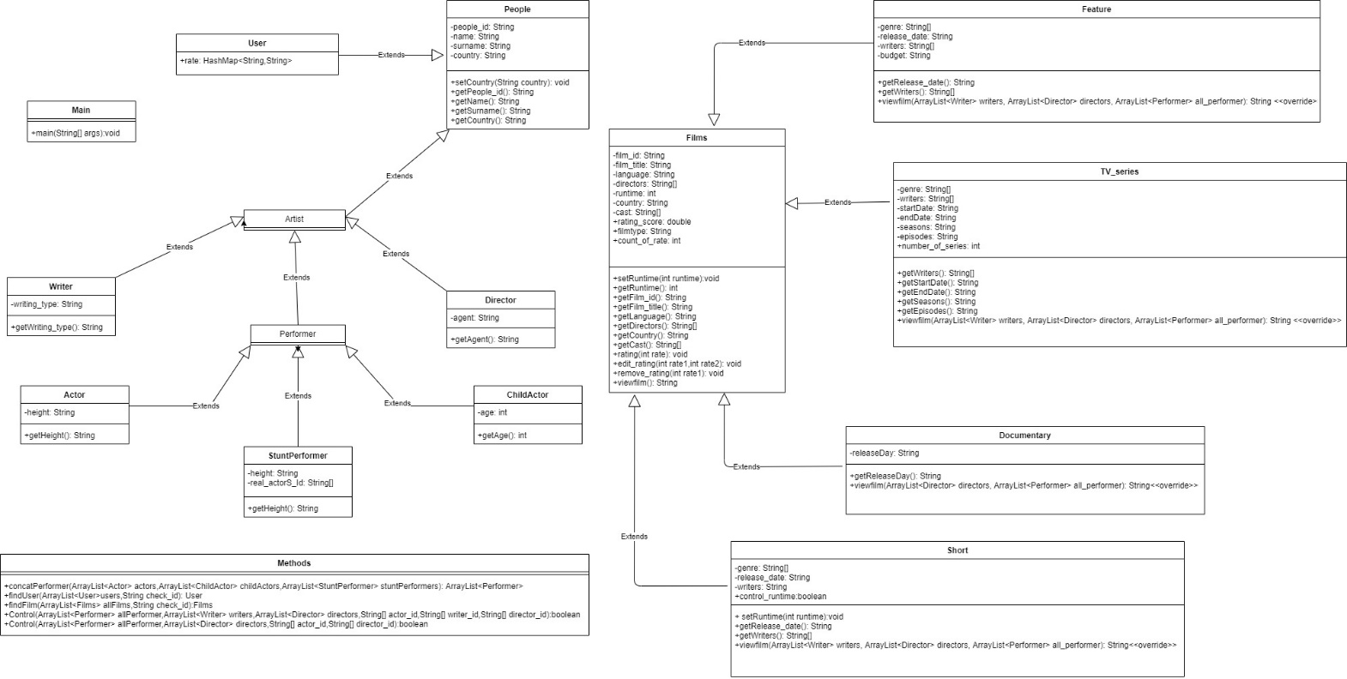

**3.Comments**

In this program, I created a movie database system with inheritance. It has a structure with people, movies and their subclasses. In solving this problem, users rated the movies. I think it would be better if the players could also vote. We could also allow voters to vote with age restrictions, for example, those over 18 could vote on romantic movies, and those under 18 could vote on children's movies.

**4.References**

[**https://www.w3schools.com/java/java_hashmap.asp**](https://www.w3schools.com/java/java_hashmap.asp)

[**https://www.tutorialspoint.com/java/java_files_io.htm**](https://www.tutorialspoint.com/java/java_files_io.htm)