|  |
| --- |
| **HACETTEPE UNIVERSITY**  **COMPUTER SCİENCE AND ENGİNEERİNG DEPARTMENT**  **NAME-SURNAME :** Şura Nur ERTÜRKMEN  **IDENTITY NUMBER :** 21946127  **COURSE :** BBM104  **EXPERİMENT :** Programming Assignment III  **SUBJECT :** Polymorphism, Exceptions  **DATA DUE :** 07.05.2021  **ADVİSORS :** Bahar GEZİCİ  **E-MAİL :** suraerturkmen@gmail.com  **MAİN PROGRAM :** A war game |

2.Software Design Notes

2.1 **Problem :** A war between two sides. Borh of them sides have three types characters. The game is played on a board. The sides are called ZORDE and CALLİANCE. When any side's characters die completely the game is over and the survivor wins.

2.2 **Solution:**

2.2.1 **Create object :** Firstly I read the initials file and create the characters. The character Calliance has three types character. These are Elf,Human and Dwarf. The character Zorde has three types to. These are Goblin,Troll and Ork.

2.2.2 **Read commands and move :** With the commands file the characters move on the board. In my solution I found the characters with found loop their name and match them with their character object with hashmap. When the character tries to go out of the board I catch it with Arrayoutofbound Exception. If the character’s move sequences are not correct(it mean the constant sequences are not correct) I throw an exception which name is myException. I created before this exception class.

2.2.3 **War :** Each of characters have hp and ap. The ap is attack power of the characters. The hp is healthy of the characters and it is decrease with enemy ap. I added Constant class the characters initials hp. I used ap and hp with this class instance for Attack, RangeAttack and fightToDeath methods and create the character objects with hp. The game has some special cases.

2.2.3.1 **Attack :** When the characters move on the board, they attack to neighboor cell enemy. I provided it with Attack methods in the subclasses of characters which are zorde and calliances. The Elf characters has ranged attack at the last attack. It range attack two cell away from itself so I created RangeAttack method in the Elf class.

2.2.3.2 **Fight to Death :** When any character want to move enemy cell, they must fight to death. I maked it with fightToDeath methods in the subclasses of the characters which are zorde and calliances. I also override this method in their subclass because the character must attack to enemy before fight to death.

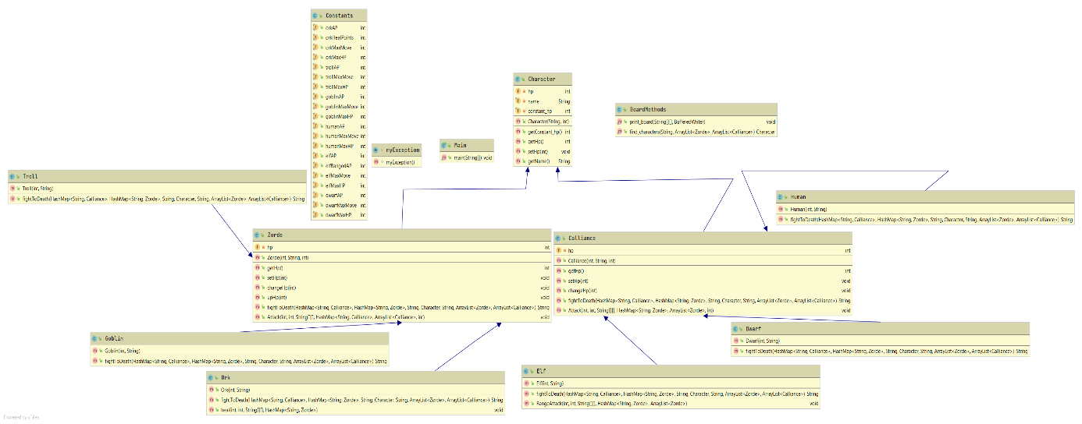

2.2.4 My classes:

2.2.4.1 Character class is super class. It contains character’s hp,name and constant_hp(It is for print the initial hp) instance variable and get/set methods.

2.2.4.2 Zorde is subclass of character class. It also contain character’s hp because it is easy to get hp for me but I could only write hp in Character class and I could use hp with getHp() method and this class contains get/set method, changHp method which decrease the characters hp method, upHp method which increase the characters hp method, fightToDeath and Attack(I mentioned them 2.2.3).

2.2.4.2.1 Troll is subclass of Zorde it has figthToDeath method which is override method.

2.2.4.2.2 Goblin is subclass of Zorde it has figthToDeath method which is override method.

2.2.4.2.3 Ork is subclass of Zorde it has figthToDeath method which is override method and heal method heal the neighboor cells characters before the orks move sequences.

2.2.4.3 Calliance is subclass of character class. It also contain character’s hp because it is easy to get hp for me but I could only write hp in Character class and I could use hp with getHp() method and this class contains get/set method, changHp method which decrease the characters hp method, upHp method which increase the characters hp method, fightToDeath and Attack(I mentioned them 2.2.3).

2.2.4.2.1 Dwarf is subclass of Calliance it has figthToDeath method which is override method.

2.2.4.2.2 Human is subclass of Calliance it has figthToDeath method which is override method.

2.2.4.2.3 Elf is subclass of Calliance it has figthToDeath method which is override method and RangeAttack method attack to range 2 cells, it is special case for elf.

2.2.4.4 BoardMethods class has two method. First one is print_board method. When it is called , it print the board. Second one is find_characters if find the characters type Zorde or Calliances, I use it for find the enemy character to move cell.

2.2.4.5 Constants class has constant values which are AP,MAXHP,MAXMOVE and HEALPOİNTS(it is used only ork).

2.2.4.6 I create an Exception class which name is myException. I use it for move secquences error.