**Programming Questions**

1. Develop a car rental Restful API using Express Router. Use promises.

* Get / post / Put / Delete

1. Find the Fibonacci number, make sure your program supports asynchronous.

**Short Answers**

1. What is event loop, and how does it work?

**Event loop -** A loop that picks events from the event queue and pushes their callbacks into the call stack

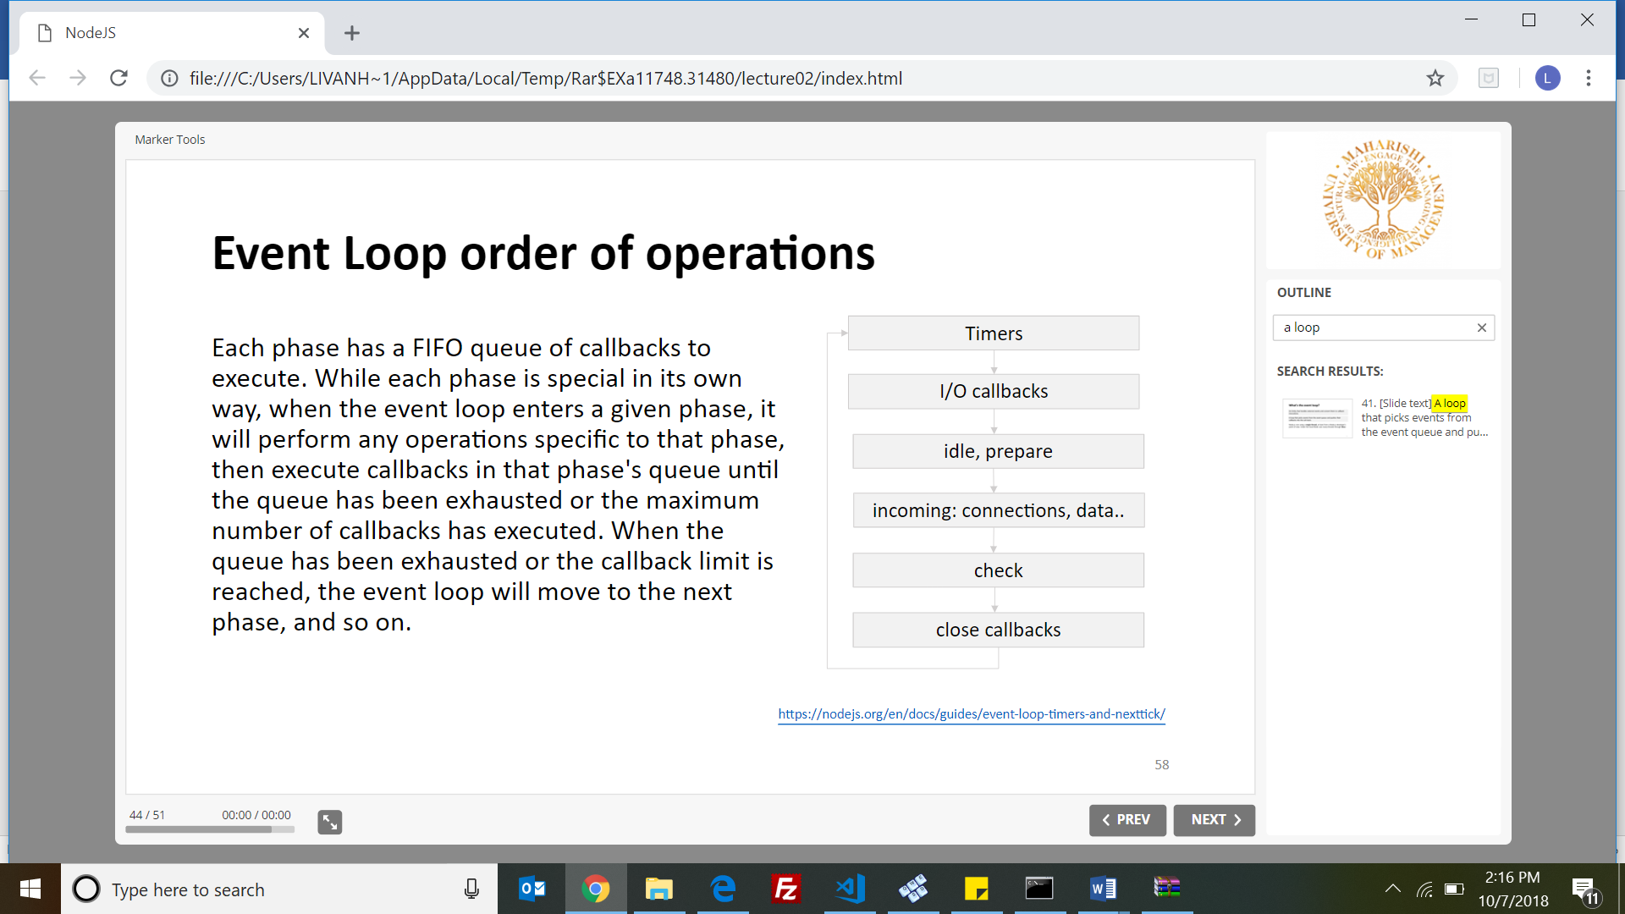

1. Write 6 global objects in node is?

Buffer, Console, URL, URL SearchParams, Global, Process,require,module

1. how does require () method works?

1.Resolve 2.Load 3.Wrap 4.Evaluate 5.Cache



1. What is the use of JSONP, and how does it work, and do we need to configure the server to start?



JSONP is a lightweight format that is used for data interchanging.



JSONP is a way to fetch JSON data from a different domain, often in an asynchronous way, but without being restricted by the browser’s same-origin policy like you would be with XMLHttpRequest.



No, we don’t need to start it.

1. d/c b/n setTimeout and setImmediate.

setImmediate: goes directly to the cache,.

setTimeout: goes to timer

1. What is the difference between these two queries?

db.col.find( { price: { $not: { $gt: 1.99 } } } )

db.col.find( { price: { $lte: 1.99 } } )

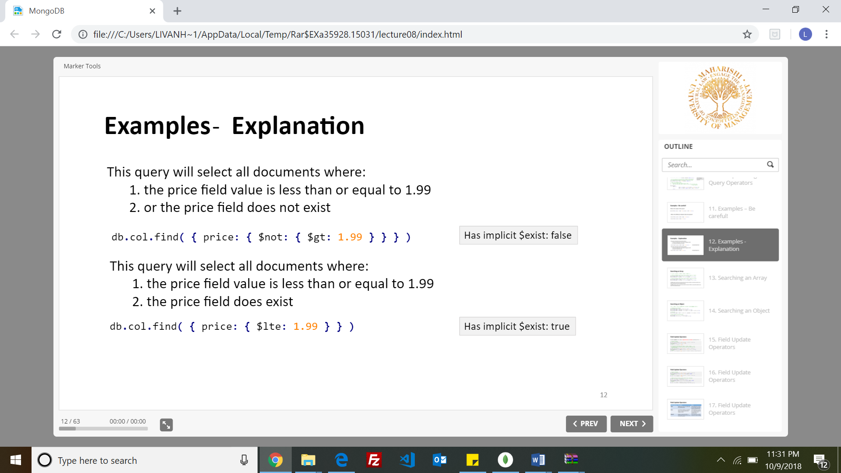

**Multiple Questions**

1. What is the Use of pipe in stream?

method used to connect two streams.

1. Which one is not http methods?

**Safe methods** are HTTP methods that do not modify resources. E.g OPTIONS, GET, HEAD

**idempotent HTTP method** is a HTTP method that can be called many times without different outcomes.

1. What is use of. on method in event emitters?

**EventEmitter object:**

•It has **.emit()** on the prototype using .call() .apply() to invoke all the listeners functions.

•It has **.on()** which is a shortcut to addListener() function also on the prototype.

1. Why node js is fast though it is written JavaScript?

Because its built on Google Chrome's V8 JavaScript Engine and its non-blocking.

1. How do we achieve scalability in node js.

We can achieve scalability for our Node application in three ways:

•Cloning (using multi processors on single machine)

•Decomposing (micro services)

•Sharding (using multi machines)

1. Process.nextTick persistently block the I/0 operations? T/F

True.

**Definition: process.nextTick()** is not part of the event loop, it adds the callback into the nextTick queue.

1. Where do we find package.json

In the npm: Node Package Manager

**npm init**

**Mango DB questions**

1. What is the output of the following queries?
2. Difference between push and addToSet?

Difference between push and addToSet is that push doesn’t check for duplicates and it just adds the same. . addToSet adds by checking for duplicates

1. What is the output of the index?
2. Aggregate queries and outputs
3. Updating data using set in a query

=================================================================

**Notes from eden**

**Set**

**Inc**

**Search in arrays or crud operations**

**Indexing, know all d/cs b/n them**