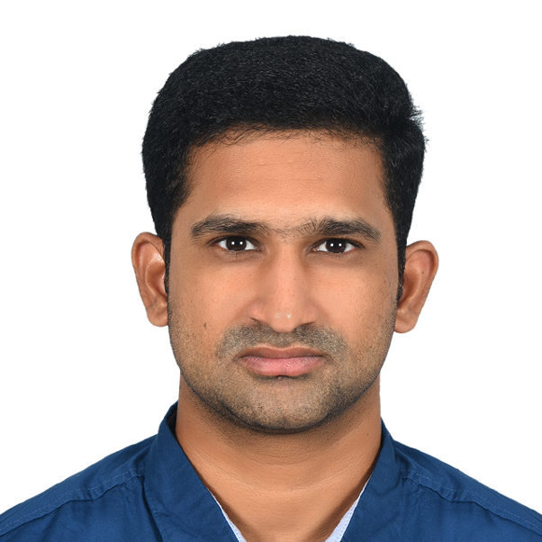

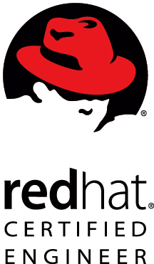
CURRICULAM VITAE
Janakiram Suragani
Mobile: +971 588531465, +91 9700944779 Email:suraganijanakiram@gmail.com

PROFESSIONAL SUMMARY

- I have around 12 years of industry experience in Linux, Cloud, Datacenter, VMware, Devops and shell scripting.
- Having good knowledge of ITIL and Agile (scrum) methodologies.
- Good experience in 24/7 production environment support / Data Center Operations.
- Creating the SOP and process by aligning with teams and sharing with the team.
- Acting as team leader and moving the team forward for good results.
- Troubleshooting server-based problems with root cause analysis.
- Experience in resolving the issues on LVM and RAID.
- Performance and network monitoring using netstat, iotop, top, htop, iftop,Tracert and sar.
- Installing and configuring servers, applications like DNS, Syslog, FTP, Apache, VNC, Samba, NFS, Tomcat, Mysql, PhP, phpmyadmin, DHCP etc.
- Installing and configuring Monitoring tools like Nagios, MRTG, Cacti, monit and Bandwidthd.
- Running the scripts like apachetuner, mysqltuner and mem.py for tuning.
- Installing/ updating packages in Linux through YUM, RPM and apt-get.
- Scheduling of tasks using crontab and taking backups with tar and scp.
- Having Knowledge on BASH Shell Scripting and basic ansible automation to simplify the tasks.
- Good in Communication and willing to learn new technologies which boost up my career.
- Maintaining a blog in my free time for Linux https://linuxscripts.blogspot.com
- Written shell scripts and kept them in GITHUB https://github.com/suraganijanakiram

Educational Qualifications

- B.Tech (CSE) from JNTU Kakinada University with 65%.
- Board of Intermediate Education, A.P. (MPC) with 70%.
- Board of secondary Education, A.P. (10th) with 76%.

Certification
- RHCE (Red Hat Certified Engineer) on Enterprise Linux V 6.0. #140-026-360
- ITIL (foundation certified) GR750256353JS
- G42Cloud certified Associate
- OCI fundamental associate
- Azure solution architect

WORK EXPERIENCE

- Working as Platform support Team at Tesnus, Abu Dhabi from April 2025 till to date [ Moved to this from G42 as part of the project transfer].

Operating Systems : Red Hat Linux, UBUNTU, EulerOS and CentOS
Programming languages : BASH Shell Scripting.
Ticketing Tool : Jira
Designation : system administrator/ platform support engineer
Period : April 2025 - March 2025.
Roles and Responsibilities

- Installing and managing Linux servers like dedicated, Virtual and G42cloud cloud.
- Responsible for monitoring zabbix and uptime of servers and services.
- Monitoring cloud scope
- maintaining different tools like Grafana, DNS, SMTP with OpenDKIM, LAMP services, bareos, dockers and containerizing applications etc.
- Responsible for preparing the proper documentation after the implementation of tools and services.
- Installing docker swarm cluster and deploy application.
- Installing glusterfs and giving the storage to dockers for persistence storage.
- Deploying applications like Grafana, draw.io, mysql, pgsql as a stack in the docker swarm cluster with persistence storage.

- I worked as System administrator at G42cloud, Abu Dhabi from June 2022 March 2025.

Operating Systems : Red Hat Linux, UBUNTU, EulerOS and CentOS
Programming languages : BASH Shell Scripting.
Ticketing Tool : Jira
Designation : system administrator
Period : June 2022 to March 2025.

Roles and Responsibilities

- Installing and managing Linux servers like dedicated, Virtual and G42cloud cloud.
- Responsible for monitoring Zabbix and uptime of servers and services.
- Monitoring cloud scope
- maintaining different tools like Grafana, DNS, SMTP with OpenDKIM, LAMP services, bareos, dockers and containerizing applications etc
- Responsible for preparing the proper documentation after the implementation of tools and services.
- Installing docker swarm cluster and deploy application.
- Installing glusterfs and giving the storage to dockers for persistence storage.
- Deploying applications like grafana, draw.io, mysql, pgsql as a stack in the docker swarm cluster with persistence storage.
- Adding nodes to the docker cluster and troubleshooting if any issues.
- Applying patches to the docker servers.
- Writing yml files as per the need to deploy the applications in the docker swarm.

- I worked as Linux Support Engineer II at Rackspace Technologies (Datacenter services), Bangalore from FEB 2021 to May 2022.

Operating Systems : Red Hat Linux, UBUNTU and centos
Programming languages : BASH Shell Scripting.
Ticketing Tool : Service Now, Core and Encore (internal tools)
Designation : Linux Support Engineer
Period : Feb 2021 to May 2022.

Roles and Responsibilities

- Installing and managing Linux servers like dedicated, Virtual and Rackspace cloud.
- Delivering the product based on ITIL process.
- Troubleshooting client issues supporting 10000+ customers.
- Coordinating with clients on calls and meetings for resolution of client issues.
- Supporting client in a 24/7 production environment / Data Center Operations.
- Coordinating with vendor for critical issues and bug fixes.
- Coordinating with different teams to resolve the issues of client through ticketing tool.
- Installing and troubleshooting Ftp, MySQL, php, phpmyadmin, VNC, Apache, NTP, NFS, dockers
- Performance monitoring using recap, systat etc
- Installing and troubleshooting php-fpm, memcached and redis etc

- I Worked as Sr Eng IT Engn at GLOBAL FOUNDRIES (Semiconductor manufacturing Company), Bangalore from April 2019 to Feb 2021.

Operating Systems : Red Hat Linux, CentOS
Programming languages : Shell Scripting.
Ticketing Tool : Service Now.
Designation : Sr Eng IT Engn
Period : APR 2019 to FEB 2021.

Roles and Responsibilities

- Installing Linux OS on physical servers manually and supporting them.
- Configuring the ILO, RAID controllers during the build phase and make sure they comply with the company standards.
- Creating Vm’s using templates manually and supporting them.
- Installing and configuring Grafana, influx dB and telegraf setup for performance monitoring.
- Adding the server into Grafana for performance monitoring and creating the dashboards in Grafana.
- Installed and tested ELK stack for configuring the monitoring
- Creating the vm’s in the RHEV environment.
- Deploying the telegraf client using the ansible role.
- Maintaining 99% uptime of the fabrication servers which are critical manufacturing servers of semiconductors.
- Installation and configuration of ansible tower.
- Maintaining the sftp server’s uptime and resolving the client issues.

- I worked as Sr Systems Mgmt Analyst at Optum (United health group), Hyderabad from OCT 2016 to APR 2019.

Operating Systems : Red Hat Linux.
Programming languages : Shell Scripting.
Ticketing Tool : Service Now.
Designation : Sr Systems Mgmt Analyst
Period : OCT 2016 to APR 2019.
Roles and Responsibilities

- Joined as Systems Mgmt Analyst and promoted to Sr Systems Mgmt Analyst.
- Managed a team of 10 members as the lead.
- Installing OS on physical servers manually, by using foreman tool and supporting them.
- Configuring the ILO, RAID controllers during the build phase and make sure they comply with the company standards and deploying the OS with foreman.
- Creating VM using templates manually and supporting them.
- Basic administration of VMware like adding disk and checking logs etc.
- Following Agile Scrum methodology for the delivery of the products.
- Working totally on night shifts to support the US clients.
- Updating the scrum master with all the project deliverables and meeting the deadlines.
- Troubleshooting client issues raised in service now Ticketing Tool.
- Coordinating with different teams and vendors to resolve issues of client through ticketing tools.
- Automating the tasks with ansible by writing play books and creating pipelines in Jenkins.
- Maintaining the scripts through git and pushing them to the internal GitHub repository.
- Managing build and release with HPSA and HPOV monitoring tools.
- Creating, Extend and Reducing the LVM.
- Package management using yum, rpm and apt-get.
- Troubleshooting on Operating system issues, works with OEM for quick resolution if required.
- Monitoring the system’s performance using top, iftop, netstat, sar etc

- I worked as Linux Engineer at CTRLS DATA CENTER’s, Hyderabad from NOV 2015 to OCT 2016.

Operating Systems : Red Hat Linux, Cent OS and Ubuntu.
Programming languages : Shell Scripting.
Ticketing Tool : Kayako.
Designation : Linux Engineer.
Period : Nov 2015 to OCT 2016.

Roles and Responsibilities

- Installing and managing Linux servers.
- Supporting different Banking and finance clients like Bandhan bank etc
- Delivering the product based on ITIL process.
- Troubleshooting client issues raised in KYAKO Ticketing Tool supporting 3000+ customers.
- Supporting client in a 24/7 production environment / Data Center Operations.
- Coordinating with different teams to resolve the issues of clients through ticketing tool.
- Writing required shell scripts when needed.
- Installing and troubleshooting Ftp, MySQL, php, phpmyadmin, VNC, Apache, Tomcat, NTP, NFS, csf etc.
- Maintaining mail servers like squirrel mail and Qmail.
- Installing and maintaining Syslog, MRTG and Nagios.
- Checking the logs for application related issues and troubleshooting them.
- Creating, Extend and Reducing the LVM.
- Configuring RAID on servers based on client requirement and checking the server’s via KVM for hardware related issues.
- Package management using yum, rpm and apt-get.
- Maintain DNS services through Smbind.
- Taking backup by compressing size of data using tar and zip.
- Troubleshooting of servers by taking KVM Switch when required.
- Troubleshoot the servers directly by going into the data center when kvm switch is not available.
- Monitoring the systems performance using top, iftop, netstat, sar etc.
- Written shell scripts to run and configure the MRTG on a switch.

- I worked as a Trainee Network Engineer at Voxvalley Technologies, Hyderabad from Mar 2014 to NOV 2015.

Operating Systems : Cent OS and Ubuntu.
Programming languages : Shell Scripting.
Ticketing Tool : Kayako.
Designation : Trainee-Network Engineer.
Period : Mar 2014 to Nov 2015.

Roles and Responsibilities

- Installing and managing Linux servers.
- Installation of windows xp,7,8,10 and software management in them.
- Performing system Administration tasks like maintaining and monitoring day-to-day activities.
- Writing required shell scripts when needed.
- Configuring the network cables, crimping the cables as per the need like straight and cross cables etc.
- Package management using yum, rpm and apt-get.
- Installing and configuring servers like FTP, Apache, MySQL, VNC server.
- Troubleshooting and monitoring the VOIP servers in which the application was running.
- Managing users by creating, modifying their properties and deleting them.
- Creating partition by using fdisk. Formatting partition by using mkfs.
- Managing the hard disk space by using LVM and RAID.
- Taking backup by compressing size of data using tar and zip.
- Taking MySQL backups and restoring them
- Installing and configuring Nagios server and client for email alerts and troubleshoot Nagios alerts.

PERSONAL DETAILS
Name : Suragani Janakiram
Father Name : S. Narasimharao
Sex : Male
Marital Status : Married
Nationality : Indian
Passport No : W0508182
Date Of Birth : 12-11-1992

