TOPIC: ENVIRONMENTAL MONITORING

**Project Documentation & Submission**

1 .DOCUMENTATION :

• Describe the project's objectives, IoT device deployment, platform development, and code implementation.

• Include diagrams, schematics, and screenshots of the IoT devices, environmental monitoring platform, and data display.

• Explain how the real-time environmental monitoring system benefits park visitors and promotes outdoor activities.

2 .SUBMISSION :

• Share the GitHub repository link containing the project's code and files.

• Provide instructions on how to replicate the project, deploy IoT devices, develop the environmental monitoring platform, and integrate them using Python.

• Include example outputs of IoT device data transmission, platform UI, and environmental data display

1 .DOCUMENTATION :

Project Objectives:

The project aims to develop an environmental monitoring system using IoT (Internet of Things) devices ie ESP32 Audrino and web technology(html , css and javascript) . The primary objectives of the project include:

ENVIRONMENTAL DATA COLLECTION: Collect real-time data on various environmental parameters, such as temperature and humidity using sensors

DATA VISUALIZATION: Create a user-friendly platform for visualizing the collected data through graphs, charts, and statistics to provide insights into environmental conditions.

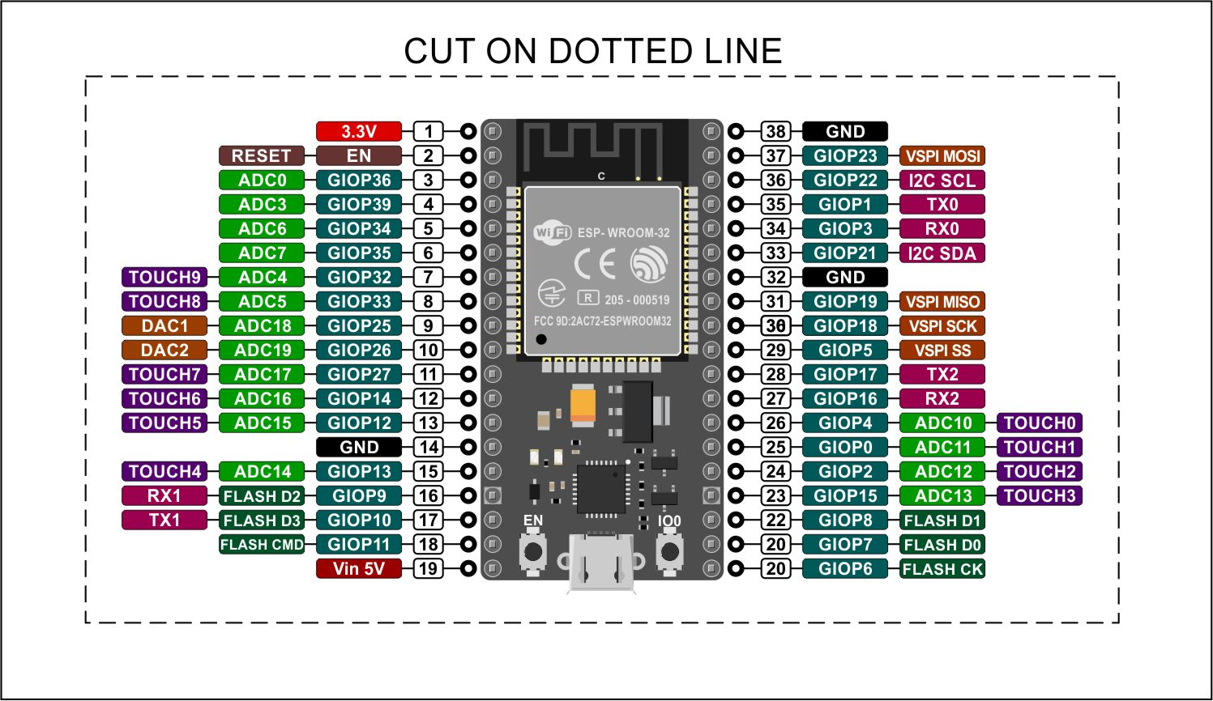

Fig : ESP 32

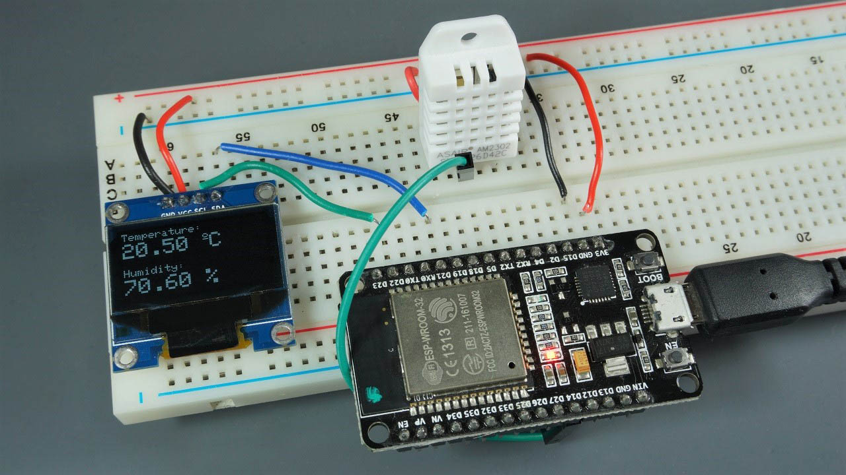

Fig : Showing ESP 32 connected with temperature and humidity sensor and live data displayed to an oled display

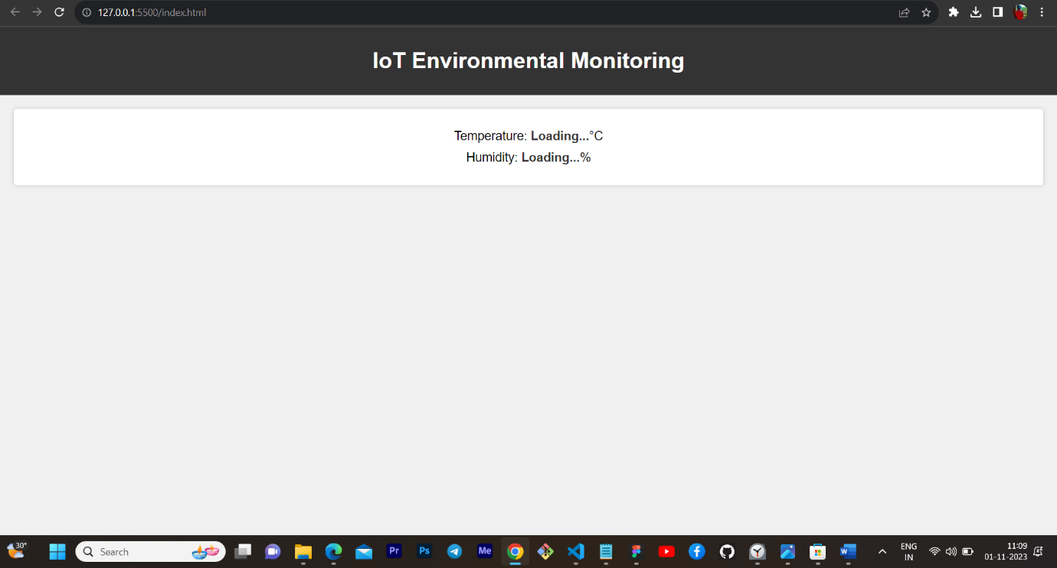

Fig : environment monetering platform using basic html css and javascript

A real-time environmental monitoring system focusing on temperature and humidity can benefit park visitors and promote outdoor activities in the following ways:

ACTIVITY PLANNING:

Knowing the current environmental conditions allows visitors to plan activities that are suitable for the weather. They can choose the best times for hiking, picnicking, or other outdoor activities, optimizing their experience

ENVIRONMENTAL AWARENESS:

Displaying real-time temperature and humidity data can educate visitors about how these parameters affect the park's ecosystem. Visitors gain insights into the park's climate and its influence on plant and animal life.

2 .SUBMISSION :

GIT HUB REPOSITORY LINK :

<https://github.com/suraj-0628/IOT.git>

To replicate the project clone it using the command in your terminal

git clone <https://github.com/suraj-0628/IOT.git>

only consider the necessary code files and avoid docx pptx and any other reference file

deploy the iot devices using wokwi

wokwi code is given below : use it for simulation

https://wokwi.com/projects/345395196387656275

The code for environment monetering platform is also uploaded on the repository and is mentioned in IOT_Phase4.docx

Clone it from the git hub repo mentioned above or copy from IOT_Phase4.docx in the same repo