content

S.NO. | TITLE OF EXPERIMENT | PAGE NO. | SIGN.
1. | Study of multiplexer and demultiplexer. | 2-3
2. | Study of half Adder and half subtractor. | 3-4
3. | Explain full Adder and Full Subtractor. | 4-5
4. | WAP to add 8 bit number and store result in location 2000. | 5-6
5. | WAP to multiply two 8 bit numbers stored at memory location 2000 and 2001 and stores the result at memory location 2000 and 2001 | 6-7
6. | Implement a c++ program to conversion of number system. | 7-8
7. | Multiplication of two binary numbers (signed) using Booth’s Algorithms. | 9-10
8. | Assume that 3 bytes of data are stored at consecutive memory addresses of the data memory starting at 2000. Write a program which loads register C with (2000), i.e. with data contained at memory address2000, D with (2001), E with (2002) and A with (2001 | 11-12
9. | Implement Logic gates using NAND and NOR gates. | 13-14
10. | Design a Full adder using gates. | 15-16

- Study of multiplexer and demultiplexer.

Multiplexer :

A multiplexer is a data selector which takes several inputs and gives a single output. In multiplexer, we have 2n Input lines and 1 output lines where n is the number of selection lines.
The single-pole multi-position switch is a simple example of a non-electronic circuit of the multiplexer, and it is widely used in many electronic circuits. The multiplexer is used to perform high-speed switching and is constructed
by electronic components.

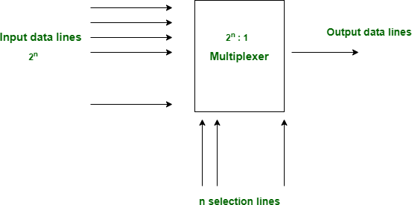

Demultiplexer :

Demultiplexer is a data distributor which takes a single input and gives several outputs. In demultiplexer we have 1 input and 2n output lines where n is the selection line.

It is used to send a signal to one of the many devices. The main difference between a multiplexer and a de-multiplexer is that a multiplexer takes two or more signals and encodes them on a wire, whereas a de-multiplexer does reverse to what the multiplexer does.

Given below is the block diagram of the Demultiplexer, It will have one Input line and will give 2n output lines.
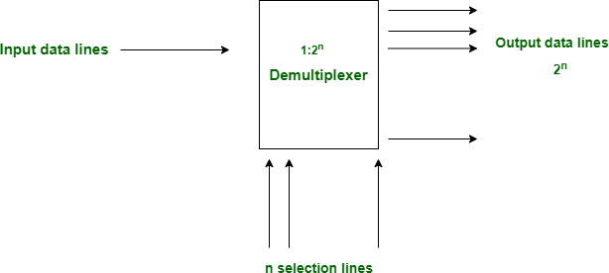

- Study of half Adder and half subtractor.
- Half Adder :
The Half-Adder is a basic building block of adding two numbers as two inputs and produce out two outputs. The adder is used to perform OR operation of two single bit binary numbers. The augent and addent bits are two input states, and 'carry' and 'sum 'are two output states of the half adder.

Block diagram

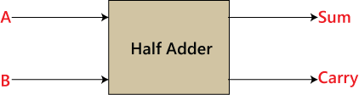

Truth Table
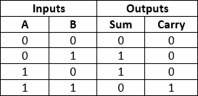

In the above table,

  - 'A' and' B' are the input states, and 'sum' and 'carry' are the output states.
  - The carry output is 0 in case where both the inputs are not 1.
  - The least significant bit of the sum is defined by the 'sum' bit. The SOP form of the sum and carry are as follows:
Sum=x'y+xy' Carry = xy
Half Subtractor :
The half subtractor is also a building block for subtracting two binary numbers. It has two inputs and two outputs. This circuit is used to subtract two single bit binary numbers A and B. The 'diff' and 'borrow' are two output states of the half subtractor.

Block diagram

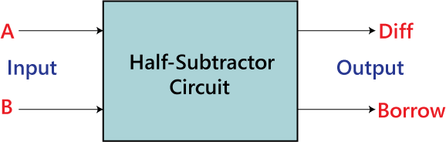

Truth Table
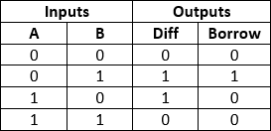

The SOP form of the Diff and Borrow is as follows:
Diff=A'B+AB'
Borrow = A'B
In the above table,

- 'A' and 'B' are the input variables whose values are going to be subtracted.
- The 'Diff' and 'Borrow' are the variables whose values define the subtraction result, i.e., difference and borrow.
- The first two rows and the last row, the difference is 1, but the 'Borrow' variable is 0.
- The third row is different from the remaining one. When we subtract the bit 1 from the bit 0, the borrow bit is produced.

Explain full Adder and Full Subtractor.

Full Adder:
The half adder is used to add only two numbers. To overcome this problem, the full adder was developed. The full adder is used to add three 1-bit binary numbers A, B, and carry C. The full adder has three input states and two output states i.e., sum and carry.

Block diagram
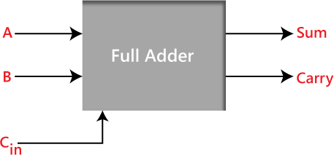

Truth Table
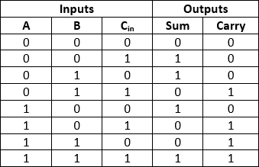

In the above table,

  - 'A' and' B' are the input variables. These variables represent the two significant bits which are going to be added
  - 'C_{in}' is the third input which represents the carry. From the previous lower significant position, the carry bit is fetched.
  - The 'Sum' and 'Carry' are the output variables that define the output values.
  - The eight rows under the input variable designate all possible combinations of 0 and 1 that can occur in these variables.

Full Subtractor :

The Half Subtractor is used to subtract only two numbers. To overcome this problem, a full subtractor was designed. The full subtractor is used to subtract three 1-bit numbers A, B, and C, which are minuend, subtrahend, and borrow, respectively. The full subtractor has three input states and two output states i.e., diff and borrow.

Block diagram

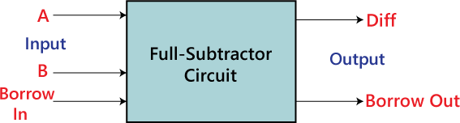

Truth Table
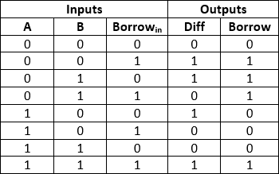

In the above table :

- 'A' and' B' are the input variables. These variables represent the two significant bits that are going to be subtracted.
- 'Borrowin' is the third input which represents borrow.
- The 'Diff' and 'Borrow' are the output variables that define the output values.
- The eight rows under the input variable designate all possible combinations of 0 and 1 that can occur in these variables.

WAP to add 8 bit number and store result in location 2000. start: nop
mvi A,10H sta 1998

;mvi B,12H
;sta 1999 mvi C,34 sta 1999 Add C sta 2000 hlt

Output :
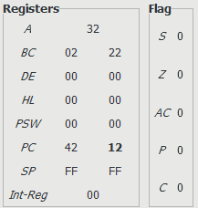
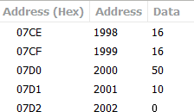

- WAP to multiply two 8 bit numbers stored at memory location 2000 and 2001 and stores the result at memory location 2000 and 2001

start: nop mvi A,5H sta 2000 mvi B,2H sta 2001 mov C,B
label: ADD A dcr C

jz label sta 2001 hlt

Output :
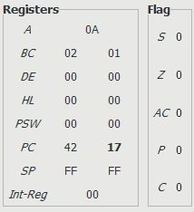
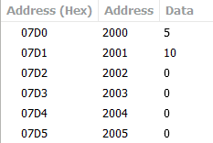

Implement a c++ program to conversion of number system.
#include<iostream> #include<math.h> using namespace std; class conversion{
public:
int num,i=0,j,b=0,c,sum=0;

void bin_to_dec()
{
cout<<"Enter a Binary number : "; cin>>num;
while(num>0)
{
int s=num%10; if(s==1)
{
c=s*pow(2,i);
}
else if(s>1)
{
cout<<"Not a binary number"; break;
}
b=b+c; i=i+1;
num=num/10;
}
cout<<endl<<b;
}
void oct_to_dec()
{
cout<<"Enter a Octal number : ";

cin>>num;
while(num>0)
{
int s=num%10; c=s*pow(8,i); b=b+c;
i=i+1; num=num/10;
}
cout<<endl<<b;
}

void hex_to_dec()
{

char hexval[10];
cout<<"Enter a hexadecimal number : "; cin>>hexval;
int p=0;

int dec_val = 0;

for ( i = 1; hexval[i]!='\0'; i++) { p=p+1;
}
for ( i = 0;hexval[i]!='\0'; i++) {

if (hexval[i] >= '0' && hexval[i] <= '9') { dec_val += (int(hexval[i]) - 48) * pow(16,p); p=p-1;
} else{ if (hexval[i] >= 'A' && hexval[i] <= 'F') { dec_val += (int(hexval[i]) - 55) * pow(16,p); p=p-1;
}

}
}
cout<<dec_val;
}

void dec_to_bin(){
cout<<"Enter a decimal number : "; cin>>num;
while(num>0)
{
c=num%2; sum=pow(10,i)*c+sum; num=num/2;
i++;
}
cout<<sum;
}
void dec_to_oct(){
cout<<"Enter a decimal number : "; cin>>num;
while(num>0)
{
c=num%8; sum=pow(10,i)*c+sum; num=num/8;
i++;
}
cout<<sum;
}
void dec_to_hexa()
{
cout<<"Enter a decimal number : "; cin>>num;
while(num>0)

{
c=num%16; sum=pow(10,i)*c+sum; num=num/16;
i++;
}
cout<<sum;
}};
int main(){
conversion ob; int key;
cout<<"Press key for conversion :\n";
cout<<"1.Binary to Decimal \n2.Octal to Decimal \n3.Hexadecimal to Decimal\n"; cout<<"4.Decimal to binary\n5.Decimal to Octal\n6.Decimal to Hexadecimal\nKEY==";
cin>>key; if(key==1)
ob.bin_to_dec(); else if(key==2)
ob.oct_to_dec(); else if(key==3)
ob.hex_to_dec(); else if(key==4)
ob.dec_to_bin(); else if(key==5)
ob.dec_to_oct(); else if(key==6)
ob.dec_to_hexa(); else
cout<<"wrong key";
}

Output :
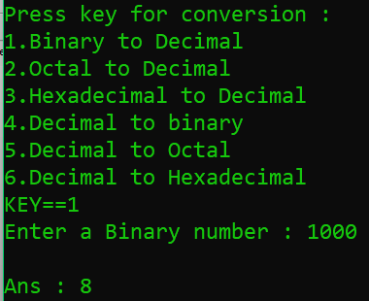

- Assume that 3 bytes of data are stored at consecutive memory addresses of the data memory starting at 2000. Write a program which loads register C with (2000), i.e. with data contained at memory address2000, D with (2001), E with (2002) and A with (2001)

start: nop lda 2000 mov C,A lda 2001 mov D,A lda 2002 mov E,A lda 2003

hlt

Output -
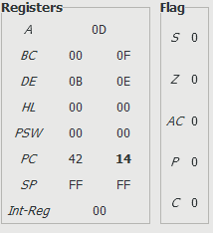
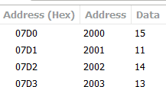

9.Implement logic gates using NAND and NOR gate.

Implement OR gate using Universal gate

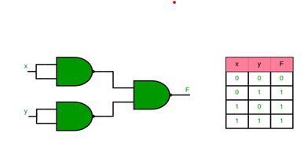
Implement NOR gate using Universal gate

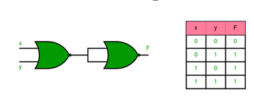

Implement NOT gate using Universal gate

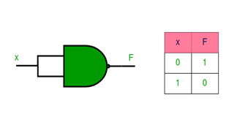

Implement NOR gate using NAND gate

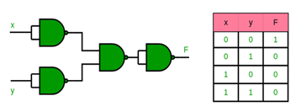

10.Design a full adder using Logic gates.

