Requirement Docmentation

A full stack working website which has diffrent view on mobile

Desktop website

figma link of design

https://www.figma.com/file/nd3RJNJLujLAAL6ZstKY7l/car-blog-real-design-24.12.2022?node-id=0%3A1&t=hWGJ3GcbTHcwJGOR-0

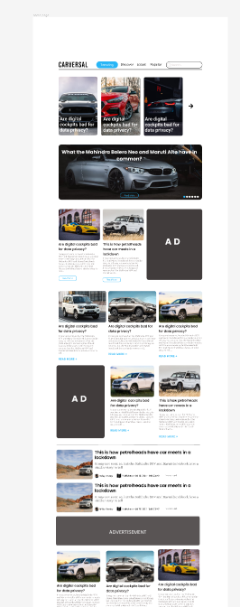
pages need to be made out of this link

On home there will be majorly 4 sections

1. Trending = In trending , blogs will be shown on the basis of time range for eg most viewd blogs in a week will be shown there. This will be our home page with google stories on top .

2. Discover = In discover page , Content will be shown randomly ( scrolling feed for user )

3. Popular = In popular page , our most viewd blogs will be shown in ascending order.

4. Latest = In latest page , our latest uploads will be their

On right it is layout for Home page (Trending)

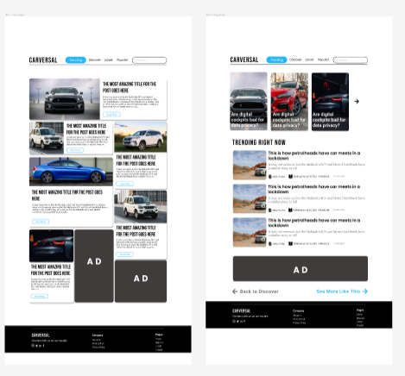

for popular , discover and latest this two layout will be followed

Blog page with editor window only for admin

There will be a add a poll option too in blog editing window for which designs are given in figma .

There should be an option for user to like and share the blog on blog tile.

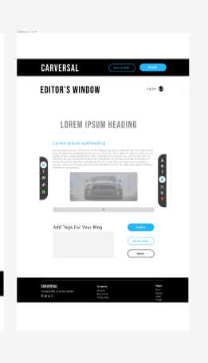
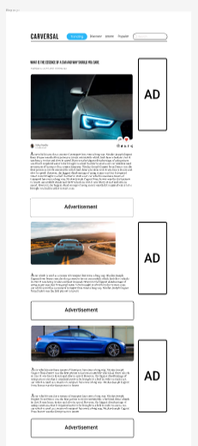

Mobile design

figma link of design

https://www.figma.com/file/EXk9s2Q587noFnX9ZiP0uo/phone-design-24.12.2022?node-id=0%3A1&t=c4O2Kl05bFVuMs7S-1

same 4 major trending . Popular , latest and discover pages will be made

there will be diffrent view on mobile as shown in design but the feature will be same .

Major instructions

1. There will be a dark mode on both mobile and desktop.

2. Admin access should be secure and Login for users

3. Editorial window for blogging and there should be basic function like heading change editing pictures resizing etc.

4. Avoid using third party links (to maintain speed) well not mandatory though

5 . There will be freedom in Tech stacks.

6. all the rights of the website code and other resources will be our after completion of this project

