**CI/CD Pipeline to deploy artifacts to Jfrog Artifactory**

pipeline {

    agent any

    tools{

        maven "M3"

         }

    stages {

        stage ('Git Checkout') {

            steps {

                git 'https://github.com/Saswat93/java-maven-junit-helloworld.git'

            }

        }

        stage ('Maven Build')  {

            steps {

        bat "mvn -Dmaven.test.failure.ignore=true clean package"

            }

        }

                stage ('Upload Artifacts') {

            steps {

                script {

                    def server = Artifactory.server 'artifactory'

                    def uploadSpec = """{

                        "files": [{

                       "pattern": "*",

                       "target": "DALHC/"

                    }]

                 }"""

                 server.upload(uploadSpec)

                    }

                }

           }

           stage ('Postbuild')   {

                steps {

                                   archiveArtifacts 'target/*.jar'

buildJob (‘Job2’)

                }

           }

        }

}

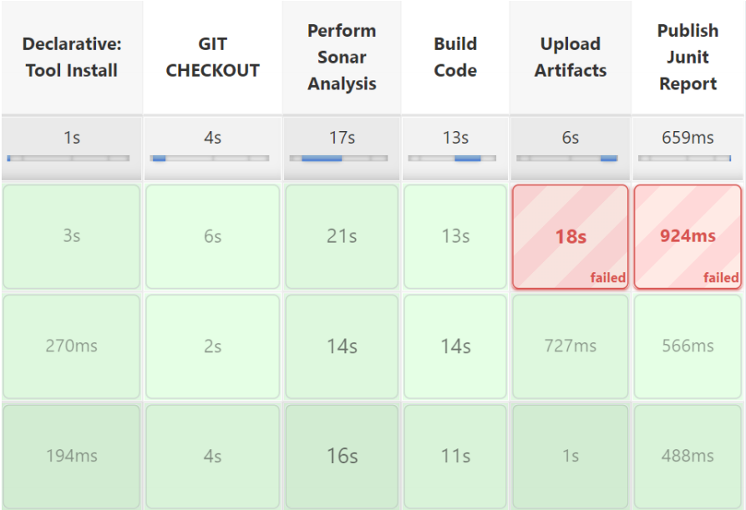

Job2 – This will build the application & build into image and deploy to Kubernetes Cluster provisioned using Terraform (IaC)

node{

    stage ("Git Checkout"){

    git credentialsId: 'GIT_CREDENTIALS', url: ''

}

    stage ("Maven Build"){

        def mavenHome= tool name:"M3" , type: "maven"

        def mavenCMD= "${mavenHome}/bin/mvn"

        sh "${mavenCMD} clean package"

    }

    stage ("Build Docker Image"){

        sh "docker build -t saswat/apple ."

    }

    stage ("Push to docker registry"){

        sh "docker login -u saswatpattnaik21 -p"

        sh "docker push saswat/apple"

    }

}

stage("Deploy To Kuberates Cluster"){

kubernetesDeploy(

configs: 'springBootMongo.yml',

kubeconfigId: 'KUBERNATES_CONFIG',

enableConfigSubstitution: true

)

}