Steps to run the software:

1) Change the directory to the folder containing the jar file.

2) There are five options to run the software:

1. To get the prediction from both the patent and software classifier

**Command: java -jar Combined_Classifier.jar *(path_to_file/filename)***

Example: java jar Combined_Classifier.jar C:\Users\sggattan\Desktop\NASA_files\ aeronautics\a1.html

**Output:**

1. Display the predicted class for both classifiers on the command line.

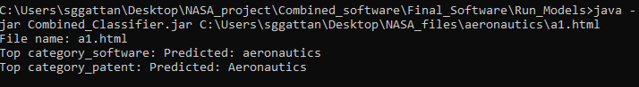

1. Create two files:

**Prediction_Patent_(*filename*)**

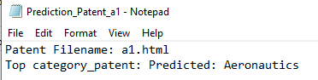

**Prediction_Software_(*filename*)**



1. To get the prediction from patent classifier with the probability for each class

**Command: java -jar Combined_Classifier.jar *(path_to_file/filemame)* -p -pc**

Example: java jar Combined_Classifier.jar C:\Users\sggattan\Desktop\NASA_files\ aeronautics\a1.html -p -pc

**Output:**

1. Display the predicted class and probabilities for patent classifier on the command line.

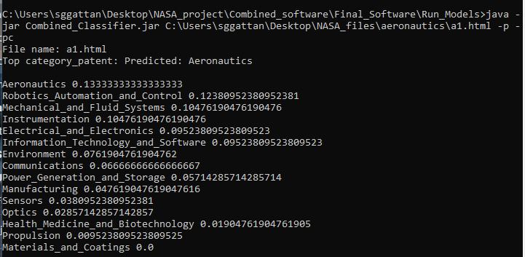

1. Create an output file with name **Prediction_Software_(*filename*)**

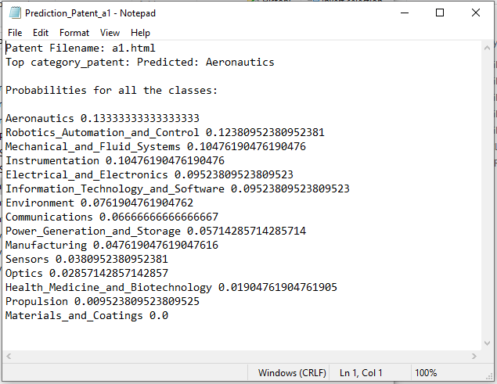

1. To get the prediction from patent classifier with the tag words

**Command: java -jar Combined_Classifier.jar *(path_to_file/filemame)* -t -pc**

Example: java jar Combined_Classifier.jar C:\Users\sggattan\Desktop\NASA_files\ aeronautics\a1.html -t -pc

**Output:**

1. Display the predicted class for patent classifier on the command line.

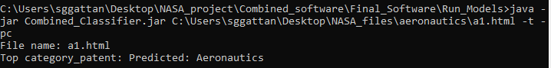

1. Three output files:

**Prediction_Patent_(*filename*)**

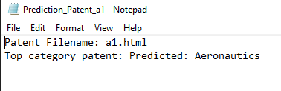

**CategoryTagWords_Patent_(*filename*)**

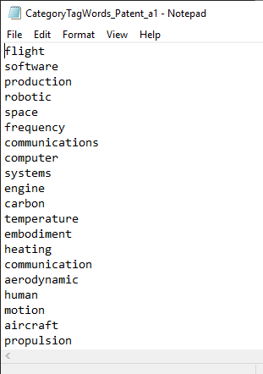

Tag words for the predicted category

**InputTagWords_Patent_(*filename*)**

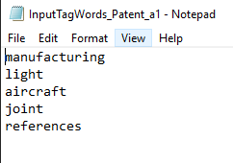

Tag words from the input file

1. To get the prediction from software classifier with the probability for each class

**Command: java -jar Combined_Classifier.jar *(path_to_file/filemame)* -p -sc**

Example: java jar Combined_Classifier.jar C:\Users\sggattan\Desktop\NASA_files\ aeronautics\a1.html -s -pc

**Output:**

1. Display the predicted class and probabilities for patent classifier on the command line.

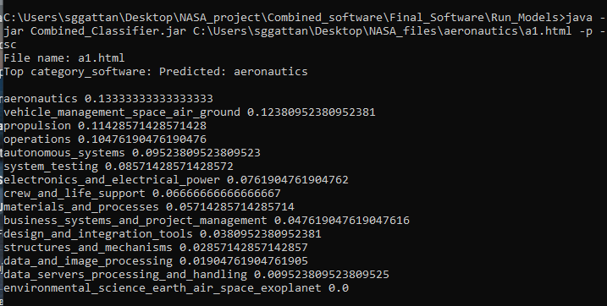

1. Create an output file with name **Prediction_Software_(*filename*)**

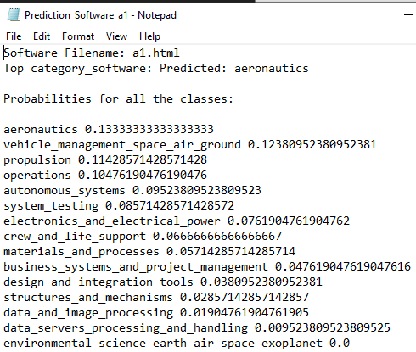

1. To get the prediction from software classifier with the tag words

**Command: java -jar Combined_Classifier.jar *(path_to_file/filemame)* -t -sc**

Example: java jar Combined_Classifier.jar C:\Users\sggattan\Desktop\NASA_files\ aeronautics\a1.html -t -sc

**Output:**

1. Display the predicted class for patent classifier on the command line.

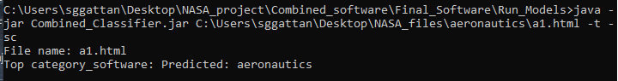

1. Three output files:

**Prediction_Patent_(*filename*)**

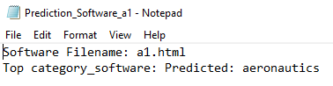

**CategoryTagWords_Patent_(*filename*)**

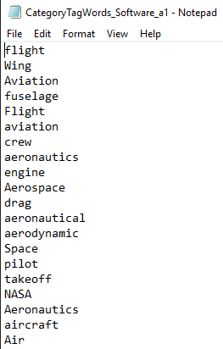

Tag words for the predicted category

**InputTagWords_Patent_(*filename*)**

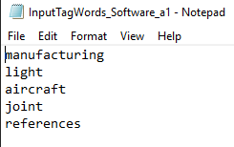

Tag words from the input file

=================== THE END ==========================