User Manual

In this Project Contain 5 Modules. Admin, College, Department, Teacher and Student.

* Admin
  + Managing Basic Data’s Like
    - District
    - Place
    - Department Type
    - Semester
    - Course
  + Registering new Colleges
  + Sorted view of
    - Colleges
    - Departments
    - Teachers
    - Students
  + Manage Colleges Complaints and Feedbacks
    - View
    - Reply
* College
  + Privacy Settings
    - View Profile
    - Edit Profile
    - Change Password
  + Registering new Departments
  + Sorted view of
    - Departments
    - Teachers
    - Students
  + Chat
    - Departments
  + Post
    - Posting new post
    - Posting new Photo
    - Post Privacy
    - Delete Posts
    - Comment and Like
  + Complaint
    - Send Complaints to Admin.
    - View Complaints Reply.
    - View Departments Complaints.
    - Send Reply to Departments Complaints.
  + Feedback
    - Send Feedback to Admin
    - View Department Feedbacks
* Department
  + Privacy Settings
    - View Profile
    - Edit Profile
    - Change Password
  + Registering new Teachers
  + Assign Teachers with Subjects
  + Registering new Students
  + Sorted view of
    - Assigned Teachers
    - Teachers
    - Students
  + Chat
    - College
    - Department Members
  + Post
    - Posting new post
    - Posting new Photo
    - Post Privacy
    - Delete Posts
    - Comment and Like
  + Complaint
    - Send Complaints to College.
    - View Complaints Reply.
    - View Teachers Complaints.
    - View Students Complaints.
    - Send Reply to Teachers Complaints.
    - Send Reply to Students Complaints.
  + Feedback
    - Send Feedback to College
    - View Teachers Feedbacks.
    - View Students Feedbacks.
* Teacher
  + Privacy Settings
    - View Profile
    - Edit Profile
    - Change Password
  + Chat
    - Department Members
  + Lectures
    - Send Lectures by Subjects
  + Post
    - Posting new post
    - Posting new Photo
    - Post Privacy
    - Delete Posts
    - Comment and Like
  + Complaint
    - Send Complaints to Department.
    - View Complaints Reply.
  + Feedback
    - Send Feedback to Department.
* Student
  + Privacy Settings
    - View Profile
    - Edit Profile
    - Change Password
  + Chat
    - Department Members
  + Lectures
    - View Lectures by Subjects
    - Download Lectures
  + Post
    - Posting new post
    - Posting new Photo
    - Post Privacy
    - Delete Posts
    - Comment and Like
  + Complaint
    - Send Complaints to Department.
    - View Complaints Reply.
  + Feedback
    - Send Feedback to Department.

Extract Project and open in Netbeans

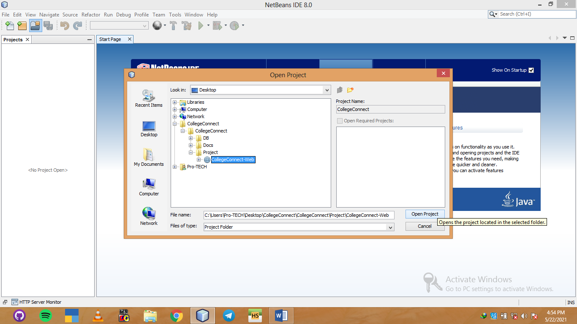

3. Click this button

2. Select project folder

1. Click Here

Open project

Open Heidsql and import database

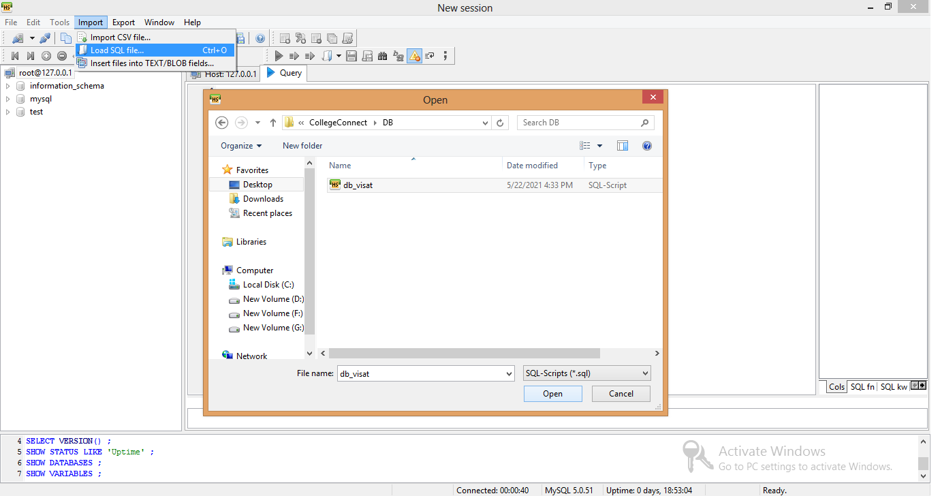

4. Click this blue play button for execute the queries

3. Click here import database

2. Select sql file from DB Folder

1. Click here and load sql file

Then Close heidsql and re-open heidsql

Now you can see db_visat under information_schema

Double click on it, now check the 20 tables.

Open project folder in netbeans and find ConnectionClass.java,

And compare with heidsql same or not

If those are same leave it else change

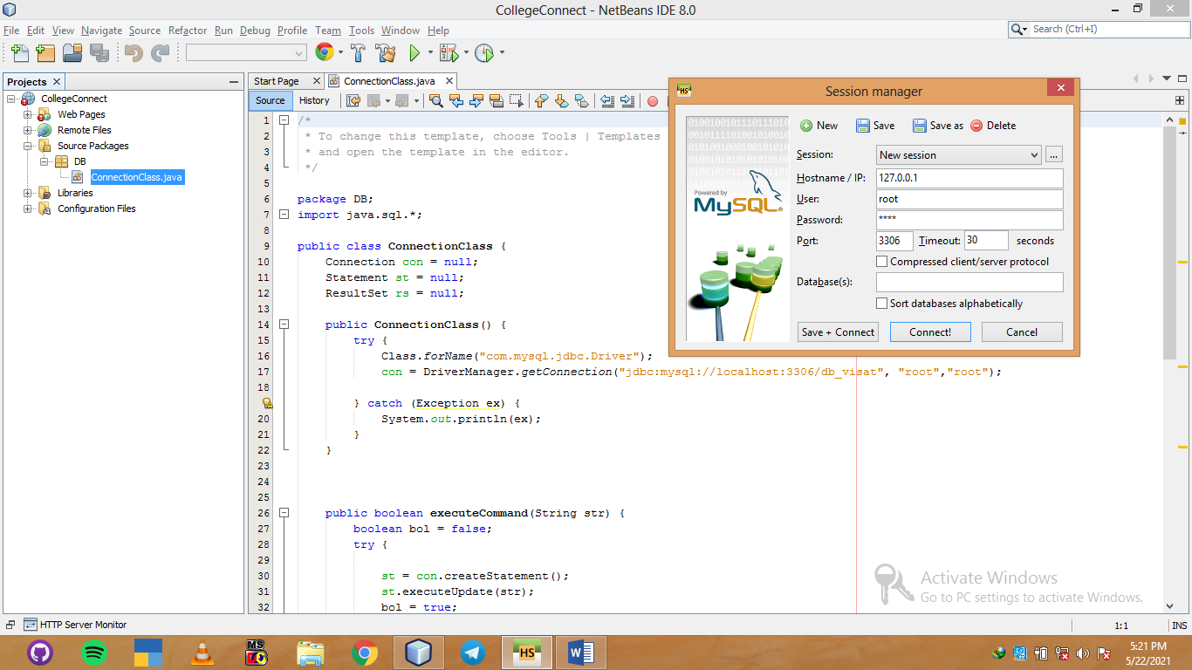

Green play Button

Check this is your database name is correct

ConnectionClass.java

Open this

Open this

If everything is ok press this green play button.

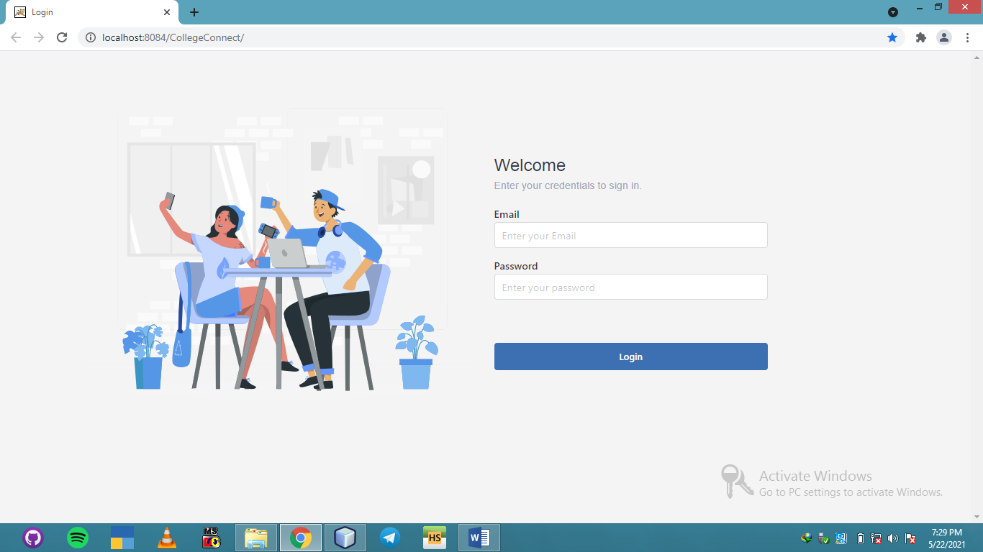

If everything is ok after pressing green play button redirected to login page.

Project Flow

Login as admin credentials are in tbl_admin check database.

Enter basic data’s.

Register Colleges.

Login College using the credentials given by admin (check tbl_college for credentials).

Add Departments.

Login as department using the credentials given by college (check tbl_department).

Add Teachers and Students.

Assign Teachers.

Login teacher

Lecture management.

Login Student

View and Download lectures.

Every One Can Post Contents, Comment and like.

College can chat with departments.

Departments can chat with college and Department Members.

Teacher Can Chat with Department Members.

Students Can Chat With Department Members.