**BASIC SALARY CALCULATION**

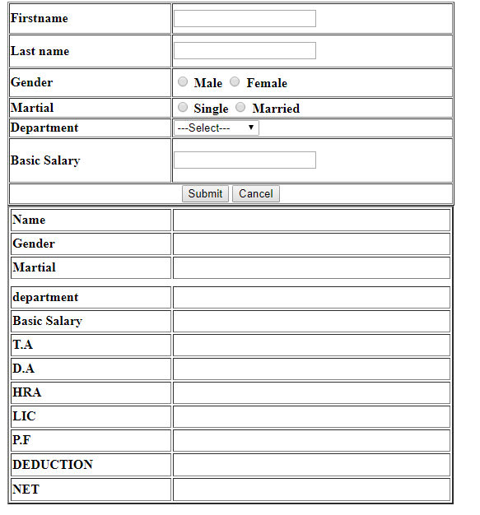

**CALCULATION**

|  |  |  |
| --- | --- | --- |
| **B.S>=10000** | **B.S>=5000**  **AND B.S <10000** | **B.S<5000** |
| **TA = 40% of B.S**  **DA = 35% of B.S**  **HRA = 30% of B.S**  **LIC = 25% of B.S**  **PF = 20% of B.S** | **TA = 35% of B.S**  **DA = 30% of B.S**  **HRA = 25% of B.S**  **LIC = 20% of B.S**  **PF = 15% of B.S** | **TA = 30% of B.S**  **DA = 25% of B.S**  **HRA = 20% of B.S**  **LIC = 15% of B.S**  **PF = 10% of B.S** |
| **DEDUCTION=LIC+PF**  **NET AMOUNT=** **BS+TA+DA+HRA-(LIC+PF)** | | |