User Manual

In this Project Contain 5 Modules. Admin, College, Department, Teacher and Student.

* Admin
  + Managing Basic Data’s Like
    - District
    - Place
    - Department Type
    - Semester
    - Course
  + Registering new Colleges
  + Sorted view of
    - Colleges
    - Departments
    - Teachers
    - Students
  + Manage Colleges Complaints and Feedbacks
    - View
    - Reply
* College
  + Privacy Settings
    - View Profile
    - Edit Profile
    - Change Password
  + Registering new Departments
  + Sorted view of
    - Departments
    - Teachers
    - Students
  + Chat
    - Departments
  + Post
    - Posting new post
    - Posting new Photo
    - Post Privacy
    - Delete Posts
    - Comment and Like
  + Complaint
    - Send Complaints to Admin.
    - View Complaints Reply.
    - View Departments Complaints.
    - Send Reply to Departments Complaints.
  + Feedback
    - Send Feedback to Admin
    - View Department Feedbacks
* Department
  + Privacy Settings
    - View Profile
    - Edit Profile
    - Change Password
  + Registering new Teachers
  + Assign Teachers with Subjects
  + Registering new Students
  + Sorted view of
    - Assigned Teachers
    - Teachers
    - Students
  + Chat
    - College
    - Department Members
  + Post
    - Posting new post
    - Posting new Photo
    - Post Privacy
    - Delete Posts
    - Comment and Like
  + Complaint
    - Send Complaints to College.
    - View Complaints Reply.
    - View Teachers Complaints.
    - View Students Complaints.
    - Send Reply to Teachers Complaints.
    - Send Reply to Students Complaints.
  + Feedback
    - Send Feedback to College
    - View Teachers Feedbacks.
    - View Students Feedbacks.
* Teacher
  + Privacy Settings
    - View Profile
    - Edit Profile
    - Change Password
  + Chat
    - Department Members
  + Lectures
    - Send Lectures by Subjects
  + Post
    - Posting new post
    - Posting new Photo
    - Post Privacy
    - Delete Posts
    - Comment and Like
  + Complaint
    - Send Complaints to Department.
    - View Complaints Reply.
  + Feedback
    - Send Feedback to Department.
* Student
  + Privacy Settings
    - View Profile
    - Edit Profile
    - Change Password
  + Chat
    - Department Members
  + Lectures
    - View Lectures by Subjects
    - Download Lectures
  + Post
    - Posting new post
    - Posting new Photo
    - Post Privacy
    - Delete Posts
    - Comment and Like
  + Complaint
    - Send Complaints to Department.
    - View Complaints Reply.
  + Feedback
    - Send Feedback to Department.

Extract Project and open in Netbeans

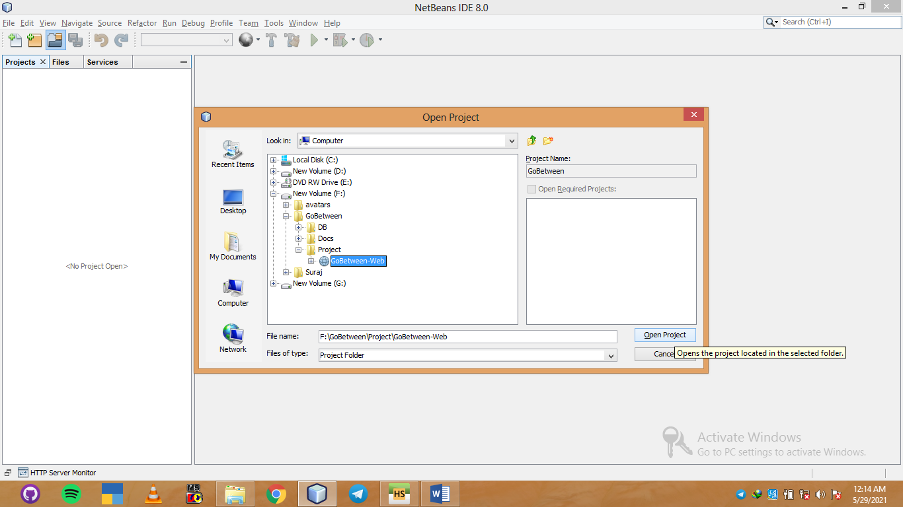

3. Click this button

2. Select project folder

1. Click Here

Open project

Open Heidsql and import database

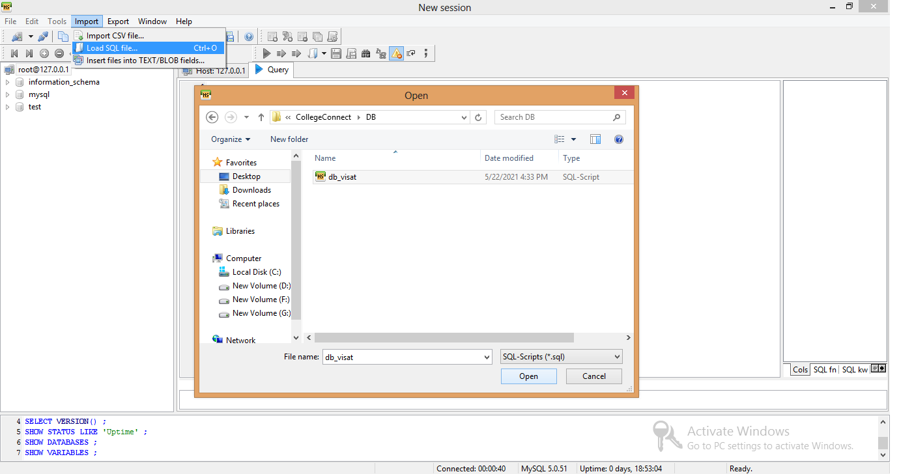

db_mainproject

db_mainproject

Go-Between

4. Click this blue play button for execute the queries

3. Click here import database

2. Select sql file from DB Folder

1. Click here and load sql file

Then Close heidsql and re-open heidsql

Now you can see db_mainproject under information_schema

Double click on it, now check the 20 tables.

Open project folder in netbeans and find ConnectionClass.java,

And compare with heidsql same or not

If those are same leave it else change

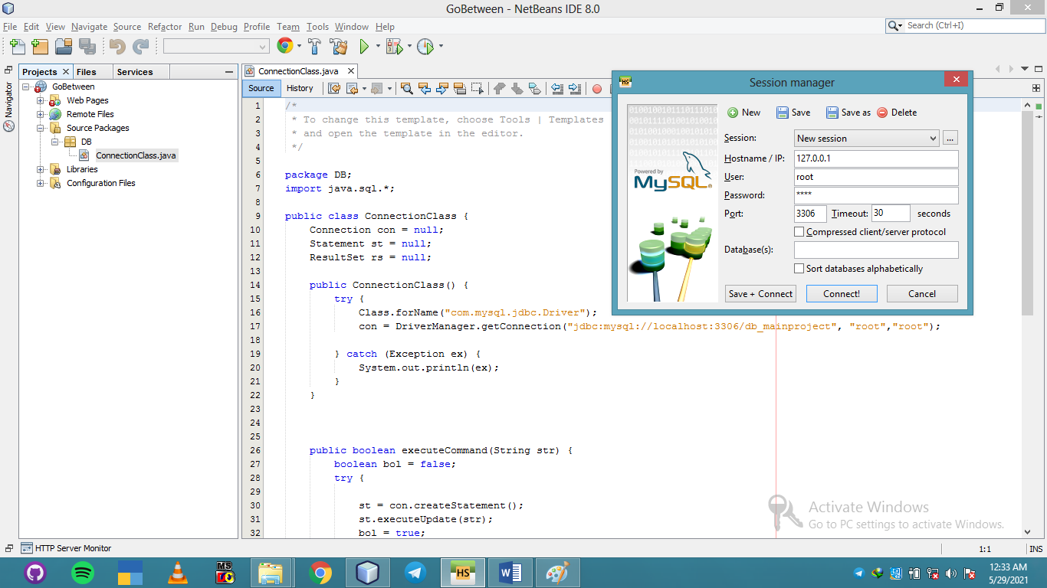

Check this is your database name is correct

ConnectionClass.java

Open this

Open this

Then select index.html and run

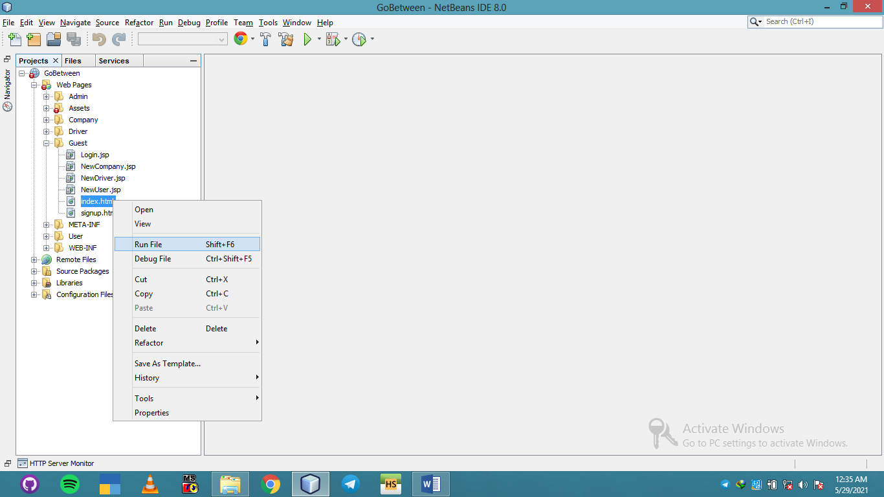

If everything is ok redirect this page.

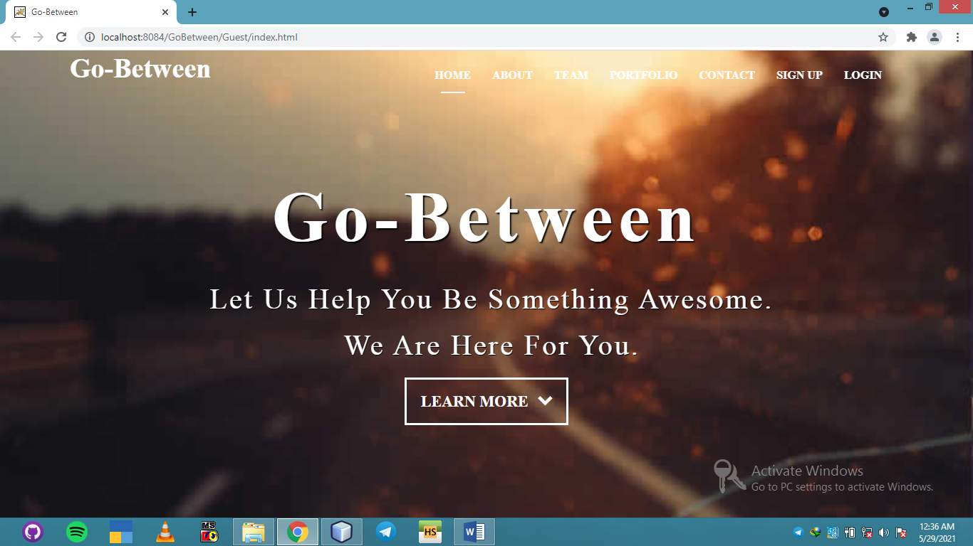

If above page appear to login as an admin.

Click login then enter email [admin@gmail.com](mailto:admin@gmail.com) and password is “Admin@123”.

Project Flow

Login as admin credentials are in tbl_admin check database.

Enter basic data’s.

Login Company using the credentials (check tbl_company for credentials).

Add new vehicle.

Login as Driver using the credentials (check tbl_driver).

Add License Details.

Request to company

Company managing driver request.

Login as a user enquiry send to company

Company managing user transport request and assign to driver.

Driver accepting the scheduled trip and start traveling after clicking start button

The user can see the progress (location) the vehicles