I-Notebook

1. Create an app

PS D:\Workspace\React> npx create-react-app inotebook

1. Create a folder named backend for node.js
2. Open terminal
3. Fire command and answer the questions

$npm init

1. Now install packages like express, mongoose and nodemon

$npm i express

$npm i mongoose

$npm i nodemon

1. Now creating models for user and notes
2. Create folder models
3. Create user model

//user.js

const mongoose = require('mongoose');

const Schema = mongoose.Schema;

const userSchema = new Schema({

    name: {

        type: String,

        required: true,

    },

    email: {

        type: String,

        required: true,

        unique: true,

    },

    password: {

        type: String,

        require: true,

    },

    time: {

        type: Date,

        default: Date.now

    },

});

module.exports = mongoose.model('user', userSchema);

1. Create notes model

//notes.js

const mongoose = require('mongoose');

const Schema = mongoose.Schema;

const notesSchema = new Schema({

    title: {

        type: String,

        required: true,

    },

    desciption: {

        type: String,

        required: true,

    },

    tag: {

        type: String,

        default: "general",

    },

    time: {

        type: Date,

        default: Date.now

    },

});

module.exports = mongoose.model('notes', notesSchema);

1. Now create a mongo connection

//db.js

const mongoose = require('mongoose');

const url = "mongodb://localhost:27017/"; // copy url from mongo compas

const connectToMongoose = () => {

    mongoose.connect(url).then(() => {

        console.log("connected to mangoose successfuly!");

    }).catch((err) => console.log(err));

}

module.exports = connectToMongoose;

1. Create index.js

//index.js

const express = require('express');

const connectToMongoose = require('./db');

const app = express();

const port = 3000;

connectToMongoose();

app.get('/', () => {

    console.log("hello");

})

app.listen(port, () => {

    console.log(`app is listening at port http://localhost:${port}`)

});

1. Now add a script to run file index.js edit package.json

"scripts": {

    "test": "echo \"Error: no test specified\" && exit 1",

    "start": "nodemon index.js" //this is means ‘npm start’ to run project

  },

1. Now lets create a routers for authentication and notes
2. Routers/notes.js

//notes.js

const express = require('express');

const router = express.Router();

router.get('/', (req, res) => {

    res.send([]);

});

module.exports = router;

1. Routers/auth.js

//auth.js

const express = require('express');

const router = express.Router();

router.get('/', (req, res) => {

    obj = {

        name: 'suraj',

        password: 'khot'

    }

    res.send(obj);

});

module.exports = router;

1. Now add routers to a=index.js files

//index.js

const express = require('express');

const connectToMongoose = require('./db');

const app = express();

const port = 3000;

connectToMongoose();

// routers

app.use('/api/auth',require('./routers/auth'));

app.use('/api/notes',require('./routers/notes'));

app.listen(port, () => {

    console.log(`app is listning at port http://localhost:${port}`)

});

1. now start server

PS D:\Workspace\React\inotebook\Backend> npm start

> inotebook-backend@1.0.0 start

> nodemon index.js

[nodemon] 3.1.4

[nodemon] to restart at any time, enter `rs`

[nodemon] watching path(s): \*.\*

[nodemon] watching extensions: js,mjs,cjs,json

[nodemon] starting `node index.js`

app is listning at port http://localhost:3000

connected to mangoose successfuly!

Now check by using thunder client

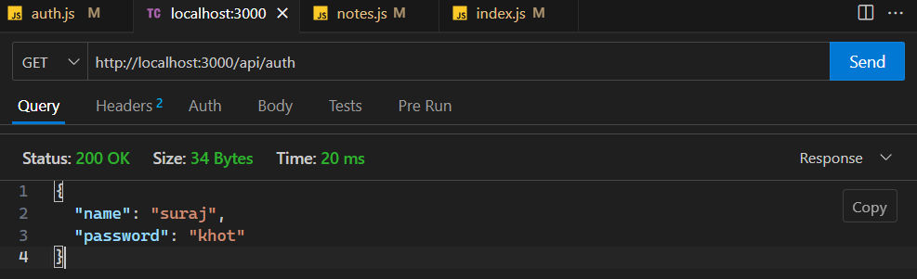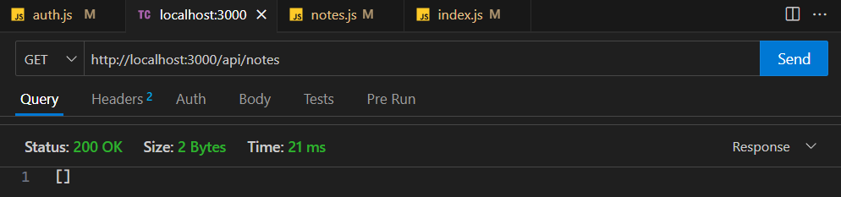

1. now creating a router for accepting user using user schema(name,email,password)
2. auth.js

//auth.js

const express = require('express');

const router = express.Router();

const User = require('../models/User'); //import user schema

//sending post request and save user to db

router.post('/', (req, res) => {

//accepting request

    const request = req.body;

    const user = User(request);

    user.save();

    res.send(request);

});

module.exports = router;

1. now for that we require middleware instead we add one middleware in index.js

//index.js

//code

// middleware for accept json

app.use(express.json());

//code

1. now sending req through thunder client

for that define content type as application/json in body and send

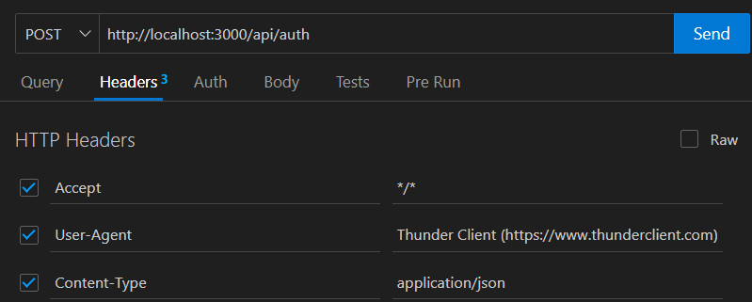

1. now send data

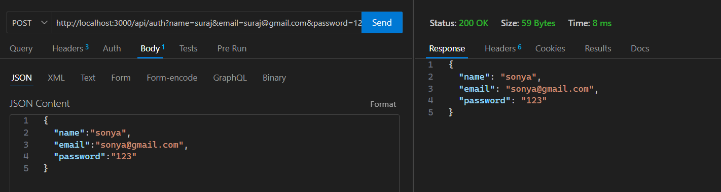

1. now see in mongoodb

