**Project Name: Flipkart**

**Overview**

Flipkart is an Indian e-commerce website for items ranging from phones, laptops, watches, clothing, footwear, gadgets, appliances and much more.

**Goals:**

1. **Home Page (as shown above)**

**## Header**

A. Logo  
B. Search Bar (item search)

C. Login / Signup [using email/mobile and password]

C. My Account [Drop Down] (My Profile, Orders, Wishlist, Logout)

D. Cart

**## MAIN BODY**

1. Drop down of items like Top offers, Mobiles, Electronics, Appliances and more.
2. Sliding images (with left right sliders)
3. Deal of The Day
4. Discounts for you
5. Top Offers on
6. Fashion for everyone
7. Suggested for you

**## Footer**

1. Contact Us
2. About Us
3. Connect (social media icons)

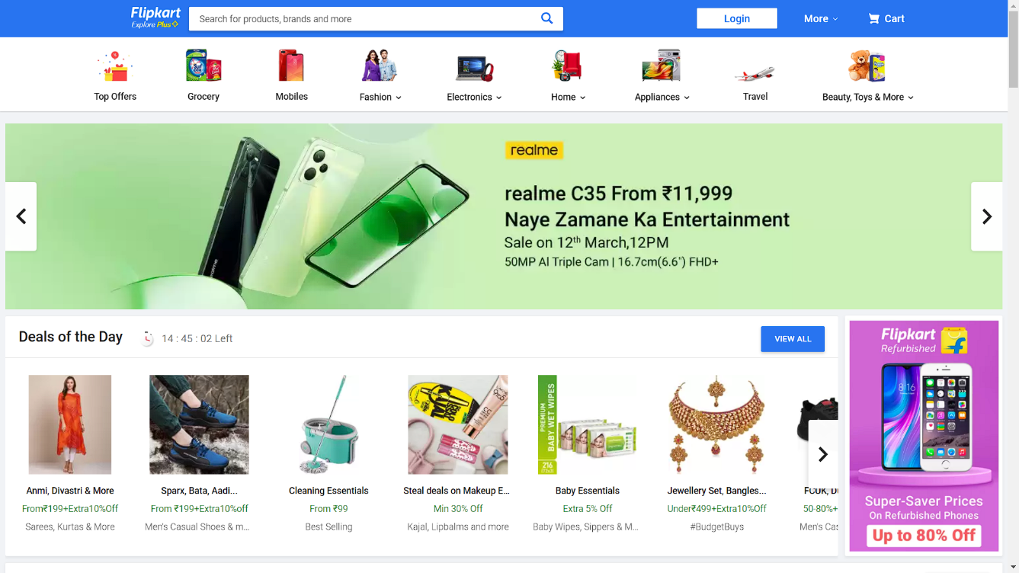

1. **Search items result page**
2. **Filters** 
   1. Categories (if any)
   2. Price Range
   3. Brand (list of checkboxes for different brand)
   4. Customer Ratings
   5. Availability
   6. Discount
3. **Products list in form of cards**

> **Top strip for sort by:** Relevance, Price Low to High, Price High to Low, Newest First

> **Below will be cards of items and Each card has:**

1. Add to cart (heart icon)
2. Image of item
3. Name of item
4. Cost
5. Rating
6. Discounts (if any)
7. Specs (if required, like in laptops)

> **At bottom side will be reviews on related products.**

> **Footer**

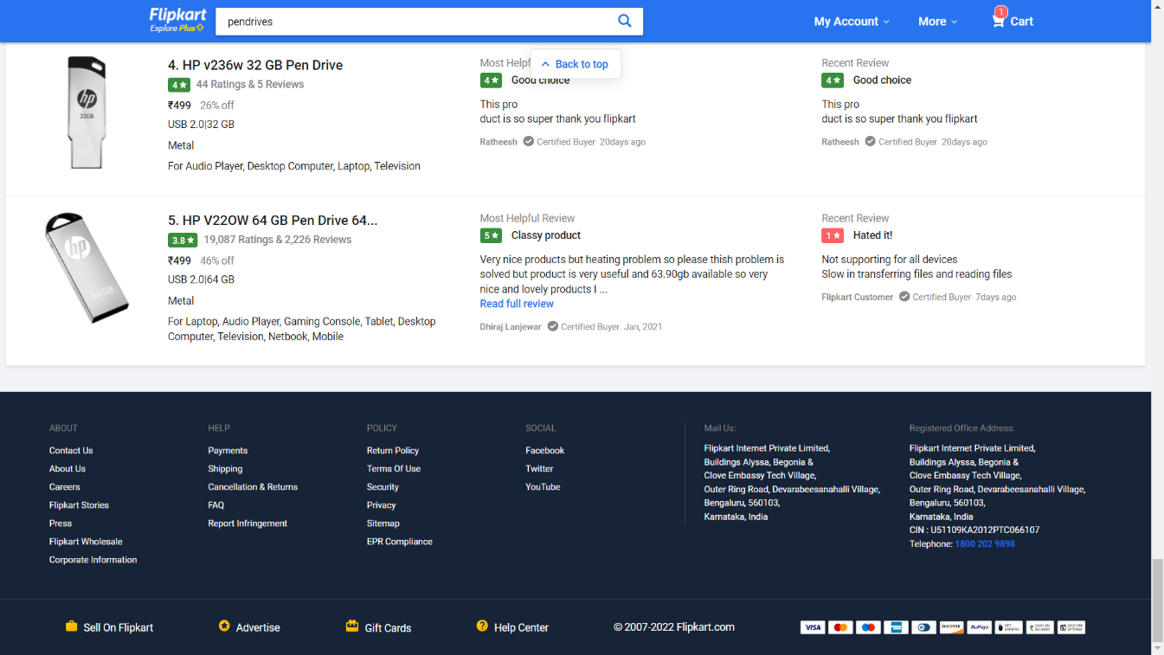

**3. Product Detail Page (Selected Product)**

a. image of item (left side)

b. Add to cart, Buy Now

c. Right side of image

Name, Rating, Price, Discount (if any), Available offers, Delivery (pin), Highlights, Seller, Specifications of product, Rating & Reviews, Questions & answers,

Below all this: Similar Products, Products you might be interested in

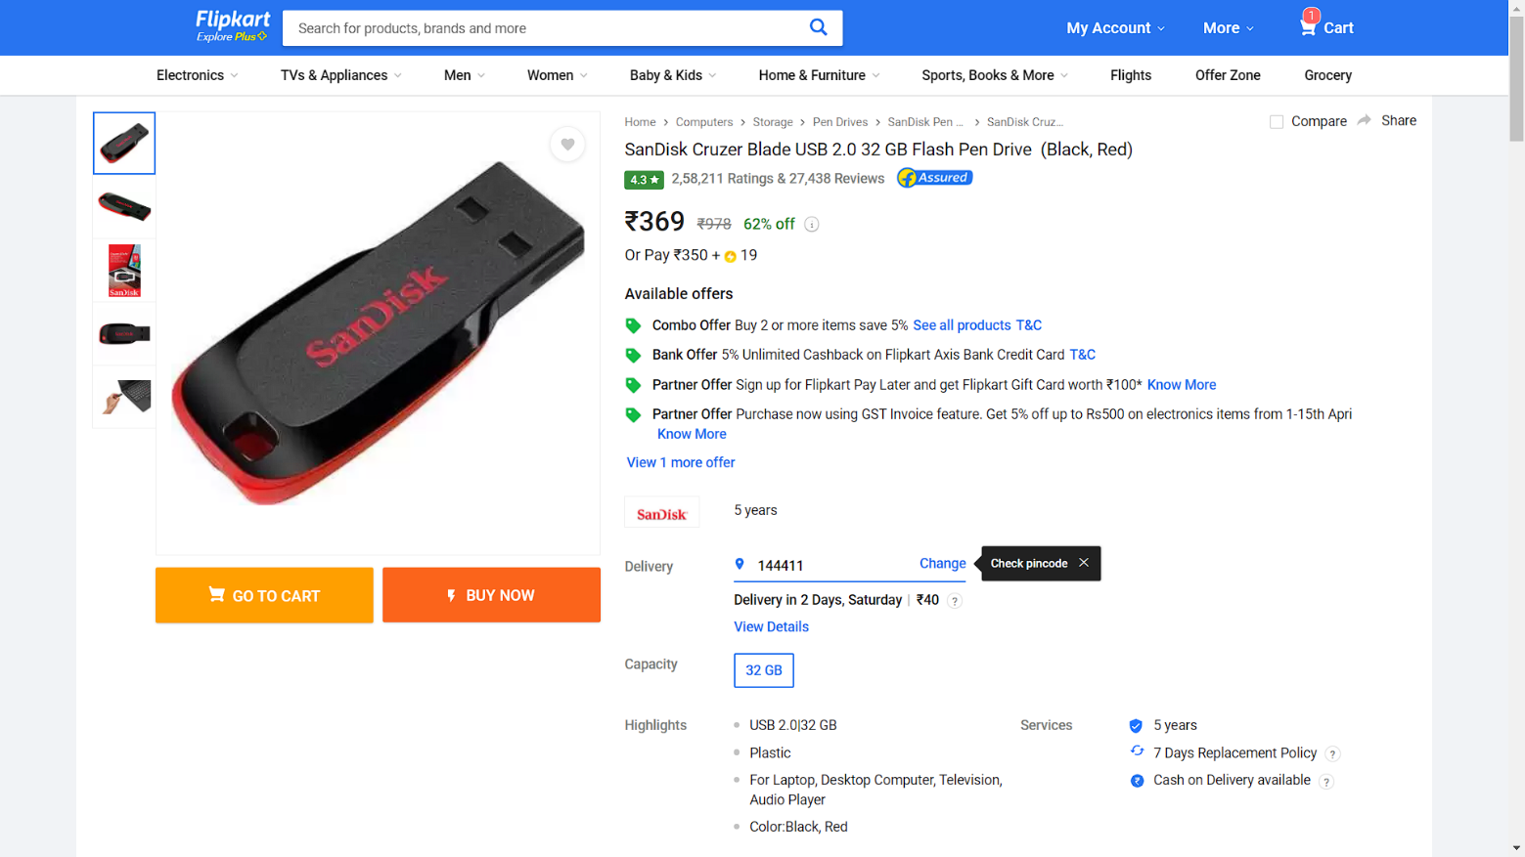

**4. Buy Now button (leads to ->**

**Delivery Address Select**

**Order Summary**

image, name, price and expected delivery date

**Price Details**

**Payment page**

UPI, Credit Card, Cash on Delivery

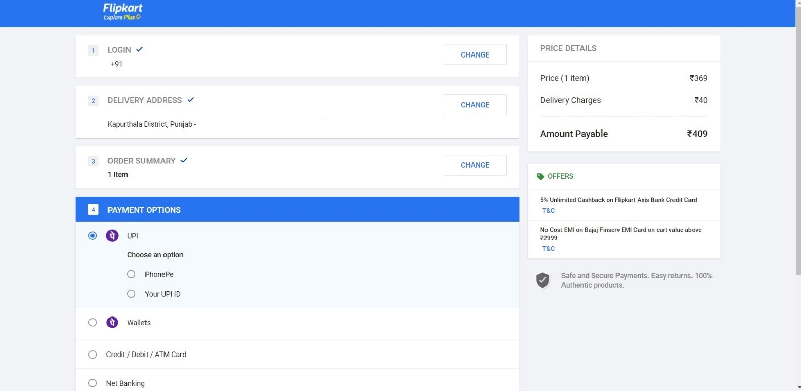

**Final page (order placed)**

Order placed, delivery address, more actions (pay now, cancel), Expected delivery date, suggestion based on order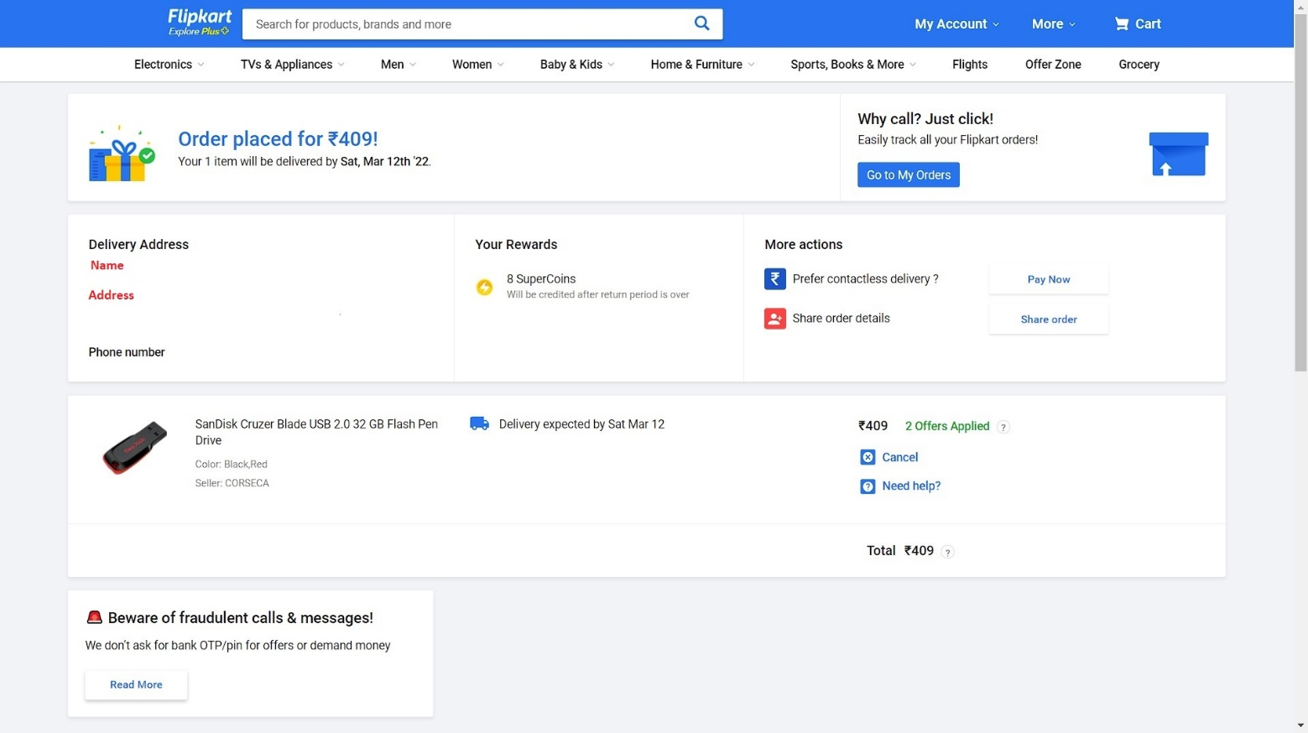

**5. Cart**

Contains list of all the items added to cart, with image, expected delivery date, price

Price details on right hand side

Place Order button (which leads to Order page)

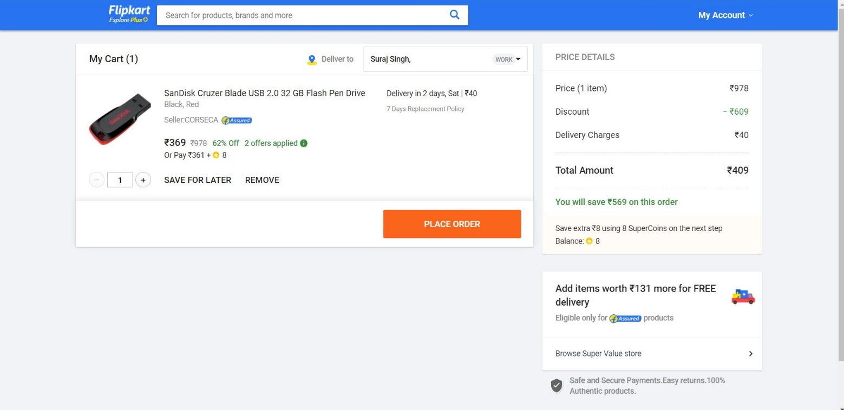

**6. Orders (list)**

Contains List of all previous orders, and currently ordered items.

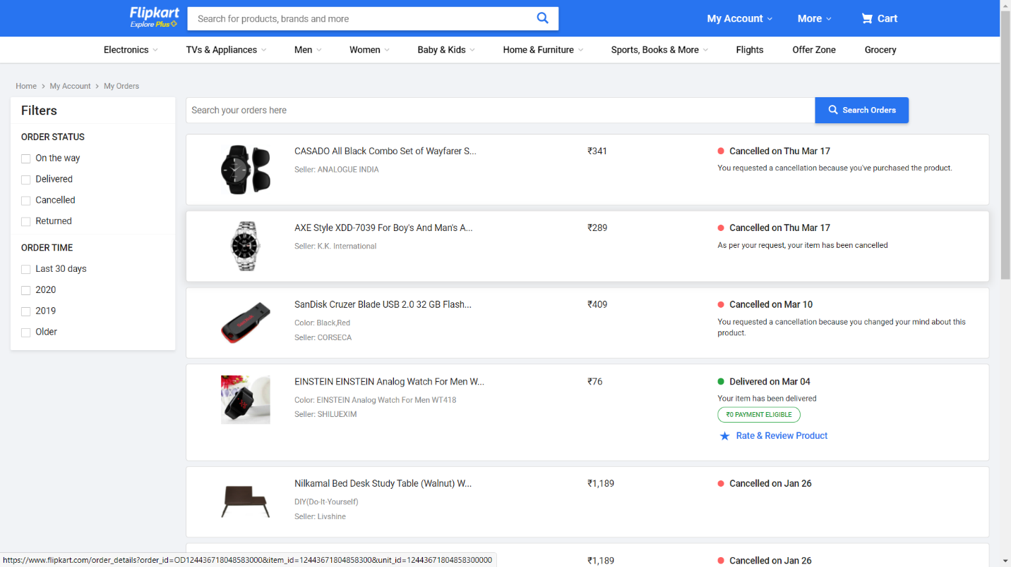

**7. Wish List**

Contains list of all the items added to wish list

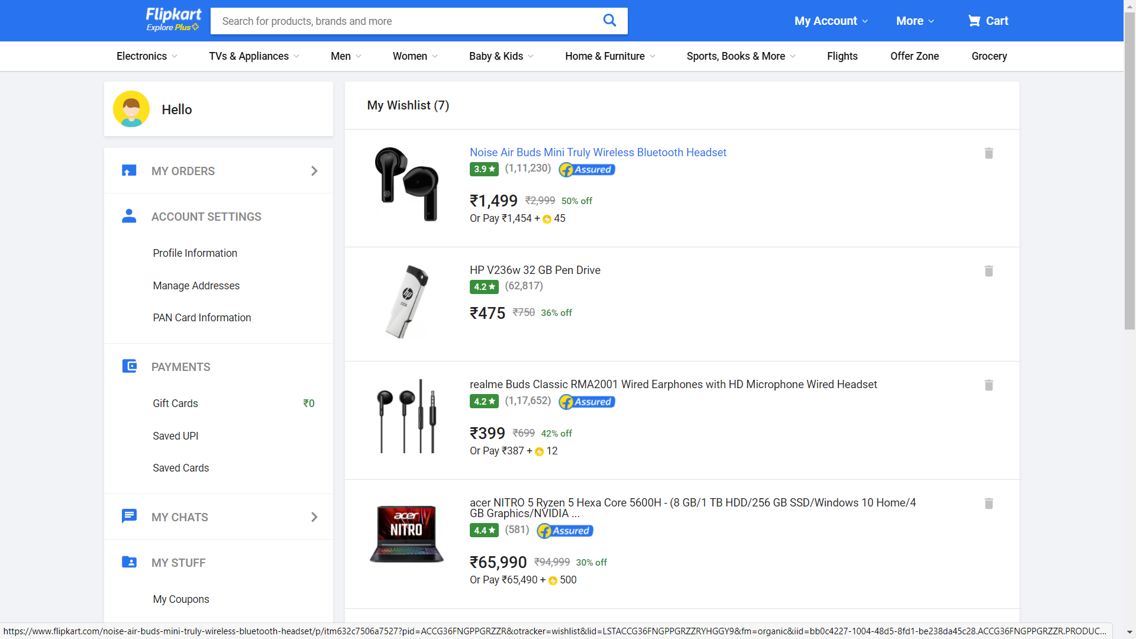

**8. Profile (Account Settings)**

**Profile Information**

Name, Gender, email, mobile, Deactivate account (button)

**Manage Address**

Add new Addresses

**My Wishlist**

**

**Technologies Used in Flipkart Project**

**Front-End:**

1. HTML
2. CSS
3. Bootstrap
4. React

**Dynamic:**

1. JavaScript
2. Ci/cd with AWS (check what)
3. Login and Logout (oauth and jwt) (check what)

**Database:**

1. Mongodb
2. Json Data (check where)

**Code Compilers:**

1. Visual Studio Code
2. Git bash
3. Git hub
4. Node js