Freight Rate Prediction — Assessment Report
Machine Learning Engineer take-home · Spotter

1. Data Exploration & Quality Issues
The development set (data/train_test.csv) contains 48,000 labeled loads from 2025-01-01 through 2025-10-31, with 14 columns: load_id, pickup/delivery city + lat/lon, distance, equipment, weight, date, market_index, quote_signal, and the target posted_rate.

Key findings
- posted_rate is strongly driven by distance (Pearson r ≈ 0.91). Weight, market_index and quote_signal individually have weak linear correlation with the raw rate, but do carry information once distance is accounted for (rate-per-mile), and were kept as model features.
- Equipment type carries a modest rate premium: Reefer > Flatbed > Dry Van on average.
- There is a mild seasonal / weekly pattern in rate-per-mile (slightly higher mid-year and mid-week), used via month, day-of-week and cyclical day-of-year features.
- posted_rate is right-skewed with a small tail of very high rate-per-mile loads (~0.7% of rows > 5x the median rate-per-mile). These look like genuine spot-market surge pricing rather than data errors — the associated distances and cities are all valid — so they were kept in training rather than removed, but they do inflate RMSE relative to MAE.

Data-quality issues identified and how they were addressed
- weight: ~0.6% of rows (292/48,000) had sign-flipped negative values (e.g. -31,724 lb) whose magnitudes match the normal weight distribution exactly. Fixed with abs(). A further ~0.6% were missing and were imputed using the median weight for that equipment type.
- market_index: ~0.8% missing (374/48,000), imputed using the median market_index for that calendar month.
- A small number of rows (22/48,000, all for the Shreveport ↔ New Orleans lane) have a distance value inconsistent with the haversine distance implied by their lat/lon. This looks like a geocoding issue for those two cities rather than a distance error. It affects <0.05% of rows and was left as-is (flagged here rather than 'corrected' without ground truth).
- No duplicate load_id or fully duplicated rows were found.

2. Train / Test Split & Validation Approach
The task is fundamentally a forecasting problem: validation.csv and the December chart both ask for predictions on dates later than most of the labeled data. A random split would let the model be evaluated on dates interleaved with its training data, overstating real-world accuracy.
Split used: sort all rows by date, train on the earliest 80% (2025-01-01 → 2025-08-31, 38,400 rows), hold out the most recent 20% (2025-09-01 → 2025-10-31, 9,600 rows) purely for evaluation. All reported metrics below are on this time-based holdout, never seen during training.

3. Modeling
Three model families were compared on the same time-based holdout: linear regression (baseline), random forest, and gradient-boosted trees (XGBoost). A second XGBoost model was trained on a reduced feature set (same features, minus market_index/quote_signal) because those two columns are not available in december_chart_inputs.csv — they represent live market-quote conditions that can't be known in advance for a future, hypothetical date. Using one shared cleaning/feature pipeline (src/data_utils.py) keeps both models consistent.
Model | MAE ($) | RMSE ($) | MAPE (%) | R²
linear_full | 195.02 | 654.12 | 10.69 | 0.816
random_forest_full | 162.79 | 648.46 | 7.15 | 0.8192
xgboost_full | 124.71 | 636.48 | 5.54 | 0.8258
xgboost_reduced_no_market_signals | 128.63 | 638.52 | 5.65 | 0.8247

XGBoost was selected: lowest MAE and MAPE of the three families, and by a wide margin on typical-case error (MAPE 5.5% vs 10.7% for linear regression). The reduced (no-market-signal) model performs nearly as well (MAE $128.6 vs $124.7), confirming market_index/quote_signal add only a small amount of incremental signal once distance, geography, equipment and date are captured — consistent with their weak standalone correlations in the exploration step.
Top features by importance (full model): distance, pickup/delivery longitude, delivery latitude, then equipment type. The reduced model relies on the same top features minus the two market columns.

4. December 2025 Forecast
december_chart_inputs.csv fixes pickup=Lexington, delivery=Fort Wayne, distance=360 mi, equipment=Dry Van, weight=32,000 lb for all 31 days of December 2025 — only the date changes. Lexington/Fort Wayne lat/lon (not present in that file) were looked up from their known values in train_test.csv so the reduced model sees the same feature schema it was trained on. Predictions come from the reduced (no-market-signal) model described above, run once per date.
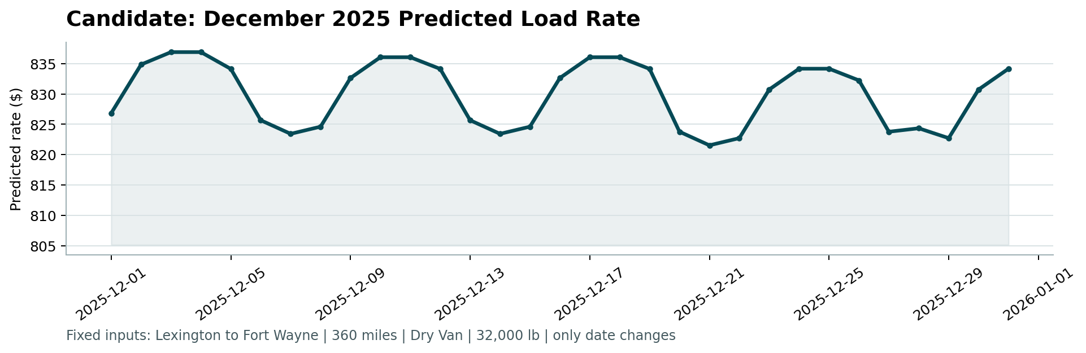
The forecast (~$820–$837, i.e. ~$2.29–$2.32/mile) shows a repeating weekly pattern — modest midweek premium, modest weekend dip — which is the dominant date-driven signal the model found in the training data. Because train_test.csv only spans January–October 2025, December is outside the observed date range; the cyclical (sin/cos) day-of-year encoding lets the model generalize via periodicity (December sits close to January on the yearly cycle) rather than extrapolating linearly, but the resulting range is narrower than a full seasonal swing might realistically be — a limitation worth flagging rather than presenting as high-confidence.

5. Reproducing These Results
See README.md in the repository root for exact setup and run commands (python src/train.py, then python src/predict.py, then the provided score.py). Full metrics, feature importances and EDA notes are saved under reports/.

