Chapter 5 : Experimental Methodology
5.1. EXCIPIENTS PROFILE³¹⁻³⁷
5.1.1. MICROCRYSTALLINE CELLULOSE³¹
Table 5.1: microcrystalline cellulose profile
Parameters | Description
Name | Microcrystalline Cellulose (Avicel PH 102)
Nonproprietary Names | BP:Microcrystalline cellulose,JP:Microcrystalline cellulose:PhEur:cellulose:USP-NF:Microcrystalline cellulose.
Synonym | Avicel PH, Celex, Cellulose gel, Celphere, Emcocel, Fibrocel, MCC sanaq, Pharmacel, Vivapur.
CAS registry Number | [9004-34-6]
Empirical formula | (C₆H₁₀O₅)_{n}
Average Molecular  Weight | 36,000gm/mol
Structure | 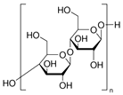
Description | Microcrystalline cellulose is a purified, partially depolymerized cellulose that occurs at a white, odorless, tasteless, crystalline powder composed of porous particles.
Functional  Category | Adsorbent, Suspending agent, Tablet and Capsule diluent, Tablet disintegrant.
Acidity/alkalinity | For a 1% w/v aqueous solution at 258 o C(depending on source  And grade): pH = 3.8–5.5 (type A); pH = 5.0–7.5 (type B).
Density | 0.337 g/cm³
Moisture Content | Typically, less than 5%
Solubility | Practically insoluble in water, dilute acid and most organic solvent. Slightly soluble in 5 %w/v NaOH solution.
Melting point | Chares at 260−270 °C
Partical size distibution | Mean particle size is 20−200 µm
Stability and Storage Conditions | Mcc is a unable through hygroscopic material.The bulk material should be stored in a well-closed container in a cool,dry place.
Incompatibilities | It is incompatible with strong oxidizing agents
Use concentration | As an adsorbent: 20−90%, As a tablet binder/diluent: 20−90%, As a capsule binder/diluent: 20−90%, As a tablet disintegrant: 5−15%
Applications | It is a key diluent for drug formulations and an essential component for almost every kind of oral dosage, including tablets, capsules, sachets, pellets and others as well.

5.1.2 . Mannitol ³²
Table 5.2: Mannitol profile
Parameters | Description
Name | Mannitol
Nonproprietaey Names | BP:Mannitol,JP:D-Mannitol,PhEur:Mannitol,USP:Mannitol
Synonym | Cordycepic acid, Manna Sugar, D-Mannite, Pearlitol, Mannogem.
Chemical Name | D-Mannitol
Empirical  formula | C₆H₁₄O₆
Molecular Weight | 182.20gm/mol
Specific surface area | 0.37−0.39 m²/g
Structure | 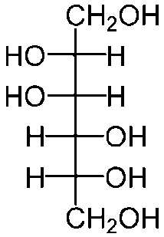
Description | Mannitol is D-mannitol. It is a hexahydric alcohol related to mannose and is isomeric with sorbitol.mannitol occurs as a white, odorless, crystalline powder, or free-flowing granules. It has a sweet taste, approximately as sweet as glucose and half as sweet as sucrose, and imparts a cooling sensation in the mouth.
Functional  Category | Diluent, Plasticizer, Sweetening agent, Tablet and capsule diluent, Tonicity agent.
Dissociation constant | pKa 13.5 at 18 °C
Density(Bulk) | 0.430 g/cm³
Flash point | 150°C
Dissociation constant | pKa 13.5 at 18 °C
Melting point | 166 – 168 °C
Solubility | Practically insoluble in ether and 216 gm/L in water .
Stability and  storage  Conditions | Stable in dry state and aqueous solution. It does not undergo Millard reaction.
Incompatibilities | Precipitation has been reported to occur when a 25 %w/v mannitol solution was allowed to contact plastic. It is incompatible with xylitol infusion and may forms complexes with some metals such as aluminium, copper and iron.
Method of Manufacture | Mannitol extracted from the dried sap of manna and other natural sources by means of hot alcohol or other selective solvents.It is produced by the catalytic or electrolytic reduction of mono saccharides such as mannose and glucose.
Safety | Mannitol is naturally occurring sugar alcohol found in animals and plants;it is present in small quantities in almost all vegetables.Allergic , hypersensitive type reactions may occur when Mannitol is used as an excipient.
Application | - Mannitol is most widely used in pharmaceutical and food industry. In tablet formulation it is used as a diluent and may be used in direct compression for which granular and spray dried forms were available.  - It is commonly used as a excipients in chewable tablet formulation because of its negative heat of solution, sweetness, and provides pleasant mouth feel.  - It has been suggested as a plasticizer in soft-gelatin capsules, as a component of sustained-release tablet formulations, and as a carrier in dry powder inhalers.  - It is also used as a diluent in rapidly dispersing oral dosage forms. It is used in food applications as a bulking agent.  - Therapeutically, mannitol administered parenterally is used as an osmotic diuretic, as a diagnostic agent for kidney function, as an adjunct in the treatment of acute renal failure, and as an agent to reduce intracranial pressure, treat cerebral edema, and reduce intraocular pressure.

5.1.3. Magnesium Stearate³³
Table 5.3: . Magnesium Stearate profile
Parameters | Description
Name | Magnesium Stearate
Synonym | BP: Magnesium Stearate, JP: Magnesium Stearate, PhEur: Magnesium Stearate, USP-NF: Magnesium Stearate.
Case number | [554-04-0]
Empirical  formula | C₃₆H₇₀MgO₄
Average  Molecular  Weight | 591.24 gm/mol
Structure | 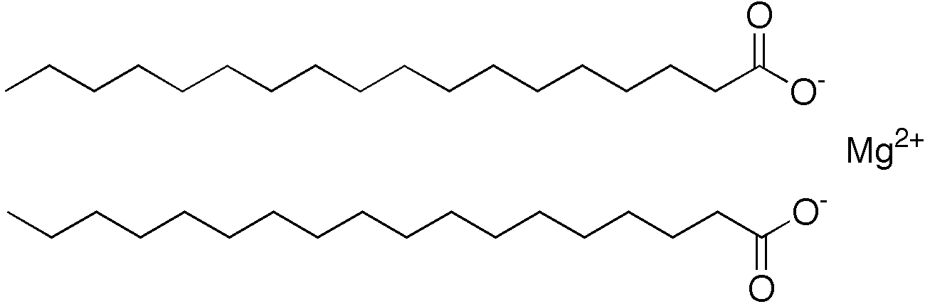
Description | Magnesium stearate is very fine, light white, precipitated or milled, impalpable powder of low bulk density, having a faint odor of stearic acid and a characteristic taste. The powder is greasy to the touch and readily adheres to the skin.
Functional  Category | Tablet and capsule lubricant.
Chemical Name | Octadecanoic acid magnesium salt
Structural Formula | [CH₃(CH₂)₁₆COO]₂Mg
Bulk Density | 0.159 g/cm³
Stability and storage conditions | Magnesium silicate should be stored in a well closed container in a cool and dry place.
Melting point | 117–150°C (commercial samples);126–130°C (high purity magnesium stearate).
Solubility | Practically insoluble in ethanol, ethanol (95%), ether and water; slightly soluble in warm benzene and warm ethanol (95%).
Application | Magnesium stearate is widely used in cosmetics, foods, and pharmaceutical formulations. It is primarily used as a lubricant in capsule and tablet manufacture at concentrations between 0.25%and 5.0% w/w. It is also used in barrier creams.
Incompatibility | Magnesium Stearate may decrease the oral bioavailability of drugs such as Mebeverine hydrochloride,sucralfate, and tetracycline, via chelation or binding ,when they are taken together.

5.1.4. Talc³⁴
Table 5.4: . Talc profile
Parameters | Description
Name | Talc
Synonym | Altalc; E553b; hydrous magnesium calcium silicate; hydrousmagnesium silicate; Imperial; Luzenac Pharma; magnesium hydrogenmetasilicate; MagsiOsmanthus; Magsil Star; powdered talc; purified French chalk; Purtalc; soapstone; steatite; Superiore; talcum.
Nonproprietary Names | BP: Purified Talc, JP: Talc, PhEur: Talc, USP: Talc
Empirical formula | Talc is a purified, hydrated, magnesium silicate, approximating to the formula Mg6(Si₂O₅)₄(OH)₄. It may contain small, variable amounts of aluminium silicate and iron.
MolecularWeight | 758.50gm/mol
Structure | 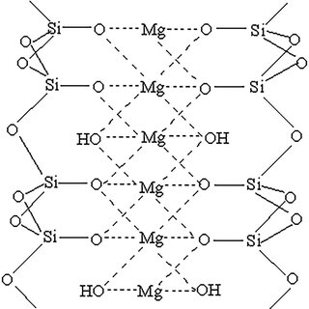
Description | Talc is a very fine, whhite to grayish-white, odorless, impalpable, unctuous, crystalline powder. It adheres readily to the skin and is soft to the touch and free from grittiness.
Functional  Category | Anticaking agent; glidant; tablet and capsule diluent; tablet and capsule lubricant.
Acidity/alkalinity | pH = 7–10 for a 20% w/v aqueous dispersion
Hardness (Mohs) | 1.0–1.5
Moisture content | Talc absorbs insignificant amounts of water at 258°C and relative humidities up to about 90%.
Solubility | Practically insoluble in dilute acids and alkalis, organic solvents, and water.
Refractive index | η²⁰_{D} = 1.54–1.59
Handling | Observe normal precautions appropriate to the circumstances
Specific gravity | 2.7–2.8
Specific surface  area | 2.41–2.42m²/g
Stability and Storage Conditions | Talc is a stable material and may be sterilized by heating at 160°C for not less than 1 hour. It may also be sterilized by exposure to ethylene oxide or gamma irradiation.Talc should be stored in a well closed container in a cool and dry place.
Incompatibility | Incompatible with quaternary ammonium compound.

5.1.5. Starch³⁵
Table 5.5: Starch profile
Parameters | Description
Name | starch
Non proprietary Names | BP:Maize starch,JP:corn starch,PhEur:Pea starch,USP-NF:wheat starch
Synonyms | Amido;amidon;amilo;amylum;c*pharmgel;Eurylon;fecule;hylon;maydis amylum;Melojel;Meritena;oryzae amylum;pearl;pisi amylum;uni-pure.
Chemical name | starch
Case number | [9005-25-8]
Empirical Formula | (C₆H₁₀O₅)_{n}
Molecular Formula | 342.30 g/mol
Description | Starch occur as an odorless and tasteless, fine, white to off-white powder. It consists of very small spherical or ovoid grannules or grains whose size and shape are characteristic for each botanical variety.
Structure | 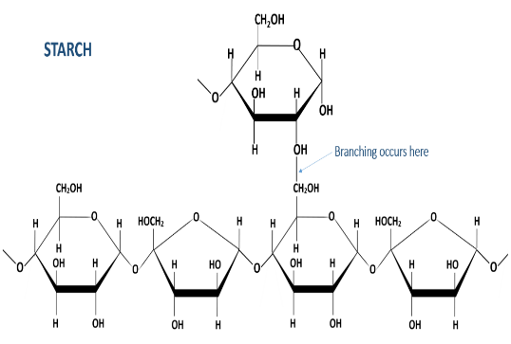
Functinal category | Tablet and capsule diluent; tablet and capsule disintegrant ; tablet binder; thickening agent
Density | 1.478g/cm³
Solubility | Practically insoluble in cold ethanol (96%)and in cold water.starch swells instantaneously in water by about 5-10%at 37°C.
Stability and Storage Conditions | Dry starch is stable if protected fron high humidity. Starch is considered to be chemically and micobiologically inert under normal storage condition.starch should be stored in an airtight container in cool,dry place.
Incompatibility | Starch is incompatible with strongly oxidizing substances.Colored inclusion compounds are formed with iodine.
Safety | Starch is edible food substance,considerd a food ingredient and nor a food additive.it is regarded as an essentially nontoxic and nonirritant material.
Application | Starch is a versatile excipient used primarily in oral solid dosage formulations where it is utilized as a binder,diluent, and disintegrant.

5.1.6. HPMC³⁶
Table 5.6: HydroxyPropyl MethylCellulose profile
Parameters | Description
Name | HydroxyPropyl MethylCellulose
Synonym | Hypromellose, Hydroxypropyl Cellulose, Methocel, E4M, HPMCP, Pharmacoat, Cellulose, 2-hydroxypropyl methyl ether, Methocel E, Methocel K, Metolose, Pharmacoat 603, Pharmacoat HP, Tylose, Tylopur, Hypromellose acetate succinate, Methocel A, Methocel E5, Methocel F, Methocel K100, Methocel K15M.
Chemical Name | Cellulose 2-hydroxypropyly methyl ether.
Empirical formula | C6H7O2(OH)3.5-4.0.
Average Molecular  Weight & formula | 1,261.45 g/mol  C56H108O30
Structure | 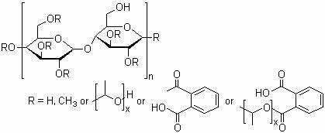
Description | HPMC is a powder, varying from white to off-white, with modest hygroscopic traits and no noticeble odor. It easily dissolves in water, producing either clear or slightly cloudy solutions, and pH stability. It is a versatile component utilized across pharmaceuticals, food and industrial domains.
Functional  Category | HPMC belongs to the category of cellulose ethers, functioning as a versatile polymer in pharmaceuticals, cosmetics, food, and other industries.
Chemical Name | Cellulose 2-hydroxypropyly methyl ether.
Solubility | Hydroxypropyl methylcellulose (HPMC) is soluble in various solvents, including water, alcohols (such as ethanol and methanol), acetone, chloroform, and certain acids and amines. However, it is insoluble in ethers, hydrocarbons, some esters, some ketones, and mineral oil.
Stability and  storage Conditions | HPMC should be stored in a cool, dry place below 25°C, shielded from direct sunlight and heat, and tightly sealed to prevent moisture absorption. Improper storage can lead to clumping or hardening due to moisture absorption, and degradation in extreme temperatures or humidity, affecting its performance in formulations.
Incompatibilities | - Incompatibilities of HPMC include strong oxidizing agents, which may cause decomposition or degradation of the polymer. Additionally, it should not be mixed with alkali metals or strong acids due to potential reactions leading to changes in its physical or chemical properties.

5.1.7. PVP³⁷
Table 5.7: Polyvinyl Pyrrolidine profile
Parameters | Description
Name | Polyvinyl Pyrrolidine
Synonym | PVP, Povidone, Polyvidone, Plasdone, Kollidon, Povidonum, Poly[1-(2 oxo-1-pyrrolidinyl)ethylene], 1-vinyl-2-pyrrolidinone polymer, 2-pyrrolidinone-1 ethenyl- homopolymer, Polyvidonum.
Non-Proprietary Name | USP: Povidone BP: Povidone JP: PVP PhEur: Povidone USP-NF: PVP
Empirical formula | (C6H9NO)n
Chemical Name | Chemical Name: 1-ethenylpyrrolidin-2-one.
Average Molecular  Weight | 111.14
Structure | 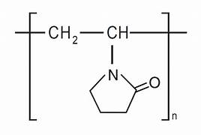
Description | PVP is a white, odorless, and tasteless powder with fine particles, easily handled and incorporated into formulations. It is hygroscopic, soluble in water and many organic solvents, forming clear solutions. PVP possesses film-forming properties, allowing it to create protective coating on tablets.
Functional  Category | Polyvinylpyrrolidone (PVP), a water-soluble polymer is derived from the monomer N-vinylpyrrolidone. It belongs to the class of synthetic polymers known as polyvinyl polymers, and is commonly employed as a tablet binder, disintegrant, and coating agent due to its biocompatibility, inertness, and film forming properties.
Density (true) | 11.12-1.20
Freezing Point (°C) | 150
Surface Tension (mN/m) | 30-70
Viscosity (Dynamic) [mPas(cP)] | 3-30
Solubility | It is soluble readily in water, ethanol, methanol, chloroform, acids, and amines, while being insoluble in ethers, hydrocarbons, certain esters, certain ketones, and mineral oil.
Method of Manufacture | PVP synthesis relies on the Reppe Acetylene chemistry pioneered by BASF. This process begins with the primary synthesis of the monomer, N-vinylpyrrolidone, which is then polymerized to produce the end product, PVP.
Application | PVP, extensively utilized in tablet formulations, acts as a binding agent in wet granulation, ensuring tablet cohesiveness. It is employed in fluidized bed granulation to prevent hydrolysis, resulting in sturdy tablets. Furthermore, in tablet coating, PVP's film-forming properties prevent micro-cracks and ensure uniform color distribution. Moreover, PVP enhances drug solubility and dissolution in solid dispersions and liquisolid compacts. Additionally, PVP facilitates various dosage forms like granules, pellets, and capsules by serving as a binder. Dong et al. harnessed PVP to stabilize amorphous drug-polyelectrolyte nanoplexes, improving the solubility of poorly soluble drugs. Campardelli et al. utilized PVP in the preparation of hollow gold nanoshells for drug delivery. Guduru et al. incorporated PVP in magneto-electric nanoparticles for ovarian cancer therapy. Javed et al. showcased the multifunctional effects of PVP-capped CuO nanoparticles. Finally, Gaikwad et al. integrated PVP in pectin-curcumin particles to enhance drug

Table 5.6.1 Different Grades of PVP, their K Value range and Molecular Weight
PVP GRADE | K-VALUE RANGE | MOLECULAR WEIGHT (Daltons)
PVP K-12 | 12.2-13.8 | 2500
PVP K-15 | 15.0-15.9 | 8000
PVP K-17 | 16.0-17.5 | 10,000
PVP K-25 | 24.0-26.0 | 30,000
PVP K-30 | 29.0-32.0 | 50,000
PVP K-60 | 55.0-65.0 | 4,00,000
PVP K-90 | 86.0-95.0 | 10,00,000
PVP K-120 | 119.2-124.6 | 30,00,000

5.2. EXPERIMENTAL SET UP
5.2.1. List of Instruments
Table 5.8: List of Instruments
Sr. No. | Instruments | Company
1 | Digital weighing balance | Skeltech
2 | Friability test apparatus | Bhavana, india
3 | Hardness tester (Monsanto type) | D. K. Scientific, Ahmedabad
4 | Tablet disintegration test apparatus | Bhavana, india
5 | Vernier caliper | Zhart
6 | Tablet compression machine | Cronimach
7 | USP dissolution type II apparatus | Bhawana, india
8 | UV spectrophotometer | Shimadzu 1900
9 | FTIR | Alpha II Bruker

5.2.2. List of Materials
Table 5.9: Materials used in present work
Sr. No. | Materials | Source
1 | Gymnema | Local store
2 | Moringa | Local store
3 | HPMC | Chemadyes corporation, Rajkot
4 | PVP | Chemadyes corporation, Rajkot
5 | Talc | Chemadyes corporation, Rajkot
6 | Mannitol | Chemadyes corporation, Rajkot
7 | Magnesium stearate | Chemadyes corporation, Rajkot
8 | Microcrystalline cellulose | Chemadyes corporation, Rajkot
9. | Starch | Chemadyes corporation, Rajkot
5.3.Standardization of Gymnema & Moringa³⁸
Determination of ash values:
The total ash method is designed to measure the total amount of material remaining after ignition. This includes both “physiological ash”, which is derived from the plant tissue itself, and “non-physiological” ash, which is the residue of the extraneous matter (e.g. sand and soil) adhering to the plant surface.
Total Ash Value:
2 g of the ground air-dried sample is to weigh into previously ignited,dried and tarred silica crucible. Spread the material in an even thin layer. It is then kept on a gas burner under a low flame and is ignited slowly to obtain a carbonized residue. It is then placed in the muffle furnace and the temperature of the muffle is adjusted to 450-500°C and ignition is then allowed in the muffle furnace. After 3 hours, switch off the muffle furnace and allow it to cool and remove the silica crucible. Further cool in a desiccator and weigh. If carbon free ash cannot be obtained in this manner, moist residue with 2 mL of water or saturated solution of ammonium nitrate. Then it is dried on water bath and then on hot plate, and after that ignite in muffle furnace to constant weight. Remove from muffle furnace and allow cooling for 30 minutes in a desiccator and weight. Finally, percentage of ash is calculated.
Acid Insoluble Ash:
To the silica crucible containing the total ash obtained, 25 mL of hydrochloric acid (~70 g/l) is added. Cover with a watch glass and boil gently for 5 minutes on a hot plate or burner. Rinse the watch glass with 5 mL of hot water and add these washings to the crucible. The insoluble matter will collect on an ash less filter paper by filtration and rinse the filter paper repeatedly with hot water until the filtrate becomes neutral/free from acid. Transfer the filter paper containing the insoluble matter to the original crucible, dry on a hot plate, and ignite to a constant weight in the muffle furnace at 450- 500ºC. Remove the silica crucible from the muffle furnace and allow cooling the matter in a desiccator for 30 minutes, and then weighing without delay. The content of acid insoluble ash will be calculated as percentage.
Water-Soluble Ash:
The ash is boiled for few minutes with required amount of water, collect the insoluble matter in a silica crucible and then wash with hot water and ignite for 15 minutes at a temperature not exceeding 450°C. The weight of the insoluble matter will be subtracted from the weight of the ash. The difference in weight represents the water-soluble ash. The percentage of water-soluble ash is calculated with reference to the air-dried drug.
Calculation: Total ash/Acid insoluble ash/Water soluble ash % = (B − C) × 100/A
Where, A - Sample weight in g;
B - Weight of dish + contents after drying (g)
C - Weight of empty dish (g)
Determination of extractable matter:
All the chemical constituents are soluble either in polar, semi polar or organic solvents. Total soluble constituents of the drug in any particular solvent or mixture of solvents may be called its extractive value or percent extractive.
Water Soluble Extractive Value:
Prepare coarse powder of air-dried drug. Take 100 mL of chloroform water in conical flask. Macerate 5 g of powdered drug in a conical flask, and close the flask for 24 hours. In between the flask is shake for first 6 hours and then stand for 18 hours. Filter rapidly by decanting the water extract and then evaporate 25 mL of the filtrate to dryness in a tarred flat bottomed shallow dish. Dry at 105°C and weight it. Calculate the % of water-soluble extractive with reference to the air-dried drug. Calculation: The percentage of water-soluble extractive value/alcohol soluble extractive value = (B – A) × 4 × 100/W
where, A: Empty weight of the dish (g);
B: Weight of dish + residue (g);
W: Weight of plant material taken (g)
Determination of Loss on Drying:
Loss on drying is the loss of weight expressed as percentage w/w resulting from water and volatile matter of any kind that can be driven off under specified conditions. The test is carried out on a well-mixed sample of the substance. If the substance is in the form of large crystals, reduce the size by rapid crushing to a powder. To decide the loss on drying, a watch glass is weighed precisely, then 1gm of sample is taken in weighed watch glass and dried in an electric hot air oven at 110◦C for 6 hours. After cooling, weighed and calculated again. The difference in the 2 weights which gives the Loss on drying of the sample in percentage.
5.4 EXTRACTION OF GYMNEMA AND MORINGA ³⁹
Maceration
- Maceration is a simple extraction method that involves soaking the plant prepared raw material in a coarse or powder form in a solvent of interest at room conditions for at least three days with intermittent agitation .
- After the extraction is completed, the mixture is strained either through sieves or a net with tiny holes.
- Subsequently, the marc is pressed, and the liquid extract is cleaned using either filtration or decantation after standing.
- This method is convenient and very suitable for extraction of plant material.

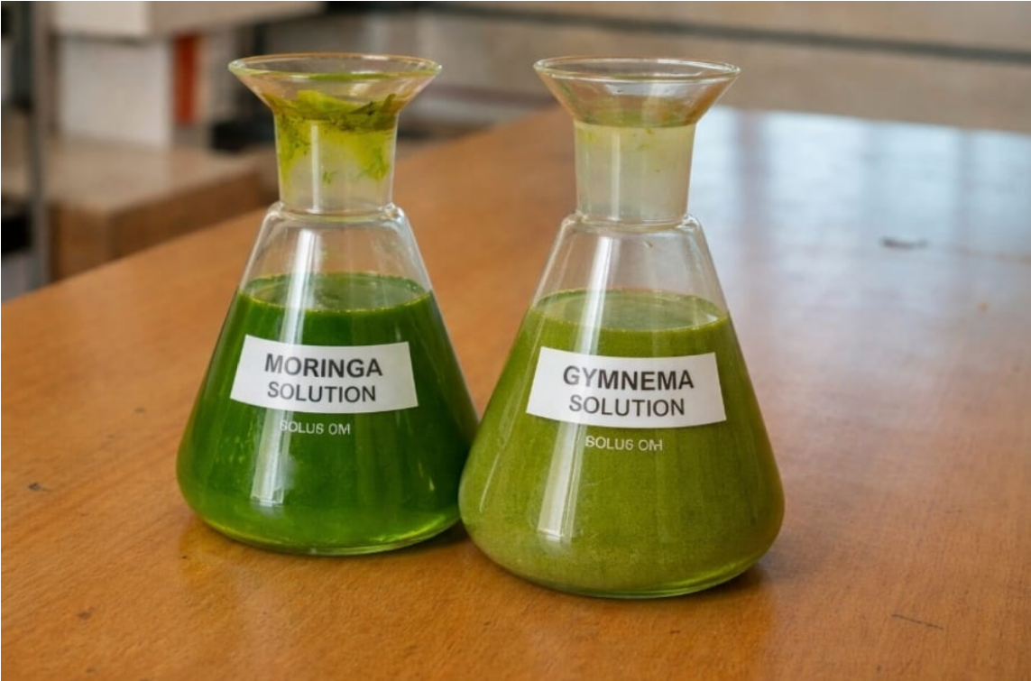
Fig.5.1: extraction of Moringa & Gymnema
5.5.FORMULATION DESIGN OF MORINGA AND GYMNEMA TABLET BY DIRECT GRANULATION METHOD
- All ingredients of formulation were weighed accurately.
- Tablets of Moringa And Gymnema were prepared by direct compression method using different binders such as MCC,HPMC and PVP to evaluate the role of different binders in different percentages.
- Raw material preparation: the API and excipients such as diluents, binders, lubricants, disintegrants.
- Mixing: the ingredients are thoroughly mixed using a suitable blender like MCC,HPMC,PVP to ensure a homogeneous blend.
- Tablet Compression: the Blended powder is fed into a tablet press, where it is compressed under high pressure between punches to from tablets.
- Punch movement : the upper and lower punch move together , compressing the powder within the die cavity.
- Pressure adjustment: the compression pressure can be adjusted to control tablet hardens.

Ingredients | Formulation code
 | F1 | F2 | F3 | F4 | F5 | F6 | F7 | F8 | F9
Moringa(mg) | 100 | 100 | 100 | 100 | 100 | 100 | 100 | 100 | 100
Gymnema (mg) | 150 | 150 | 150 | 150 | 150 | 150 | 150 | 150 | 150
Starch(mg) | 25 | 25 | 25 | 25 | 25 | 25 | 25 | 25 | 25
MCC(mg) | 100 | 110 | 120 | - | - | - | - | - | -
HPMC(mg) | - | - | - | 10 | 15 | 20 | - | - | -
PVP(mg) | - | - | - | - | - | - | 5 | 15 | 25
Talc(mg) | 50 | 50 | 50 | 50 | 50 | 50 | 50 | 50 | 50
Magnesium stearate(mg) | 5 | 5 | 5 | 5 | 5 | 5 | 5 | 5 | 5
Mannitol | q.s | q.s | q.s | q.s | q.s | q.s | q.s | q.s | q.s
Total weight (gm) | 500 | 500 | 500 | 500 | 500 | 500 | 500 | 500 | 500
Table.10:formulation design for Moringa And Gymnema

5.6 EVALUATION PARAMETERS OF TABLET⁴⁰
PRE COMPRESSION PARAMETERS
Bulk density :
Bulk density is defined as the mass of the powder divided by the bulk volume and is expressed as gm/cm3. Specific bulk volume or reciprocal of bulk density is called bulkiness or bulk.
$$\text{Bulk Density = }\frac{\text{Mass of sample (gm)}}{\text{ Bulk Volume (ml)}}$$
Tapped density:
It is the ratio of total mass of the powder to the tapped volume of the powder. It is expressed in g/ml.
$Tapped Density=\frac{Mass of powder \left(gm\right)}{ Tapped Volume of powder \left(ml\right)}$
Angle of repose :Angle of repose defined as the maximum angle possible between surface of pile of powder and horizontal plane. It is characteristic related to inter particulate friction or resistance movement between particles.
Ɵ = tan-1h/r
Where,
Ɵ = Angle of repose
h = Height of pile
r = Radius of pile
Table 5.11: Relationship between Angle of repose and powder flow
Angle of repose | Powder flow
<25 | Excellent
25−30 | Good
30−40 | Passable
>40 | Very poor
Hausner’s Ratio :
Hausner’s ratio is correlated to the flowability of a powder or granular material. If it is greater than 1.25 is considered to be indication of poor flowability.
H = Dt/Ddb
Where,
Dt: Tapped density;
Dbd: Bulk density
% compressibility:
Percent compressibility of powder mix was determined by carr’s compressibility index. Carr’s index (%) = TTBD – LBD / TBD x 100
Where, BD: Bulk density
TD: Tapped density
Table 5.12: Relationship between % compressibility and powder flow
% Compressibility | Powder flow
5−15 | Excellent
12−16 | Good
18−21 | Fair to passable
23−35 | Poor
33−38 | Very poor
>40 | Extremely poor
POST COMPRESSION PARAMETERS
- Physical Appearance
The general appearance of a tablet, its identity and general elegance is essential for consumer acceptance, for control of lot‐to‐lot uniformity and tablet‐to‐tablet uniformity. The control of general appearance involves the measurement of size, shape, color, presence or absence of odor, taste etc.
- Size and shape
Size and shape of a tablet has been determined by its thickness. Size and shape of table plays an important role in its patient compliance as the size of the tablet increases it is not much easier for its administration. Micrometer is the devise which is used to determine the thickness of a tablet. It can be acceptable if the batch falls within the •±5% of standard deviation.
- Organoleptic properties
Color should be distributed uniformly without appearance of any signs of mottling. Colour of the tablet should be compared with the standard colour for comparison. Stickiness and grittiness
Texture of the medicated jelly in terms of stickiness and grittiness can be determined by mildly rubbing the jelly between fingers.
- Uniformity of thickness
To determine the uniformity of thickness random selection of tablets has to be done from each and every batch and need to measure its thickness independently. If the thickness of any single tablet varies then the batch containing that batch will not be dispatched into market.
- Hardness
The ability of a tablet to withstand for mechanical shocks is known as hardness. Pfizer hardness tester is the instrument which is used to determine the hardness of tablet. It is expressed in kg/cm2. Take three tablets from each batch and hardness should be determined and the selection of tabled should be done randomly. Then the mean and standard deviation values should be determined.
- Friability
Friability of a tablet can determine in laboratory by Roche friabilator. This consist of a plastic chamber that revolves at 25 rpm, dropping the tablets through a Distance of six inches in the friabilator, which is then operate for 100 revolutions. The tablets are reweighed. Limits: loss in weight less than 0.5 to 1% of the initial weight of the tablet should be considered as acceptable limits.
Percentage of friability is calculated as: F={(W initial)- (W final)/ (W initial)}×100.
- Drug content uniformity
Initially weigh the tablet and then extract it. Now the powdered tablet is transferred into a 100 ml volumetric flask and adds 0.1 N HCl up to mark. Now filter the solution and discard first few ml of filtrate. Take 10 ml of filtrate should be taken into a 50 ml volumetric flask and add 0.1 N HCl up to the mark and analysed spectrophotometrically at nm and nm. The concentration of the content of the drug (μg/ml) was calculated by using the standard calibration curve of the respective drug. Drug content is calculated by using the below formula Concentration of the drug in (μg/ml) × 100 × 50/10 × 1000.
- Weight variation test
Random selection of 20 tablets from each batch should be done and note down the weight of the tablet individually and check for any variation in its weight. According to US Pharmacopeias small variations in the weight is negligible and can be accepted. Below is the acceptable limit of percentage deviation in weight variation.
- Disintegration Test :
The U.S.P. device to test disintegration uses 6 glass tubes that are 3” long; open at the top and 10 mesh screen at the bottom end. To test for disintegration time, one tablet is placed in each tube and the basket rack is positioned in a 1‐L beaker of water, simulated gastric fluid or simulated intestinal fluid at 37 ± 2 0 C such that the tablet remain 2.5 cm below the surface of liquid on their upward movement and not closer than 2.5 cm from the bottom of the beaker in their downward movement. Move the basket containing the tablets up and down through a distance of 5‐6 cm at a frequency of 28 to 32 cycles per minute. Floating of the tablets can be prevented by placing perforated plastic discs on each tablet. According to the test the tablet must disintegrate and all particles must pass through the 10 mesh screen in the time specified. If any residue remains, it must have a soft mass. Disintegration time: Uncoated tablet: 5‐30 minutes Coated tablet: 1‐2 hours Fig. 5. Disintegration test apparatus
- Dissolution Test : Two set of apparatus:
Apparatus‐1: A single tablet is placed in a small wire mesh basket attached to the bottom of the shaft connected to a variable speed motor. The basket is immersed in a dissolution medium (as specified in monograph) contained in a 100 ml flask. The flask is cylindrical with a hemispherical bottom. The flask is maintained at 37±0.50C by a constant temperature bath. The motor is adjusted to turn at the specified speed and sample of the fluid are withdrawn at intervals to determine the amount of drug in solutions.
Apparatus‐2: It is same as apparatus‐1, except the basket is replaced by a paddle. The dosage form is allowed to sink to the bottom of the flask before stirring. For dissolution test U.S.P. specifies the dissolution test medium and volume, type of apparatus to be used, rpm of the shaft, time limit of the test and assay procedure for. The test tolerance is expressed as a % of the labeled amount of drug dissolved in the time limit.

