1.What are the two values of the Boolean data type? How do you write them?

ANS:-

It has two possible values: True and False , which are special versions of 1 and 0 respectively and behave as such in arithmetic contexts.

2. What are the three different types of Boolean operators?

ANS:-

The three basic boolean operators are: AND, OR, and NOT.

3. Make a list of each Boolean operator's truth tables (i.e. every possible combination of Boolean values for the operator and what it evaluate ).

ANS:-

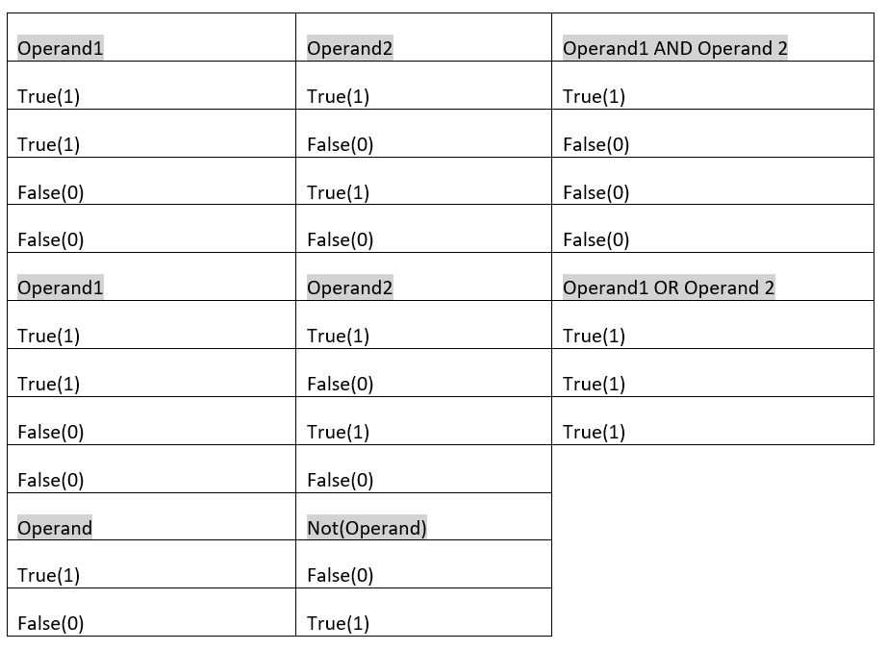

4. What are the values of the following expressions?

(5 > 4) and (3 == 5)

not (5 > 4)

(5 > 4) or (3 == 5)

not ((5 > 4) or (3 == 5))

(True and True) and (True == False)

(not False) or (not True)

ANS:-

(5 > 4) and (3 == 5) -> 0

not (5 > 4) -> 0

(5 > 4) or (3 == 5) -> 1

not ((5 > 4) or (3 == 5)) -> 0

(True and True) and (True == False) -> 0

(not False) or (not True) -> 1

5. What are the six comparison operators?

ANS:-

|  |  |  |
| --- | --- | --- |
| Assignment | = | x = 5 |
| Equivalence | = or == | if x = 5 or if x == 5 |
| Less than | < | if x < 5 |
| Less than or equal to | <= | if x <= 5 |
| Greater than | > | if x > 5 |
| Greater than or equal to | >= | if x >= 5 |
| Does not equal | <> or != | If x <> 5 or if x != 5 |

6. How do you tell the difference between the equal to and assignment operators?Describe a condition and when you would use one.

ANS:-

### Assignment Operator (=)

In mathematics and algebra, = is an **equal to** operator. In programming = is an [assignment operator](https://developer.mozilla.org/en-US/docs/Web/JavaScript/Reference/Operators/Assignment), which means that it assigns a value to a variable.

For example, the following code will store a value of 5 in the variable x:

Let x: // declaring Variable

x=6; //assigning a value of 6 to the variable

### Equality Operator (==)

In JavaScript, the operator that compares two values is written like this: ==. It is called an [equality operator](https://developer.mozilla.org/en-US/docs/Web/JavaScript/Reference/Operators/Equality). The equality operator is one of the many [comparison operators](https://developer.mozilla.org/en-US/docs/Web/JavaScript/Guide/Expressions_and_Operators#comparison_operators) in JavaScript that are used in logical and conditional statements.

The equality operator returns true or false based on whether the operands (the values being compared) are equal.

For example, the following code will return false:

Let x =5: // declares x and assigns x to the value 5

7. Identify the three blocks in this code:

spam = 0

if spam == 10:

print('eggs')

if spam > 5:

print('bacon')

else:

print('ham')

print('spam')

print('spam')

ANS:-

The three blocks are everything inside the if statement and the lines print('bacon') and print('ham').

print('eggs')

if spam > 5:

print('bacon')

else:

print('ham')

print('spam')

8. Write code that prints Hello if 1 is stored in spam, prints Howdy if 2 is stored in spam, and prints Greetings! if anything else is stored in spam.

ANS:-

spam = input()

if spam == 1:

print('Hello')

elif spam == 2:

print('Howdy')

else:

print('Greetings!')

9.If your programme is stuck in an endless loop, what keys you’ll press?

ANS:-

An infinite loop is a loop that runs indefinitely and it only stops with external intervention or when a break statement is found. You can stop an infinite loop with CTRL + C .

10. How can you tell the difference between break and continue?

ANS:-

Break statement stops the entire process of the loop. Continue statement only stops the current iteration of the loop. Break also terminates the remaining iterations. Continue doesn't terminate the next iterations; it resumes with the successive iterations.

11. In a for loop, what is the difference between range(10), range(0, 10), and range(0, 10, 1)?

ANS:-

### range(stop)

When we pass only one argument to the range(), it will generate a sequence of integers starting from 0 to stop -1.

range(10)

output : 0 1 2 3 4 5 6 7 8 9

### range(start, stop)

When we pass two arguments to the range(), it will generate integers starting from the start number to stop -1.

range(0,10)

output : 0 1 2 3 4 5 6 7 8 9

### range(start, stop, step)

When we pass all three arguments to the range(), it will return a sequence of numbers, starting from the start number, increments by step number, and stops before a stop number.

Here we can specify a different increment by adding a step parameter.

range(0,10,1)

output : 0 1 2 3 4 5 6 7 8 9

12. Write a short program that prints the numbers 1 to 10 using a for loop. Then write an equivalent

program that prints the numbers 1 to 10 using a while loop.

ANS:-

for i in range(1,11):

Print(i)

i=1

while(i<=10):

print(i)

i+=1

13. If you had a function named bacon() inside a module named spam, how would you call it after importing spam?

ANS:-

If you had a function named bacon() inside a module named spam, how would you call it after importing spam ? This function can be called with spam. bacon().