**Name: Suraj Kumar**

**USN :1NT19IS167**

**Experiment 4: Map Reduce Program**

**package** suraj_prog4;

**import** java.io.IOException;

**import** java.util.*;

**import** org.apache.hadoop.fs.Path;

**import** org.apache.hadoop.io.*;

**import** org.apache.hadoop.mapred.*;

**public** **class** WordCount {

//MAPPER CODE

**public** **static** **class** Map **extends** MapReduceBase **implements**

Mapper<LongWritable, Text, Text, IntWritable> {

**private** **final** **static** IntWritable ***one*** = **new** IntWritable(1);

//private Text word = new Text();

**public** **void** map(LongWritable key, Text value, OutputCollector<Text,

IntWritable> output, Reporter reporter) **throws** IOException {

String myString = value.toString();

String[] userCount = myString.split(",");

output.collect(**new** Text(userCount[3]), ***one***);

}

}

//REDUCER CODE

**public** **static** **class** Reduce **extends** MapReduceBase **implements**

Reducer<Text, IntWritable, Text, IntWritable> {

**public** **void** reduce(Text key, Iterator<IntWritable> values,

OutputCollector<Text, IntWritable> output, Reporter reporter) **throws**

IOException { //{little: {1,1}}

**int** finaluserCount = 0 ;

Text mykey = key ;

**while**(values.hasNext()) {

IntWritable value = values.next();

finaluserCount += value.get();

}

output.collect(mykey, **new** IntWritable(finaluserCount));

}

}

//DRIVER CODE

**public** **static** **void** main(String[] args) **throws** Exception {

JobConf conf = **new** JobConf(WordCount.**class**);

conf.setJobName("wordcount");

conf.setOutputKeyClass(Text.**class**);

conf.setOutputValueClass(IntWritable.**class**);

conf.setMapperClass(Map.**class**);

conf.setCombinerClass(Reduce.**class**);

conf.setReducerClass(Reduce.**class**);

conf.setInputFormat(TextInputFormat.**class**);

conf.setOutputFormat(TextOutputFormat.**class**);

FileInputFormat.*setInputPaths*(conf, **new** Path(args[0]));

FileOutputFormat.*setOutputPath*(conf, **new** Path(args[1]));

JobClient.*runJob*(conf);

}

}

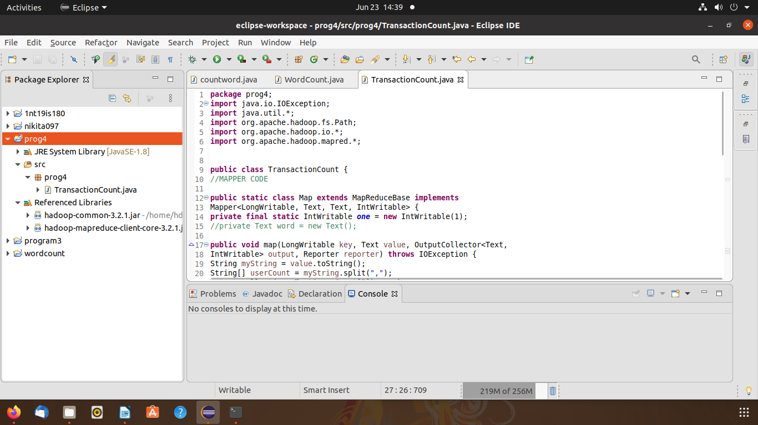

$ cd $HADOOP_HOME/sbin

./start-all.sh

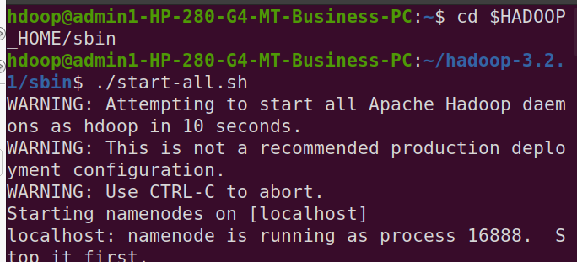

hdfs dfs -mkdir -p /suraj

hdfs dfs -copyFromLocal /home/hdoop/Documents/suraj.csv /suraj

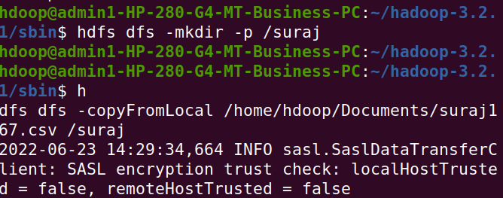

hadoop jar /home/hdoop/Documents/suraj.jar /suraj /surajabcd

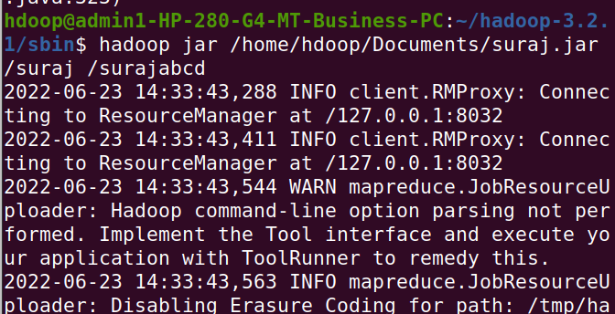

hdfs dfs -cat /surajabcd/part*

