SURAJ KUMAR 1NT19IS167
C2 Batch
6th sem

Experiment no. 5

Download the file as .csv file. Using the Sales.csv file, create a database called “salesdb”. Create a table under that with the heading “sales”. (Adjust the rows by looking at the csv file columns)

- Insert 5 records using Insert command in HiveQL

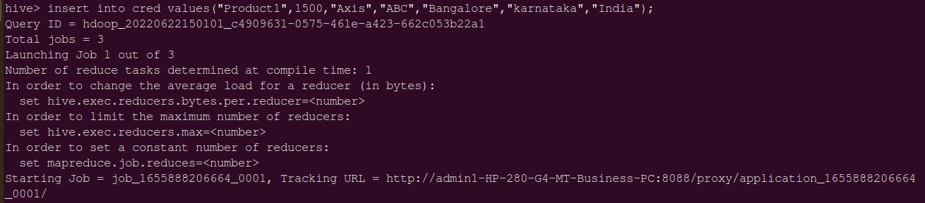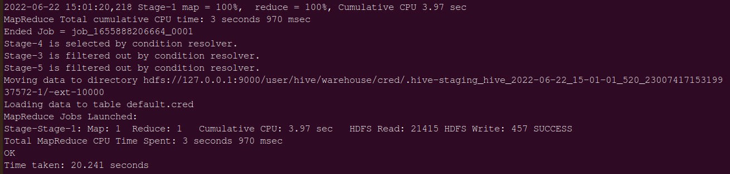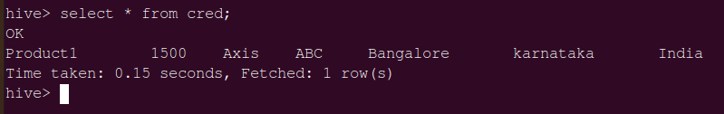

- Import the dataset from the sales.csv file

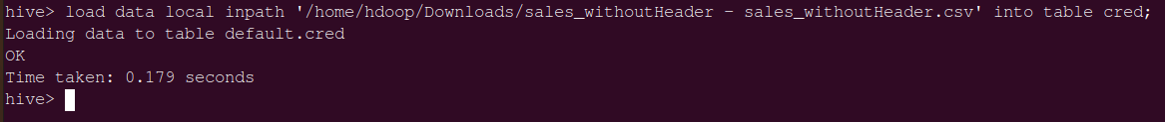

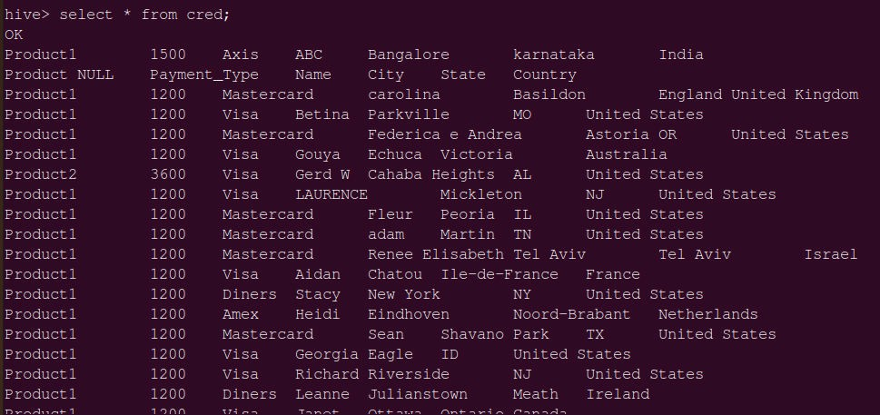

- Count the number of sales done by each country

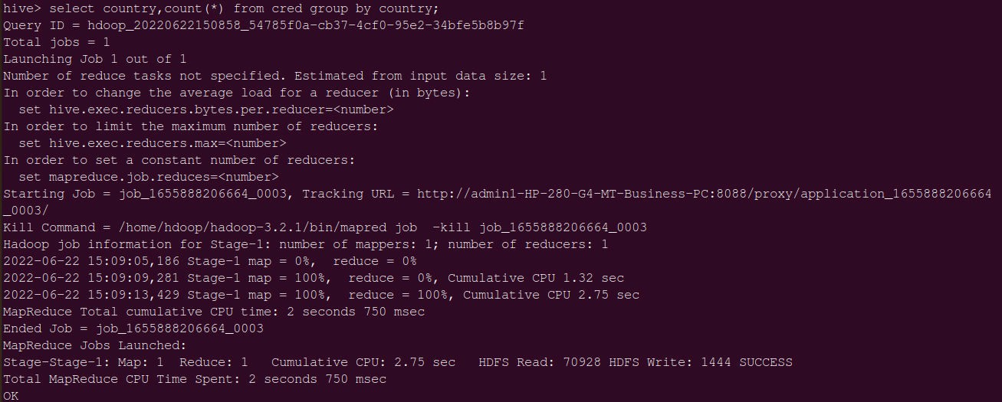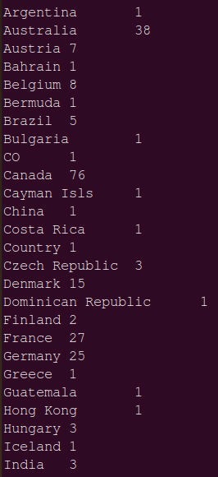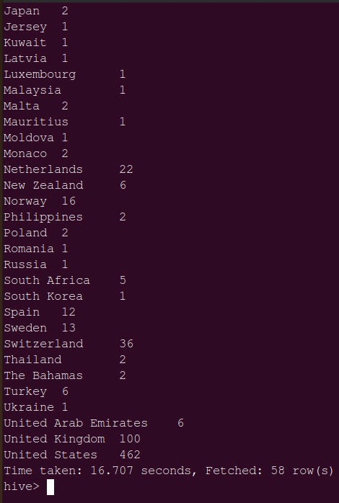
- Count the number of sales done by each state

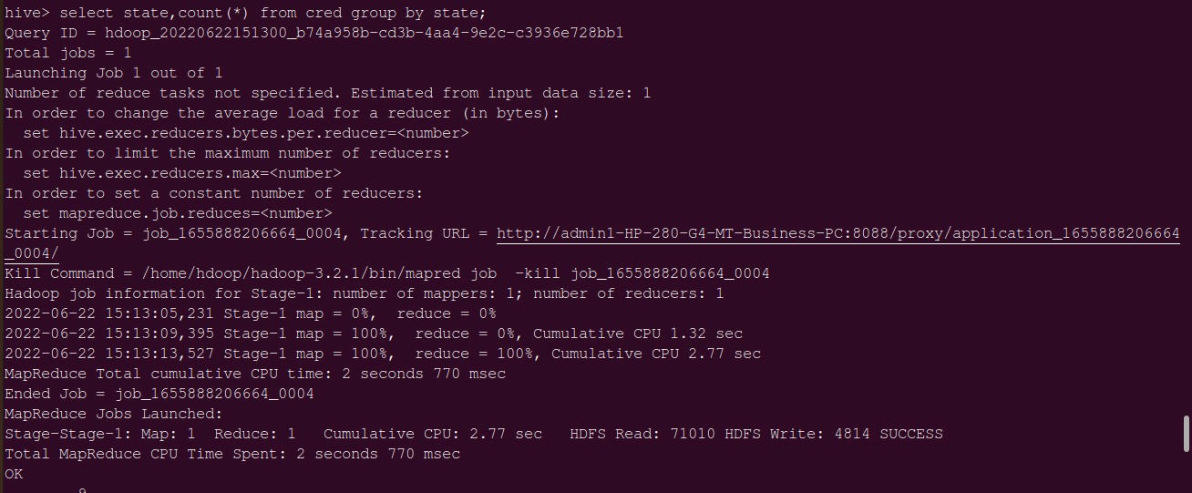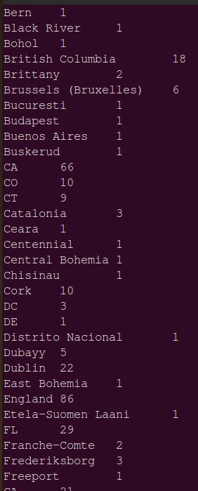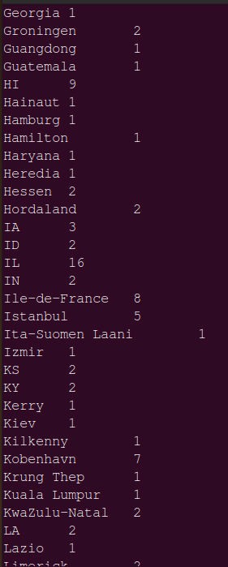
- Display (Product, name) grouped by product

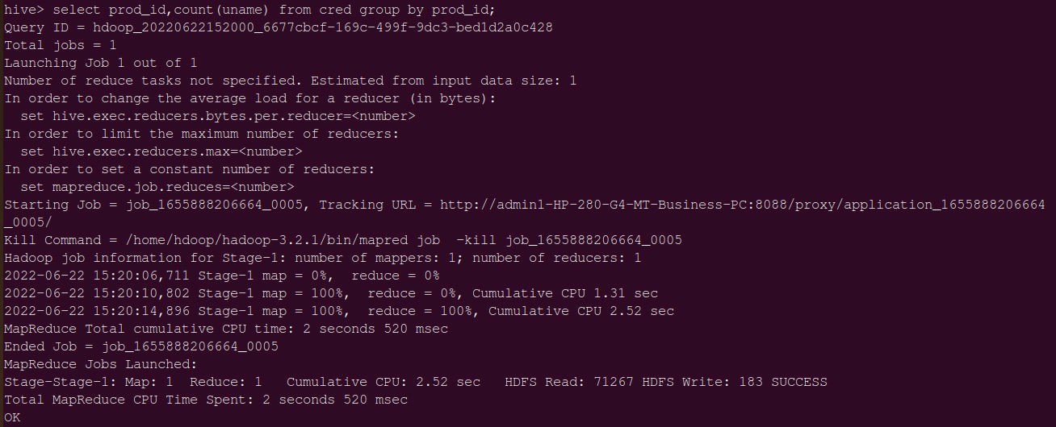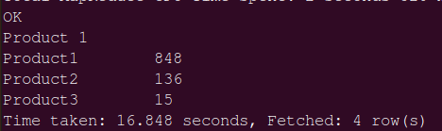

- Create separate views for VISA and Mastercard

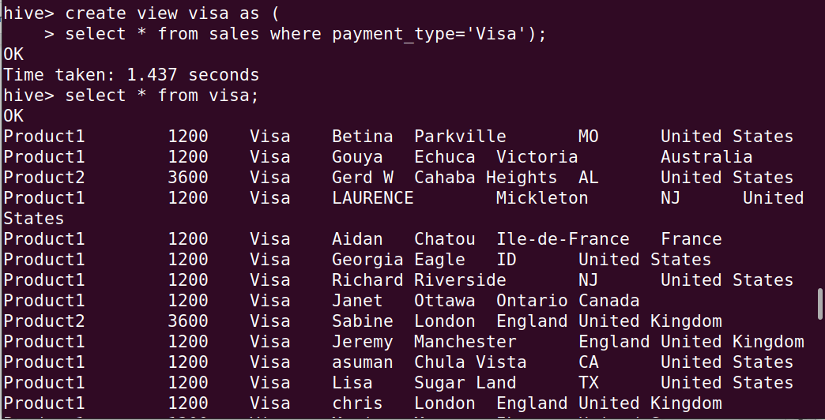

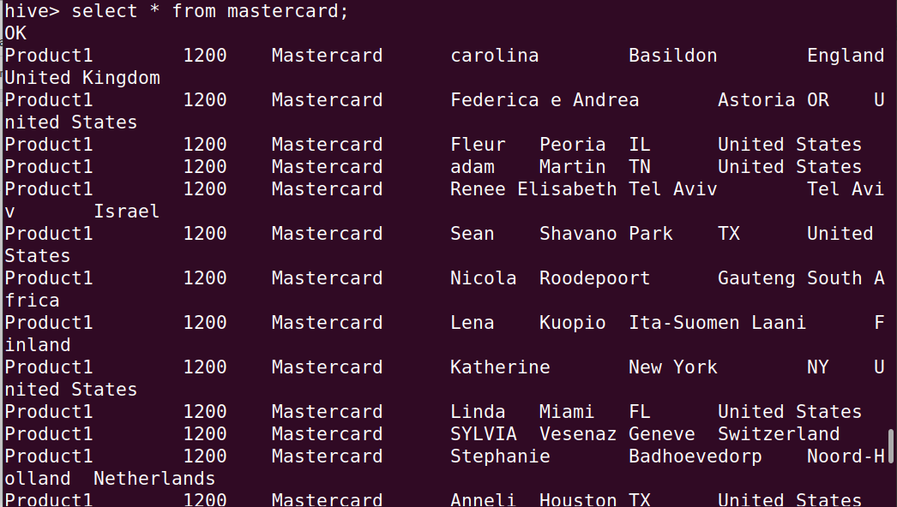

- Show all the transactions done in Seattle

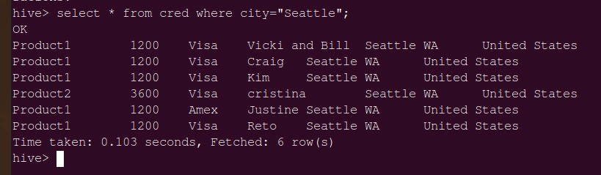

- Find the max number of transactions done within the state of Ontario
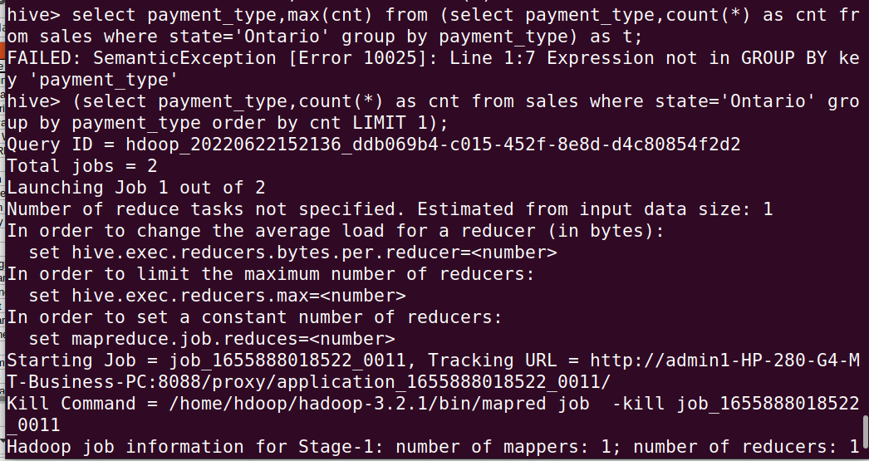

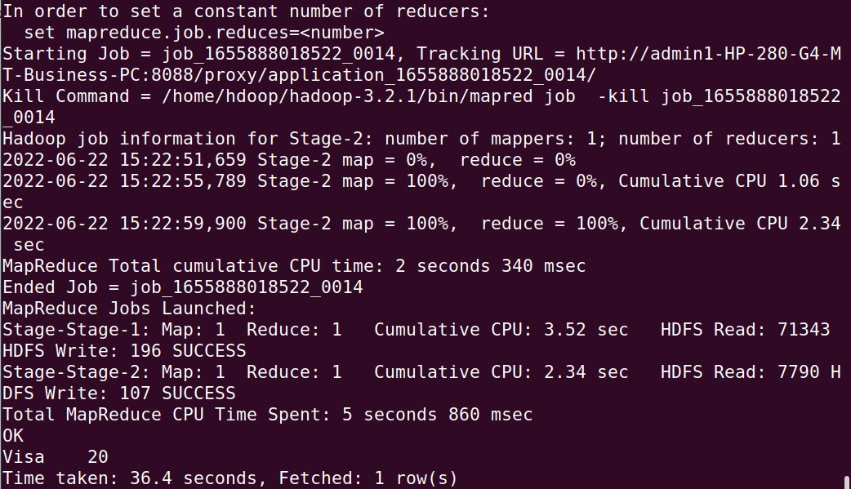

- Find the number of transactions whose price is in between 1500- 3600
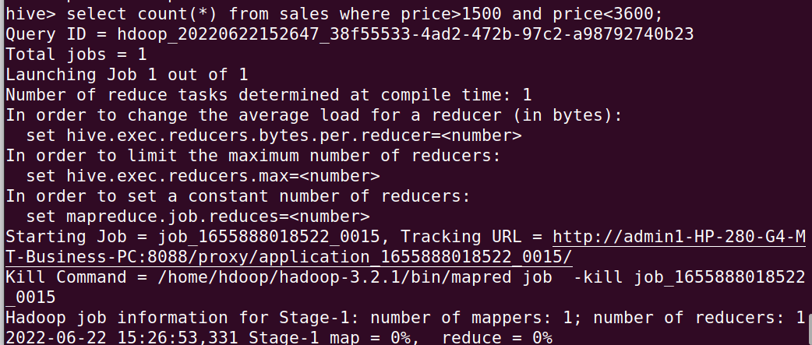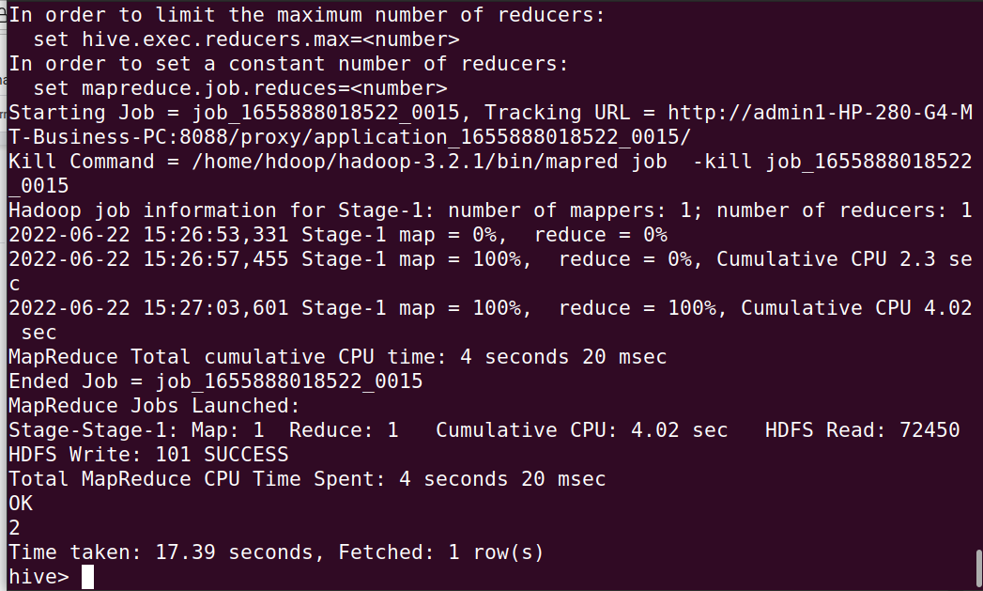
- List all the transactions done in the United States using Mastercard

