**<Hospital Management System >**

**Technical Design Documentation**

**Version 1.0**

02/11/2019

<**Created By**>

**Aayush Makharia**

**Vivek Kumar**

**Anubhav Tyagi**

**Vineet Malik**

**Rakesh Reddy Theegala**

**K Rhythm**

# INTRODUCTION

This document is a generic Technical Design Document for use made by Hospital Management System Project Team. It provides guidance and template material which is intended to assist the relevant management or technical staff, whether client or supplier, in producing a project‑specific Technical Design Document. It is also useful background reading for anyone involved in developing or monitoring the Hospital Management System.

# 

# Table of Contents

0 Preface 1

0.1 Purpose of this document 1

0.2 Overview 2

0.3 Specific Design Considerations 3

1 Introduction 4

1.1 Scope 5

1.2 Basic Layout of the Project 6

2 System Description 7

2.1 System Characteristics 8

2.2 System Architecture 9

3 Functional Map 11

3.1 Complete Functional map of the System 19

4 Functional Details 7

4.1 Code design and functions

# Preface

### Purpose of the Document

This document will basically provide all the technical as well as system details. A future developer can use this documentation to better understand the functional details of the system. Client can use the document to know about the system specifications, system requirements for running the project successfully. This document will also provide in-depth details of the technical functions and build insights of the project Hospital Management System. Reader base of this documentation includes both clients and future team which will work on this project.

### Overview

The basic structure of this documentation is described as follows:

System Introduction and Layout

Functional Details

System Description and Requirements

Security and Future Development

Documentation Layout

### Specific Design Considerations

OOD is increasingly used in the Programme as developments seek to create systems that are more maintainable over their deployment lifetime. The knock on effect of this will be an increasing emphasis on the use of the project Commercially. OOD has also made the code more readable for the future developers.(OOD is Object Oriented Design)

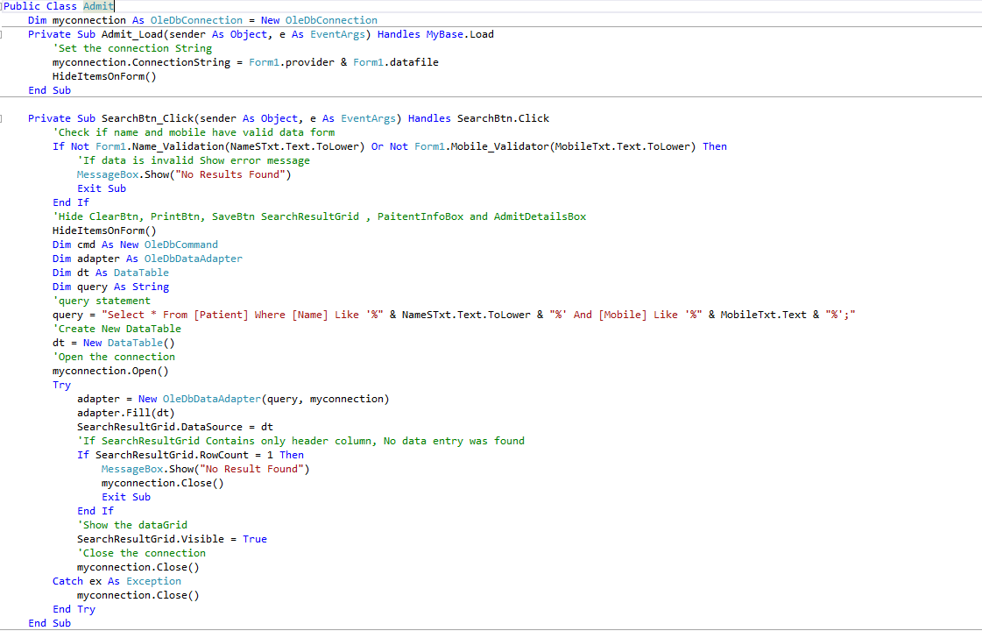

# Introduction

### Scope

This section should:

identify the products to be produced;

explain what the proposed system will do (and will not do, if necessary);

define relevant benefits, objectives and goals as precisely as possible;

define any security risks associated with the system;

be consistent with similar statements in higher-level specifications, if they exist.

### Basic Layout of the Project

* Login
  + Admin Login
  + Staff Login
* Patient
  + Registration
  + Check-up
  + Admit/Discharge
  + Update Details
* Staff
  + Availability
* Blood Bank
  + Register Donor
  + Register Receiver
  + Blood Availability
* Personal Info
  + Edit Profile
  + Logout

# System Description

### System Characteristics and Architecture

Project is best suited for 1920x1080 resolution and 64bit architecture. Project Uses Microsoft Access Database 2016 for back-end database uses. Project works only on Windows environment. System is made using Visual Basic and utilises .NET Framework.

### References

System Uses following references for its proper functioning.

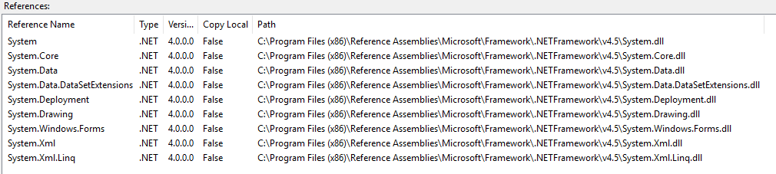

### Application and Platform Details

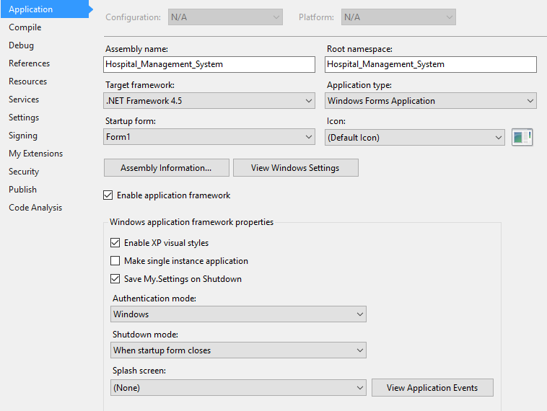

# Functional Map of Project

Represents the various functions that can be performed by various objects of the System.

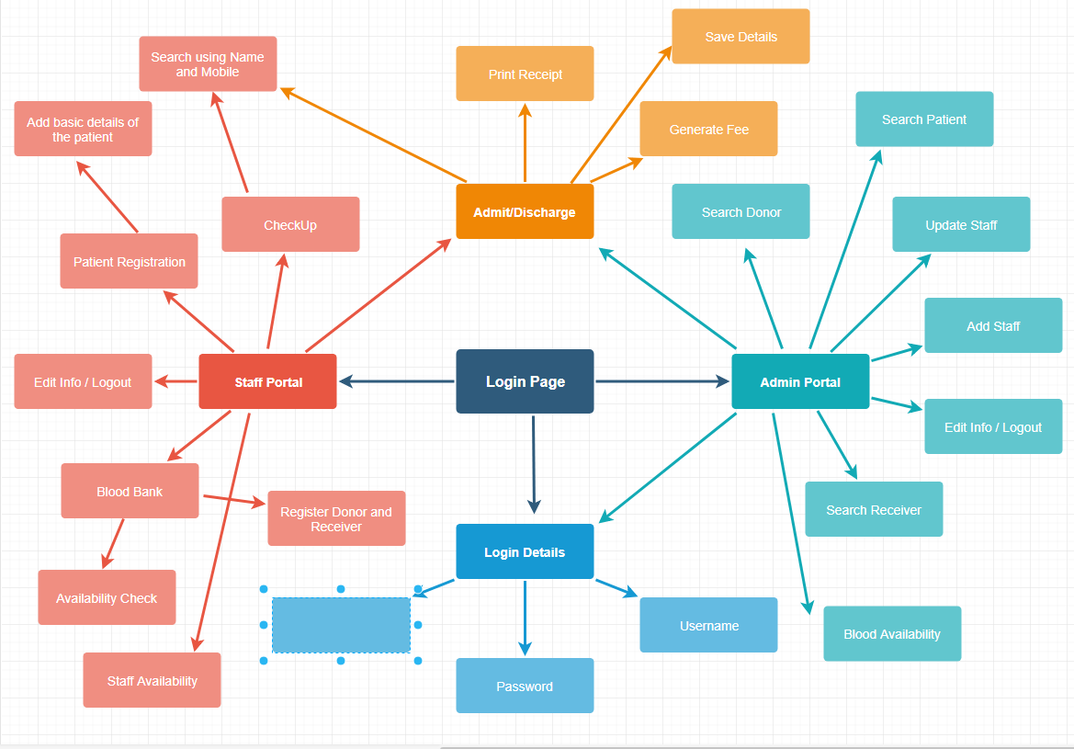

# Code Details

### Login Page

The following piece of code does the basic function of login for the admin and staff.

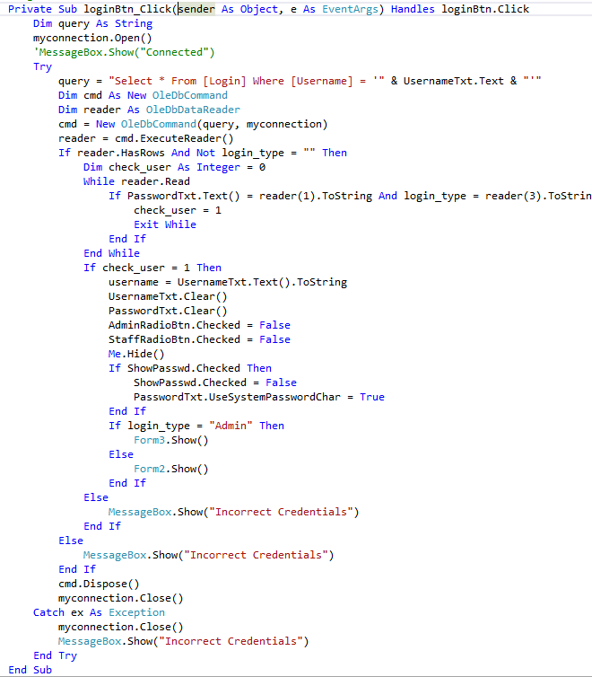

# Staff Portal

The following methods with mentioned functionalities have been used in the admin as well as staff portal with slight changes for the different objects of the system.

**Registration**

This control is used to register new patients in the system visiting the hospital for the first time. Various fields such as Name, Mobile, Age, Gender are used as identifiers for the patients. Clear is also provided to clean up the form.



**Check Up**

Search function using name and mobile number of the patient is used to search the details of the patient and then token number can be generated and finally we can print the form.



**Admit and Discharge**

Search function using name and mobile number of the patient is used to search the details of the patient and then fields for the Room No. and Room Type are provided to choose from the available options. After choosing the in date and out date, fee can automatically be generated using no. of days and type of room chosen in the fields above.



**Update Details**

From here, we can change the fields such PID, Name, Age, Address and Phone for the patients.



**Staff Availability**

From here, we can check the availability of the doctors, nurse and receptionist using the name of the object as key to search.



**Register Donor**

From here, blood donors can be registered using the various identifier fields provided in the form. Parameter checks for the various diseases have been provided for checking the quality of the blood donated by the donor to the hospital.



**Register Receiver**

From here, blood receivers can be registered using the various identifier fields provided in the form.



**Blood Availability**

From here, staff member can check the availability of the blood of various groups. We can also see the list of the recipients.



**Edit Profile**

Staff can change its various details as well as option to change the password has been provided in this control.



**Logout**

Staff can logout from the system using this control. Form will redirect to login page.

# Admin Portal

**Search Patient**

Search function using name and mobile number of the patient is used to search the details of the patient and then full access is provided to the admin to change the various identifiers of the patient. Delete function is also provided we admin wants to delete the patient from the database.



**Add Staff**

This control is exclusive to the admin only, to add staff with the designations such as doctor, nurse and receptionist. Work shift of the staff can also be assigned by the admin.



**Update Staff**

Search function has been provided to search the staff using key as the name of the staff member. After that admin can change the details of the staff members with full access.



**Search Donor**

This control lets admin search and see the donors who have donated blood to the hospital. Name and Phone are used as key to search the donors.



**Search Receiver**

This control lets admin search and see the receivers who have received blood from the hospital. Name and Phone are used as key to search the receivers.



**Blood Availability**

From here, admin can check the availability of the blood of various groups. We can also see the list of the recipients who have received blood till date.



**Edit Profile**

Admin can change its various details as well as option to change the password has been provided in this control.



**Logout**

Admin can logout from the system using this control. Form will redirect to login page.