CREATE TABLE PERSON ( DRIVER_ID VARCHAR2(10), NAME VARCHAR2(20),ADDRESS VARCHAR2(15),PRIMARY KEY(DRIVER_ID));

CREATE TABLE CAR (REGNO VARCHAR2(20), MODEL VARCHAR2(20), YEAR NUMBER(4), PRIMARY KEY(REGNO));

CREATE TABLE ACCIDENT(REPORT_NO NUMBER(5), ACC_DATE DATE, LOCATIOPN VARCHAR2(15), PRIMARY KEY(REPORT_NO));

CREATE TABLE OWNS(DRIVER_ID VARCHAR2(10), REGNO VARCHAR(10),PRIMARY KEY(DRIVER_ID,REGNO),FOREIGN KEY(DRIVER_ID) REFERENCES PERSON(DRIVER_ID),FOREIGN KEY(REGNO) REFERENCES CAR(REGNO));

CREATE TABLE PARTICIPATED(DRIVER_ID VARCHAR2(10),REGNO VARCHAR2(10),REPORT_NO NUMBER(5),DAMAGE_AMT NUMBER(7,2),PRIMARY KEY(DRIVER_ID,REGNO,REPORT_NO),FOREIGN KEY(DRIVER_ID,REGNO) REFERENCES OWNS(DRIVER_ID,REGNO) ON DELETE CASCADE, FOREIGN KEY(REPORT_NO) REFERENCES ACCIDENT(REPORT_NO) ON DELETE CASCADE);

INSERT INTO PERSON VALUES('&DRIVER_ID','&NAME','&ADDRESS');

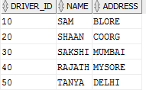

INSERT INTO CAR VALUES('&REGNO','&MODEL',&YEAR);

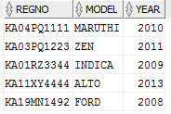

INSERT INTO ACCIDENT VALUES(&REPORT_NO,'&ADATE','&LOCATION');

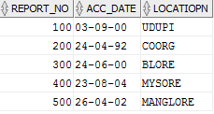

INSERT INTO OWNS VALUES('&DRIVER_ID','&REGNO');

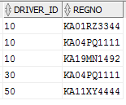

INSERT INTO PARTICIPATED VALUES('&DRIVER_ID','&REGNO','&REPORT_NO',&DAMAGE_AMT);

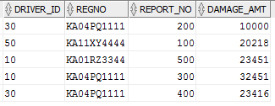

UPDATE PARTICIPATED SET DAMAGE_AMT=25000 WHERE REPORT_NO =300 AND REGNO='KA04PQ1111';

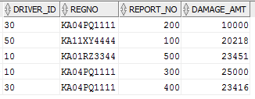

SELECT COUNT(*) FROM ACCIDENT WHERE ADATE LIKE '__-__-2002';

C:\Users\BMSCECSEIL74\Desktop\DATECHANGE.PNG

SELECT COUNT(A.REPORT_NO) FROM ACCIDENT A, PARTICIPATED P, CAR C WHERE A.REPORT_NO=P.REPORT_NO AND P.REGNO=C.REGNO AND C.MODEL='MARUTHI';

C:\Users\BMSCECSEIL74\Desktop\CARCOUNT.PNG