create table student(regno number(2),sname varchar(10),major varchar(10),bdate date,primary key(regno));

create table course(id number(3),cname varchar(10),dept varchar(10),primary key(id));

create table book(bid number(3),book_name varchar(10),publisher varchar(10),author varchar(10),primary key(bid));

create table book_adoption(id number(3),sem number(1),bid number(3),primary key(id,bid),foreign key (id) references course(id),foreign key (bid) references book(bid));

create table enroll(regno number(2),id number(3),sem number(1),marks number(3),foreign key (regno) references student(regno),foreign key (id) references course(id));

insert into student values(&regno,'&sname','&major','&bdate');

select * from student;

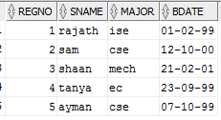

insert into course values(&id,'&cname','&dept');

select * from course;

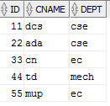

insert into book values(&bid,'&book_name','&publisher','&author');

select * from book;



insert into book_adoption values(&id,&sem,&bid);

select * from book_adoption;

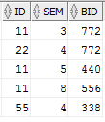

insert into enroll values(&regno,&id,&sem,&marks);

select * from enroll;

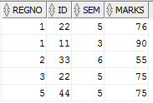

insert into book values(650,'ALGORITHM','SAPNA','REEMA');

insert into book_adoption values(22,4,650);

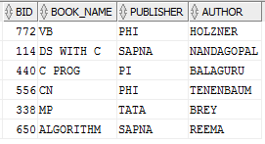 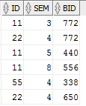

select c.cname,b.bid,b.book_name from course c,book b,book_adoption ba where c.id in (select ba.id from book_adoption ba,course c where c.dept='cse' and c.id=ba.id group by ba.id having count(*)>2) and c.id=ba.id and b.bid=ba.bid order by c.cname;

