CREATE TABLE BRANCH

(

branch_name varchar2(10),

branch_city varchar2(10),

assets number(20,5),

primary key (branch_name)

)

INSERT INTO BRANCH VALUES('&branch_name', '&branch_city',&assets);

SELECT * FROM BRANCH

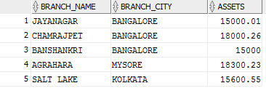

CREATE TABLE ACCOUNTS

(

accno NUMBER(15),

branch_name varchar2(10),

balance NUMBER(7,2),

PRIMARY KEY (accno),

FOREIGN KEY (branch_name) REFERENCES BRANCH(branch_name)

)

INSERT INTO ACCOUNTS VALUES('&accno', '&branch_name', &balance);

SELECT * FROM ACCOUNTS

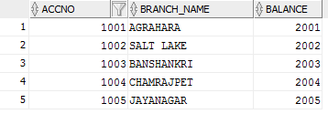

CREATE TABLE CUSTOMER

( customer_name varchar2(10),

customer_street varchar2(10),

customer_city varchar2(10),

PRIMARY KEY (customer_name)

)

INSERT INTO CUSTOMER VALUES('&customer_name' , '&customer_street', '&customer_city')

SELECT * FROM CUSTOMER

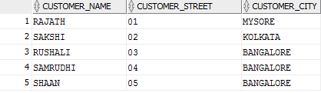

CREATE TABLE DEPOSITOR

(

customer_name varchar2(10),

accno NUMBER(15),

PRIMARY KEY (customer_name,accno),

FOREIGN KEY (accno) REFERENCES ACCOUNTS(accno),

FOREIGN KEY (customer_name) REFERENCES CUSTOMER(customer_name)

)

INSERT INTO DEPOSITOR VALUES('&customer_name' , '&accno');

SELECT * FROM DEPOSITOR

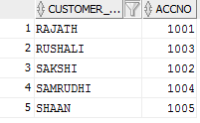

CREATE TABLE LOAN

(

loan_number NUMBER(15),

branch_name varchar2(10),

amount NUMBER(7,2),

PRIMARY KEY(loan_number),

FOREIGN KEY (branch_name) REFERENCES BRANCH(branch_name)

)

INSERT INTO LOAN VALUES('&loan_number', '&branch_name', &amount);

SELECT * FROM LOAN;

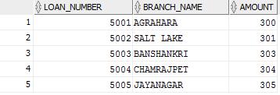

CREATE TABLE BORROWER

(

customer_name varchar2(10),

loan_number NUMBER(15),

PRIMARY KEY (customer_name),

FOREIGN KEY (loan_number) REFERENCES LOAN(loan_number)

)

INSERT INTO BORROWER VALUES('&customer_name','&loan_number');

SELECT * FROM BORROWER;

