**VISVESVARAYA TECHNOLOGICAL UNIVERSITY**

**“JnanaSangama”, Belgaum -590014, Karnataka.**



## MINI PROJECT WORK REPORT

**on**

**“Bubble Health App”**

***Submitted by***

**Lokesh R  (1BM20CS078)**

**MD Suraj Kumar(1BM20CS079)**

**M Udaya Raj (1BM20CS080)**

**Prashant R Joshi (1BM20CS110)**

***Under the Guidance of***

***Dr. Latha N.R***

***Assistant Professor, BMSCE***

***in partial fulfillment for the award of the degree of***

**BACHELOR OF ENGINEERING**

***in***

## **COMPUTER SCIENCE AND ENGINEERING**



**B. M. S. COLLEGE OF ENGINEERING**

**(Autonomous Institution under VTU)**

## BENGALURU-560019

**May-2023 to July-2023**

**B. M. S. College of Engineering,**

**Bull Temple Road, Bangalore 560019**

(Affiliated To Visvesvaraya Technological University, Belgaum)

**Department of Computer Science and Engineering**



**CERTIFICATE**

This is to certify that the project work entitled “**Bubble Health App**” carried out by **Lokesh R(1BM20CS078), MD Suraj Kumar(1BM20CS079),M Udaya Raj (1BM20CS080), AND Prashant R Joshi(1BM20CS110)**who are bonafide students of **B.M.S.College of Engineering.** It is in partial fulfillment for the award of **Bachelor of Engineering in Computer Science and Engineering** of the Visveswaraiah Technological University, Belgaum during the year 2021. The project report has been approved as it satisfies the academic requirements in respect of **OOMD(20CS6PCOMD)** work prescribed for the said degree.

|  |  |  |
| --- | --- | --- |
| Signature of the Guide  Dr Latha N.R  Assistant Professor |  | Signature of the HOD  Dr. Jyothi S Nayak  Professor & Head, Dept. of CSE |
| BMSCE, Bengaluru |  | BMSCE, Bengaluru |
| Name of the Examiner | External Viva | Signature with date |

1.

2.  

## **B. M. S. COLLEGE OF ENGINEERING**

## **DEPARTMENT OF COMPUTER SCIENCE AND ENGINEERING**



***DECLARATION***

We, **Lokesh R (1BM20CS078)**, **MD Suraj Kumar(1BM20CS079)**, **M Udaya Raj (1BM20CS080), Prashant R Joshi(1BM20CS110)**, students of 5th Semester, B.E, Department of Computer Science and Engineering, B. M. S. College of Engineering, Bangalore, hereby declare that, this Mini Project Work entitled "Bubble Health App" has been carried out by us under the guidance of Dr Latha N.R, Assistant Professor, Department of CSE, B. M. S. College of Engineering, Bangalore during the academic semester May-2023-July-2023.

We also declare that to the best of our knowledge and belief, the development reported here is not from part of any other report by any other students.

                                                                                  Signature

**Lokesh R (1BM20CS078)**

**MD Suraj Kumar(1BM20CS079)**

**M Udaya Raj (1BM20CS080)**

**Prashant R Joshi(1BM20CS110)**

**Team Details:**

Lokesh R - 1BM20CS078

M D Suraj Kumar - 1BM20CS0079

M Udaya Raj - 1BM20CS080

Prashant R Joshi - 1BM20CS110

Class - 6B

Batch - B2

**MINI PROJECT - BUBBLE HEALTH APP**

**Problem Statement :**

* Lack of accessible and timely medical assistance in remote areas leads to avoidable deaths and delays in critical healthcare. The existing healthcare infrastructure is limited, with hospitals and clinics situated far away, requiring hours of travel before receiving necessary medical care. Our on-demand doctor application aims to bridge this gap by enabling individuals, particularly rural inhabitants, to seek medical advice, schedule appointments, and access timely assistance from anywhere, thereby potentially saving lives and improving healthcare outcomes.

**Motivation :**

There are several motivations for developing a patient-doctor communication app. Here are some key reasons:

**1. Convenience and Efficiency:** A dedicated appointment booking feature allows patients to schedule their appointments at their convenience, anytime and anywhere. They can easily view the doctor's availability, select a suitable time slot, and book an appointment without the need for phone calls or waiting on hold. This streamlines the process and saves both patients and staff valuable time.

**2. Improved Patient Engagement and Satisfaction:** By providing patients with control over their appointment scheduling, the app enhances patient engagement and satisfaction. Patients appreciate the flexibility and autonomy to book appointments based on their availability and preferences. This empowerment fosters a positive patient experience and strengthens the doctor-patient relationship.

**3. Efficient Resource Allocation:** By automating the appointment booking process, staff members can allocate their time and resources more efficiently. They can focus on other critical tasks instead of spending significant time on manual appointment scheduling and management.

**4. Efficient Information Sharing:** A dedicated app can streamline the exchange of information between patients and doctors. Patients can securely share medical records, test results, and symptoms, allowing doctors to make more informed decisions and provide accurate diagnoses and treatment recommendations.

**Scope of the report:**

The scope of a report on a patient-doctor communication and appointment booking app can vary depending on the specific requirements and objectives of the report. However, here are some key areas that can be covered:

**1. Introduction and Background:**

* Overview of the patient-doctor communication landscape.
* The importance of effective communication and appointment management in healthcare.
* Introduction to the concept of a patient-doctor communication and appointment booking app.

**2. Objectives and Goals:**

* Clearly define the objectives and goals of the app.
* Identify the target audience (patients, doctors, healthcare providers, etc.).
* Explain the intended benefits and outcomes.

**3. App Features and Functionality:**

* Provide an overview of the features and functionality of the app.
* Highlight key components such as secure messaging, appointment booking, appointment reminders, virtual consultations (if applicable), and any other relevant features.

**4. User Experience and Interface:**

* Describe the user interface and user experience design of the app.
* Discuss how the app ensures ease of use, accessibility, and intuitive navigation for both patients and doctors.

**5. Technical Infrastructure:**

Outline the technical infrastructure required for the app, including the server architecture, data storage, security measures, and integration with existing systems (such as electronic health records).

**6. Appointment Booking Process:**

* Detail the steps involved in the appointment booking process.
* Explain how patients can view doctor availability, select suitable time slots, and book appointments.
* Discuss any additional features like rescheduling, cancellations, or waitlist management.

**7. Patient-Doctor Communication:**

* Describe how the app facilitates secure and efficient communication between patients and doctors.
* Discuss messaging functionalities, including text-based communication, file sharing, and response mechanisms.
* Highlight privacy and security measures to protect patient information.

**8. Integration and Interoperability:**

* Discuss the integration of the app with existing healthcare systems and electronic health records.
* Explain how data flows between the app and other systems to ensure seamless information exchange.

**9. Data Security and Privacy:**

* Address data security measures implemented within the app.
* Discuss encryption protocols, compliance with privacy regulations (such as HIPAA), and safeguards to protect patient data.

**10. Implementation and Deployment:**

* Discuss the implementation process of the app, including development, testing, and deployment phases.
* Address any potential challenges or considerations related to implementation.

**11. User Adoption and Feedback:**

* Explain strategies for promoting user adoption of the app among patients and doctors.
* Discuss user feedback mechanisms, such as surveys or user testing, to gather feedback and improve the app's functionality and usability.

**12. Conclusion and Future Directions:**

* Summarize the key findings and benefits of the patient-doctor communication and appointment booking app.
* Provide recommendations for future enhancements, upgrades, or expansion of the app's features.

**Software Requirement Specification(SRS)**

**1.** **Introduction:**

**a.** **Purpose of this document:**

The purpose of this document is to address the critical problem of limited access to medical assistance in remote areas. It outlines the requirements for developing an on-demand doctor application that enables individuals in these areas to seek timely medical advice and schedule appointments. The SRS document serves as a comprehensive guide for the development team, providing a clear understanding of the functionality, performance, and design considerations needed to bridge the gap in healthcare access. It aims to improve healthcare outcomes, reduce avoidable deaths, and enhance the overall delivery of medical assistance in remote areas.

**b.** **Scope of this document:**

**The following are the functionalities of this project:**

i. User Registration

ii. Connecting Patients with Doctors

iii. History

iv. Send Attachments

v. Message Status.

**c.** **Overview:**

This project aims to bring accessible medical assistance to individuals through on-demand doctor applications. It focuses on bridging the gap between remote areas and healthcare by providing timely medical advice and support. The project emphasizes user-friendly interfaces, high-performance requirements, and adherence to design constraints while maintaining a feasible schedule and budget.

**2.** **General Description:**

This project aims to bring accessible medical assistance to individuals through on-demand doctor applications. It focuses on bridging the gap between remote areas and healthcare by providing timely medical advice and support. The project emphasizes user-friendly interfaces, high-performance requirements, and adherence to design constraints while maintaining a feasible schedule and budget.

**3.** **Functional Requirements:**

**a. User Registration:** On installing the application, users must be prompted to register their phone numbers. The user’s phone number will be the unique identifier of his/her account.

**b. Authentication:** is done through the OTP verification system and the user will be asked to configure as a patient or a doctor

**c. Connecting Patients with Doctors:** Bubble connects patients with doctors with different specializations.

**d. History:** With bubble patients and doctors can check their online appointment history and get a quick recap of the key takeaways from the appointment in both patient and doctor modes of the app.

**e. Send Attachments**: Patients and doctors can send images and documents as attachments.

**f. Message Status:** The user must be able to get information on whether the message sent has been read by the intended recipient. If the recipient reads the message, 2 ticks appear next to the message read.

**4.** **Interface Requirements:**

**a. User-friendly interface:** The application should have an intuitive and easy-to-use interface for both patients and doctors, allowing them to navigate the app effortlessly.

**b. Appointment scheduling:** The app should provide a feature for patients to schedule appointments with doctors based on their availability.

**c. Real-time communication:** The app should facilitate real-time communication between patients and doctors through text chat, voice calls, or video calls, ensuring seamless and efficient consultations.

**d. Medical records access:** The app should allow doctors to access and review patients' medical records, including their medical history, test results, and previous treatments.

**e. Notifications:** The app should send timely notifications to patients and doctors regarding appointment reminders, prescription refills, or any important updates.

**f. Multilingual support:** The interface should support multiple languages to cater to a diverse user base, ensuring accessibility for users with different language preferences.

**5.** **Performance Requirements:**

**a. Responsiveness:** The application should respond quickly to user actions, ensuring minimal delay in loading screens and processing requests.

**b. Scalability:** The app should be capable of handling a large number of concurrent users without significant performance degradation.

**c. Reliability:** The app should have a robust infrastructure to ensure high availability and minimize downtime, allowing users to access medical assistance whenever needed.

**d. Security:** The app should employ robust security measures to protect users' personal and medical information, ensuring compliance with data protection regulations.

**e. Compatibility:** The app should be compatible with various devices and operating systems, such as smartphones, tablets, and both iOS and Android platforms.

**f. Data storage and backup:** The app should securely store and backup patient and doctor data to prevent data loss and enable easy retrieval when needed.

**6.** **Design Constraints:**

**a. Regulatory compliance:** The app should comply with relevant healthcare regulations and privacy laws to ensure the confidentiality and security of patient data.

**b. Device limitations:** The app's design should consider the limitations of different devices, such as screen size, processing power, and network connectivity, to provide an optimal user experience across various devices.

**c. Bandwidth limitations:** The app should be designed to work efficiently even in areas with limited internet connectivity, optimizing data usage and providing offline access to essential features when possible.

**d. Integration with existing systems:** The app should integrate with existing healthcare systems, such as electronic health record systems, to streamline the exchange of patient information and avoid duplicating data entry.

**7.** **Non-functional attributes:**

**a. Performance:** The application is lightweight and sends messages instantly.

**b. User-Friendly:** The user interface is interactive and user-friendly allowing the user to avail all the features in the application easily.

**c. Scalability:** Our application provides instant messaging services to all users at any given time.

**d. Robustness:** In case the user’s device crashes, a backup of their chat history must be stored on remote database servers to enable recoverability.

**8.** **Preliminary Schedule and budget:**

a. The following is a rough outline of the preliminary schedule and budget for the project:

i. Requirement gathering and analysis: 2 weeks

ii. UI/UX design and prototyping: 4 weeks

iii. Backend development: 6 weeks

iv. Frontend development: 6 weeks

v. Integration and testing: 4 weeks

vi. Deployment and launch: 2 weeks

Total estimated development time: 24 weeks (approximately 6 months)

b. Budget allocation:

i. Development team salaries: $10,000

ii. Infrastructure and hosting: $10,000

iii. Third-party services (communication APIs, etc): $5,000

iv. Marketing and promotion: $10,000

v. Contingency and miscellaneous: $10,000

Total estimated budget: $45,000

# **2. CLASS DIAGRAM**

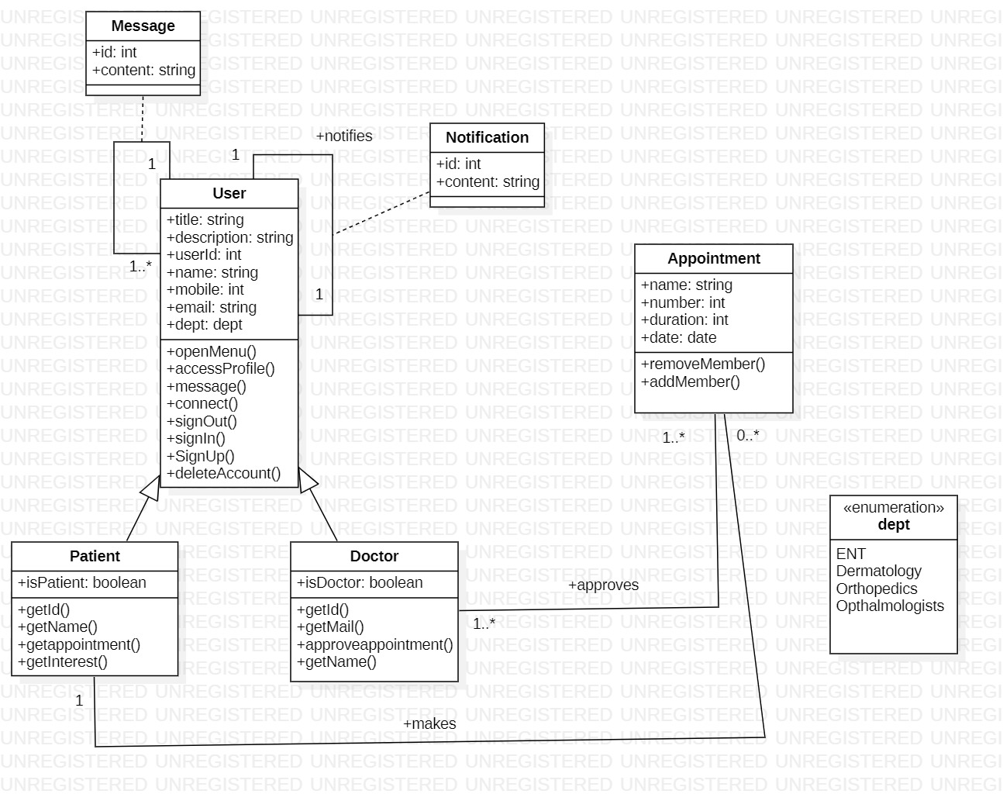

***Fig 2.1 Class Diagram***

# **3. STATE DIAGRAM**

# 

***Fig 3.1 State Diagram***

# 

# **4.USE CASE DIAGRAM**

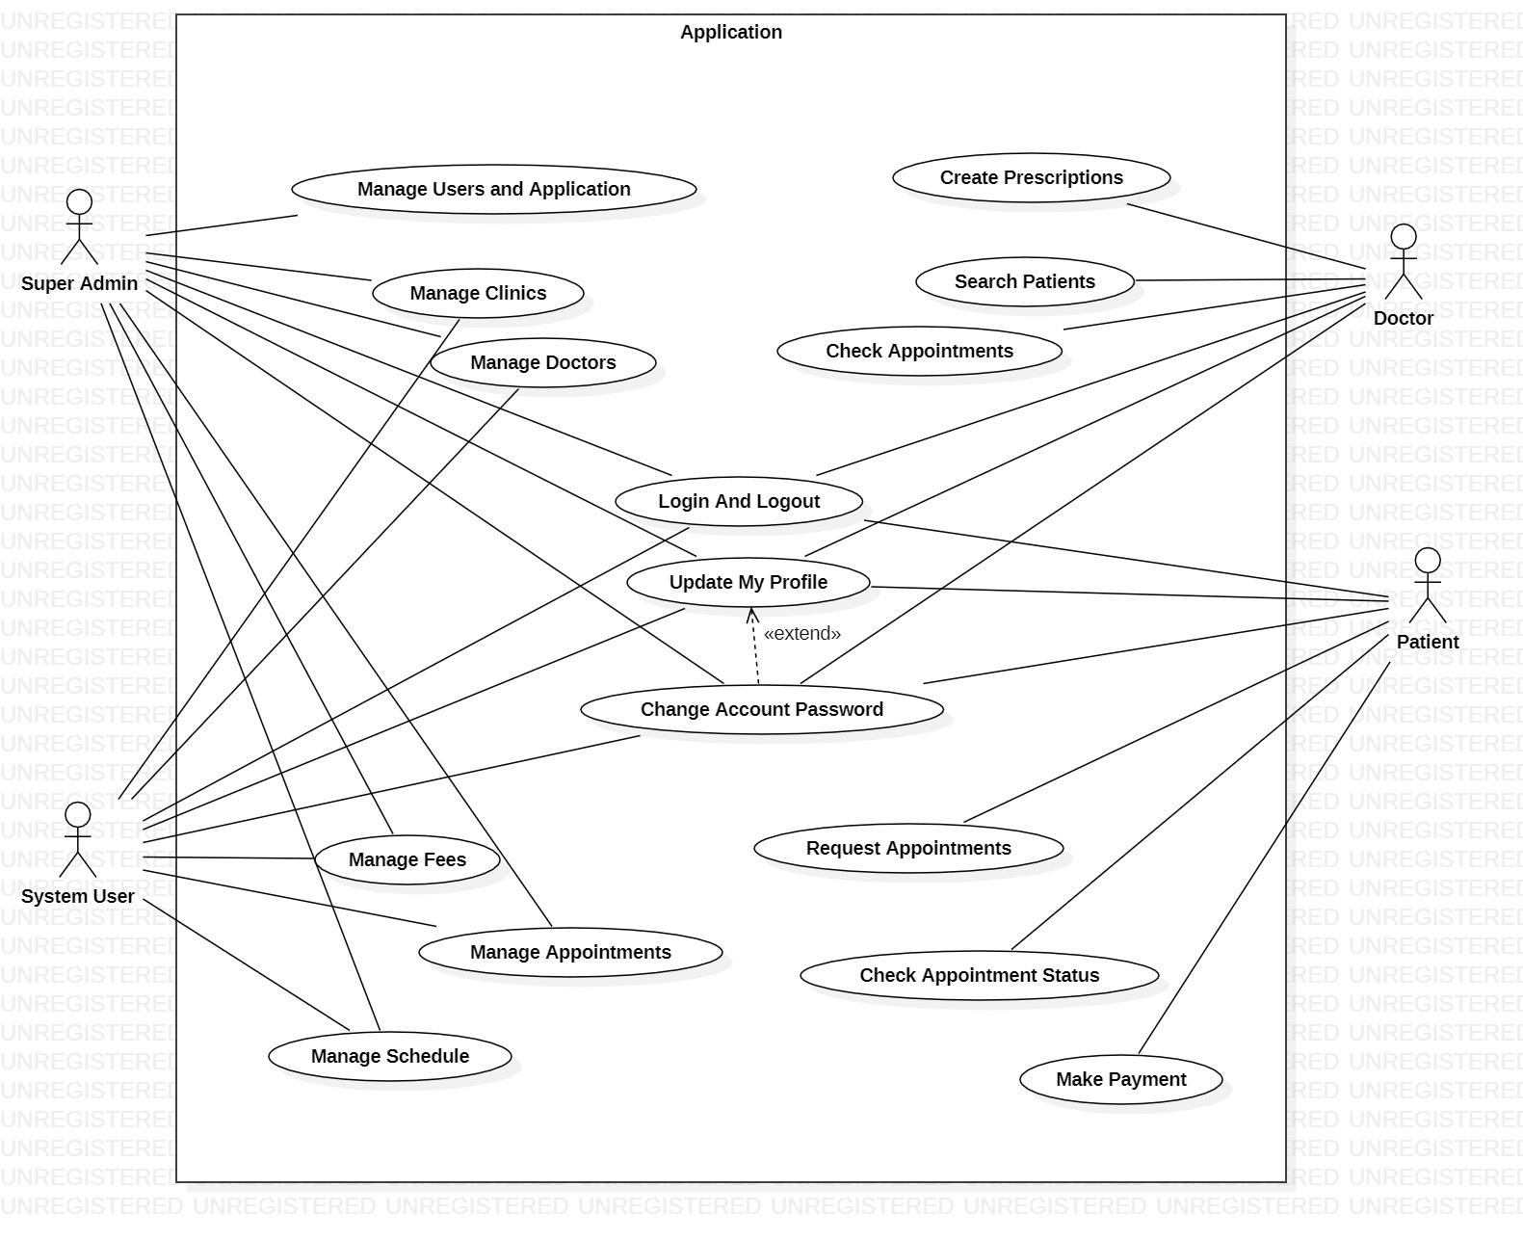

***Fig 4.1 Use Case***

**Use Case Description:**

**Make and manage appointments:** The user can make and manage- update, cancel and request multiple appointments to meet a doctor based on a fixed schedule that the doctor manages.

**Chat with doctor:** The user(patient) can send and receive text messages to and from the doctor and ask them queries they have about their health

**Generate Prescription:** The patient can request the generation of a prescription based on the symptoms he has and the doctor can provide/verify the description

# **5. SEQUENCE DIAGRAM**

**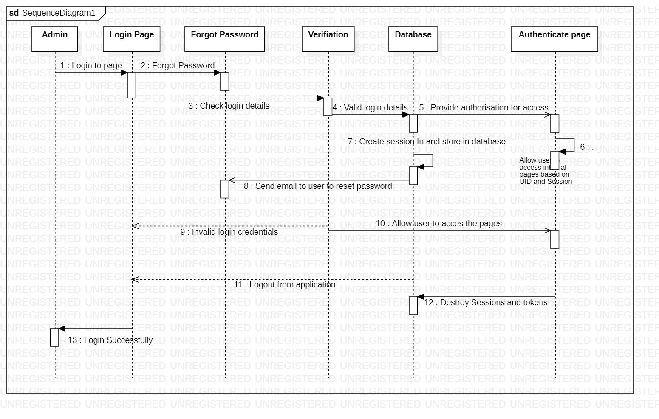*Fig 5.1 Sequence Diagram(Authentication)***

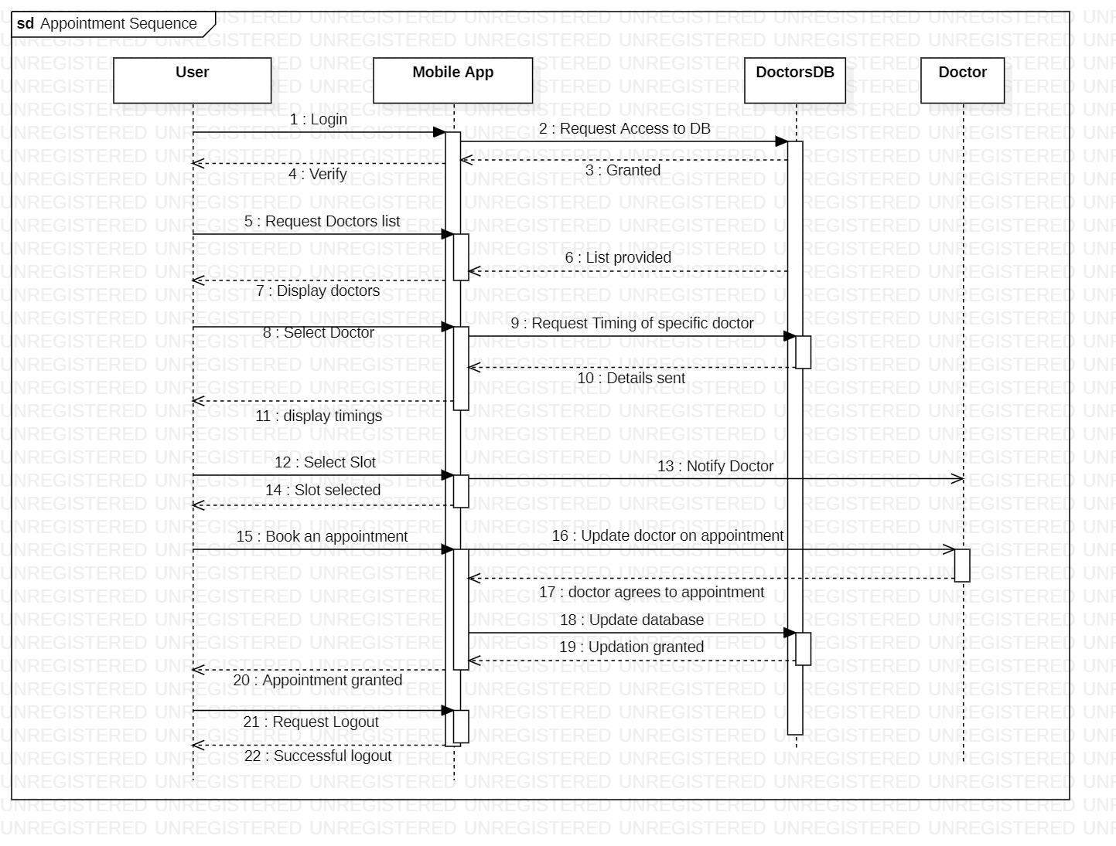

***Fig 5.2 Sequence Diagram(Appointment)***

# 

# 

# 

# 

# 

# 

# 

# **6. ACTIVITY DIAGRAM**

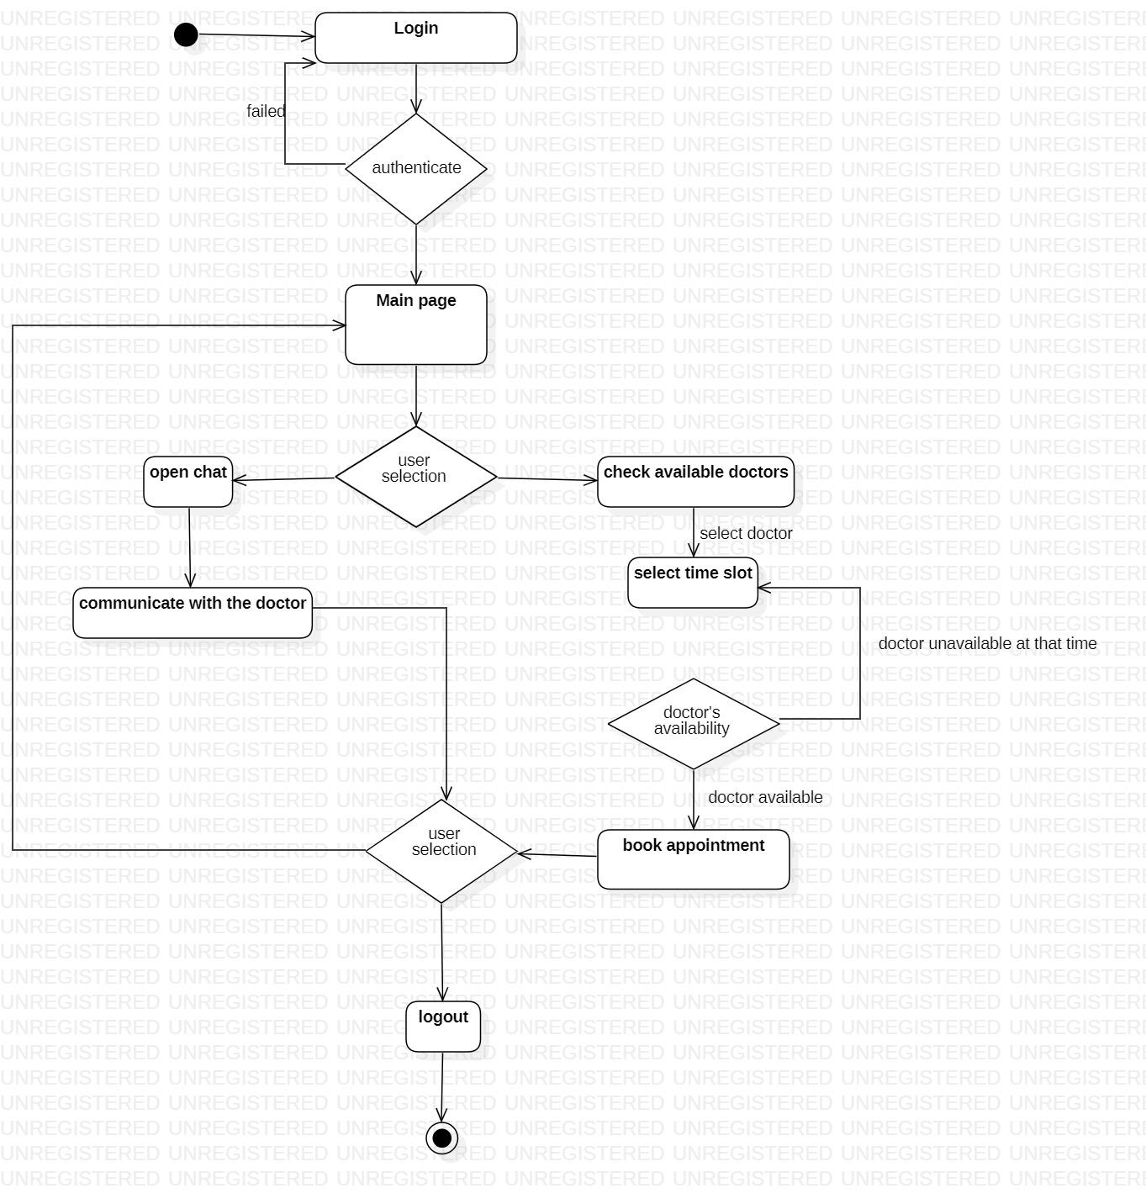

***Fig 6.1 Activity Diagram***

**UI**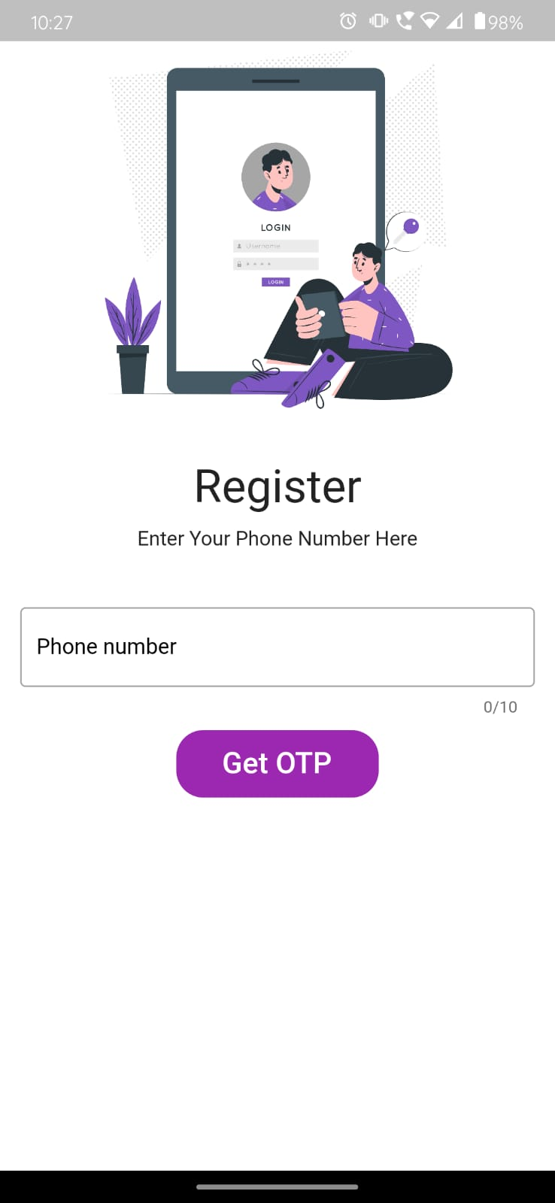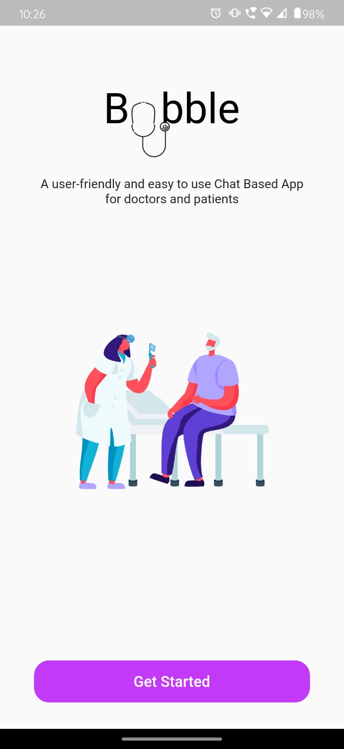

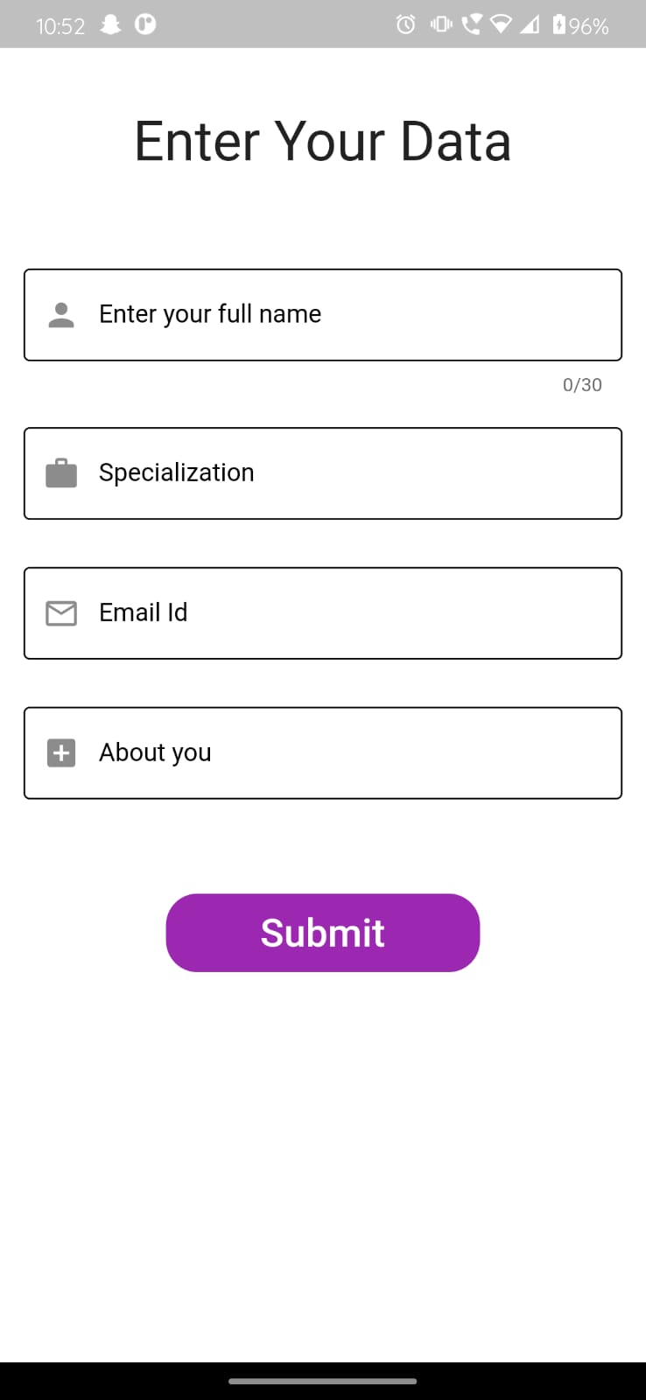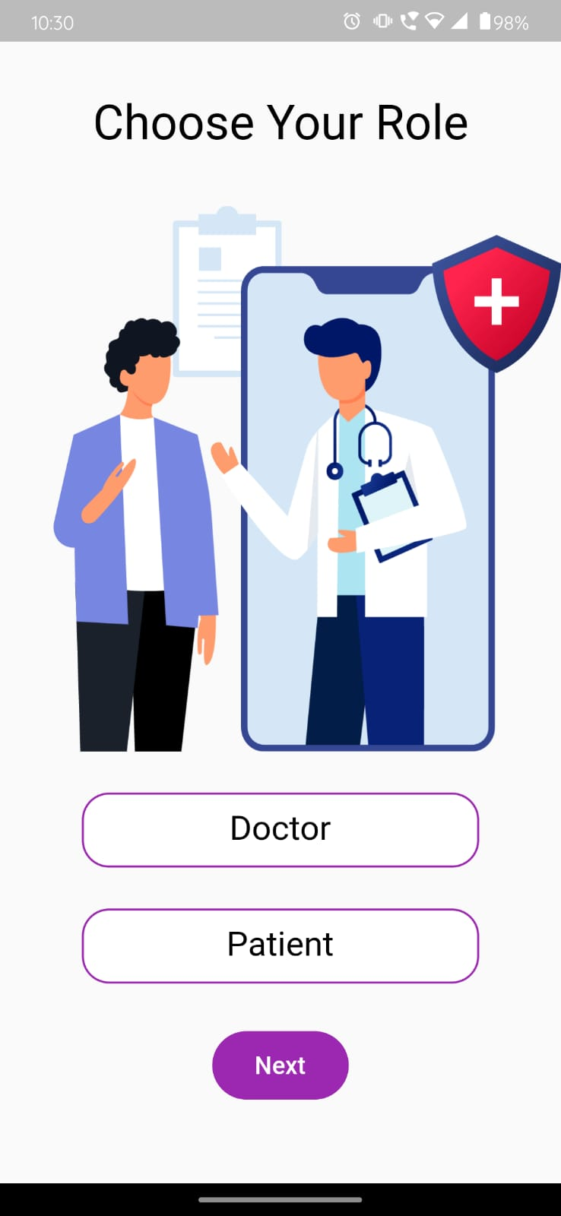

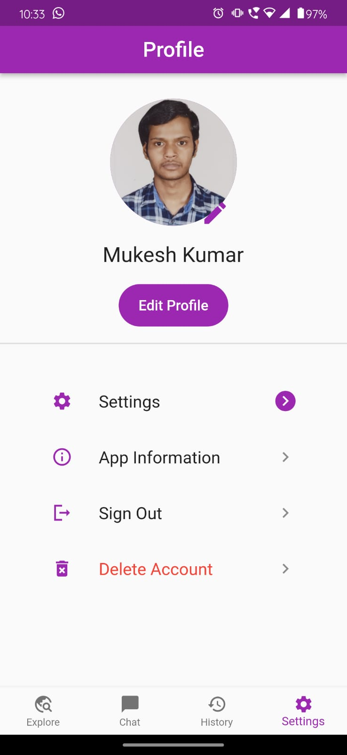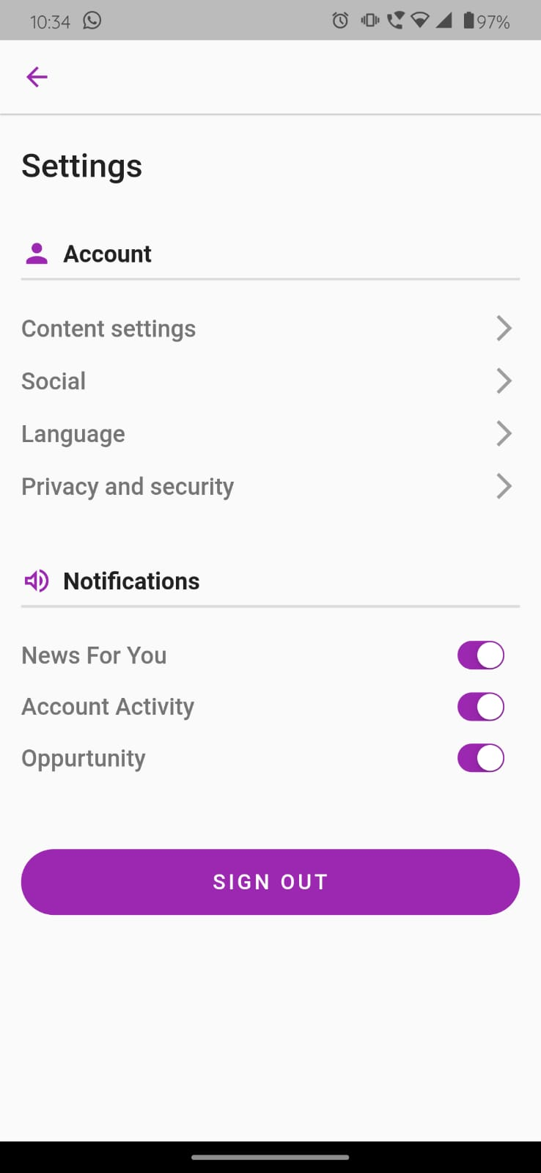

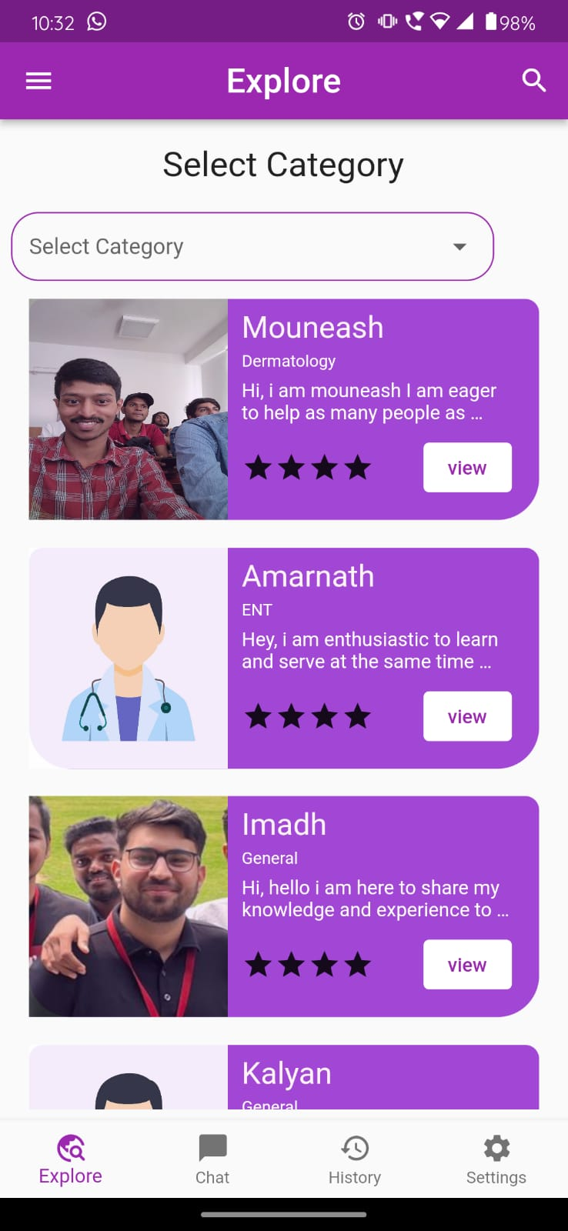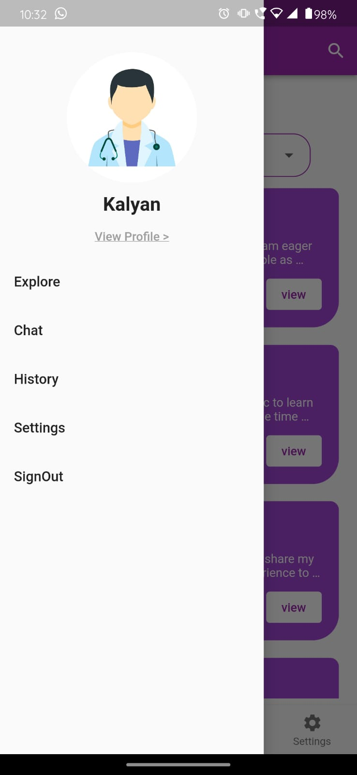

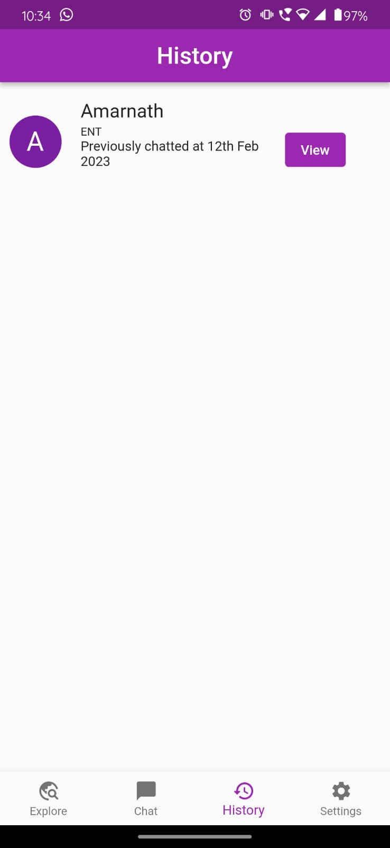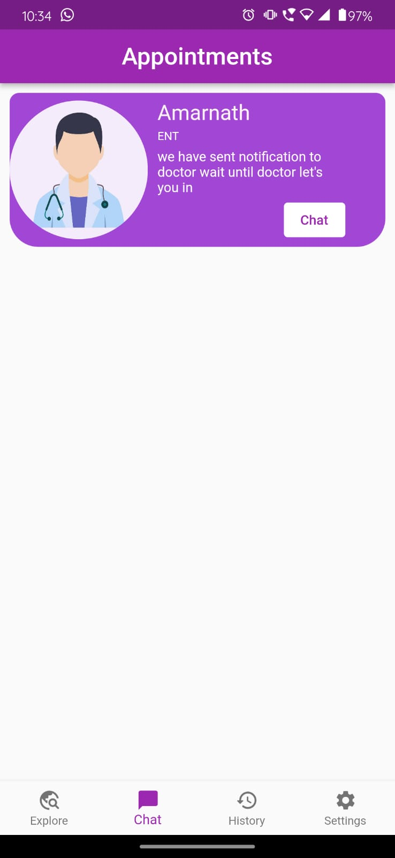

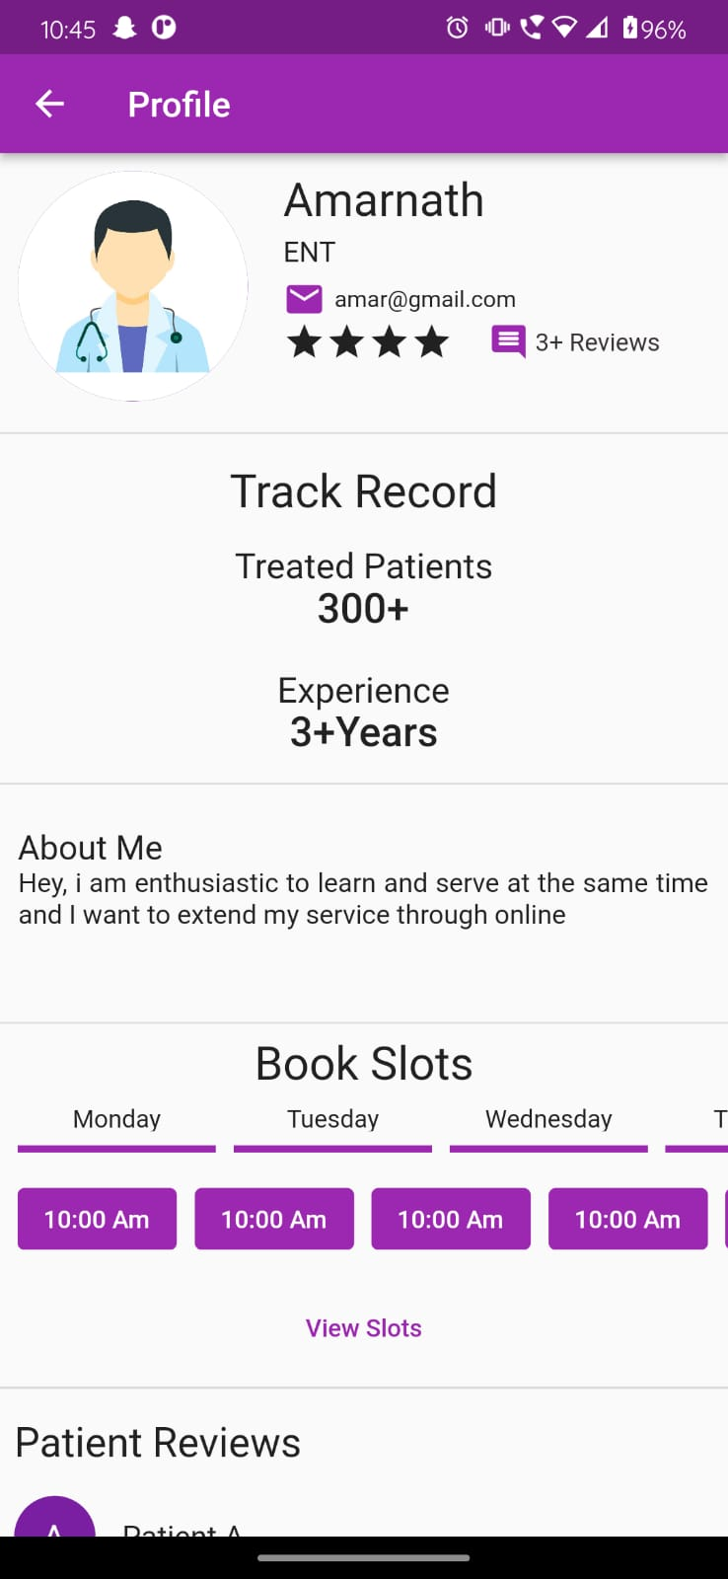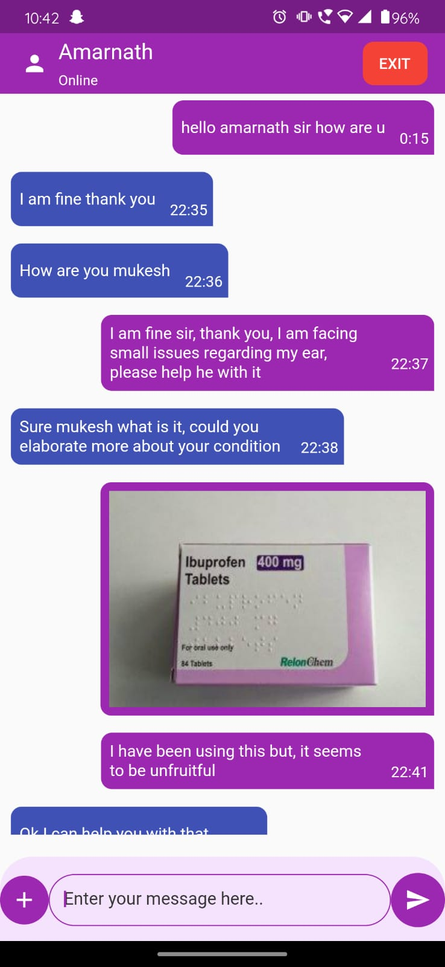

**8.CONCLUSION**

In conclusion, our on-demand doctor application has successfully addressed the challenge of lack of accessible and timely medical assistance in remote areas. By leveraging OMD (Online Medical Diagnosis) models and incorporating them into our application, we have empowered individuals, especially those residing in rural areas, to conveniently seek medical advice and schedule appointments without the need for long-distance travel.

Through the application, users can connect with healthcare professionals virtually, enabling them to receive timely medical assistance, diagnoses, and treatment recommendations. This has not only improved healthcare outcomes but also reduced the risk of avoidable deaths and delays in critical healthcare.

By leveraging technology and utilizing OMD models, we have bridged the gap between patients and doctors, allowing for remote consultations and medical support. Our application has revolutionized healthcare access and brought essential medical services to the fingertips of individuals in remote areas.

Moving forward, we aim to further enhance the application by expanding its features, such as incorporating telemedicine capabilities for real-time video consultations and implementing secure and reliable data privacy measures. We will continue to collaborate with healthcare professionals, improve the accuracy and reliability of our OMD models, and expand our user base to reach more individuals in need of accessible and timely medical assistance.