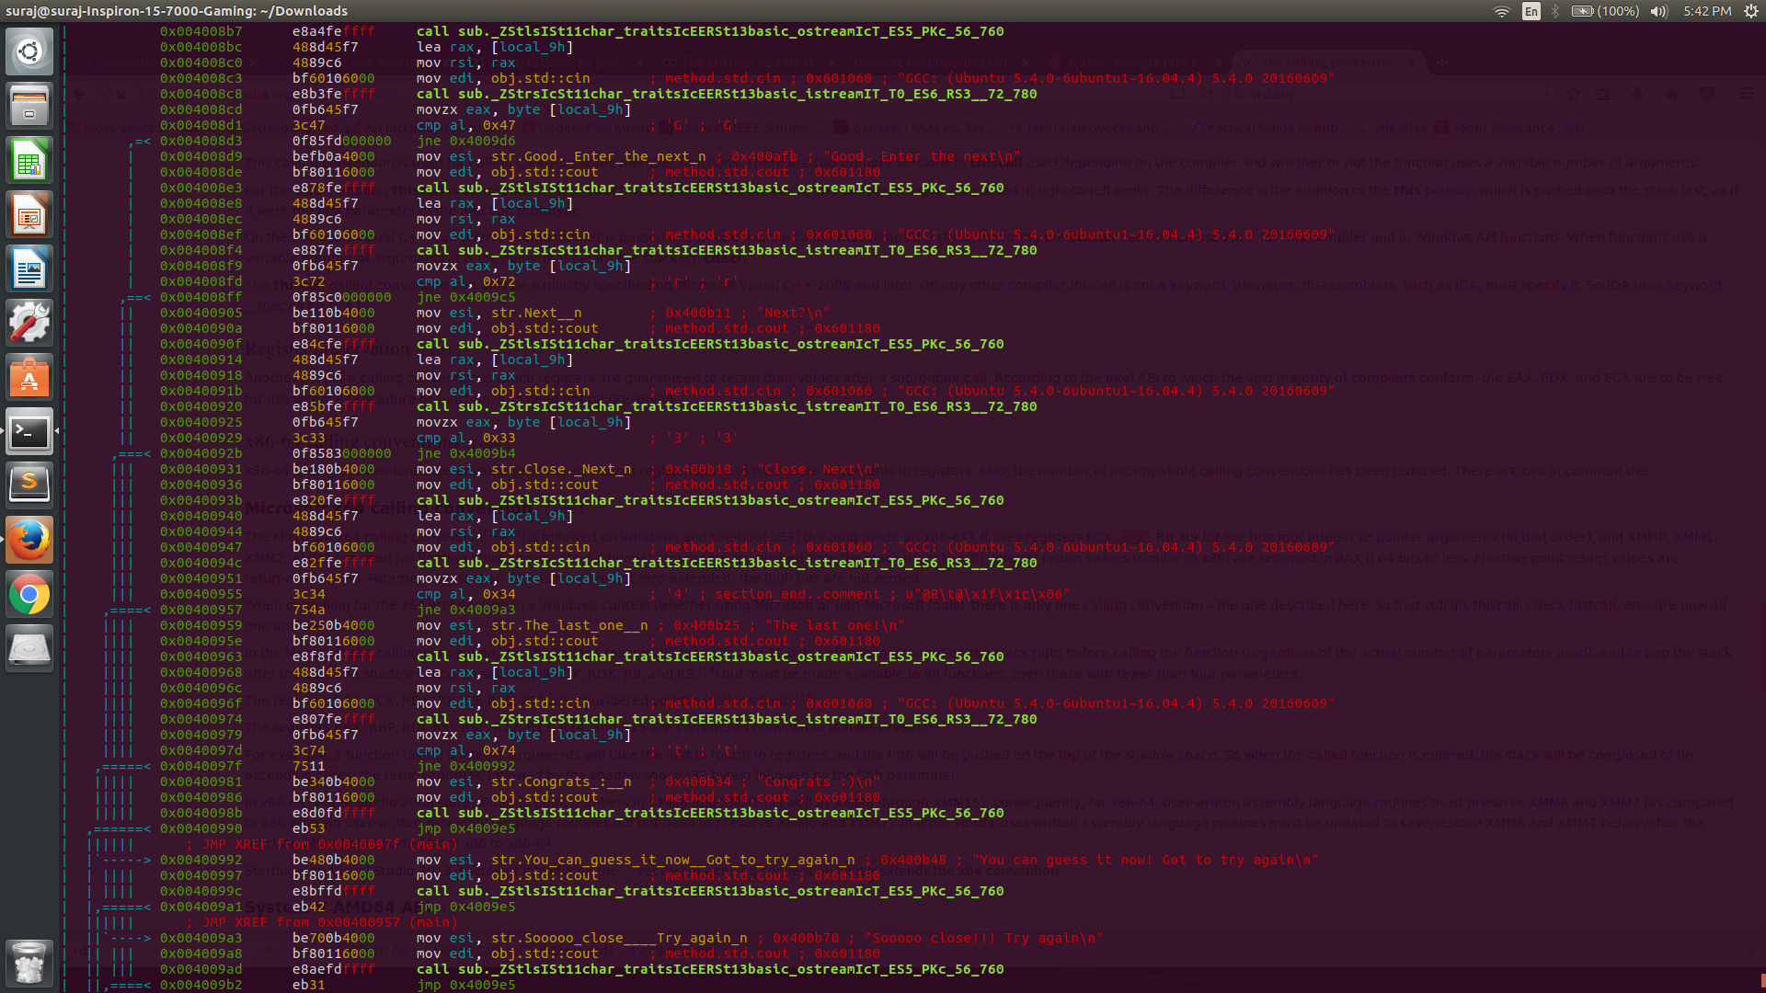
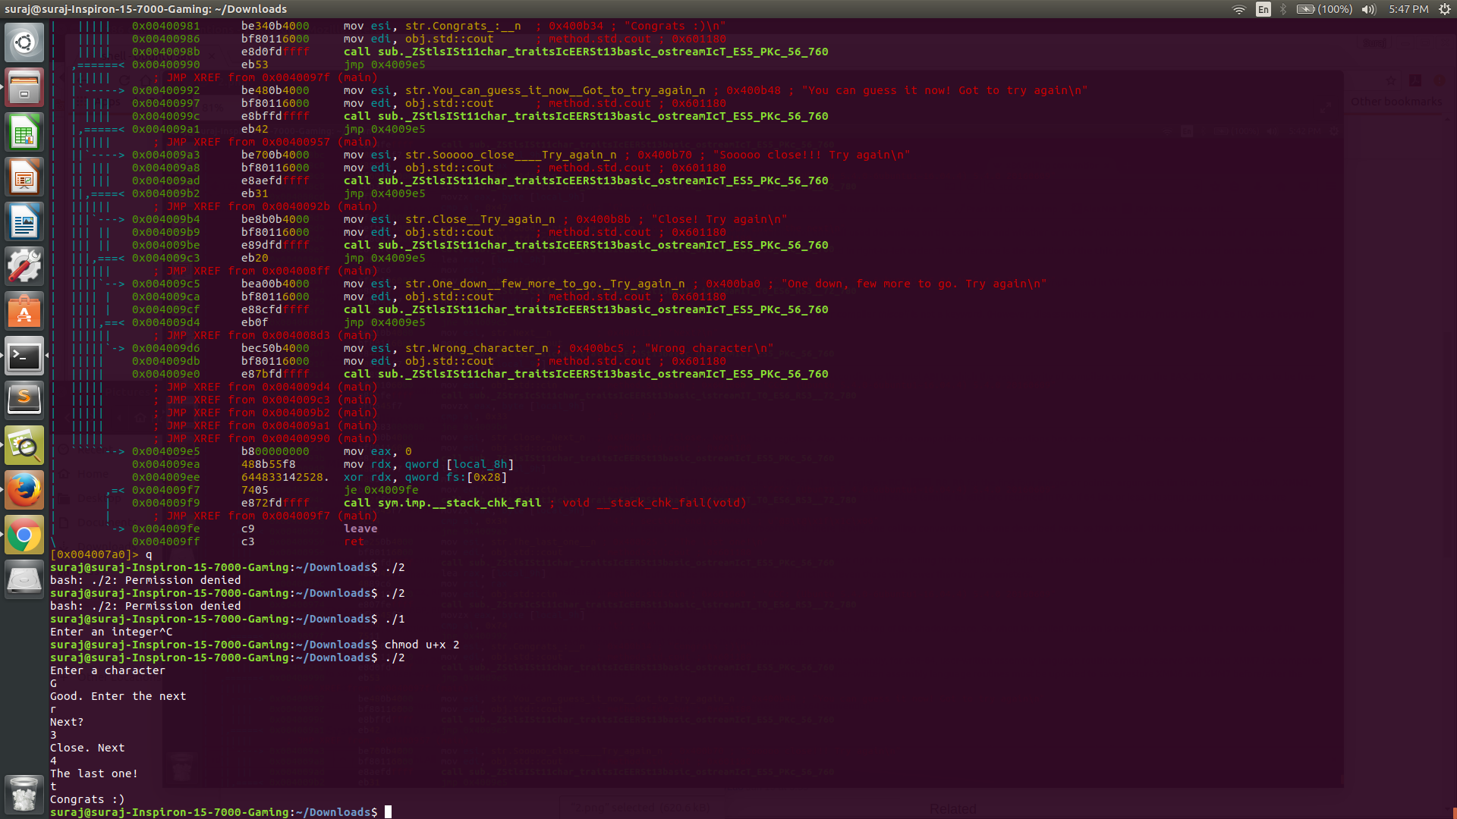
Assignment 6 (late submission)
Answer 2
By tracing the function sys.main, solving this question was fairly simple. I followed the procedure explained by the following screenshots:

