Design and Analysis of Algorithms – Assignment 1
by
Suraj Singh
16CO146

Comparison between the running time of Quick Sort and a Divide and Conquer approach for finding the kth smallest element in an unordered array

The range of the size of the array used to plot the data is from 1500 to 24610656
(Note:In every iteration, ‘k’ is randomised as well)

The following plot was obtained on running both algorithms on randomly generated arrays with unique elements for 43 iterations:
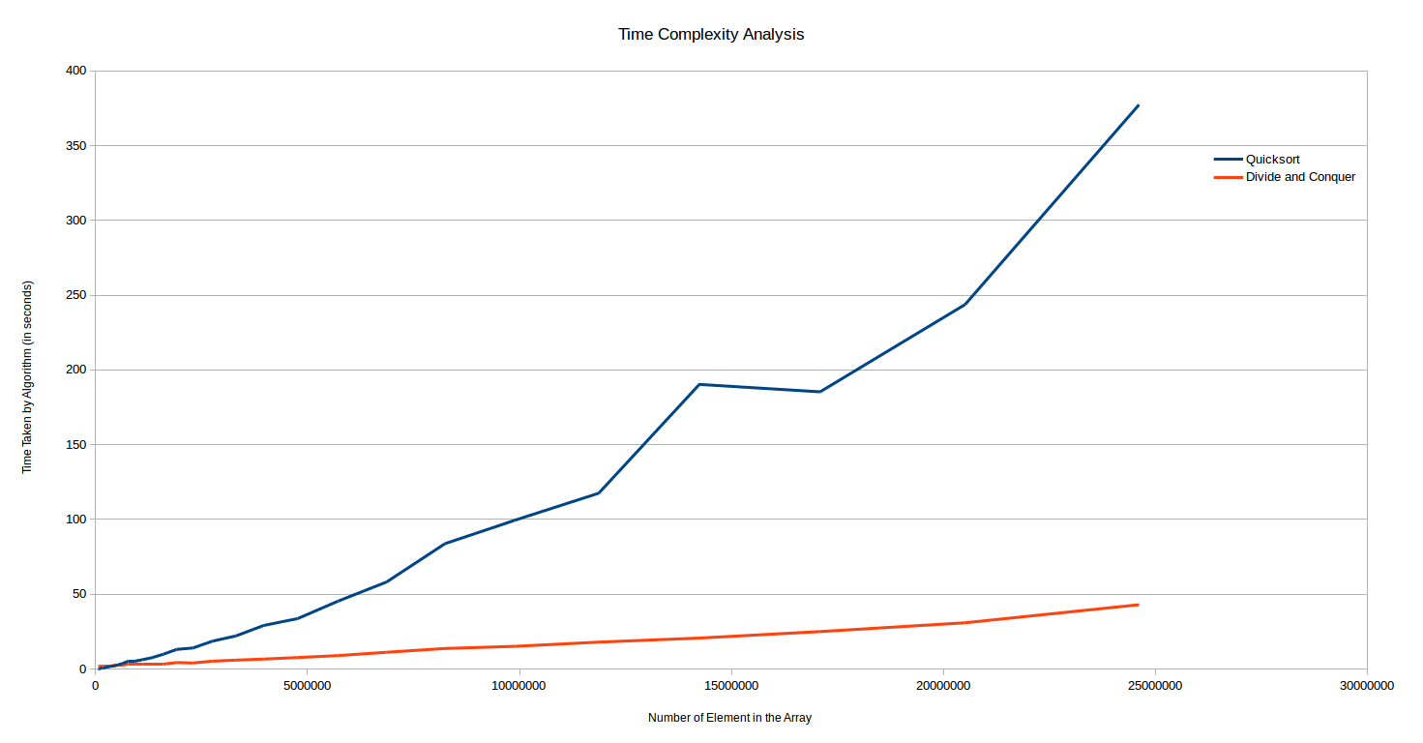

It can be seen from the graph that initially, until the array consists of 5,00,000 elements, the Quicksort algorithm does better than the Divide and Conquer algorithm for finding the kth smallest element in an unordered array. However, after that point the latter is clearly more efficient than the former and for an array size of 24610656, Quicksort takes 337 seconds whereas the Divide and Conquer algorithm only takes 43 seconds.

