**Topics: Descriptive Statistics and Probability**

1. Look at the data given below. Plot the data, find the outliers and find out $μ, σ, σ^{2}$

|  |  |
| --- | --- |
| **Name of company** | **Measure X** |
| Allied Signal | 24.23% |
| Bankers Trust | 25.53% |
| General Mills | 25.41% |
| ITT Industries | 24.14% |
| J.P.Morgan & Co. | 29.62% |
| Lehman Brothers | 28.25% |
| Marriott | 25.81% |
| MCI | 24.39% |
| Merrill Lynch | 40.26% |
| Microsoft | 32.95% |
| Morgan Stanley | 91.36% |
| Sun Microsystems | 25.99% |
| Travelers | 39.42% |
| US Airways | 26.71% |
| Warner-Lambert | 35.00% |

🡺Mean is 33.27

🡺Variance is 287.14

🡺Standard deviation is 16.945

🡺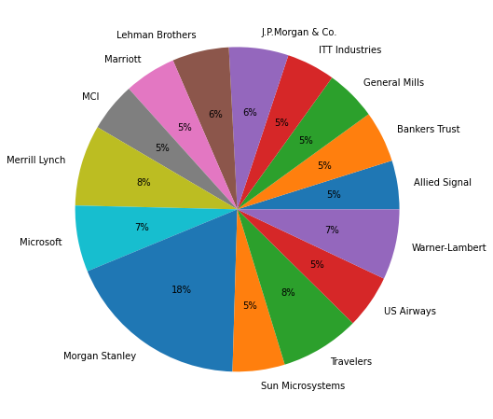

🡺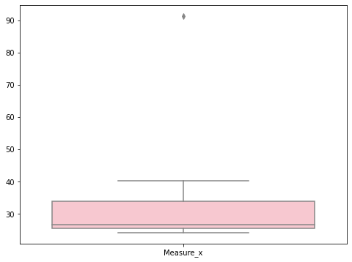

🡺from the boxplot it is clear that it has outliers.



Answer the following three questions based on the box-plot above.

1. What is inter-quartile range of this dataset? (please approximate the numbers) In one line, explain what this value implies.
2. What can we say about the skewness of this dataset?
3. If it was found that the data point with the value 25 is actually 2.5, how would the new box-plot be affected?

🡺***IQR=R3-R1***

***= 12-5=7***

***🡺The data is Right skewes(+ve) as the box to the right is geater.***

***🡺no there won’t be no affected only the values will get converted.***



Answer the following three questions based on the histogram above.

1. Where would the mode of this dataset lie?
2. Comment on the skewness of the dataset.
3. Suppose that the above histogram and the box-plot in question 2 are plotted for the same dataset. Explain how these graphs complement each other in providing information about any dataset.

🡺***The mode will lie in between 4 to 7.***

***🡺The data is positively skewed as more data points are on the left side.***

***🡺From the histogram and boxplot we can conclude that as the value of Y increases the frequency decreases, there is an outlier , most of the datapoints are in between 4 to 10.***

1. AT&T was running commercials in 1990 aimed at luring back customers who had switched to one of the other long-distance phone service providers. One such commercial shows a businessman trying to reach Phoenix and mistakenly getting Fiji, where a half-naked native on a beach responds incomprehensibly in Polynesian. When asked about this advertisement, AT&T admitted that the portrayed incident did not actually take place but added that this was an enactment of something that “could happen.” Suppose that one in 200 long-distance telephone calls is misdirected. What is the probability that at least one in five attempted telephone calls reaches the wrong number? (Assume independence of attempts.)

🡺The probability of call misdirecting = 1/200

The probability of call not misdirecting = 199/200

Total number of calls = 5

LET:

at least one in five attempted telephone calls reaches the wrong number

= 1  -  none of the call reaches the wrong number

= 1  - P(0)

= 1   -  ⁵C₀(1/200)⁰(199/200)⁵⁻⁰

= 1  -  (199/200)⁵

= 0.02475

***The probability that at least one in five attempted telephone calls reaches the wrong number is 2%.***

1. Returns on a certain business venture, to the nearest $1,000, are known to follow the following probability distribution

|  |  |
| --- | --- |
| x | P(x) |
| -2,000 | 0.1 |
| -1,000 | 0.1 |
| 0 | 0.2 |
| 1000 | 0.2 |
| 2000 | 0.3 |
| 3000 | 0.1 |

1. What is the most likely monetary outcome of the business venture?
2. Is the venture likely to be successful? Explain
3. What is the long-term average earning of business ventures of this kind? Explain
4. What is the good measure of the risk involved in a venture of this kind? Compute this measure

1)🡺 ***Most likely monetary outcome of the business venture  is 2000  $ as it has maximum probability = 0.3***

2)🡺***Yes the venture is likely to be successful.***

***Because the expected value = ∑E(X)P(X)  = 800***

3)🡺 ***long-term average earning of business ventures  = 800 $***

4)🡺***The standard deviation for a probability distribution is***

***=* ∑*(x – μ)2 P(x)***

***For the given probability distribution the mean is 800***

***So ([-2000-800] ^2 [0.0] +…+[3000-800]^2 [0.1])***

***The Standard deviation is 0.08164966.***

***The risk involved in this venture is 8%.***