**Practical 2: Basic Data Visualization using R**

**# Pie chart**

x <- c(62,21,10,53)

labels <- c("Mumbai","Delhi","Hyderabad","Surat")

pie(x,labels)

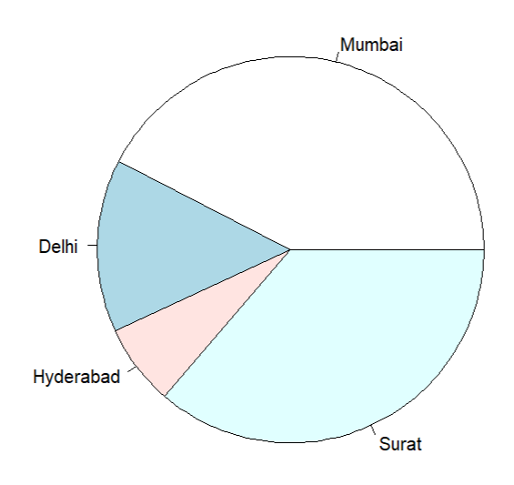

# Pie chart with color

pie(x,labels,main="City Pie Chart",col=rainbow(length(x)))

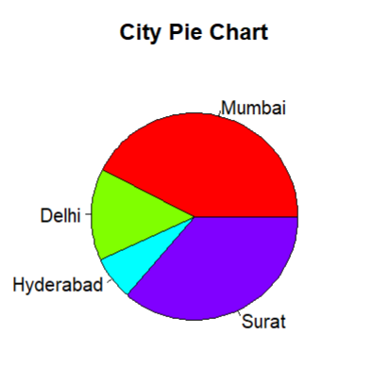

# pie chart with labels

pie(x,labels,main="City Pie Chart",col=rainbow(length(x)))

legend("topright",c(labels), cex=0.8,fill=rainbow(length(x)))

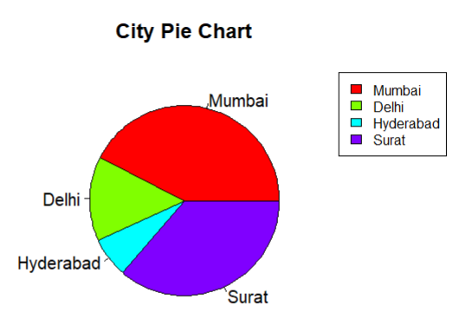

# 3d Pie chart

install.packages("plotrix")

library("plotrix")

pie3D(x,labels=labels,explode =0.1,main="Pie chart of Capitals")

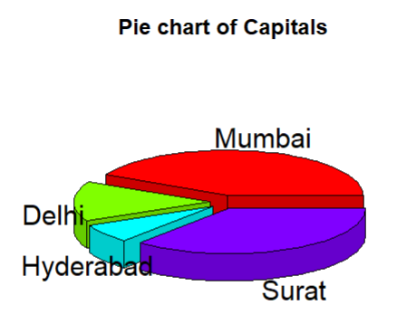

# Bar chart

h<-c(24,13,16,32,21,28)

barplot(h)

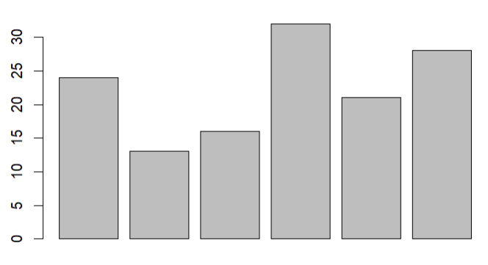

# Bar Chart with attributes

h<- c(22,17,35,42)

m <- c("Jan","Feb","Mar","Apr")

barplot(h,names.arg = m,xlabel="Months",ylabel="Sales"

,col="green",main="Sales chart",border="black")

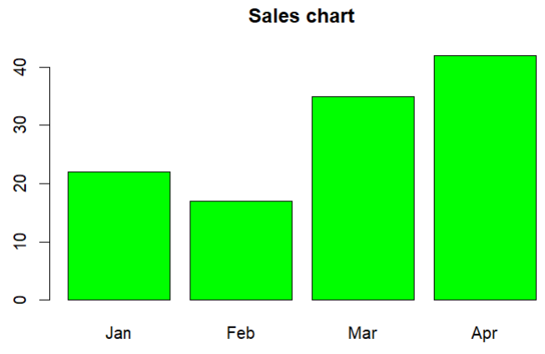

# Bar Chart - Stacked

colors <- c("green","orange","brown")

months <- c("Mar","Apr","May","Jun","Jul")

regions <- c("East","West","North")

Values <- matrix(c(2,9,3,11,9,4,8,7,3,12,5,2,8,10,11),nrow =

3,ncol = 5,byrow = TRUE)

barplot(Values,main = "total revenue",names.arg = months,xlab =

"month",ylab = "revenue", col = colors)

legend("topleft", regions, cex = 0.7, fill = colors)

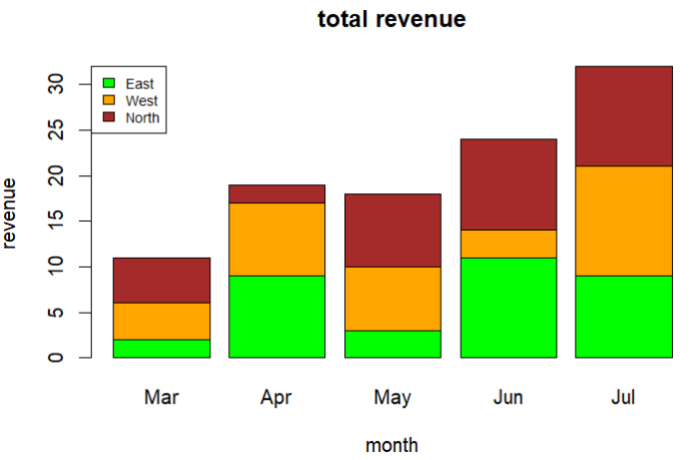

# Box Plot

input <- mtcars[,c('mpg','cyl')]

print(head(input))

boxplot(mpg~cyl, data = mtcars, xlab =

"Number of Cylinders", ylab = "Miles Per Gallon", main = "Mileage Data")

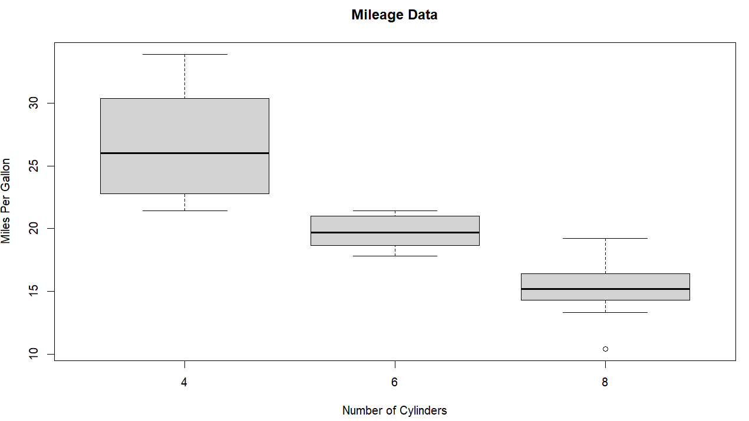

# Box plot with notch

boxplot(mpg ~ cyl, data = mtcars,

xlab = "Number of Cylinders",

ylab = "Miles Per Gallon",

main = "Mileage Data",

notch = TRUE,

varwidth = TRUE,

col = c("green","yellow","purple"),

names = c("High","Medium","Low")

)

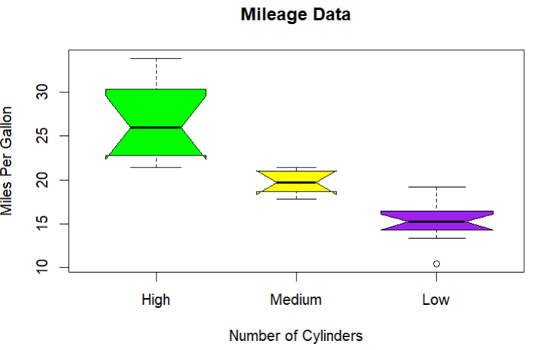

# Histogram

v <- c(9,13,21,8,36,22,12,41,31,33,19)

hist(v,xlab = "Weight",col = "yellow",border = "blue")

hist(v,xlab = "Weight",col = "green",border =

"red", xlim = c(0,40), ylim = c(0,5), breaks = 5)

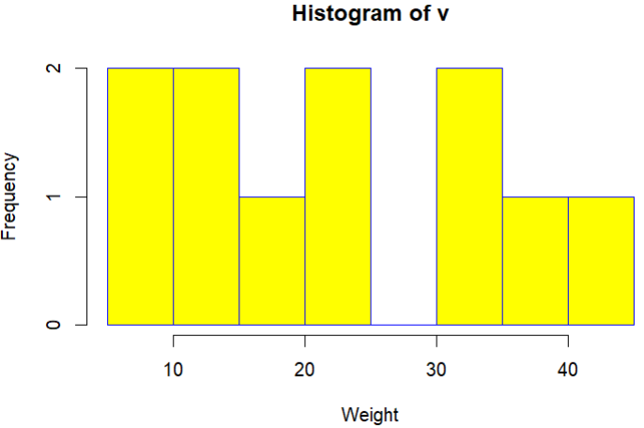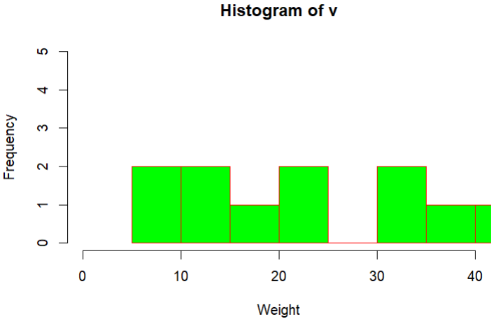

#Line graph

v <- c(7,12,28,3,41)

plot(v,type = "o", col = "red", xlab = "Month",

ylab = "Rain fall", main = "Rain fall chart")

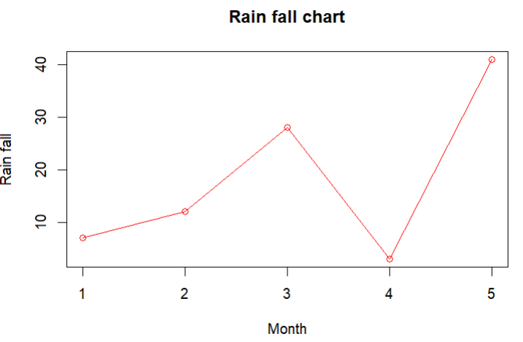

# Multiple lines in chart

v <- c(7,12,28,3,41)

t <- c(14,7,6,19,3)

plot(v,type = "o",col = "red", xlab = "Month", ylab = "Rain

fall", main = "Rain fall chart")

lines(t, type = "o", col = "blue")

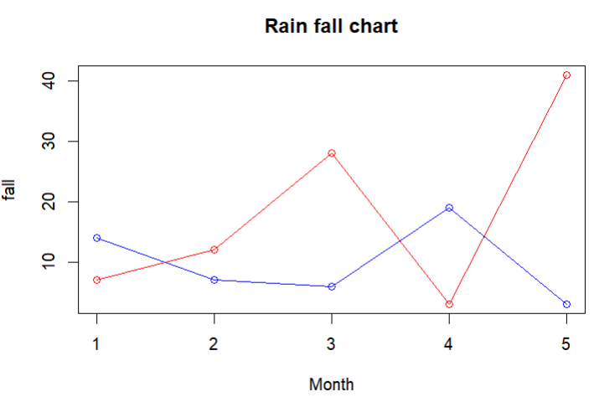

# ScatterPlot

input <- mtcars[,c('wt','mpg')]

head(input)

plot(x = input$wt,y = input$mpg,

xlab = "Weight",

ylab = "Milage",

xlim = c(2.5,5),

ylim = c(15,30),

main = "Weight vs Milage"

)

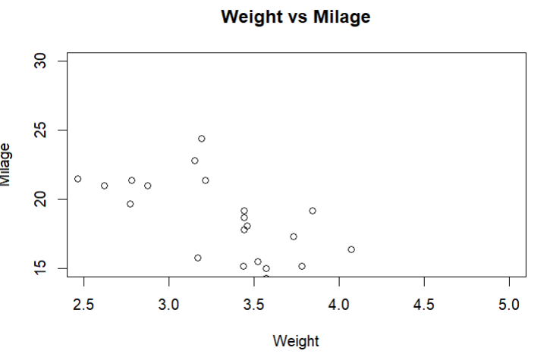

# Scatter Plot matrices

pairs(~wt+mpg+disp+cyl,data = mtcars,main = "Scatterplot Matrix")

