**Practical 3: Data Visualization using ggplot2**

data(iris)

head(iris)

libraray('ggplot2')

**# Default Plot in R**

IrisPlot <- ggplot(iris,aes(Sepal.Length,Petal.Length,colour=Species))+ geom_point() +

labs(y="Petal Length (cm)",x="Sepal lengths (cm)")+

ggtitle("Petal and speal lenth in Cm")

IrisPlot

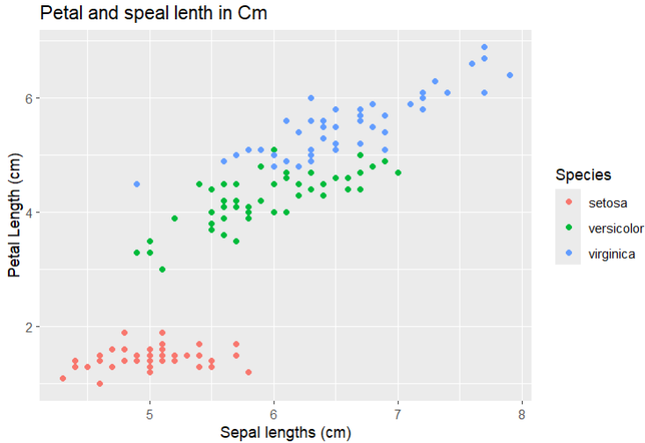

p<- ggplot(iris , aes(Sepal.Length,Petal.Length , colour=Species))+ geom_point()

p

# Adding repeat text

p+ annotate("text",x=7,y=5:7,label="Iris DataSet")

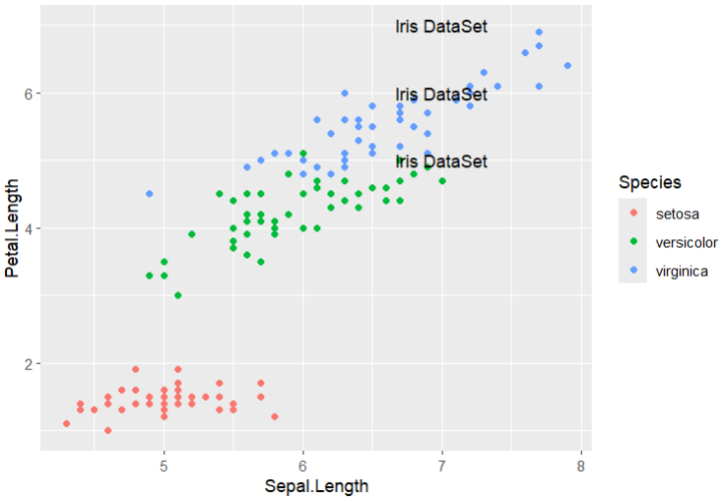

# highlighting an AREA

p+ annotate("rect",xmin=5,xmax=7,ymin=4,ymax=6,alpha=.6)

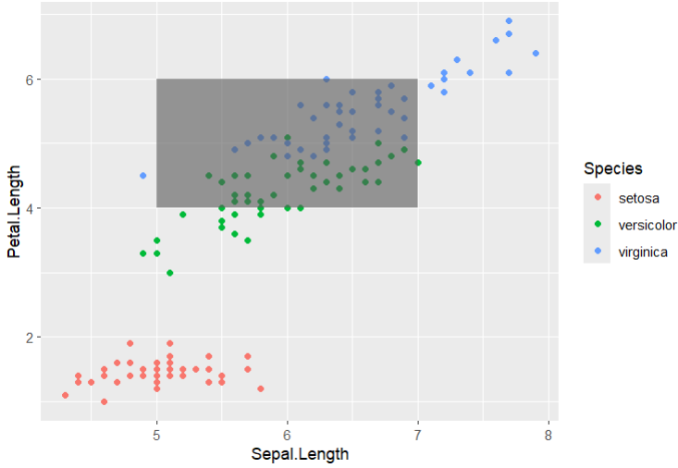

#Segment

p+ annotate("segment",x=5,xend=7,y=4,yend=5,color="black")

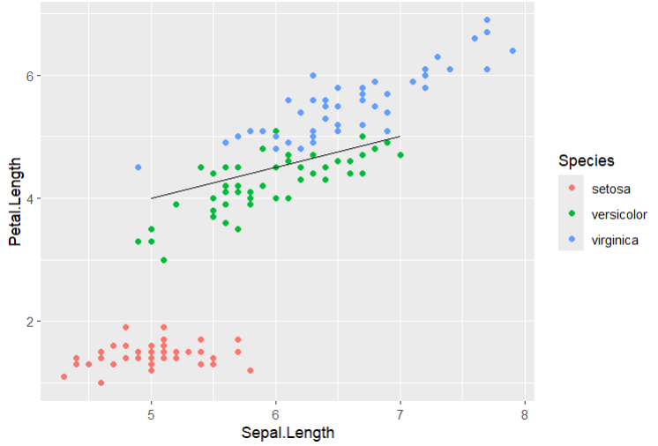

# Adding attributes with axes

# Plant Growth Data set

PG <- PlantGrowth

bp<- ggplot(PG,aes(x=group,y=weight)) + geom_point()

bp

bp<- ggplot(PG,aes(x=weight,y=group)) + geom_point()

bp

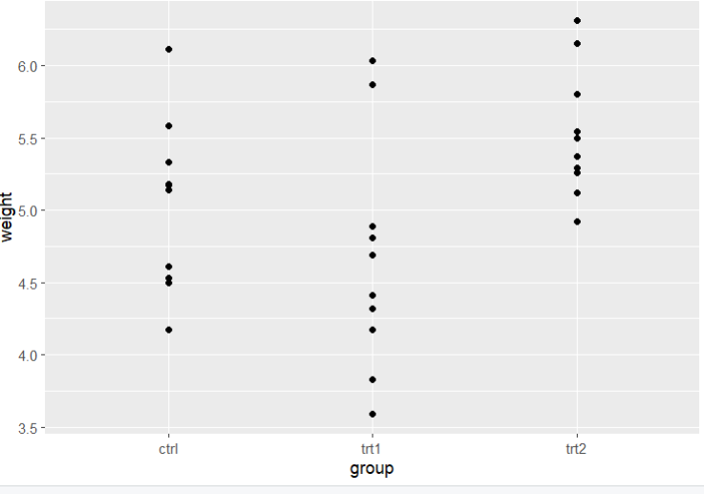 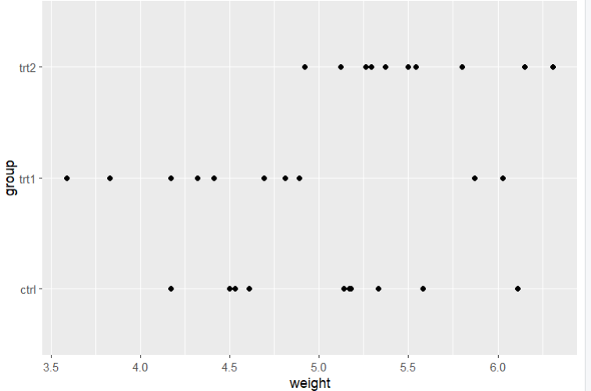

# Working with Legends

# change the legend Position

p+ theme(legend.position = "top")

p+ theme(legend.position = "bottom")

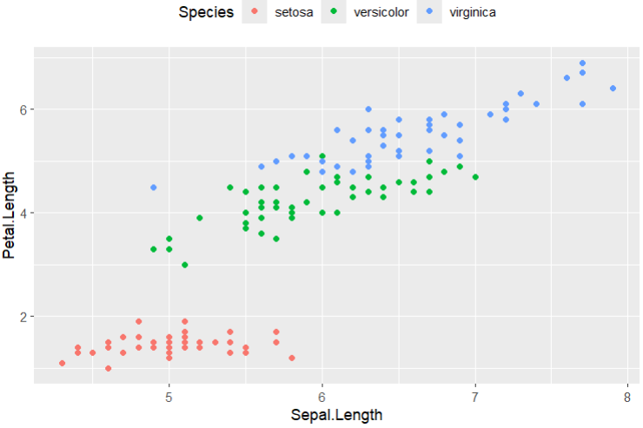

# legend Title

p+ theme(legend.title=element_text(colour="red",size=10,face="bold"))

# Legend label

p+ theme(legend.text=element_text(colour="blue",size=8,face="bold"))

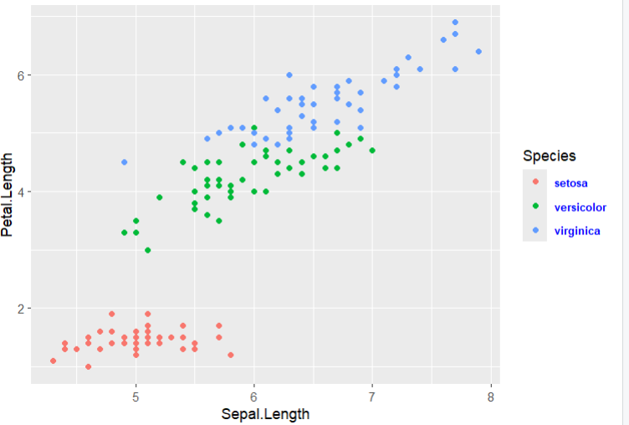

# Scatter Plots and Jitter Plots

scatter = ggplot(iris,aes(Sepal.Length,Petal.Length))+ geom_point()

scatter

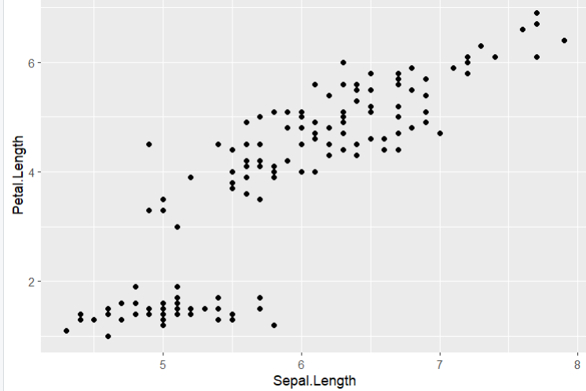

# now using color to change the attributes of plot

ggplot(iris,aes(Sepal.Length,Petal.Length,color=Species))+geom_point(shape=2)

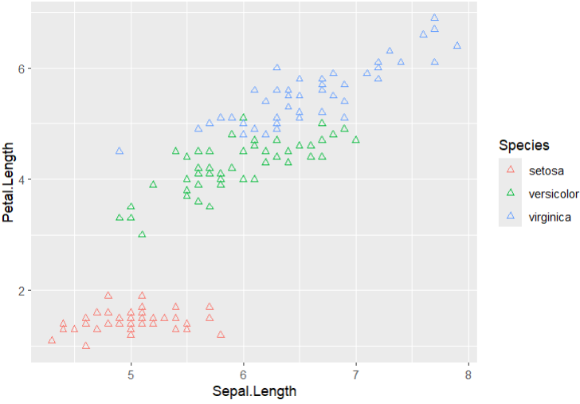

# Relationship between the variables

ggplot(iris,aes(Sepal.Length,Petal.Length,colour=Species))+

geom_point(shape=1)+geom_smooth(method = lm)

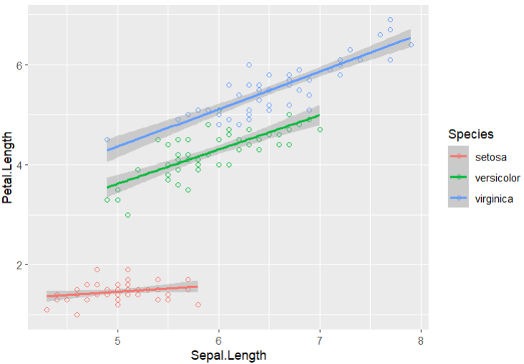

#Regression Line With no shaded region

ggplot(iris,aes(Sepal.Length,Petal.Length,colour=Species))+

geom_point(shape=1)+geom_smooth(method=lm,se=FALSE)

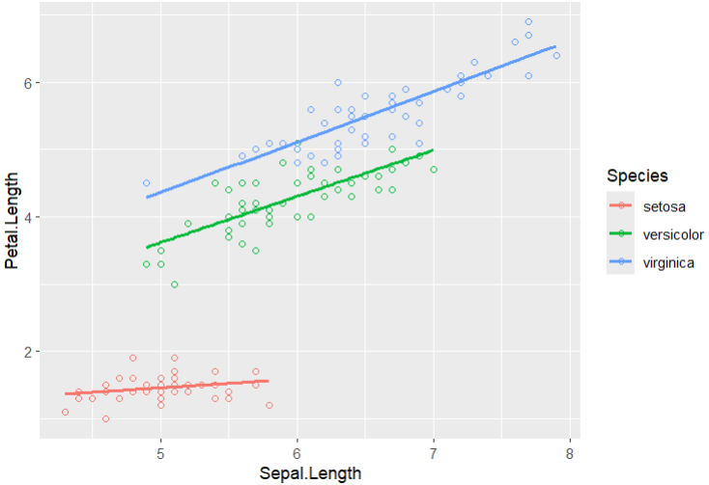

# Jitter Plot

ggplot(mpg,aes(cyl,hwy))+ geom_point()+geom_jitter(aes(colour=class))

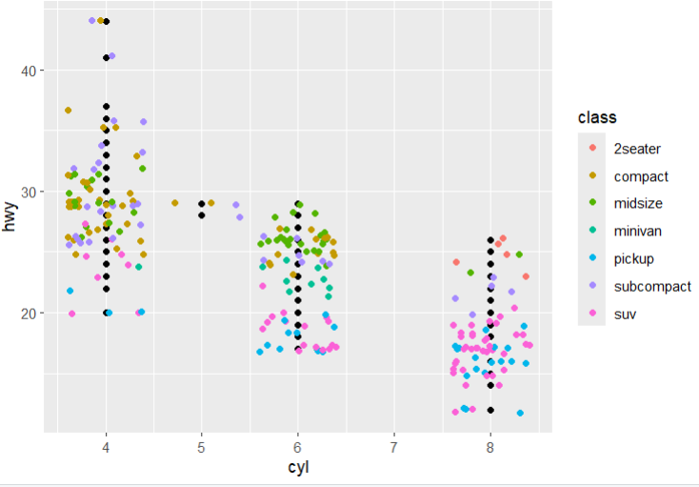

# Bar Plots and Histograms

data(mpg)

head(mpg)

hist <- ggplot(mpg,aes(x=factor(cyl)))+ geom_bar(stat="count")

hist

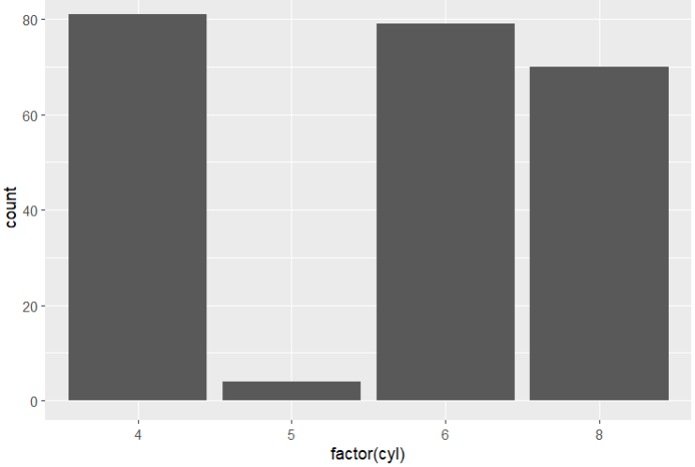

# Histogram count plot

ggplot(data=mpg,aes(x=hwy))+ geom_histogram(col="red",fill="yellow",aplha=.5,binwidth = 5)

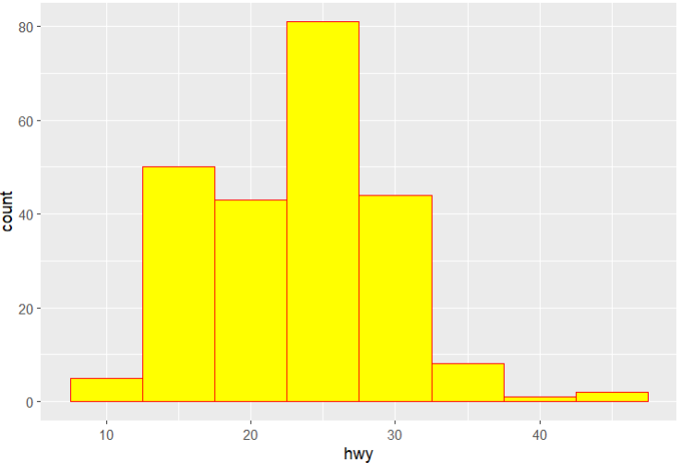

# Stacked Bar chart

p <- ggplot(mpg, aes(class, fill = drv)) +

geom_bar() +

labs(title = "Vehicle Count by Class and Drive Type",

x = "Vehicle Class",

y = "Count") +

theme_minimal()

p

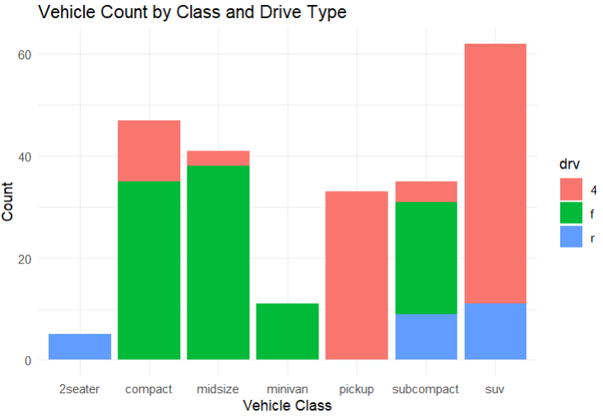

# Pie Charts

df<- as.data.frame(table(mpg$class))

colnames(df)<- c("class","freq")

pie <- ggplot(df, aes(x = "", y = freq, fill = factor(class))) +

geom_bar(width = 1, stat = "identity") +

theme(axis.line = element_blank(),

plot.title = element_text(hjust = 0.5)) +

labs(fill = "class",

x = NULL,

y = NULL,

title = "Pie Chart of class",

caption = "Source: mpg")

# Creating Co-ordinates

pie+ coord_polar(theta="y",start=0)

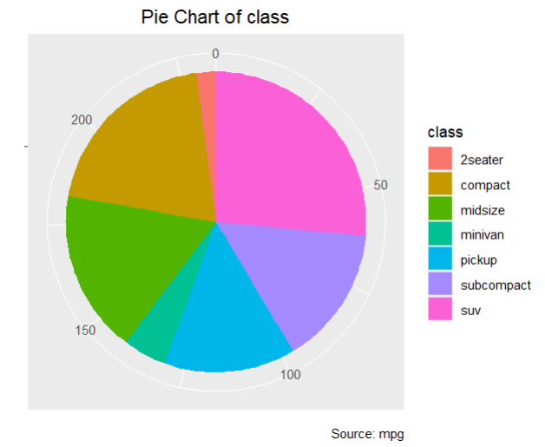

# Marginal plot

install.packages("ggExtra")

library("ggExtra")

data(mpg)

head(mpg)

# Plots

g<- ggplot(mpg,aes(cty,hwy)) + geom_count() +

geom_smooth(method="lm",se=F)

g

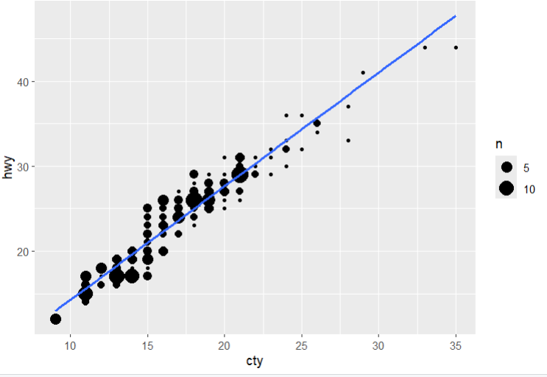

# Relation Between Variables

ggMarginal(g,type="histogram",fill="transparent") 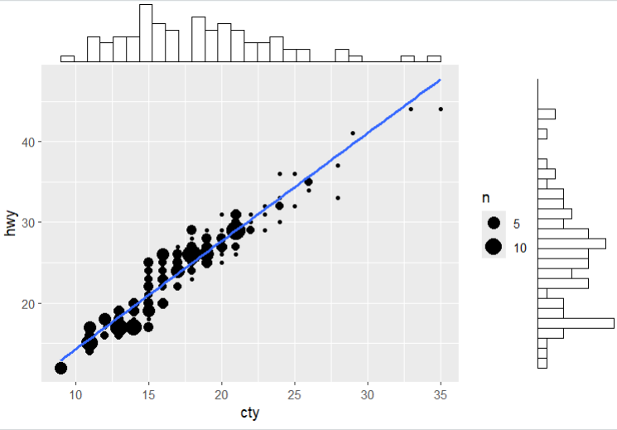

ggMarginal(g,type="boxplot",fill="transparent")

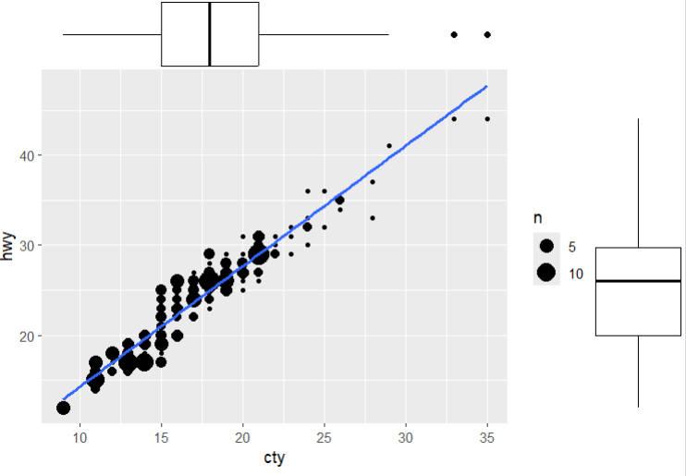

# Bubble Plots and Count Charts

filtered_mpg <- subset(mpg, manufacturer %in% c("audi", "ford", "honda", "hyundai"))

# Create the bubble chart

bubble_chart <- ggplot(filtered_mpg, aes(x = displ, y = cty, size = hwy, color = manufacturer)) +

geom_point(alpha = 0.7) +

geom_smooth(method = "lm", se = FALSE) + # Add trend lines without confidence intervals

labs(title = "Bubble chart",

subtitle = "mpg: Displacement vs City Mileage",

x = "displ",

y = "cty",

size = "hwy",

color = "manufacturer") +

theme_minimal()

bubble_chart

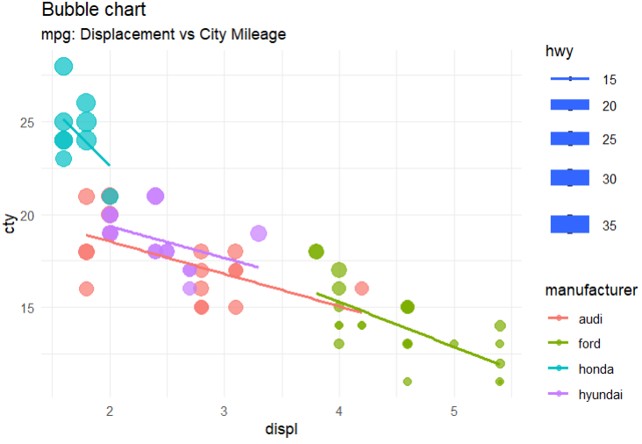

# Diverging Charts

# Add car names and calculate z-scores for mpg

mtcars$car_name <- rownames(mtcars)

mtcars$mpg_z <- round((mtcars$mpg - mean(mtcars$mpg)) / sd(mtcars$mpg), 2)

# Define the mpg_type based on z-scores

mtcars$mpg_type <- ifelse(mtcars$mpg_z < 0, "below", "above")

# Sort the data based on mpg_z

mtcars <- mtcars[order(mtcars$mpg_z),]

# Convert car names to a factor with the same order to retain sorted order in the plot

mtcars$car_name <- factor(mtcars$car_name, levels = mtcars$car_name)

# Plot

ggplot(mtcars, aes(x = car_name, y = mpg_z, label = mpg_z)) +

geom_bar(stat = 'identity', aes(fill = mpg_type), width = 0.5) +

scale_fill_manual(name = "Mileage",

labels = c("Above Average", "Below Average"),

values = c("above" = "#00ba38", "below" = "#f8766d")) +

labs(subtitle = "Normalized mileage from 'mtcars'",

title = "Diverging Bars") +

coord_flip()

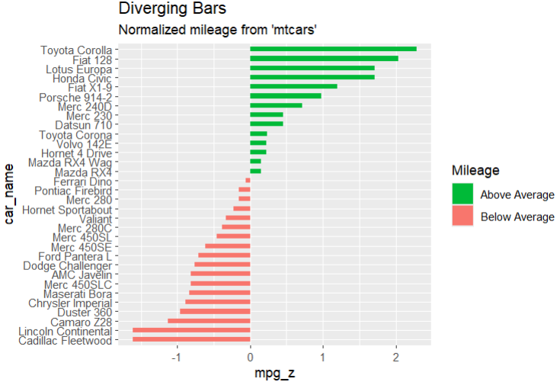

# Diverging Lollipop Chart

ggplot(mtcars , aes(x=car_name,y=mpg_z, label=mpg_z))+

geom_point(stat="identity",fill= "red",size=6) +

geom_segment(aes(y=0,

x= car_name,

yend=mpg_z,

xend=car_name),

color="black")+

geom_text(color="white",size=2)+

labs(title="Diverging Lollipop Chart",

subtitle="Normalized Mileage from mtcars : Lollipop" )+

ylim(-2.5,2.5) +

coord_flip()

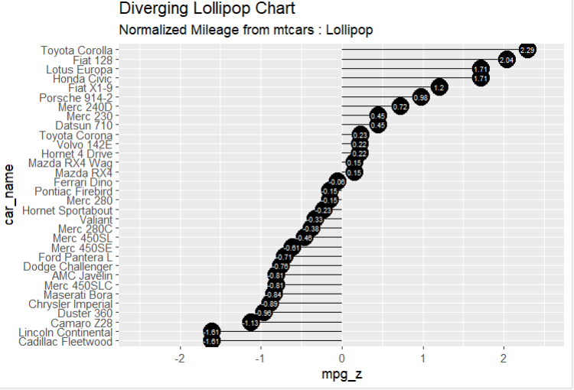

# Diverging Dot plot

ggplot(mtcars, aes(x=car_name, y=mpg_z, label=round(mpg_z, 2))) +

geom_point(stat='identity', aes(col=mpg_type), size=6) +

scale_color_manual(name="Mileage",

labels = c("Above Average", "Below Average"),

values = c("above"="#00ba38", "below"="#f8766d")) +

geom_text(color="white", size=2.5, hjust=0.5, vjust=0.5) +

labs(title="Diverging Dot Plot",

subtitle="Normalized mileage from 'mtcars': Dotplot") +

ylim(-2.5, 2.5) +

coord_flip()

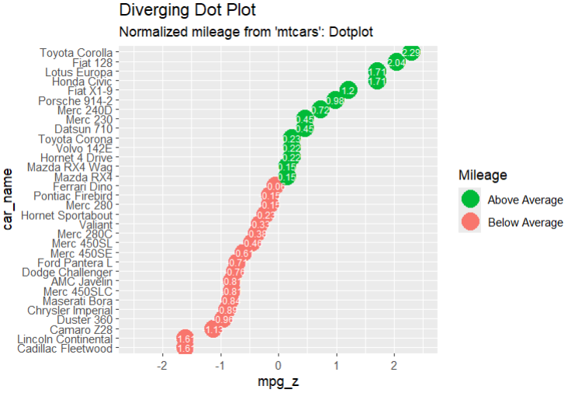

# Themes

install.packages("ggthemes")

library(ggthemes)

mpg

ggplot(mpg,aes(year,displ ,color=factor(manufacturer))) +

geom_point() +

ggtitle("This plot looks a lot difference from a default plots")+

theme_economist() + scale_color_economist()

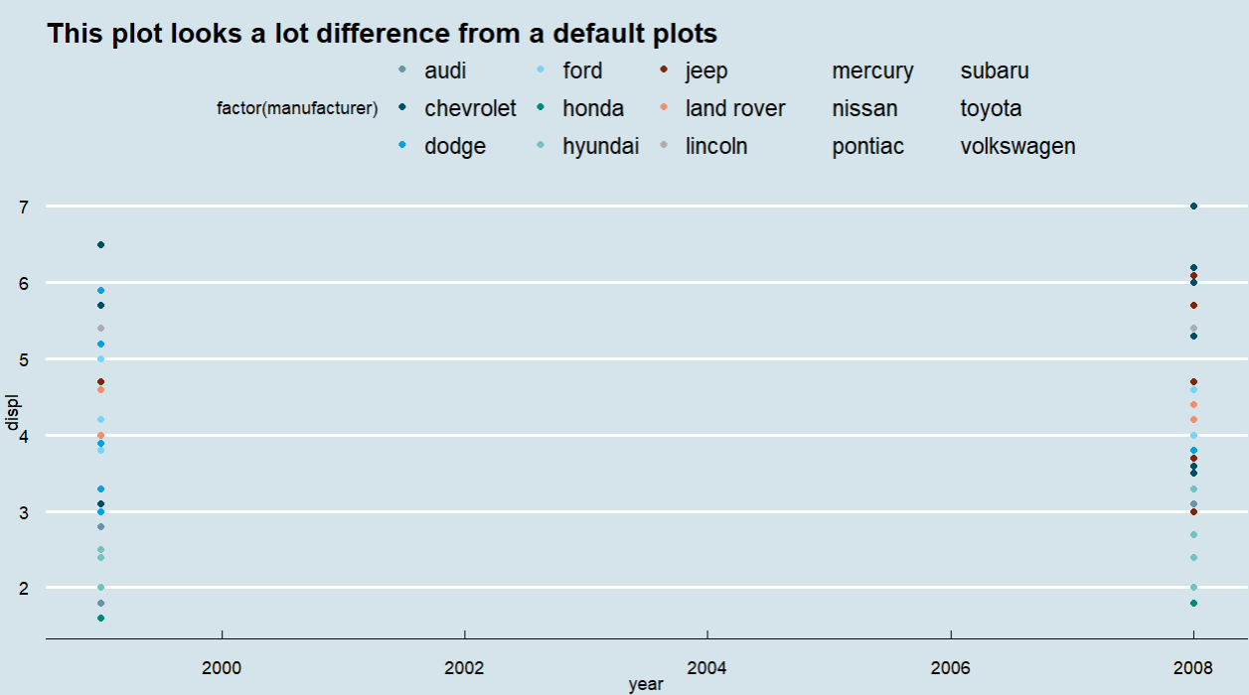

# Multi Pnael plots

par(mfrow=c(1,2))

airquality

colnames(airquality)

Temperature <- airquality$Temp

Ozone <- airquality$Ozone

par(mfrow=c(2,2))

hist(Temperature)

boxplot(Temperature,horizontal=TRUE)

hist(Ozone)

boxplot(Ozone,horizontal = TRUE)

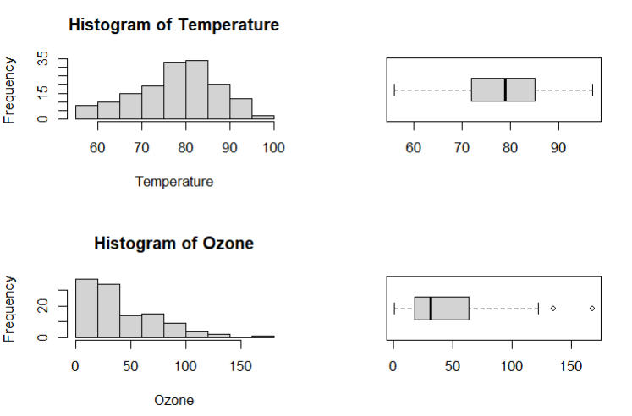

# same but now in columns

par(mfcol=c(2,2))

hist(Temperature)

boxplot(Temperature,horizontal=TRUE)

hist(Ozone)

boxplot(Ozone,horizontal = TRUE)

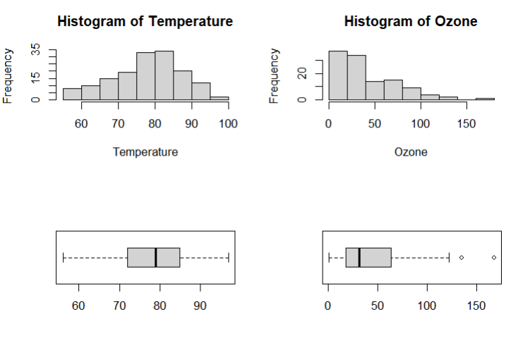

# Multiple Plots

head(mpg)

# density plot

p<- ggplot(mpg,aes(cty)) +

geom_density(aes(fill=factor(cyl)) ,alpha =0.8)

p

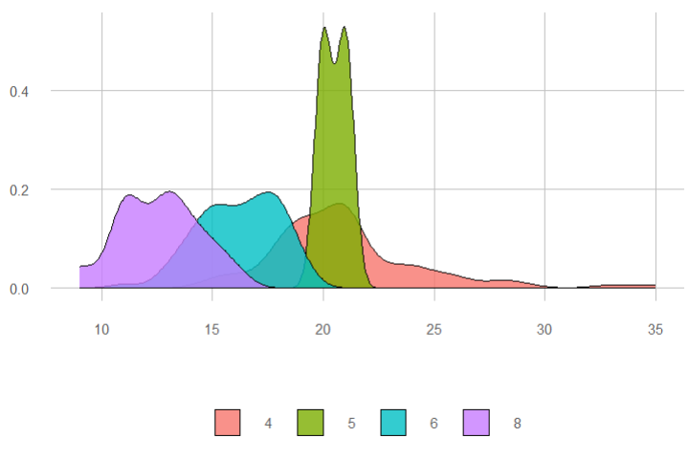

p + labs(title="Density Plot",

subtitle = "City Mileage Grouped by number of cylinders",

caption = "Source : mpg",

x="City Mileage",

fill="# Cylinders")

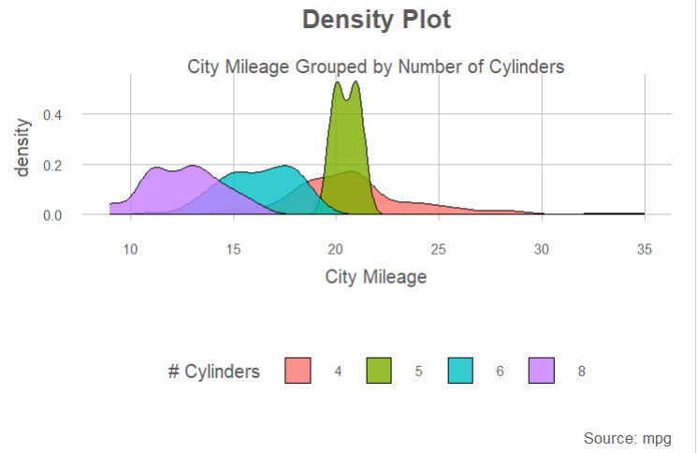

# Box Plot

p<- ggplot(mpg,aes(class,cty)) +

geom_boxplot(varwidth=T , fill ="blue")

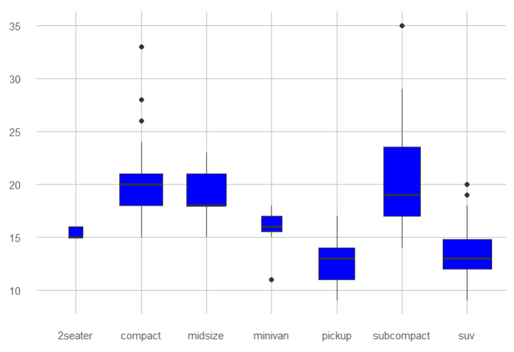

p + labs(title="A Box plot Example",

subtitle="Mileage by Class",

caption="MPG Dataset",

x="Class",

y="Mileage")

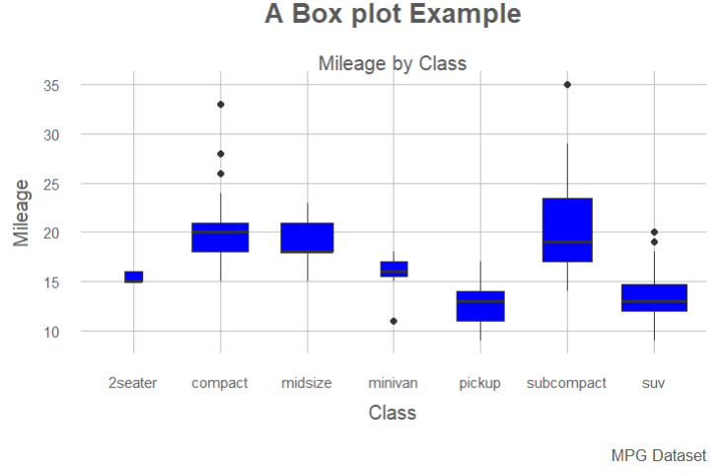

# DOT PLOT

p <- ggplot(mpg, aes(manufacturer, cty)) +

geom_boxplot() +

theme(axis.text.x = element_text(angle=65, vjust=0.6))

p

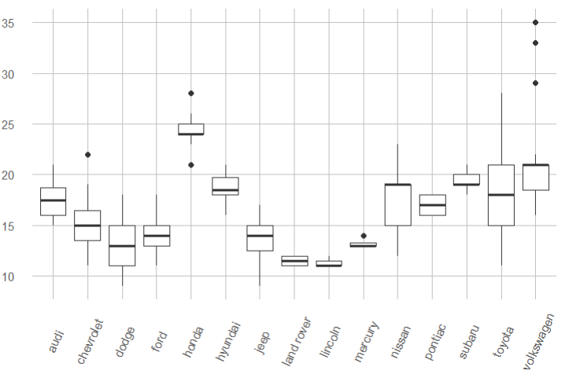

p + geom_dotplot(binaxis='y',

stackdir='center',

dotsize = .5)

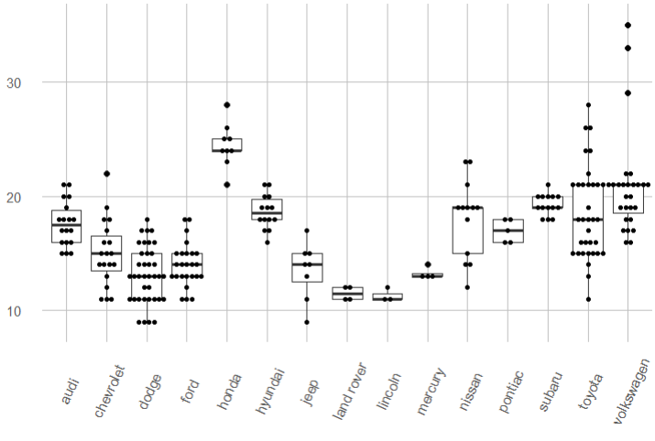

# Violin Plot

p <- ggplot(mpg, aes(class, cty))

p + geom_violin()

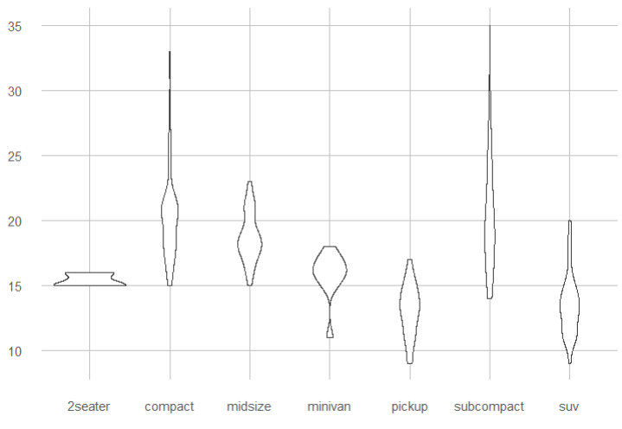

# Background Colors

ggplot(iris, aes(Sepal.Length, Species))+geom_point(color="firebrick")+

theme(panel.background = element_rect(fill = 'grey75'),

panel.grid.major = element_line(colour = "orange", size=2),

panel.grid.minor = element_line(colour = "blue"))

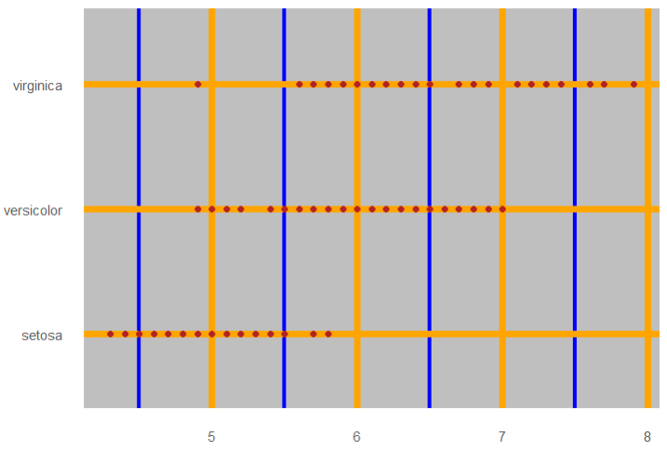

ggplot(iris, aes(Sepal.Length, Species))+geom_point(color="firebrick")+

theme(plot.background = element_rect(fill = 'pink'))

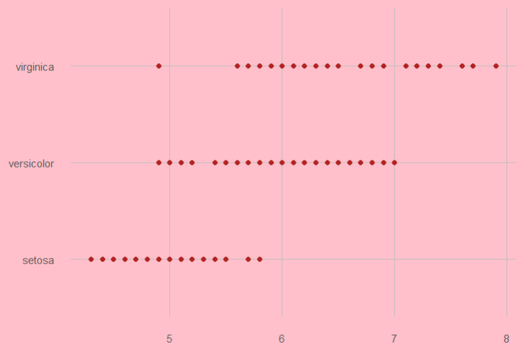

# Time Series

theme_set(theme_minimal())

head(economics)

# Basic line plot

ggplot(data = economics, aes(x = date, y = pop))+

geom_line(color = "#00AFBB", size = 2)

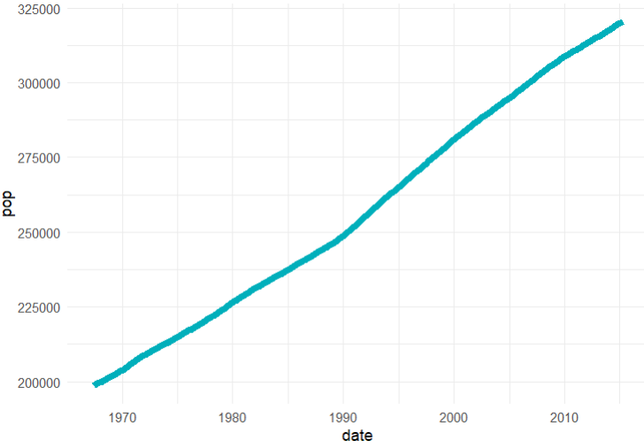

# Plot a subset of the data

ss <- subset(economics, date > as.Date("2006-1-1"))

ggplot(data = ss, aes(x = date, y = pop)) +

geom_line(color = "#FC4E07", size = 2)

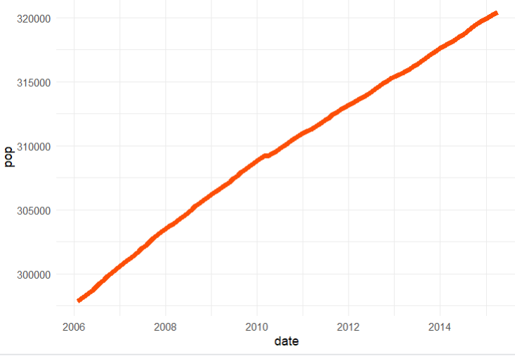

# Creating Time Series

install.packages("tidyr")

install.packages("dplyr")

library(tidyr)

library(dplyr)

df <- economics %>%

dplyr::select(date, psavert, uempmed) %>%

tidyr::gather(key = "variable", value = "value", -date)

head(df, 3)

ggplot(df, aes(x = date, y = value)) +

geom_line(aes(color = variable), size = 1) +

scale_color_manual(values = c("#00AFBB", "#E7B800")) +

labs(title="Time Series")+

theme_minimal()

