**Hindi Vidya Prachar Samiti’s**

**RAMNIRANJAN JHUNJHUNWALA COLLEGE OF ARTS, SCIENCE AND COMMERCE**

**(EMPOWERED AUTONOMOUS)**

**Mathematics for Data Science**



**Name: Surajkumar Yadav**

**Roll no: 10302**

**Class: MSc. Data Science and Artificial Intelligence Part I**

**Ramniranjan Jhunjhunwala College**

**of Arts, Science and Commerce**

**Department of Data Science and Artificial Intelligence**

**CERTIFICATE**

**This is to certify Surajkumar Yadav of MSc. Data Science and Artificial Intelligence Roll No. 10302 has successfully completed the practical of Mathematics for Data Science during the Academic Year 2024-2025.**

**Date :**

**(Prof. Rahul Yadav) External Examiner  
 Prof-In-Charge**

**INDEX**

|  |  |  |  |
| --- | --- | --- | --- |
| **SR.NO** | **PRACTICAL NAME** | **DATE** | **SIGN** |
| **1** | Perform Data Collection, Cleaning, Modelling and Compilation | 19/09/2024 |  |
| **2** | Implementation of the Exploratory Data Visualization Technique | 16/09/2024 |  |
| **3** | Perform Different Statistics Distribution | 16/09/2024 |  |
| **4** | Implementation Hypothesis Testing | 31/08/2024 |  |
| **5** | Perform for Exploring Categorical and Binary Data | 19/09/2024 |  |
| **6** | Perform One and Two-way ANOVA on the given dataset. | 16/09/2024 |  |
| **7** | Implementation of Regression Analysis | 20/09/2024 |  |
| **8** | Perform Time Series Analysis | 20/09/2024 |  |
| **9** | Computing eigenvalues and eigenvectors for dimensionality reduction. | 28/08/2024 |  |
| **10** | Calculate the Maxima and Minima for the given function. | 04/09/2024 |  |
| **11** | Impute an example based on Rolle’s and Mean Value Theorem. | 04/09/2024 |  |
| **12** | Calculate the dot product of the vector and the norm of the vector. | 28/08/2024 |  |
| **13** | Impute Inverse of matrix by adjoint method. | 28/08/2024 |  |

**Practical 1: Perform Data Collection, Cleaning, Modelling and Compilation**

**Practical 2: Implementation of the Exploratory Data Visualization Technique**

**

**

**

**

**

**Practical 3: Implement Statistical Distribution**

**

**Practical 4: Implementation Hypothesis Testing**

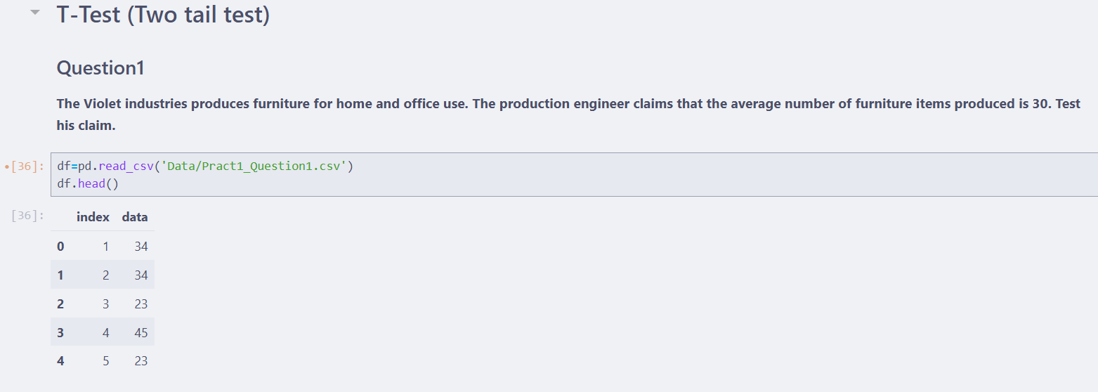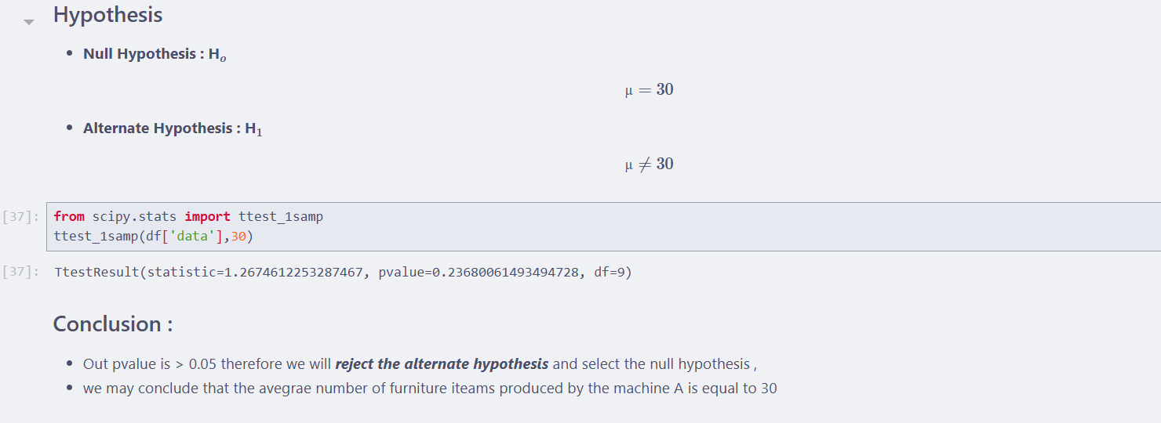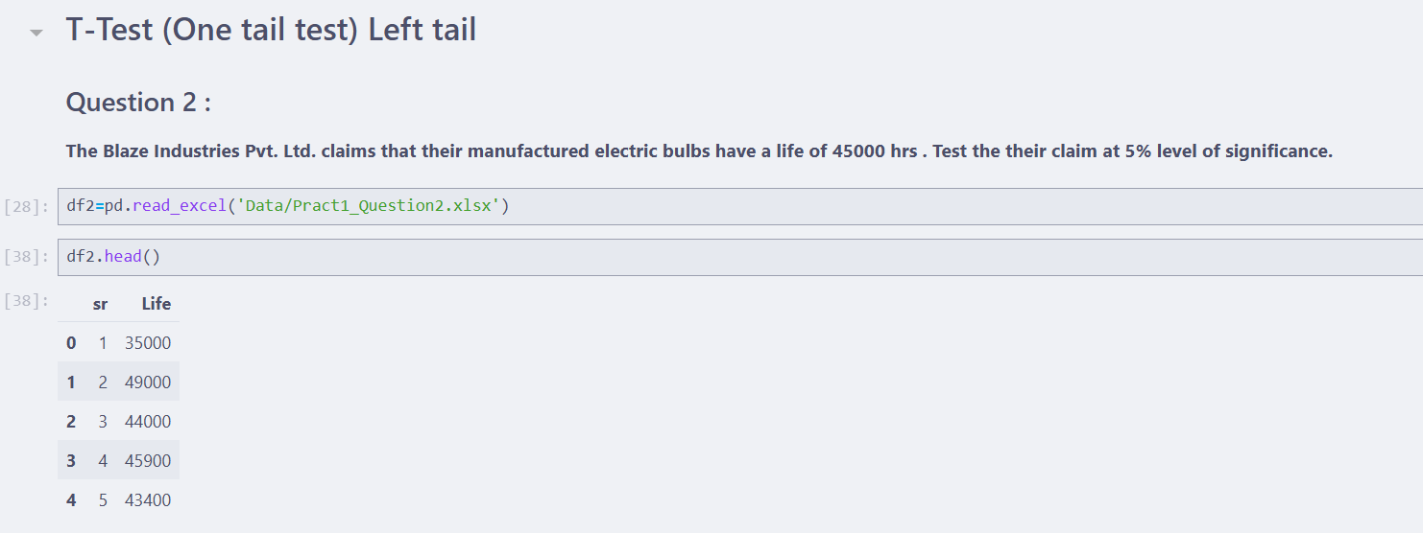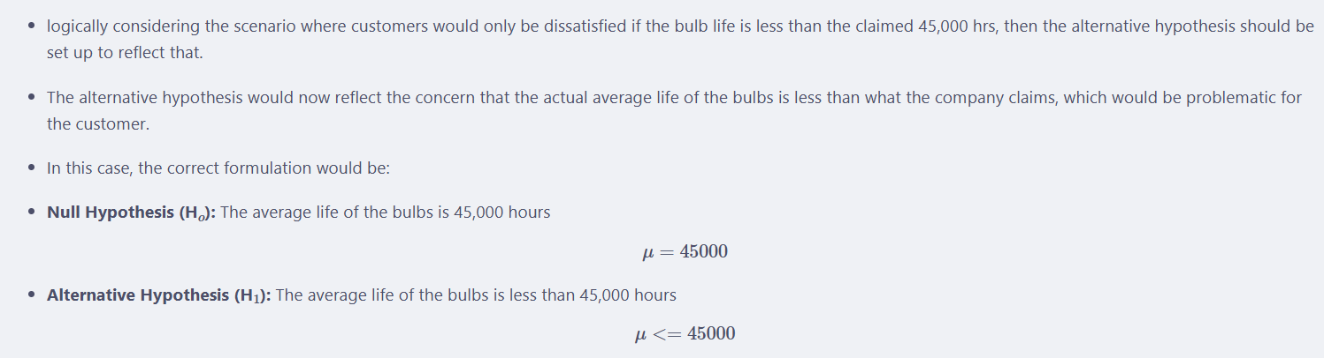

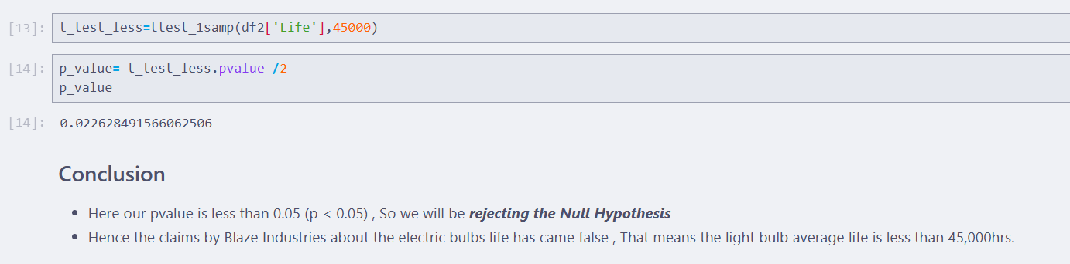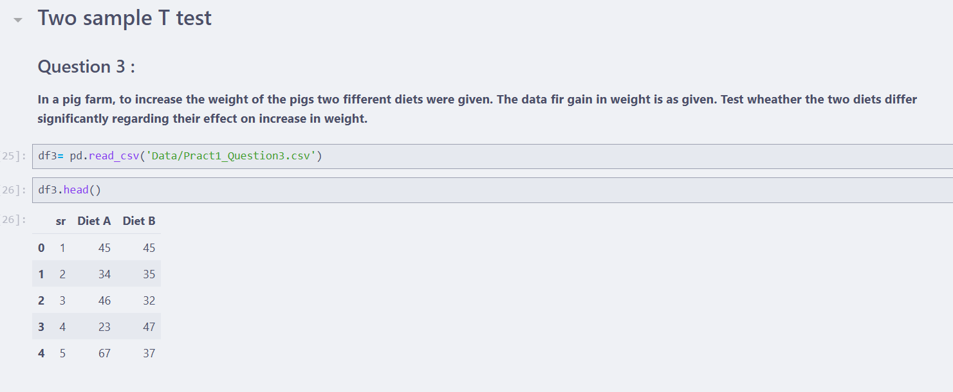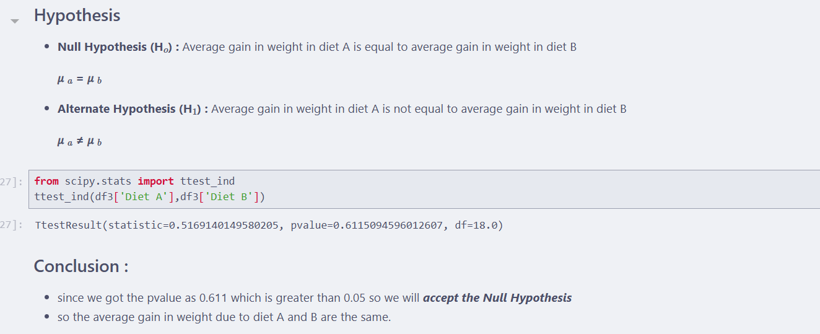

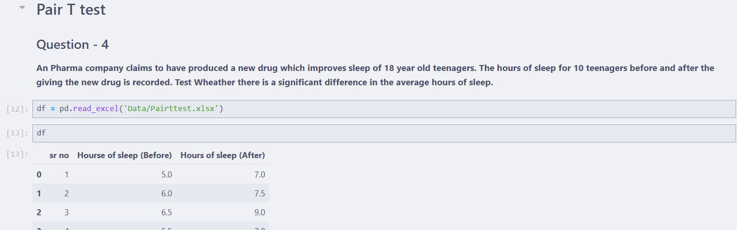

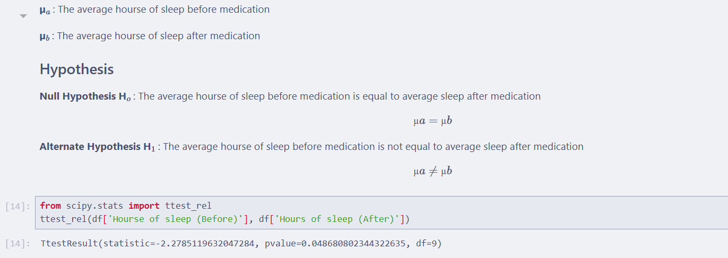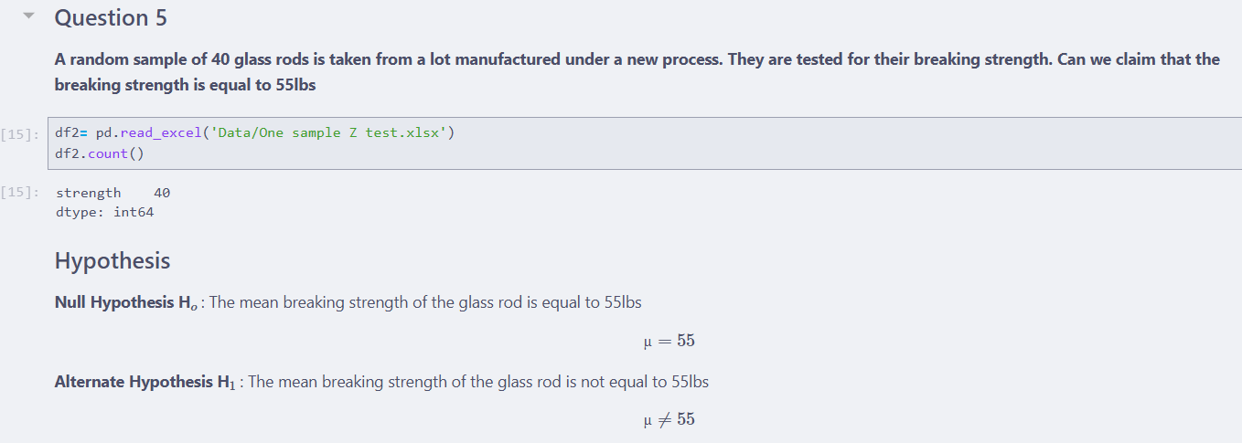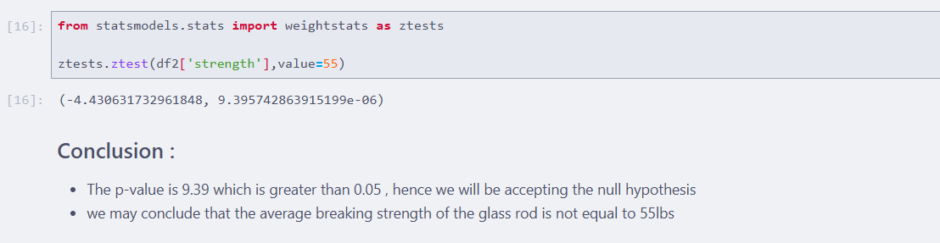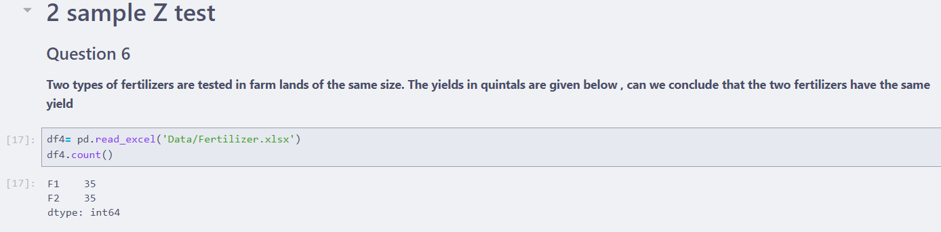

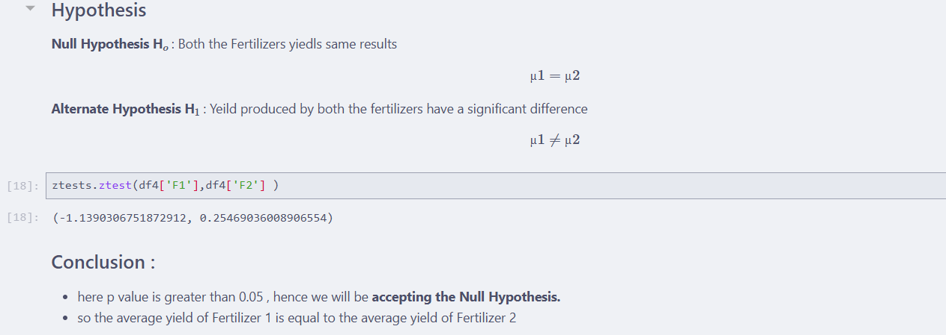

**Practical 5: Perform for Exploring Categorical and Binary Data**

**Practical 6:**

**

**Practical 7:** **Implementation of Regression Analysis**

**

**

**Practical 8: Perform Time Series Analysis**

***

