**Hindi Vidya Prachar Samiti’s**

**RAMNIRANJAN JHUNJHUNWALA COLLEGE OF ARTS, SCIENCE, AND COMMERCE**

**(EMPOWERED AUTONOMOUS)**

**Research Methodology**

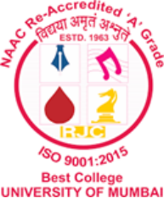

**Name: Surajkumar Yadav**

**Roll no: 10302**

**Class: MSc. Data Science and Artificial Intelligence Part I**

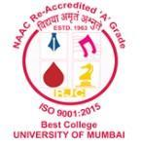

**Ramniranjan Jhunjhunwala College**

**of Arts, Science and Commerce**

**Department of Data Science and Artificial Intelligence**

**CERTIFICATE**

**This is to certify Surajkumar Yadav of MSc. Data Science and Artificial Intelligence Roll No. 10302 has successfully completed the practical of Research Methodology during the Academic Year 2024-2025.**

**Date:**

**(Dr. Karishma Rajbhar) External Examiner Prof-In-Charge**