**Advancements in Distributed Computing: Implications for Data Science and AI.**

***Surajkumar Yadav (10302),***

*M.Sc. Data Science and Artificial Intelligence part 1.*

**Introduction**

Distributed computing has revolutionized the way data is processed and analyzed in the modern technological landscape. As the volume of data continues to grow exponentially, the limitations of traditional computing systems have become increasingly evident. Distributed computing offers a scalable solution by enabling the processing of large datasets across multiple machines. This approach ensures faster computations, better resource utilization, and improved fault tolerance.

In the field of data science and artificial intelligence (AI), distributed computing plays a crucial role. Machine learning algorithms, especially those involving large datasets, often require significant computational power. Distributed systems allow for the parallel processing of data, reducing the time required for complex operations and enabling real-time analytics. With the rise of cloud computing and big data technologies, distributed computing has become an indispensable part of the data science ecosystem.

This research paper explores the fundamentals of distributed computing, examining its architecture, methodologies, and key frameworks used in modern applications. It also highlights the critical role distributed systems play in the advancement of AI technologies, with a focus on how they enhance performance, scalability, and efficiency in large-scale data processing.

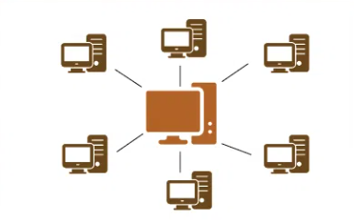

**Distributed computing**

Distributed computing is the method of making multiple computers work together to solve a common problem. It makes a computer network appear as a powerful single computer that provides large-scale resources to deal with complex challenges. It is a model of computing where tasks are divided into smaller pieces and spread across multiple computers, which work together to complete the task. Instead of relying on a single powerful machine to process all the information, distributed computing takes advantage of many computers working simultaneously to achieve a common goal.

Imagine you have a huge task, like sorting a massive amount of data. Doing this on a single computer would take a long time. However, if you divide the data into smaller parts and give each part to a separate computer, the task can be completed much faster because multiple computers are working on it at the same time.

In this model, each computer (often referred to as a "node") works on a piece of the problem, and these nodes communicate with each other to share results and ensure they are all working towards the same final solution. This system is often managed by a central coordinator that keeps track of the work being done and makes sure all nodes are working efficiently. Even though the computers are separate, they act together as one big system, pooling their resources like processing power and storage.

**Benefits of Distributed Computing:**

1. **Speed**: Since many computers are working in parallel, the task gets done faster than if it were handled by a single machine.
2. **Scalability**: As the problem or the amount of data grows, you can add more computers to handle the increased workload.
3. **Fault Tolerance**: If one computer in the system fails, the others can continue working, and the system won’t break down entirely. This makes distributed computing more reliable than relying on a single machine.

**Some distributed computing use cases:**

Distributed computing is everywhere today. Mobile and web applications are examples of distributed computing because several machines work together in the backend for the application to give you the correct information. However, when distributed systems are scaled up, they can solve more complex challenges. Let’s explore some ways in which different industries use high-performing distributed applications.

1. **Healthcare and life sciences**

Healthcare and life sciences use distributed computing to model and simulate complex life science data. Image analysis, medical drug research, and gene structure analysis all become faster with distributed systems. These are some examples:

* Accelerate structure-based drug design by visualizing molecular models in three dimensions.
* Reduce genomic data processing times to get early insights into cancer, cystic fibrosis, and Alzheimer’s.
* Develop intelligent systems that help doctors diagnose patients by processing a large volume of complex images like MRIs, X-rays, and CT scans.

1. **Engineering Research**

Engineers can simulate complex physics and mechanics concepts on distributed systems. They use this research to improve product design, build complex structures, and design faster vehicles. Here are some examples:

* Computation fluid dynamics research studies the behavior of liquids and implements those concepts in aircraft design and car racing.
* Computer-aided engineering requires compute-intensive simulation tools to test new plant engineering, electronics, and consumer goods.

1. **Financial services**

Financial services firms use distributed systems to perform high-speed economic simulations that assess portfolio risks, predict market movements, and support financial decision-making. They can create web applications that use the power of distributed systems to do the following:

* Deliver low-cost, personalized premiums
* Use distributed databases to securely support a very high volume of financial transactions.
* Authenticate users and protect customers from fraud

1. **Energy and environment**

Energy companies need to analyze large volumes of data to improve operations and transition to sustainable and climate-friendly solutions. They use distributed systems to analyze high-volume data streams from a vast network of sensors and other intelligent devices. These are some tasks they might do:

* Streaming and consolidating seismic data for the structural design of power plants
* Real-time oil well monitoring for proactive risk management

Think about websites like Google or Facebook, which are used by millions of people around the world at the same time. It wouldn’t be possible for one single computer to handle all the user requests, store all the data, and run all the computations for so many people. Instead, these companies use distributed computing, with data centers full of computers that work together to process the vast amounts of information coming from users.

Another example is cloud computing services, like Amazon Web Services (AWS) or Microsoft Azure, which allow companies to rent computing power. Instead of using their own machines, companies can run their applications on these cloud platforms, which use distributed computing to provide the necessary resources efficiently.

Distributed computing works by computers passing messages to each other within the distributed systems architecture. Communication protocols or rules create a dependency between the components of the distributed system. This interdependence is called coupling, and there are two main types of coupling.

* **Loose coupling: -**

In loose coupling, components are weakly connected so that changes to one component do not affect the other.  For example, client and server computers can be loosely coupled by time. Messages from the client are added to a server queue, and the client can continue to perform other functions until the server responds to its message.

* **Tight coupling: -**

High-performing distributed systems often use tight coupling. Fast local area networks typically connect several computers, which creates a cluster. In cluster computing, each computer is set to perform the same task. Central control systems, called clustering middleware, control and schedule the tasks and coordinate communication between the different computers.

Some common distributed computing technologies include frameworks like Apache Hadoop and Apache Spark, which are designed to handle large-scale data processing across many machines. These frameworks are popular in big data and machine learning projects, where vast amounts of data need to be processed quickly.

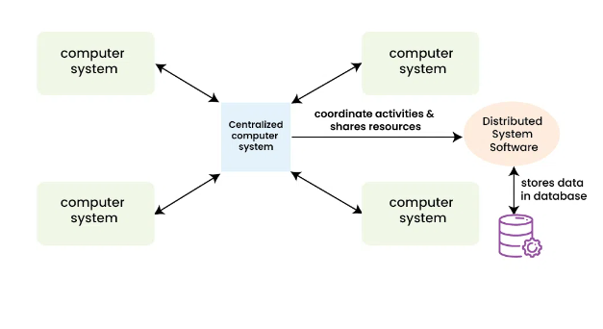*Distributed System.*

**Role of Distributed Computing in Data Science and AI**

Distributed computing plays a pivotal role in the advancement of data science and artificial intelligence (AI), enabling organizations and researchers to process massive amounts of data efficiently. As the size and complexity of datasets have grown, traditional computing systems struggle to keep up with the demand for fast and accurate processing. Distributed computing offers a solution by dividing large tasks into smaller components that can be executed in parallel across multiple machines, significantly improving both performance and scalability.

As the demand for larger and more sophisticated AI systems grows, the role of distributed computing will continue to expand, driving innovations in both AI and data science. One of the most notable areas of impact is the democratization of AI technologies, where distributed computing frameworks enable smaller organizations and researchers to access powerful computing resources at a fraction of the cost. Cloud platforms, such as Amazon Web Services (AWS), Google Cloud, and Microsoft Azure, offer scalable distributed computing solutions that can be rented on-demand, eliminating the need for costly infrastructure investments. This accessibility has lowered the barrier to entry for data science and AI, fostering innovation and accelerating research.

**Handling Large Datasets:**

In data science, the ability to process and analyze large datasets is crucial for discovering patterns, building predictive models, and extracting meaningful insights. Distributed computing frameworks like Hadoop and Apache Spark allow for the distribution of data across a cluster of computers, making it possible to handle terabytes or petabytes of information. This is particularly important for AI applications, where the quality and volume of data directly impact the performance of machine learning models. By enabling parallel processing, distributed computing reduces the time required to analyze massive datasets, allowing data scientists to run experiments and fine-tune models faster.

**Enhancing Machine Learning and AI Workflows:**

Machine learning, a core component of AI, often involves training complex models on vast datasets. Distributed computing accelerates this process by dividing both the data and the computational tasks among multiple nodes. For example, in deep learning, neural networks require large-scale computations that can take days or even weeks on a single machine. Distributed computing frameworks, such as TensorFlow and PyTorch, support distributed training by splitting the model and data across multiple machines, speeding up the training process and making it feasible to train large models within a shorter time frame.

Additionally, distributed computing is essential for hyperparameter tuning, where multiple configurations of a machine learning model need to be tested in parallel to find the optimal setup. Instead of running these tests sequentially on a single machine, distributed systems allow for the simultaneous evaluation of multiple models, drastically reducing the time required for optimization.

**Real-Time Data Processing and AI Applications:**

Many modern AI applications, such as recommendation systems, fraud detection, and autonomous vehicles, require real-time processing of data. Distributed computing frameworks like Apache Kafka and Spark Streaming allow AI systems to process streaming data in real-time, making decisions as new information becomes available. This capability is critical in fields such as finance, healthcare, and e-commerce, where timely and accurate insights can have a significant impact.

For example, in recommendation systems used by e-commerce platforms, distributed computing enables the system to process real-time customer data, analyze their preferences, and update recommendations instantly. Similarly, in fraud detection, AI models rely on distributed systems to analyze large streams of transaction data in real-time and identify suspicious patterns that may indicate fraud.

**Scalability and Flexibility:**

One of the key advantages of distributed computing is its scalability. As the need for processing power grows, organizations can simply add more nodes to the system, ensuring that their infrastructure can handle increasing amounts of data without degrading performance. This scalability is especially important in AI research, where breakthroughs in natural language processing, computer vision, and reinforcement learning require vast computational resources.

Furthermore, distributed computing frameworks are highly flexible, supporting a wide range of data science and AI workloads. From batch processing of historical data to real-time analytics and model deployment, distributed computing systems can be tailored to meet the specific needs of various AI applications.

**Distributed Computing over the Years**

The transformative impact of distributed computing on data science and artificial intelligence (AI) has been profound, reshaping the methodologies and frameworks that underpin modern computational tasks. As data volume and complexity continue to grow, the need for scalable, efficient, and reliable computing systems has never been more critical. Distributed computing has evolved over the years, with significant milestones that have shaped the landscape of data processing, AI, and machine learning. This evolution, driven by innovative frameworks and technologies, has enabled researchers and organizations to tackle massive datasets and computationally intensive algorithms with unprecedented speed and accuracy.

**The Rise of MapReduce and Early Distributed Computing:**

The modern era of distributed computing can be traced back to the introduction of the **MapReduce** framework by Dean and Ghemawat in 2004, which became widely adopted after 2008. MapReduce revolutionized data processing by enabling scalable computation over large datasets, dividing tasks into two main operations: "map" (distributing tasks to different nodes) and "reduce" (aggregating the results). This paradigm allowed data processing tasks to be efficiently distributed across multiple nodes, significantly enhancing the ability to analyze vast amounts of information in parallel. Companies like Google pioneered the use of MapReduce for indexing web pages, a critical task in search engines.

While MapReduce enabled large-scale distributed data processing, its reliance on disk I/O for intermediate results limited its performance, particularly for iterative tasks common in machine learning. The growing demands for faster, more flexible data processing frameworks led to the next evolution in distributed computing.

**The Introduction of Apache Spark:**

Building on the foundations of MapReduce, **Apache Spark**, introduced by Zaharia et al. in 2010, offered a faster alternative that addressed the limitations of its predecessor. Unlike MapReduce, Spark is built with in-memory processing capabilities, allowing for quicker data access and manipulation. This feature is particularly beneficial for iterative algorithms frequently used in machine learning, where the same dataset is processed multiple times.

Spark’s architecture also supports a unified engine for a wide range of tasks, including batch processing, stream processing, and graph analytics. This advancement simplified the development of complex data workflows, making Spark a preferred choice for many data scientists and engineers. With its flexible API and support for multiple programming languages (Scala, Python, Java, and R), Spark has become a cornerstone in the field of distributed computing.

**Distributed Machine Learning with TensorFlow:**

The introduction of *TensorFlow* by Abadi et al. in 2015 marked a significant leap in distributed machine learning. TensorFlow’s architecture is designed to support distributed training of deep learning models, which are often computationally intensive and require vast amounts of data. By enabling models to be trained across multiple GPUs or even across entire clusters of machines, TensorFlow allows for enhanced model accuracy and reduced training times. This framework has become a cornerstone for many AI applications, enabling researchers and developers to leverage distributed computing resources effectively for deep learning tasks such as natural language processing, computer vision, and reinforcement learning.

In addition to its distributed capabilities, TensorFlow introduced tools like *TensorFlow Serving*, which enables the scalable deployment of machine learning models in production environments. As AI models have become more complex and data-intensive, the ability to efficiently distribute not just training but also inference tasks across multiple machines has become a critical aspect of AI systems.

**Evolution of Distributed Frameworks: PyTorch and Beyond:**

Another significant advancement in distributed machine learning came with **PyTorch**, an open-source deep learning framework developed by Facebook’s AI Research lab. Initially released in 2016, PyTorch quickly gained popularity due to its dynamic computation graph and ease of use, making it a favorite among researchers and developers alike. In 2019, PyTorch introduced *PyTorch Distributed*, which offers a comprehensive set of tools for distributed training, enabling researchers to scale their models across multiple GPUs and machines seamlessly.

In comparison to TensorFlow, PyTorch’s dynamic nature made it more suitable for research, especially for experiments that require flexibility in model design. PyTorch Distributed also supports various strategies like **Data Parallelism** and **Model Parallelism**, making it a powerful tool for large-scale AI model training.

**Kubernetes and Distributed AI:**

In recent years, containerization technologies like *Kubernetes* have revolutionized the way distributed computing resources are managed and deployed. Kubernetes automates the deployment, scaling, and operation of containerized applications, including AI and machine learning models. When paired with distributed computing frameworks like TensorFlow and PyTorch, Kubernetes allows organizations to orchestrate distributed workloads across cloud environments efficiently.

By leveraging *Kubeflow*, an open-source Kubernetes-native platform, AI workflows can be scaled across distributed systems seamlessly. Kubeflow provides tools for managing machine learning pipelines, from data preparation to model training and deployment, all within a distributed framework. This integration has significantly streamlined the process of deploying distributed AI models in production, making Kubernetes a critical component in the future of distributed computing in AI.

**Advanced Technologies in Distributed AI and Data Science:**

As distributed computing continues to evolve, several cutting-edge technologies are shaping the future of distributed AI:

* **Federated Learning**: In this technique, data remains on local devices, and only model updates are shared with a central server. This decentralized approach to training models is crucial for privacy-sensitive industries such as healthcare and finance. It enables the training of models on distributed datasets without the need to move sensitive data across nodes.
* **Distributed Reinforcement Learning**: As reinforcement learning (RL) has gained prominence in areas like robotics and autonomous systems, distributed RL has emerged as a technique to speed up the learning process by distributing the environment simulations across multiple machines. Frameworks like **Ray** and **RLlib** have been developed to facilitate distributed RL, allowing agents to interact with multiple simulated environments in parallel.
* **Edge Computing**: The rise of edge computing is another major trend in distributed AI. In edge computing, data is processed closer to its source (e.g., IoT devices), rather than in centralized data centers. This approach reduces latency and improves response times for AI applications like autonomous vehicles and smart cities. Distributed AI models running at the edge can make real-time decisions without the need to send data back to a centralized server.

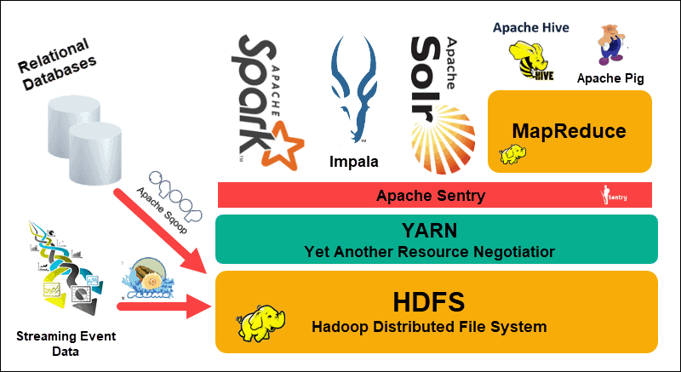

**HADOOP**

Apache Hadoop software is an open-source framework that allows for the distributed storage and processing of large datasets across clusters of computers using simple programming models. Hadoop is designed to scale up from a single computer to thousands of clustered computers, with each machine offering local computation and storage. In this way, Hadoop can efficiently store and process large datasets ranging in size from gigabytes to petabytes of data. It is a programming framework for storing a large amount of data and performing the computation. Its framework is based on Java programming with some native code in C and shell scripts. It is a framework that is used for storing and processing large amounts of data in a distributed computing environment. It is designed to handle big data and is based on the MapReduce programming model, which allows for the parallel processing of large datasets.

Hadoop uses distributed storage and parallel processing to handle big data and analytics jobs, breaking workloads down into smaller workloads that can be run at the same time.

**History:**

Hadoop traces its roots back to the early days of the World Wide Web, when the rapid growth of websites posed significant challenges for search engines. As the number of web pages surged into the millions and billions, companies like Google, Yahoo, and AltaVista sought ways to efficiently manage and automate search results. During this time, computer scientists Doug Cutting and Mike Cafarella developed a project called Nutch, inspired by Google’s early innovations in MapReduce (a method for processing large datasets) and the Google File System.

Nutch later became part of the Apache Software Foundation, where it was split into two projects: Nutch, focused on web crawling, and Hadoop, designed for distributed data storage and processing. In 2006, when Cutting joined Yahoo, Hadoop became a central component of their infrastructure and was open-sourced in 2008.

Although some mistakenly believe Hadoop is an acronym for "High Availability Distributed Object Oriented Platform," it was actually named after Cutting’s son’s toy elephant.

**Hadoop Infrastructure:**

* **Hadoop Distributed File System (HDFS):** As the primary component of the Hadoop ecosystem, HDFS is a distributed file system in which individual Hadoop nodes operate on data that resides in their local storage. This removes network latency, providing high-throughput access to application data. In addition, administrators don’t need to define schemas up front.
* **Yet Another Resource Negotiator (YARN):** YARN is a resource-management platform responsible for managing compute resources in clusters and using them to schedule users’ applications. It performs scheduling and resource allocation across the Hadoop system.
* **MapReduce:** MapReduce is a programming model for large-scale data processing. In the MapReduce model, subsets of larger datasets and instructions for processing the subsets are dispatched to multiple different nodes, where each subset is processed by a node in parallel with other processing jobs. After processing the results, individual subsets are combined into a smaller, more manageable dataset.
* **Hadoop Common:** Hadoop Common includes the libraries and utilities used and shared by other Hadoop modules.

Beyond HDFS, YARN, and MapReduce, the entire Hadoop open-source ecosystem continues to grow and includes many tools and applications to help collect, store, process, analyze, and manage big data. These include Apache Pig, Apache Hive, Apache HBase, Apache Spark, Presto, and Apache Zeppelin.

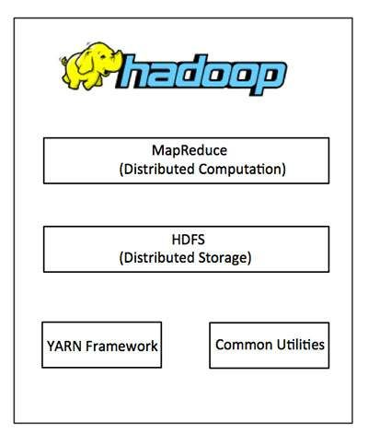

**HDFS (Hadoop Distributed File System):**

HDFS (Hadoop Distributed File System) is a master-slave architecture designed to provide high-performance access to data across highly scalable Hadoop clusters. The architecture consists of:

1. **NameNode (Master Node)**
   * Manages the file system namespace and regulates access to files by clients.
   * Stores a directory hierarchy and maps file names to blocks.
   * Maintains a memory cache of the file system namespace.
2. **DataNodes (Slave Nodes)**
   * Manage storage attached to the nodes they run on.
   * Store and retrieve data blocks in response to client requests.
   * Typically one DataNode per node in the cluster.

**Key Components**

1. **Blocks**: HDFS divides files into fixed-size blocks (typically 64 MB or 128 MB) for efficient storage and retrieval.
2. **Replication**: Data is replicated across multiple DataNodes to ensure data availability and fault tolerance.
3. **Checkpoints**: Periodic snapshots of the file system namespace are taken to ensure data consistency in case of NameNode failure.

**Additional Components**

1. **Secondary NameNode**: A standby NameNode that maintains a copy of the file system namespace and can take over in case of primary NameNode failure.
2. **Checkpoint Node**: Responsible for creating and maintaining checkpoints of the file system namespace.
3. **Backup Node**: Used for data backup and recovery in case of DataNode failure.

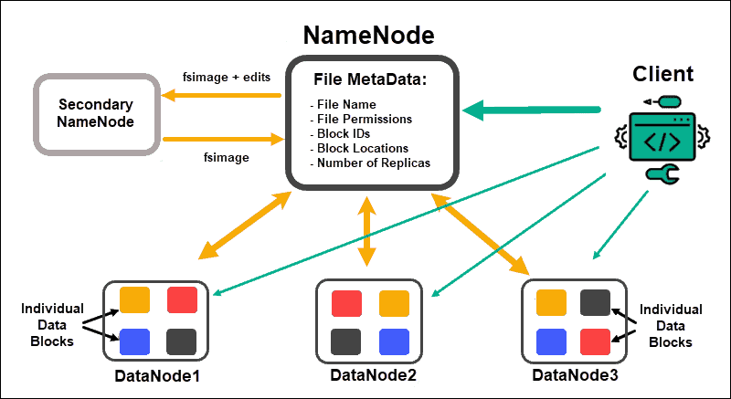

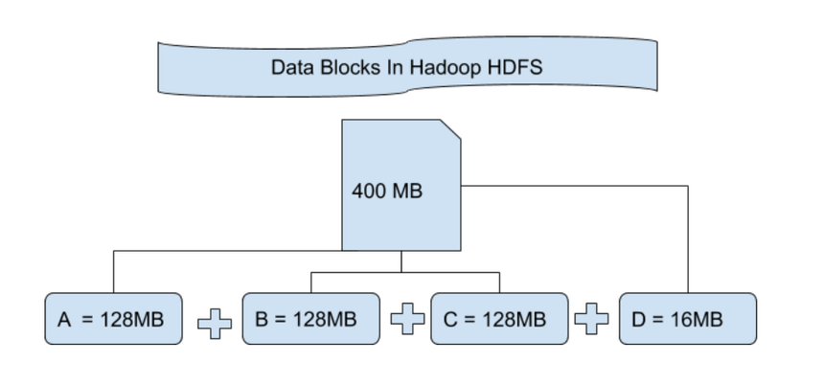

**MapReduce architecture:**

MapReduce is a programming model and software framework used for processing large-scale data sets in a distributed manner. It is a core component of the Hadoop ecosystem, designed to handle massive amounts of structured and unstructured data. The MapReduce architecture consists of several key components:

1. **Client**: The MapReduce client is the one who brings the Job to the MapReduce for processing. There can be multiple clients available that continuously send jobs for processing to the Hadoop MapReduce Manager.
2. **Job**: The MapReduce Job is the actual work that the client wanted to do which is comprised of so many smaller tasks that the client wants to process or execute.
3. **Hadoop MapReduce Master**: It divides the particular job into subsequent job-parts.
4. **Job-Parts**:  The task or sub-jobs that are obtained after dividing the main job. The result of all the job-parts combined to produce the final output.
5. **Input Data**: The data set that is fed to the MapReduce for processing.
6. **Output Data**: The final result is obtained after the processing.

In MapReduce, we have a client. The client will submit the job of a particular size to the Hadoop MapReduce Master. Now, the MapReduce master will divide this job into further equivalent job-parts. These job-parts are then made available for the Map and Reduce Task. This Map and Reduce task will contain the program as per the requirement of the use-case that the particular company is solving. The developer writes their logic to fulfill the requirement that the industry requires. The input data which we are using is then fed to the Map Task and the Map will generate intermediate key-value pair as its output. The output of Map i.e. these key-value pairs are then fed to the Reducer and the final output is stored on the HDFS. There can be n number of Map and Reduce tasks made available for processing the data as per the requirement. The algorithm for Map and Reduce is made with a very optimized way such that the time complexity or space complexity is minimum.    

The MapReduce task is mainly divided into 2 phases i.e. Map phase and Reduce phase.

1. **Map**: As the name suggests its main use is to map the input data in key-value pairs. The input to the map may be a key-value pair where the key can be the id of some kind of address and value is the actual value that it keeps. The *Map()* function will be executed in its memory repository on each of these input key-value pairs and generates the intermediate key-value pair which works as input for the Reducer or *Reduce()* function.
2. **Reduce**: The intermediate key-value pairs that work as input for Reducer are shuffled and sort and send to the *Reduce()* function. Reducer aggregate or group the data based on its key-value pair as per the reducer algorithm written by the developer.

How Job tracker and the task tracker deal with MapReduce:

1. Job Tracker: The work of Job tracker is to manage all the resources and all the jobs across the cluster and also to schedule each map on the Task Tracker running on the same data node since there can be hundreds of data nodes available in the cluster.
2. Task Tracker: The Task Tracker can be considered as the actual slaves that are working on the instruction given by the Job Tracker. This Task Tracker is deployed on each of the nodes available in the cluster that executes the Map and Reduce task as instructed by Job Tracker.

There is also one important component of MapReduce Architecture known as Job History Server. The Job History Server is a daemon process that saves and stores historical information about the task or application, like the logs which are generated during or after the job execution are stored on Job History Server.

**Benefits:**

1. **Fault Tolerance**: MapReduce can recover from node failures by re-executing tasks on other nodes.
2. **Speed**: MapReduce processes data in parallel, leveraging multiple nodes and machines.
3. **Scalability**: MapReduce can handle massive data sets by adding more nodes to the cluster.

**Programming Model:**

MapReduce programs consist of two main phases: Map and Reduce. The Map function processes input data, producing key-value pairs, while the Reduce function aggregates the output from the Map phase.

**Example Use Case:**

Consider a library with an extensive book collection on multiple floors. You want to count the total number of books on each floor. MapReduce can be used to process this task by:

1. Splitting the book collection into smaller chunks (Input Splits).
2. Processing each chunk in parallel using the Map task, producing a count of books on each floor.
3. Aggregating the output from the Map task using the Reduce task, producing the final count of books on each floor.

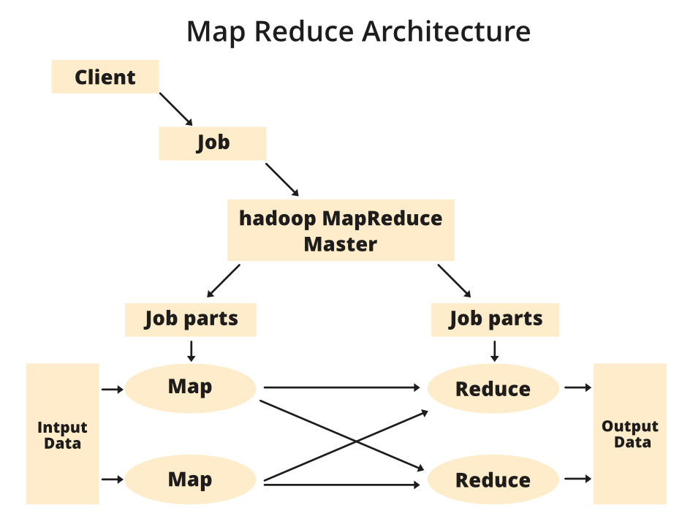

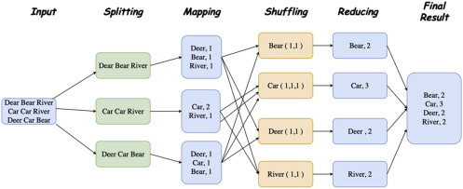

**Yarn architecture:**

YARN (Yet Another Resource Negotiator) is a resource management and job scheduling system for Hadoop clusters. It separates resource management from job scheduling and monitoring, providing a flexible and scalable architecture. The main components of YARN architecture are:

* **ResourceManager (RM)**: The global ResourceManager is responsible for managing resources (e.g., nodes, containers) across the cluster and scheduling applications.
* **ApplicationMaster (AM)**: Each application has a dedicated ApplicationMaster that manages the life-cycle of the application, including container creation and destruction.
* **NodeManager (NM)**: NodeManagers are responsible for managing resources and containers on individual nodes within the cluster.

**Key Features**

1. **Resource Management**: YARN provides a global view of resources across the cluster, allowing for efficient allocation and deallocation of resources.
2. **Job Scheduling**: YARN schedules applications based on available resources, ensuring that jobs are executed efficiently and without conflicts.
3. **Container Management**: YARN manages containers, which are lightweight, isolated environments for executing applications.
4. **Federation**: YARN supports federation, allowing multiple clusters to be combined into a single, transparently managed system.
5. **Reservation System**: YARN’s ReservationSystem enables users to reserve resources for specific time periods, ensuring predictable job execution.

**YARN Architecture Components**

* **Client**: Submits applications to YARN and monitors their progress.
* **ResourceManager**: Manages resources and schedules applications.
* **ApplicationMaster**: Manages the life-cycle of an application.
* **NodeManager**: Manages resources and containers on individual nodes.
* **Container**: A lightweight, isolated environment for executing applications.

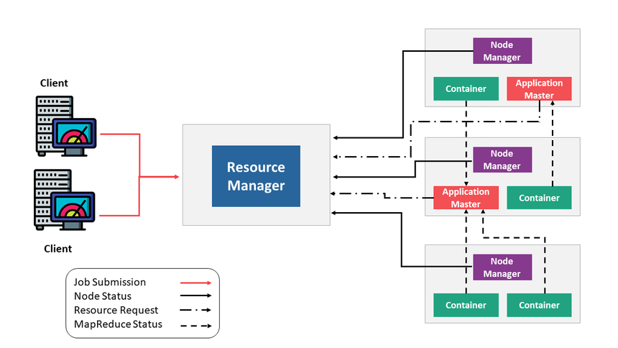

**Apache Spark**

Apache Spark is a powerful, open-source distributed computing system designed for fast and scalable data processing. Unlike traditional processing systems, Spark is built to handle large datasets by distributing tasks across multiple machines, allowing for high-speed computation. It was developed to address the limitations of earlier distributed frameworks like Hadoop MapReduce, particularly in terms of processing speed, ease of use, and handling complex data workflows.

**Key Features of Apache Spark:**

1. **In-Memory Processing**: One of Spark’s defining features is its ability to perform in-memory computations, meaning data can be processed directly in RAM rather than writing intermediate results to disk. This drastically increases the speed of iterative tasks, such as machine learning algorithms, compared to Hadoop MapReduce, which relies heavily on disk I/O.
2. **Ease of Use**: Spark provides APIs in several programming languages, including Java, Scala, Python, and R, making it accessible to a wide range of developers. Its simple and expressive API allows users to perform complex operations with fewer lines of code.
3. **Unified Engine**: Spark supports multiple types of data processing tasks, such as batch processing, stream processing, and interactive queries, all within a unified platform. This flexibility allows organizations to use Spark for a variety of use cases, from simple data transformations to advanced machine learning and graph processing.
4. **Fault Tolerance**: Spark ensures fault tolerance through a mechanism called Resilient Distributed Datasets (RDDs). RDDs automatically track lineage, which means that if a machine fails during computation, the lost data can be recomputed from the original source without affecting the entire workflow.

**Spark’s Architecture and Infrastructure:**

At its core, Spark operates on a master-slave architecture, where there is a central coordinator (the master) and multiple worker nodes (the slaves) that execute tasks.

1. **Driver Program (Master Node)**:
   * The **driver program** is the central component that oversees the execution of tasks. It takes the user's application code and breaks it down into a series of smaller tasks. The driver also coordinates the distribution of these tasks across the worker nodes in the cluster.
   * The driver is responsible for maintaining metadata about the RDDs and keeping track of their partitioning and task execution. It communicates with the **cluster manager** to allocate resources to the application.
2. **Cluster Manager**:
   * Spark uses a cluster manager to manage resources across the distributed nodes. Spark can work with different cluster managers, such as Apache Hadoop YARN, Apache Mesos, or Spark’s own standalone cluster manager. The cluster manager assigns tasks to worker nodes based on the available resources and ensures that they run efficiently.
3. **Worker Nodes (Slave Nodes)**:
   * The **worker nodes** execute the tasks assigned by the driver program. Each worker node has its own memory and CPU resources, which it uses to perform computations on the data partitions.
   * Workers communicate with the driver and other workers during task execution, especially when they need to shuffle data between nodes during operations like aggregations or joins.
4. **RDD (Resilient Distributed Datasets)**:
   * RDDs are the fundamental data structures in Spark. They are immutable, distributed collections of objects that are split across the worker nodes. RDDs are fault-tolerant because they can be recreated if a node fails, thanks to their lineage graph, which tracks the transformations applied to the data.
5. **Task Execution**:
   * The driver program breaks down the application into tasks that are distributed to the worker nodes. These tasks operate on the partitions of the RDDs, with each worker handling its share of the data. Once tasks are completed, the results are aggregated back to the driver.
6. **Caching**:
   * Spark can cache RDDs in memory, which improves performance when the same data is reused across multiple operations. This is particularly useful in iterative algorithms like machine learning, where datasets are processed repeatedly.

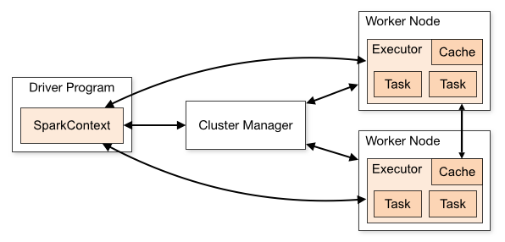

**Limitations**

While distributed computing has revolutionized data science and artificial intelligence (AI) by enabling large-scale data processing and parallel computation, it is not without its limitations. As the complexity and volume of data continue to grow, distributed systems face several challenges related to scalability, efficiency, and reliability. These challenges, if not properly addressed, can undermine the advantages that distributed computing provides.

**Network Latency and Bandwidth:**

One of the primary limitations of distributed computing is network latency. As tasks are distributed across multiple nodes, communication between those nodes becomes critical. High network latency can significantly slow down the performance of a distributed system, particularly in scenarios where nodes need to exchange large amounts of data. For example, in machine learning applications where models are trained on distributed datasets, the overhead of synchronizing parameters across different machines can lead to delays, reducing overall system efficiency.

Bandwidth limitations also present a bottleneck. Even in high-performance networks, transferring large volumes of data between nodes can consume a significant portion of the available bandwidth. As the amount of data grows, this issue becomes more pronounced, leading to slower data transfers and extended processing times. Moreover, if a single node is responsible for sending or receiving large chunks of data, it can become a bottleneck that slows down the entire system.

**Fault Tolerance and Reliability:**

Distributed systems are inherently more complex than centralized systems due to the multiple components involved. While distributed frameworks like Apache Hadoop and Spark are designed with fault tolerance in mind, ensuring the reliability of the entire system can be challenging. Hardware failures, network issues, or software bugs in one or more nodes can lead to significant disruptions in data processing.

Although techniques like data replication and task retries are built into many distributed systems, they can introduce additional overhead. For example, replicating data across multiple nodes to ensure fault tolerance consumes both storage and bandwidth, which can become costly as the size of datasets grows. Additionally, frequent failures in a large-scale distributed system may cause significant delays, as failed tasks need to be rerun, and data has to be reallocated to healthy nodes.

**Data Consistency and Synchronization:**

Maintaining data consistency in distributed environments is another challenge, especially in real-time applications. When multiple nodes are working on the same dataset or model, ensuring that all nodes have the most up-to-date information becomes critical. In some distributed systems, eventual consistency is employed, meaning that nodes may not have the same data at the same time, but will eventually converge to the same state. While this approach works for some applications, it is not suitable for use cases where real-time consistency is necessary, such as financial transactions or medical diagnostics.

Moreover, distributed machine learning models often require frequent synchronization of parameters during training, which can introduce significant overhead. Techniques like asynchronous training or gradient aggregation across multiple nodes can help, but they also increase the complexity of the system and may affect the final model’s accuracy.

**Scalability Challenges:**

Scaling a distributed system to handle large datasets or computational tasks is one of its main advantages, but there are inherent challenges. While it is easy to add more nodes to a distributed system to increase capacity, the overhead of coordinating and managing those nodes grows as well. Beyond a certain point, the benefits of adding more nodes diminish due to increased communication overhead and system complexity.

Additionally, certain algorithms or workloads are not easily parallelizable. For example, many machine learning algorithms require iterative processes that depend on the results of previous iterations. In such cases, scaling the system horizontally by adding more nodes does not necessarily result in a linear increase in performance, and may even introduce new bottlenecks. Scalability is also limited by the architecture of the underlying distributed framework. Some frameworks, like MapReduce, perform well for specific types of batch processing tasks, but may not scale efficiently for real-time or iterative workloads.

**Data Security and Privacy:**

Another significant limitation in distributed computing is ensuring data security and privacy, especially when data is distributed across multiple nodes or even across geographical regions. Distributed systems must implement robust encryption and authentication mechanisms to protect sensitive data. However, the complexity of securing a distributed environment increases as the number of nodes grows, leading to potential vulnerabilities.

In addition, privacy concerns arise when data from multiple sources is distributed across nodes that may be located in different regions, each governed by different data protection laws. For instance, regulations such as the General Data Protection Regulation (GDPR) impose strict requirements on how data can be stored and processed across borders, complicating the scalability of distributed systems.

**Conclusion**

In this paper, we explored the evolution of distributed computing and its profound impact on data science and artificial intelligence. From the early introduction of frameworks like MapReduce to modern innovations such as Apache Spark and TensorFlow, distributed computing has transformed the way we handle and process massive datasets, allowing for unprecedented scalability and efficiency. These technologies have enabled complex machine learning tasks to be completed in a fraction of the time, fueling advancements across industries.

As the demand for more powerful AI systems grows, distributed computing frameworks will continue to play a crucial role. Emerging technologies like federated learning, edge computing, and distributed reinforcement learning promise to push the boundaries of what is possible in AI, enabling real-time decision-making and processing closer to data sources. However, challenges related to network latency, fault tolerance, and data consistency must still be addressed for these systems to reach their full potential.

Looking forward, the future of distributed computing in AI and data science is promising, with the potential to revolutionize industries, empower researchers, and make advanced AI technologies more accessible. Continued research and innovation will be essential to overcoming current limitations and unlocking the full potential of distributed computing to tackle the complex problems of tomorrow.

**References:**

* Dean, J., & Ghemawat, S. (2008). MapReduce: Simplified data processing on large clusters. *Communications of the ACM, 51*(1), 107-113.
* Zaharia, M., Chowdhury, M., Franklin, M. J., Shenker, S., & Stoica, I. (2010). Spark: Cluster computing with working sets. *Proceedings of the 2nd USENIX Conference on Hot Topics in Cloud Computing*.
* Abadi, D. J., Barham, P., Chen, J., Corrado, G., Davis, A., Dean, J., ... & Zheng, X. (2016). TensorFlow: A system for large-scale machine learning. *12th USENIX Symposium on Operating Systems Design and Implementation (OSDI)*, 265-283.
* Apache Software Foundation. (n.d.). Apache Spark. Retrieved September 1, 2024, from <https://spark.apache.org/>
* Hadoop Project. (n.d.). Apache Hadoop. Retrieved September 1, 2024, from <https://hadoop.apache.org/>
* TensorFlow. (n.d.). TensorFlow: An end-to-end open-source platform for machine learning. Retrieved September 1, 2024, from <https://www.tensorflow.org/>
* [*The Future of Computing is Distributed(alluxio).*](https://www.alluxio.io/resources/videos/the-future-of-computing-is-distributed/)Ion Stoica
* [*geeksforgeeks.org*](geeksforgeeks.org)
* [*https://aws.amazon.com/*](https://aws.amazon.com/)