**Business Problems**

Vendor performance analysis

Importing Library

Importing DATA

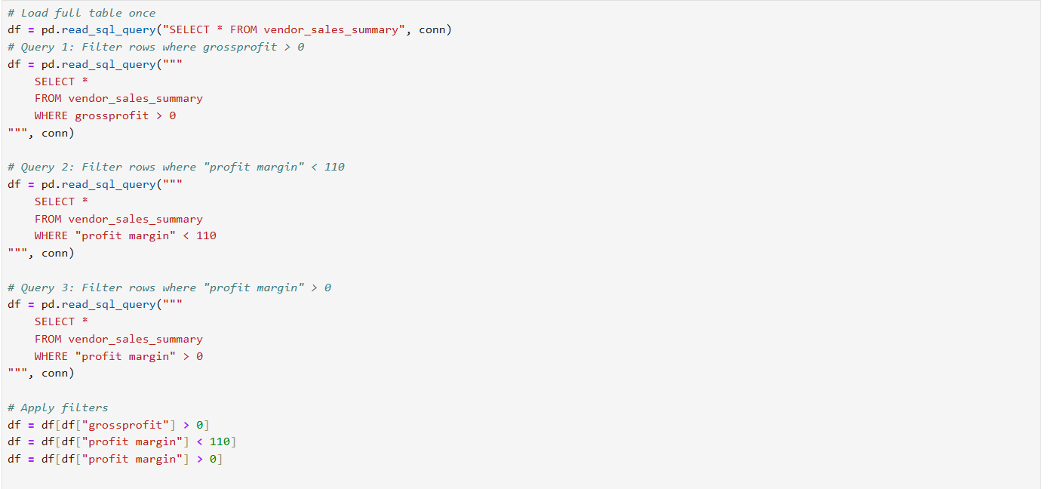

Data Table:

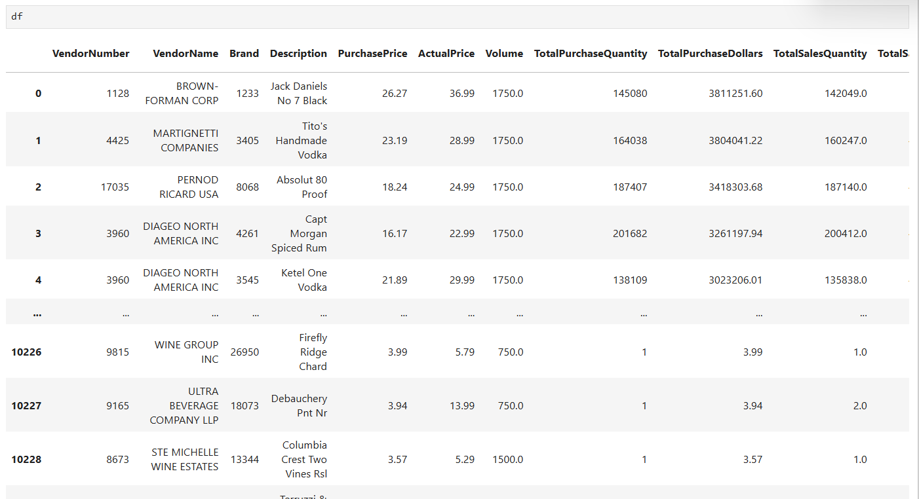

**Exploratory data Analysis insights** Summary Statistics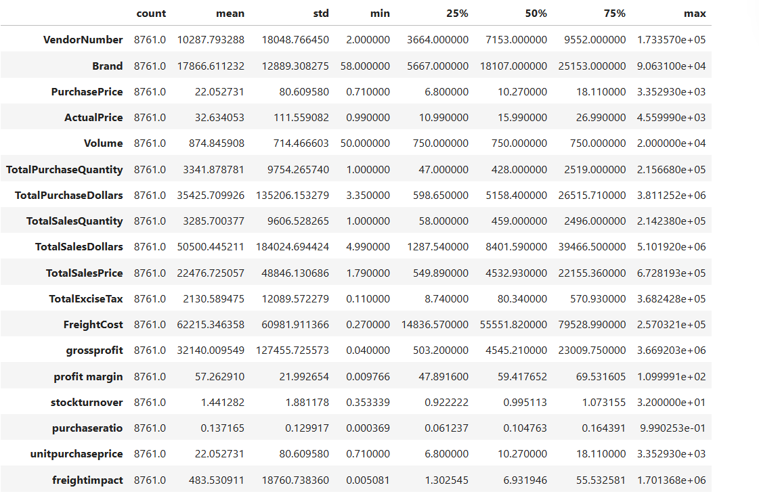

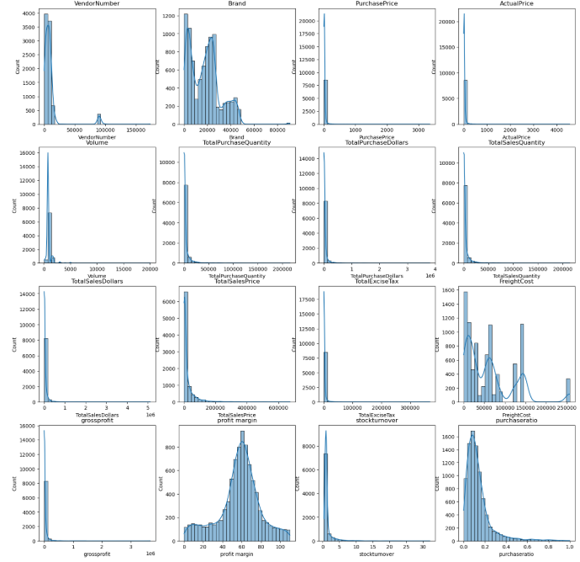

**Zero vales:**

**Total_sales quantity and sales dollars :** some product show zero sales indicating they were purchased but never sold.these may be slow-moving or absolute stock leading to inventory inefficiencies

**Outliers detected by high standard deviations**:

**Purchase & Actual prices**: The maximum values(5,681 & 7,499) are significantly higher than the mean (24.39 & 35.64),indicating premium product offerings

**Freight cost:** Extreme variation from 0.09 to 257,032 suggest logistics inefficiencies, bulk shipments, or erratic shipping costs across different products

**Stock turnover:** Ranges from 0 to 30,suggesting some products sell rapidly while others remain unsold for long periods. A value greater than 1 indicates that sales for product exceed the purchase quantity due to older stock fulfilling orders.

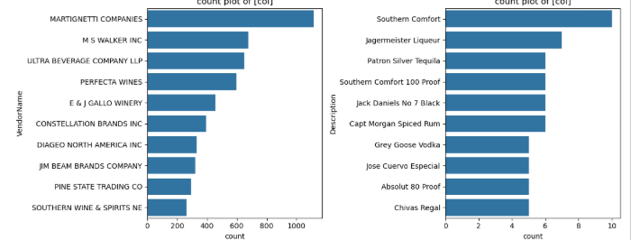

Correaltion Insights

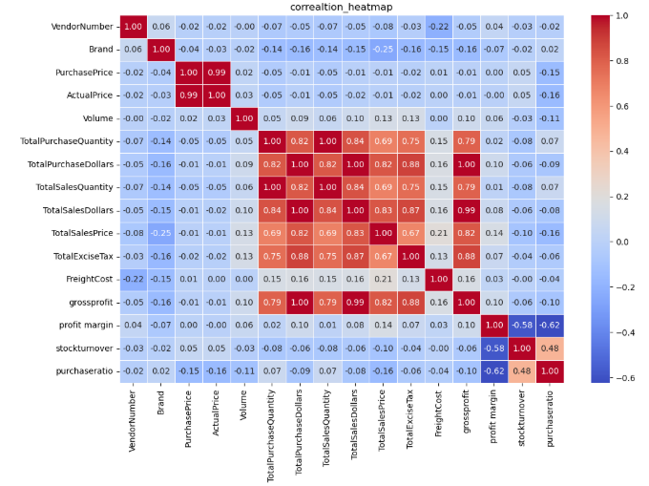

**Purchase price vs total sales & gross profit**: weak corelation (-0.022 to -0.026),indicating the price variations do not significantly impact sales and revenue or profit

**Total purchase Quantity vs total sales Quantity:** strongly corelation (0.999) ,confirming efficient inventory turnover

**Profit margin vs total sales dollar**: negatively correlation (-0.143),suggesting to increasing sales prices may lead to reduced margins due to competitive pricing pressures

**Stock turnover vs gross profit & profit margin:** Weak negative correlation(-0.58 to -0.60),indicating that faster stock turnover does not necessarily equate to higher profitability

**Research questions & key findings**

**1.top 10 vendor and top 10 brands that have sales the most**

Diageo north America in have most sales worth of(66.69 M) and jack Daniels no 7 black are the most sales brands at worth of 7.8M,the vodka is most also a high performance category in 2 and 3 place it all vodka

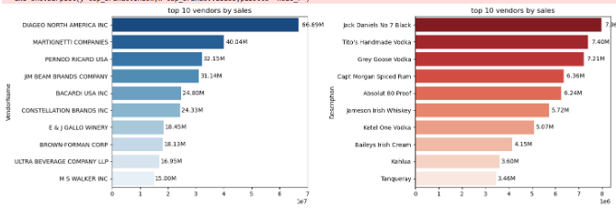

**2.top vendors by sales & purchase contribution:**

The top 10 vendors contribute 65.69% of total purchases, while other vendors contribute 34.5%.The over-reliance on few vendors is very risky suck as supply chain disruptions, indicating a need for a diversification.

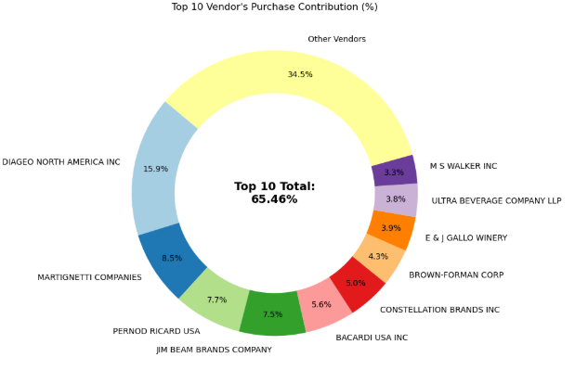

**3.impact of bulk purchasing on cost savings**

Vendors buying in large quantities receive a 72% lower unit cost ($ 11.11 per unit vs. Higher unit costs in smaller orders)

Bulk pricing strategies encourage larger orders, increasing total sales while maintaining profitability

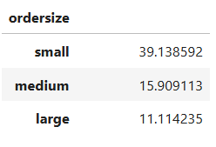

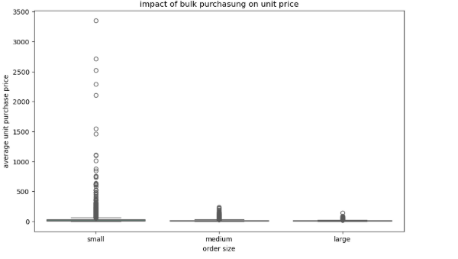

**4.vendors whose freight or excise taxes significantly reduce net profitability?**

Martignetti company have the most highest cost impact on profitability, because of higher tax and freight

