**Suraj Lokapure | 2020BTECS00081 | B5 batch**

**Project Management | Assignment 7 | 06-Nov-2023**

# Task management using Zoho

Create Fitness activity recognition for smartphone system project in Zoho with 3 team members.

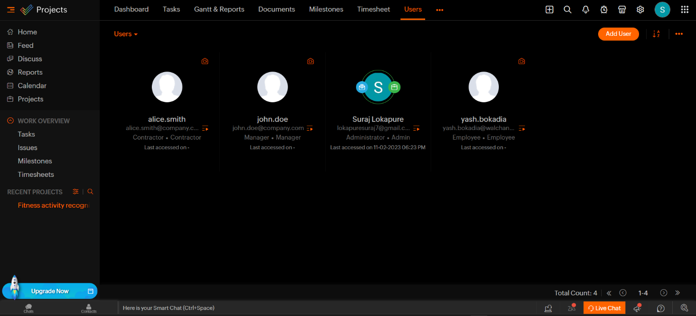

1. Create 3 tasks as
   1. Creating android application for daily activity registration
   2. Creating android application for tracking daily/weekly/monthly activity and reports
   3. Creating backend database for storing and fetching required details

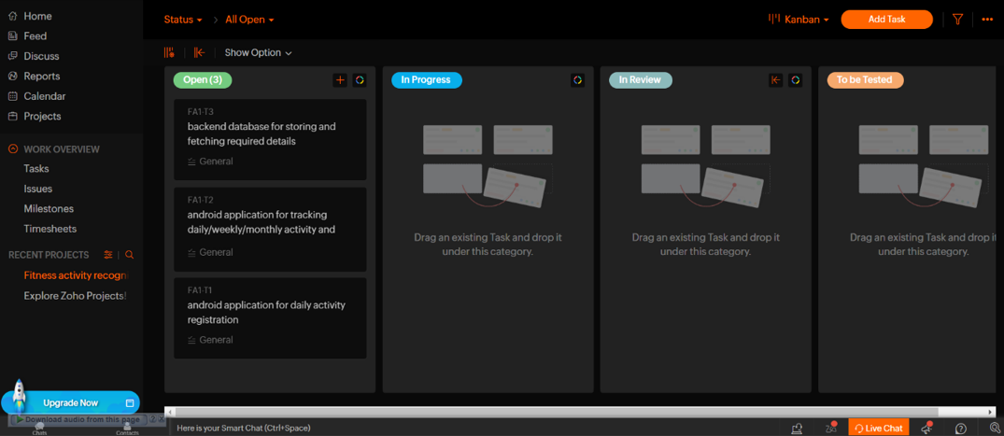

1. Create subtasks belonging to every task as
2. Task 1
   * Sub task 1: Daily activity registration form design with all components and event handling
   * Sub task 2: Testing of application with respective validations
3. Task 2
   * Sub task 3: Design of tracking daily/weekly/monthly activity and reports with all components and event handling
   * Sub task 4: Testing of application with respective validations
4. Task 3
   * Sub task 5: Creation of all necessary tables with respective constraints

* Sub task 6: Checking/Testing for different data entries

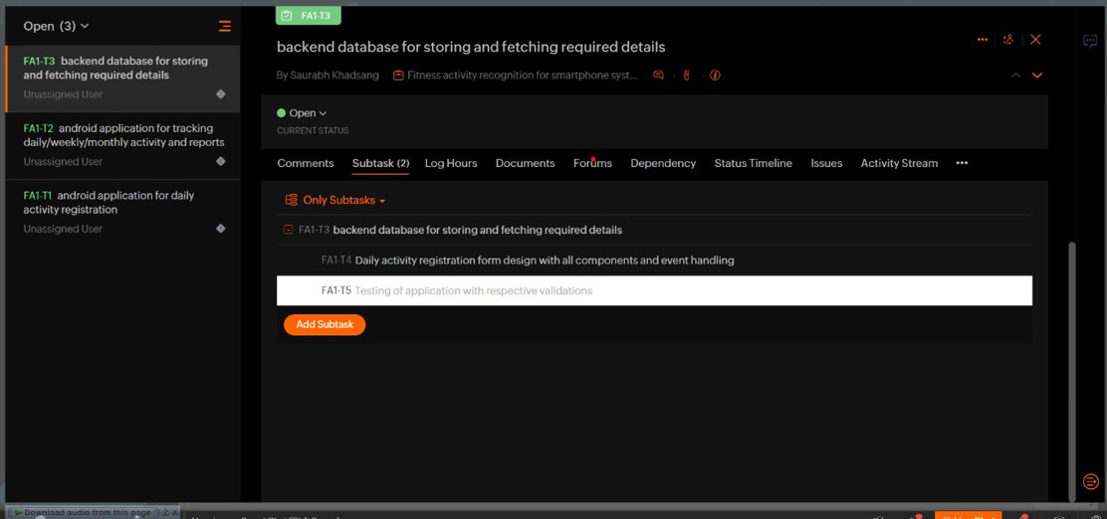

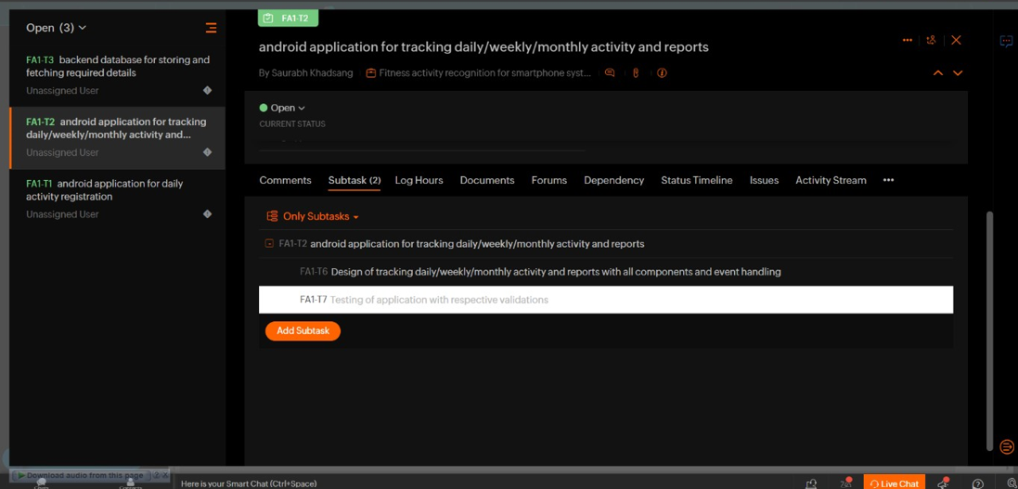

1. Assign each sub tasks to corresponding team member.

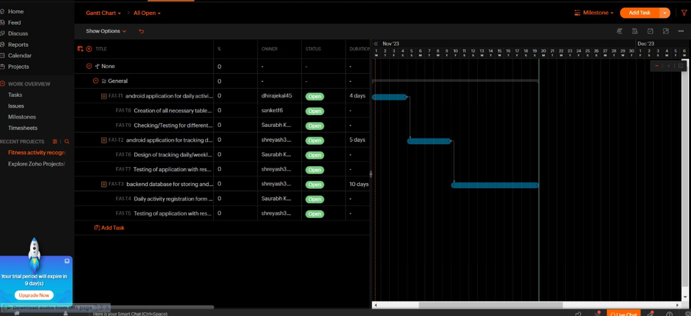

1. View tasks/ subtasks as Classic View, Plain View, Kanban View, Dependency View, and [Gantt](https://www.zoho.com/projects/gantt-charts.html) [View](https://www.zoho.com/projects/gantt-charts.html)
2. Perform track milestone. (group tasks together and quickly evaluate how close the project is to completion).
3. Activate timer for tasks.
4. View all task reports.
5. Update status of tasks.

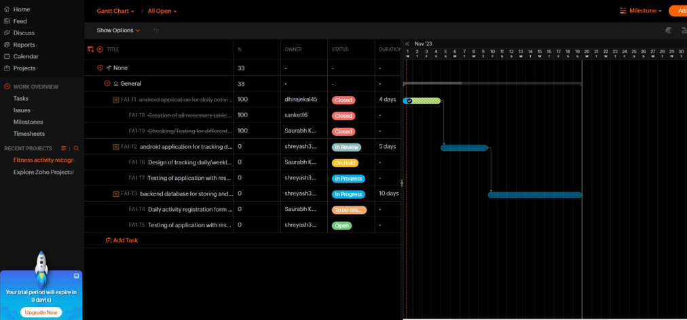

1. Set reminders and duration for tasks.

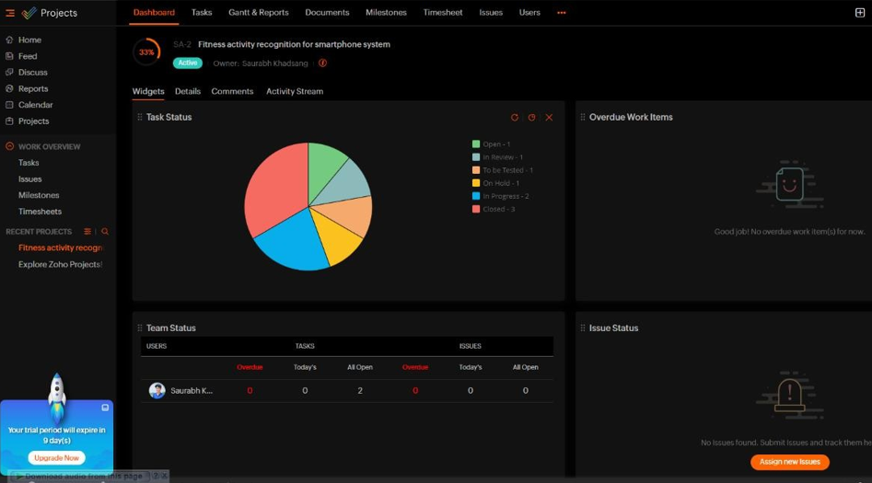

# Note: Please use below reference material

**2.** [**https://www.zoho.com/**](https://www.zoho.com/)