**Suraj Raju Lokapure | 2020BTECS00081 | B5 batch**

**Project Management | Assignment 2(UML diagrams)**

**| 25-AUG-2023**

# For the projects given below create/draw different UML diagrams.

* 1. Consider Online Shopping System (e.g Flipkart, Amezon etc.) for purchasing products online. Users can Browse Products, add to Cart the products and Checkout while Admin Can Manage Products and View Orders. A Payment system is important for processing a payment. For the above scenario draw a Use Case Diagram using online UML tool.

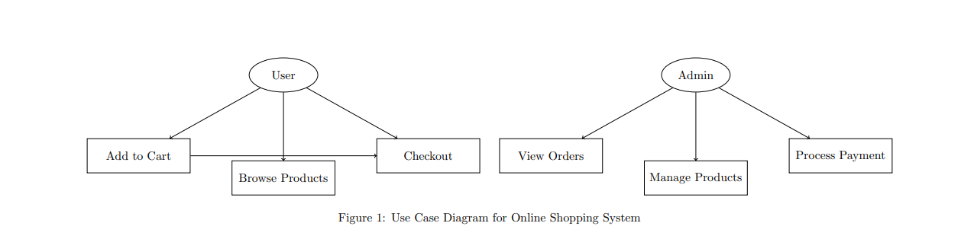

* 1. Consider online Flight Booking System for managing bookings. For the different classes given below draw a Class diagram for above scenario. Consider different classes and relationships given below.

# Classes:

**Passenger**

Attributes: passengerID, name, email Operations: searchFlight(), bookFlight() **Booking Agent**

Operations: confirmBooking(), updateFlightSchedule()

# Flight

Attributes: flightID, source, destination, departureTime, arrivalTime

# Ticket

Attributes: ticketID, flight, passenger, seatNumber

# Relationships:

A Passenger can have 0..N Tickets.

A Ticket is associated with one Flight and one Passenger

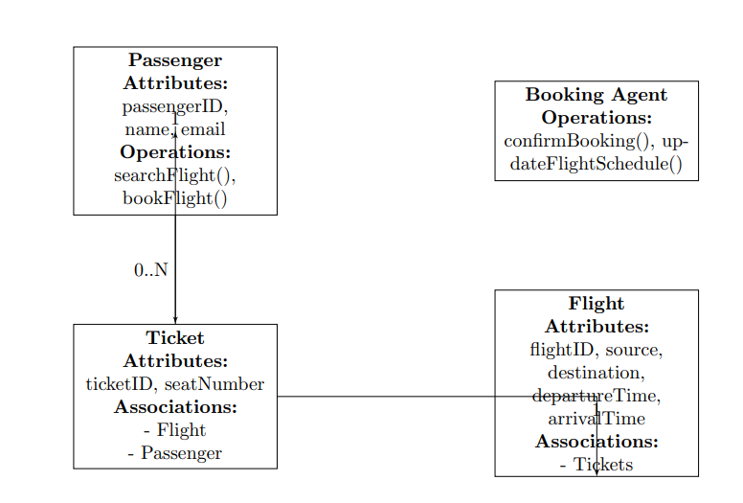

* 1. Consider the scenario of Library Management System (LMS). A library wants to develop a management system. Here are the basic requirements:
     + There are two types of users: Librarian and Member.
     + Both users can search for books.
     + Only a Librarian can add or remove a book.
     + A Member can borrow and return books.
     + Each Book has a title, ISBN number, and author(s).
     + Based on above requirements, draw a sequence diagram which can fulfil above tasks.

