**Final Year CSE AY 2023-24**

**Suraj Raju Lokapure | 2020BTECS00081 | B5 batch**

**Project Management | Assignment 3 (UML Diagrams)**

**| 06-Sept-2023**

# For the scenario given below create/draw different UML diagrams (DFD level 0, 1 and 2).

**Online Bookstore System**

An online bookstore allows users to browse books, add them to a cart, and then purchase them. Once purchased, users can download the digital version or opt for home delivery for physical copies.

# Entities (External Entities):

* 1. Customer: The person using the online bookstore.
  2. Payment Gateway: External system to handle transactions.
  3. Warehouse: Physical location where books are stored.

# Processes:

1. Search for Book: Customers can search for books using this process.
2. Add to Cart: Customers can add books to their cart using this process.
3. Checkout: Process where customers finalize their purchase.
4. Order Processing: Process where the order details are sent for either digital delivery or physical shipping.

# Data Stores:

1. Book Catalog: A database or store where all books and their details are stored.
2. Customer Cart: Temporary storage where selected books are held before purchase.
3. Order History: A record of all transactions and purchases.

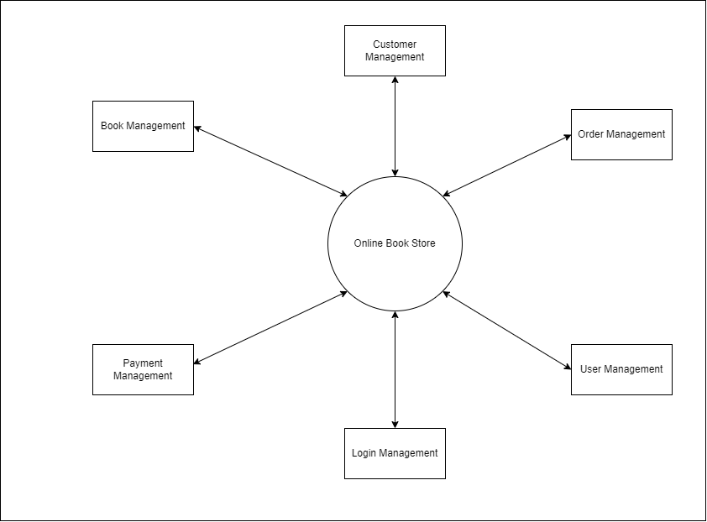

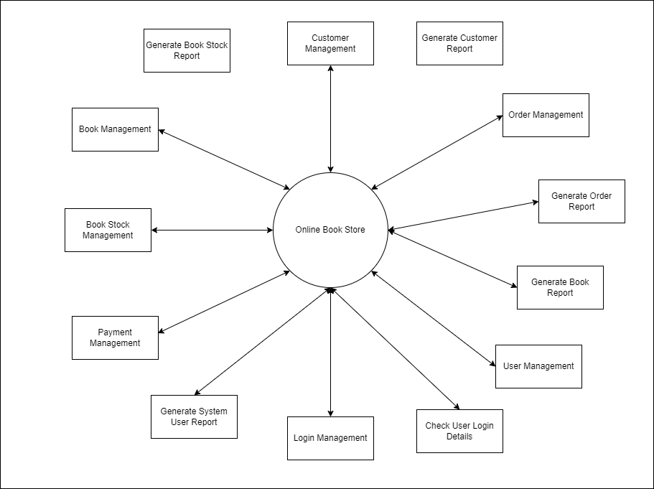

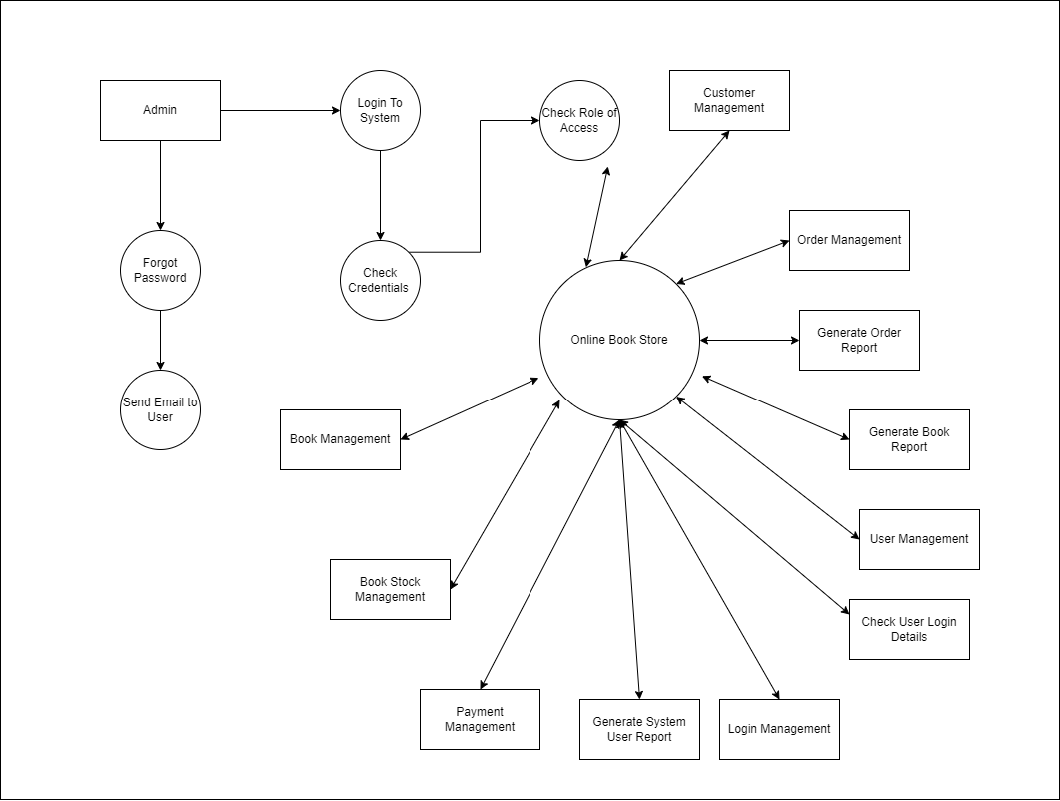

# For the scenario given below draw an activity diagram.

Hotel Room Booking Process Description:

A customer wishes to book a room in a hotel. The process starts with checking room availability for the desired dates. If a room is available, the customer provides personal details and payment information. If the payment is successful, the room is reserved, and a confirmation is sent to the customer. If the room is not available or payment fails, the customer is informed of the issue.

# Activity Diagram Steps:

1. Start the Process: Begin with a start node.
2. Check Room Availability:
3. Decision Node: "Is the room available for desired dates?" If yes, proceed to the next step.

If no, provide a message "Room not available" and end the process.

1. Enter Personal and Payment Details: The customer provides personal details and payment information.
2. Process Payment:

Decision Node: "Is payment successful?" If yes, proceed to the next step.

If no, provide a message "Payment failed" and end the process.

1. Reserve Room: The system reserves the room for the customer.
2. Send Confirmation: The system sends a booking confirmation to the customer.
3. End the Process: End with an end node.

