**Suraj Lokapure | 2020BTECS00081 | B5 batch**

**Project Management | Assignment 5 | 23-Oct-2023**

**Online examination and evaluation system**

1. Create Student exam registration and evaluation system project in Jira with template as Scrum and add 3 team members into your project



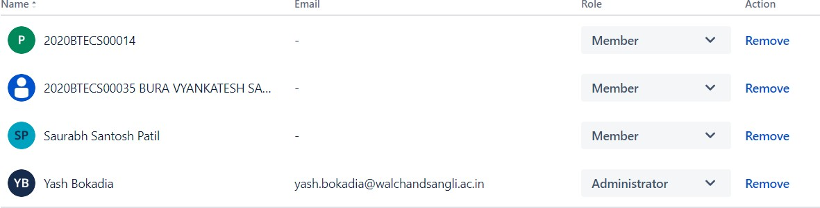

1. Create 4 Epics as
   1. Creating web application for student exam form registration
   2. Creating web application for online exam conduction
   3. Creating web application for online evaluation system
   4. Creating backend database for storing and fetching required details

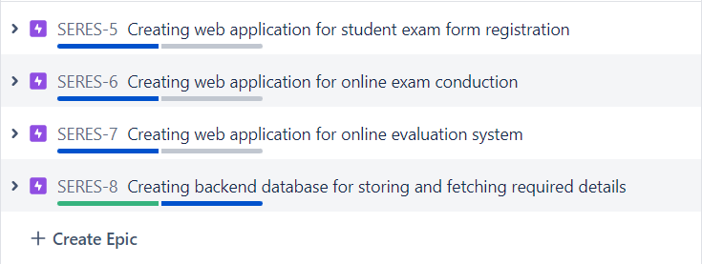

1. Create user stories belonging to every epic as
   1. Epic 1
      1. User story 1: Student exam registration form design with all components and event handling
      2. User story 2: Testing of application with respective validations

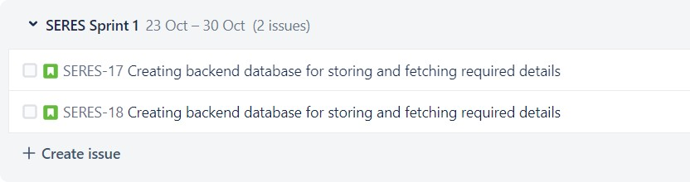

* 1. Epic 2
     1. User story 3: Online exam conduction form design with all components and event handling
     2. User story 4: Testing of application with respective validations

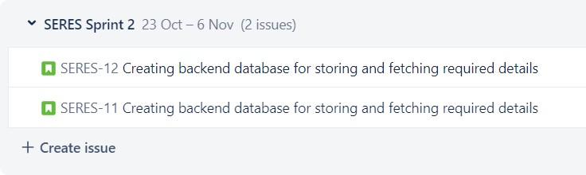

* 1. Epic 3
     1. Online exam evaluation form design with all components and event handling
     2. Testing of application with respective validations

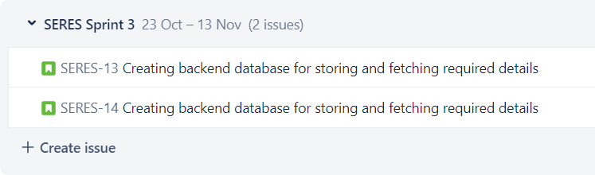

* 1. Epic 4
     1. User story 7: Creation of all necessary tables with respective constraints
     2. User story 8: Checking/Testing for different data entries

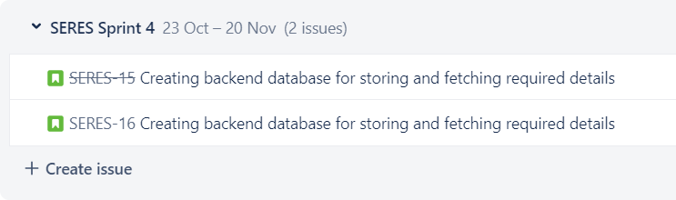

1. Assign each user story to corresponding team members.

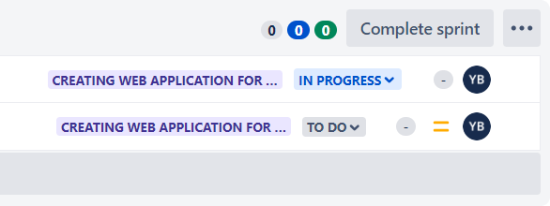

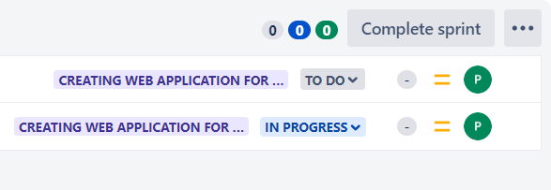

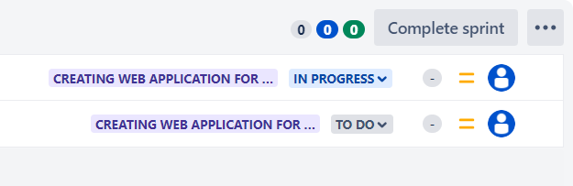

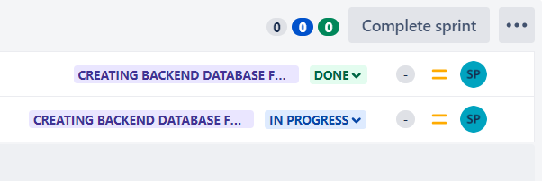

1. Create sprints for every use stories and prioritize them according to your tasks. Assign time period for every user story. (For all user stories: 1 Week)

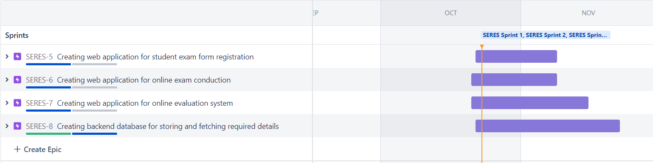

1. Update the status of some user stories as To Do, In Progress or Completed according to sprints (add appropriate comments).

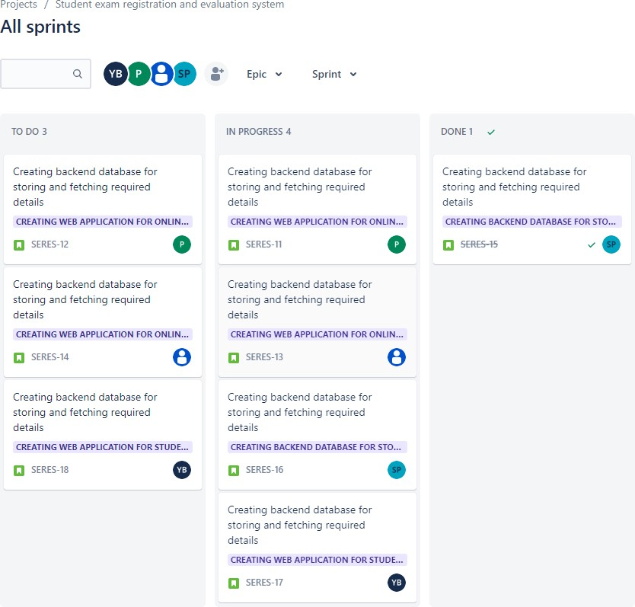

1. Create a bug/issue for respective user story and epic and assign to respective member.

